Look at this picture of the troll. Use the lenses below to write a story about what is happening.
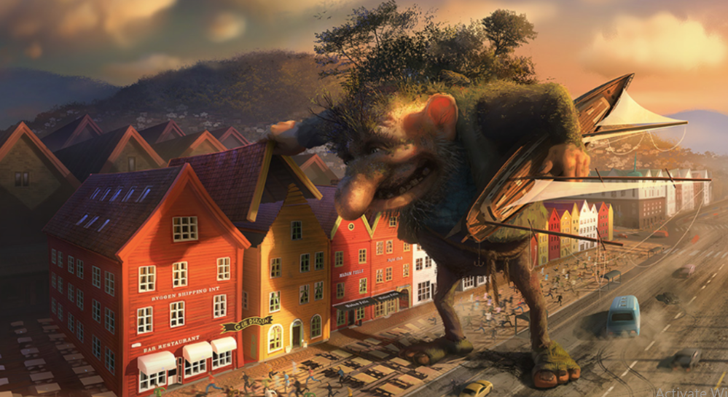

E.g. The troll is feeling angry as he stomps through town.

