Chapter 4

Chapter Details
Chapter title: Further Multiplication and Division
Start page: 147
Number of lessons: 19
Chapter description:
In this chapter, pupils will further develop their understanding of multiplication and division. They will learn how to divide and multiply by 1 and 0 and understand the law of commutativity. They will learn how to multiply three numbers together using prior knowledge of multiplication tables.
Pupils will use their tables and knowledge of place value to multiply multiples of 10, leading to the multiplication of 2-digit numbers using short multiplication. They will use their knowledge of multiplying multiples of 10 when multiplying multiples of 100, leading to multiplying 3-digit numbers using short multiplication.
Pupils will learn more about division and will divide 2-digit numbers using two methods, including numbers with remainders. They will learn to solve multiplication and division problems using the methods they have learned and will use bar models to visualise what the problem is asking them to do.
Resources
Base 10 materials (between two)
Counters (between two)
Laminated part–whole diagrams (between two)
Place-value charts (between two)
Place-value discs (between two)
Plates (between two)
£1 coins and counters (between two)

Textbook 4A
Chapter 4 – Further Multiplication and Division
Lesson 1 – Multiplying by 0 and 1
To be able to multiply by 0 and 1.
Lesson 2 – Dividing by 1
To be able to divide by 1.
Lesson 3 – Multiplying the Same Two Numbers
To be able to understand commutativity.
Lesson 4 – Multiplying Three Numbers
To be able to multiply three numbers.
Lesson 5 – Multiplying Multiples of 10
To be able to multiply with multiples of 10.
Lesson 6 – Multiplying 2-Digit Numbers
To be able to multiply 2-digit numbers without renaming.
Lesson 7 – Multiplying 2-Digit Numbers
To be able to multiply 2-digit numbers with renaming.
Lesson 8 – Multiplying Multiples of 100
To be able to multiply multiples of 100.
Lesson 9 – Multiplying 3-Digit Numbers
To be able to multiply 3-digit numbers without renaming.
Lesson 10 – Multiplying 3-Digit Numbers
To be able to multiply 3-digit numbers with renaming.
Lesson 11 – Multiplying 3-Digit Numbers
To be able to multiply 3-digit numbers with renaming.
Lesson 12 – Dividing 2-Digit Numbers
To be able to divide 2-digit numbers.
Lesson 13 – Dividing 3-Digit Numbers
To be able to divide 3-digit numbers.
Lesson 14 – Dividing 2-Digit Numbers
To be able to divide 2-digit numbers with a remainder.
Lesson 15 – Dividing 3-Digit Numbers
To be able to divide 3-digit numbers with renaming.
Lesson 16 – Dividing 3-Digit Numbers
To be able to divide 3-digit numbers with a remainder.
Lesson 17 – Solving Word Problems
To be able to solve word problems involving multiplication and division.
Lesson 18 – Solving Word Problems
To be able to solve word problems involving multiplication and division.
Lesson 19 – Chapter Consolidation
To be able use knowledge of multiplication and division to solve problems.

Lesson 1
Top of Form
Multiplying by 0 and 1
Pages 148–151
Lesson Objective
To be able to multiply by 0 and 1.
National Curriculum
Use place value, known and derived facts to multiply and divide mentally, including: multiplying by 0 and 1.
Lesson Approach
To begin this lesson, tell the class they will be learning how to use the multiplication facts they already know to help them with harder calculations. Show them the In Focus problem and give them time to discuss what they see in pairs. Ask questions, such as: How many plates are there? How many cherries are on each plate? How many cherries are there altogether? How did you calculate the total number of cherries? Work through Let's Learn 1, thinking aloud at each stage to ensure you clearly model your thought process. What is happening each time we remove a plate of cherries? We are counting backwards in fours. What would the calculation be?
Repeat the process for Let's Learn 2, allowing time for partner discussion. Then display Let's Learn 3. What does this image represent? How many plates are there? How many pears are on each plate? How many groups? How many pears in each group? What would the calculation be? Repeat the process for Let's Learn 4 and 5. Then ask pupils to think of general rules for multiplying by 0 and 1.
During Guided Practice, pupils are practising multiplying by 0 and 1. Circulate the classroom and listen to conversations to check they are using the appropriate vocabulary.
Misconceptions
Pupils believe that 4 × 1 = 1.
Pupils believe that 4 × 0 = 4.
Formative Assessment
Pupils can represent multiplication facts using concrete materials.
Pupils can represent multiplication facts using pictures.
Pupils can create a number of equal groups.
Pupils can create groups of a given number.
Pupils can represent multiplication by 0.
Non-negotiables
Pupils can represent multiplication facts using concrete materials and/or pictures, and record their thinking in a multiplication sentence.
Variation
Example 1: Multiplying 5 by 0, 1 and 2 with pictorial support.
Example 2: Multiplying 4 × 0 with pictorial support.
Example 3: Multiplying 12 × 0 with pictorial support.
Example 4: Exploring the commutative law and multiplying by 0 and 1.
Example 5: Creating number stories for 1 × 12 and 0 × 12.
Resources
Counters (between two)
Plates (between two)

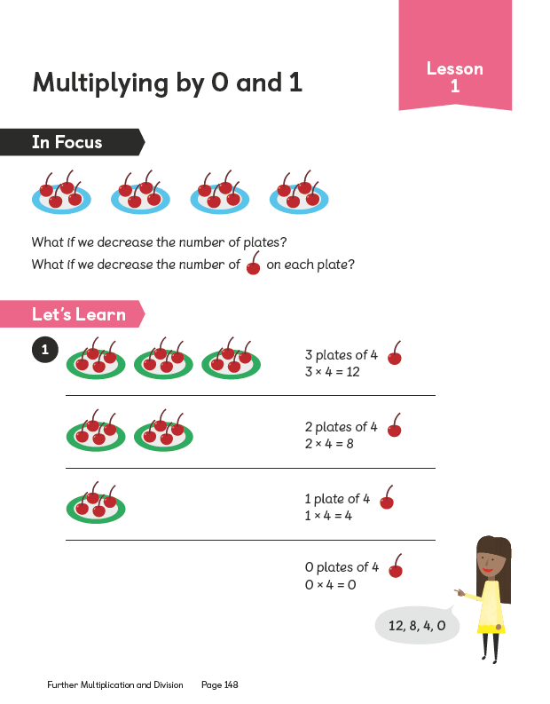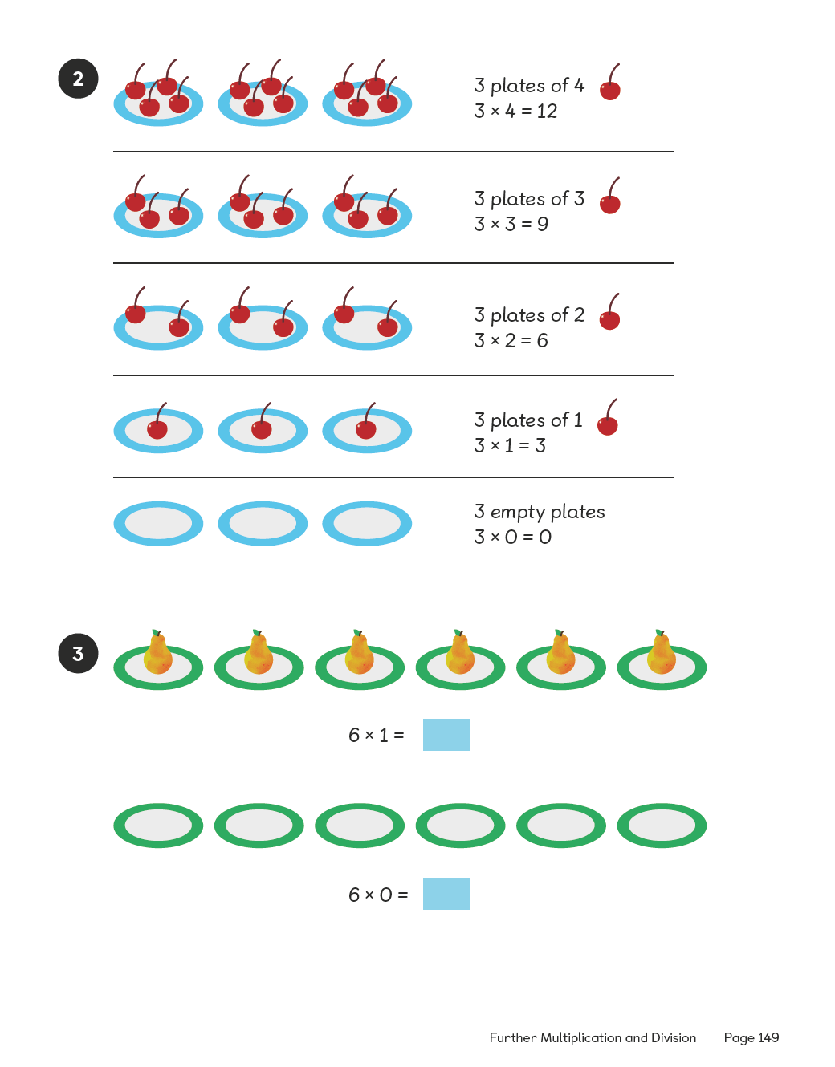

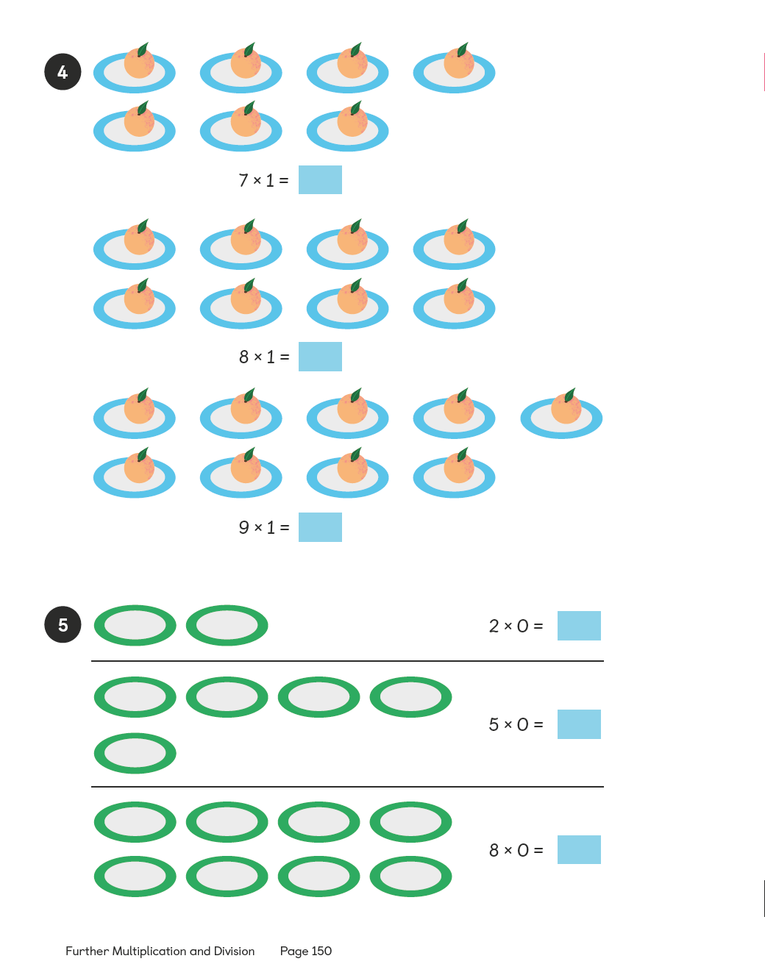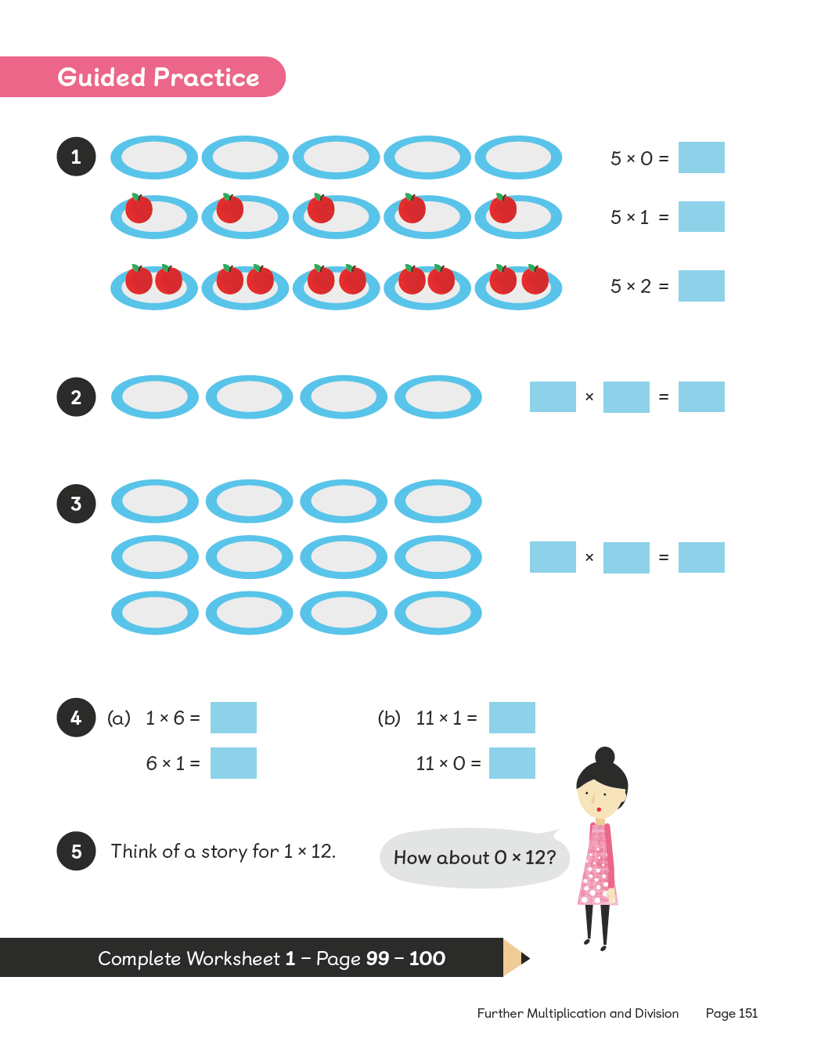

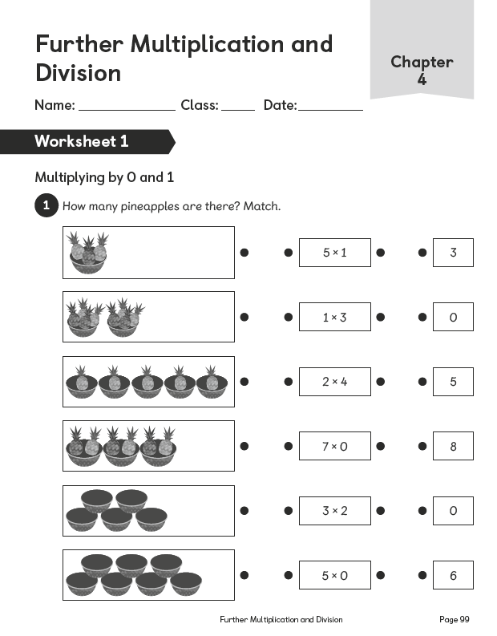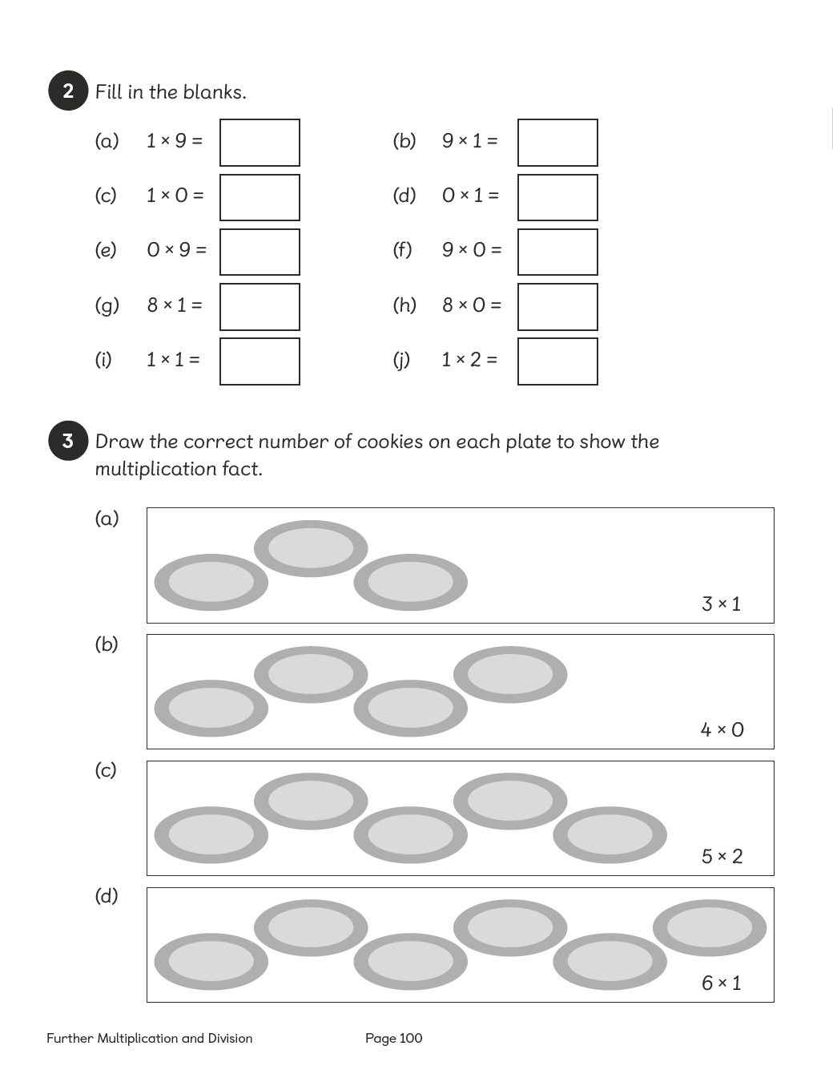

Lesson 2
Top of Form
Dividing by 1
Pages 152–154
Lesson Objective
To be able to divide by 1.
National Curriculum
Use place value, known and derived facts to multiply and divide mentally, including: dividing by 1.
Lesson Approach
To begin this lesson, remind pupils of previous learning on multiplying by 0 and 1. Then show them the In Focus task and ask: What can you see? What is the problem asking us to do? How many friends are there? How many coins? How much money in total?
Work through Let's Learn 1. Sharing 6 coins among 3 friends, each child gets 2 coins totalling £2. What calculation did we carry out? How can we check the calculation? Display Let's Learn 2 and ask: Do you think each child would get more or less money if one friend leaves? Let pupils discuss this in pairs before giving feedback, then go through what would happen. What is the calculation that matches this image?
Display Let's Learn 3 and ask: What if there were 6 friends; how much do you think each would get then? How do you know? Then discuss Let's Learn 4 with pupils. Is it true that you would get the most money if you didn't have to share with anyone. Why? How do you know? What calculation would match this statement?
During Guided Practice, pupils are practising dividing by 1. Before they begin, discuss the first part of question 1 using counters to demonstrate; look at how the algorithm matches the image. Pupils use the same procedure to complete the rest.
Misconceptions
Pupils believe that 4 ÷ 1 = 1.
Formative Assessment
Pupils can represent division facts using concrete materials.
Pupils can represent division facts using pictures.
Pupils can create a number of equal groups.
Pupils can create groups of a given number.
Pupils can divide an amount into one equal group.
Non-negotiables
Pupils can represent division facts using concrete materials and/or pictures and record their thinking in a division sentence.
Variation
Example 1: Dividing 8 into a variety of different equal groups with pictorial support.
Example 2: Dividing different numbers into equal groups, finishing with dividing a variety of numbers into one group; no pictorial support.
Resources
£1 coins and counters (between two)

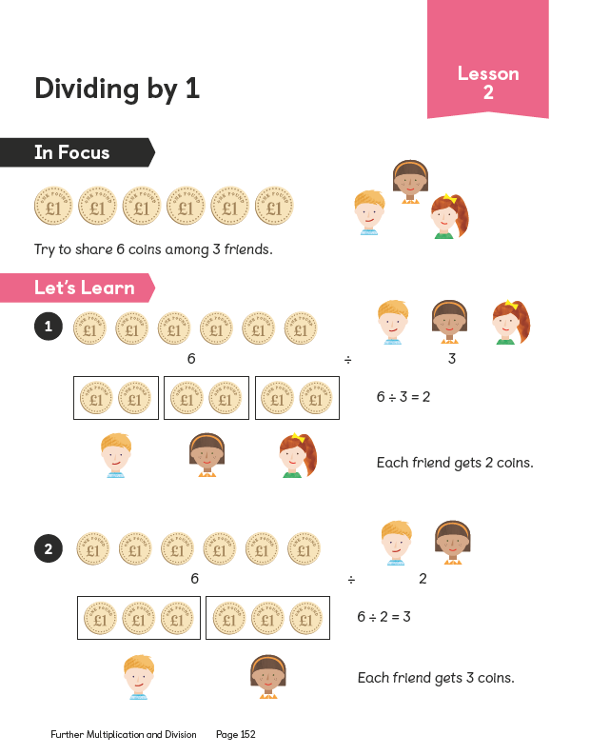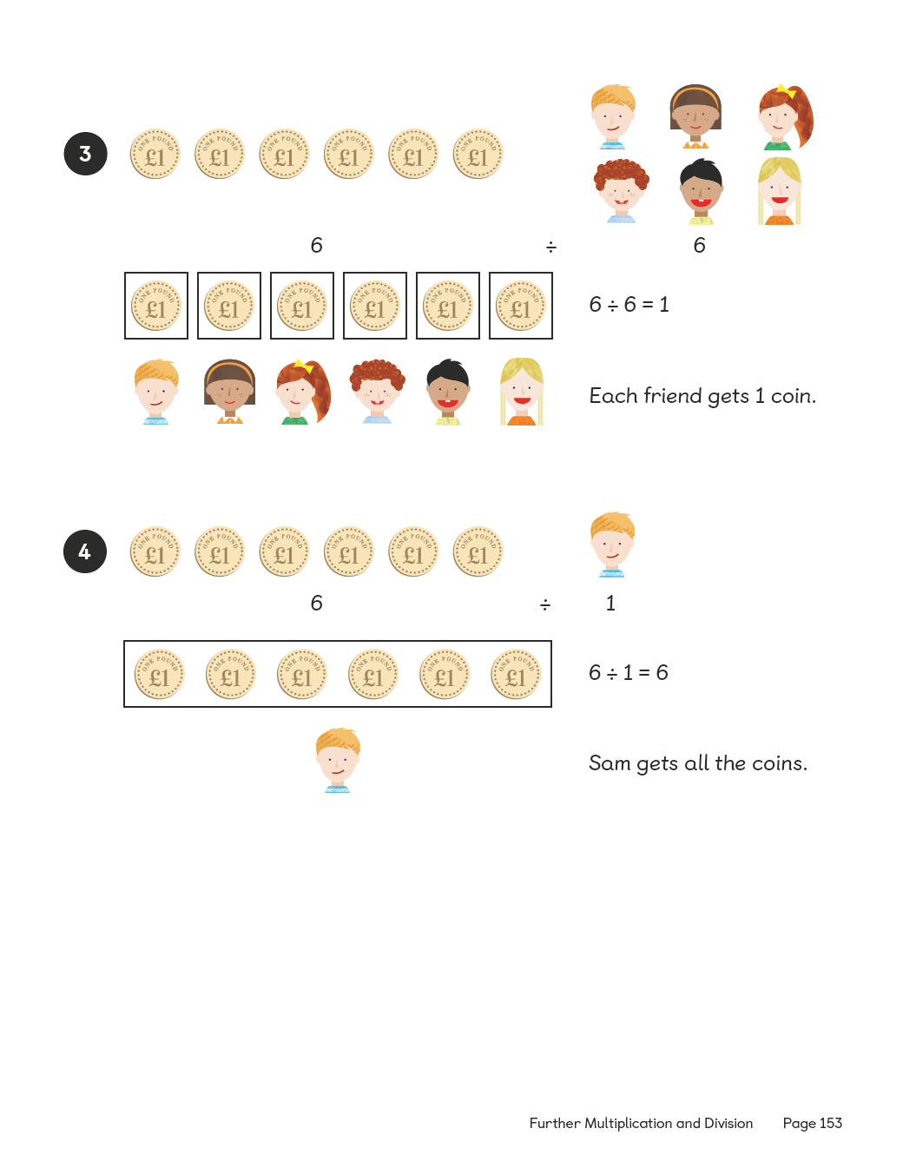
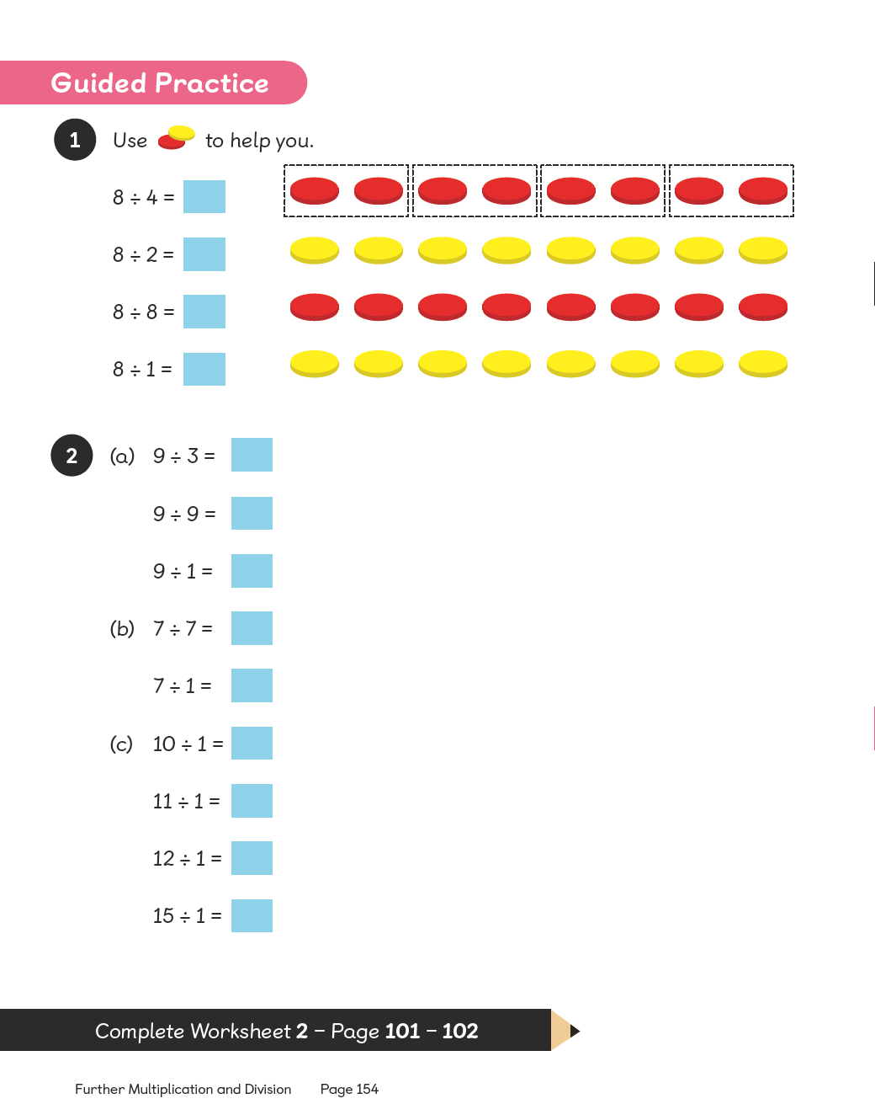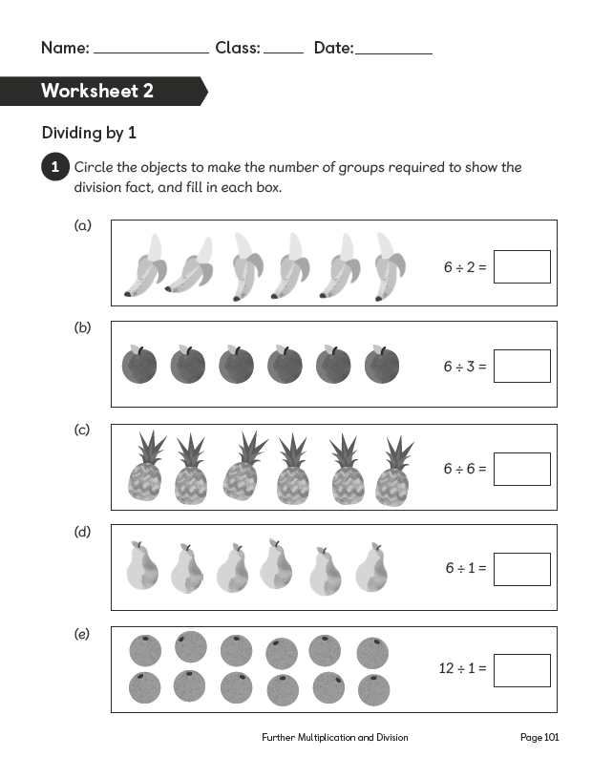

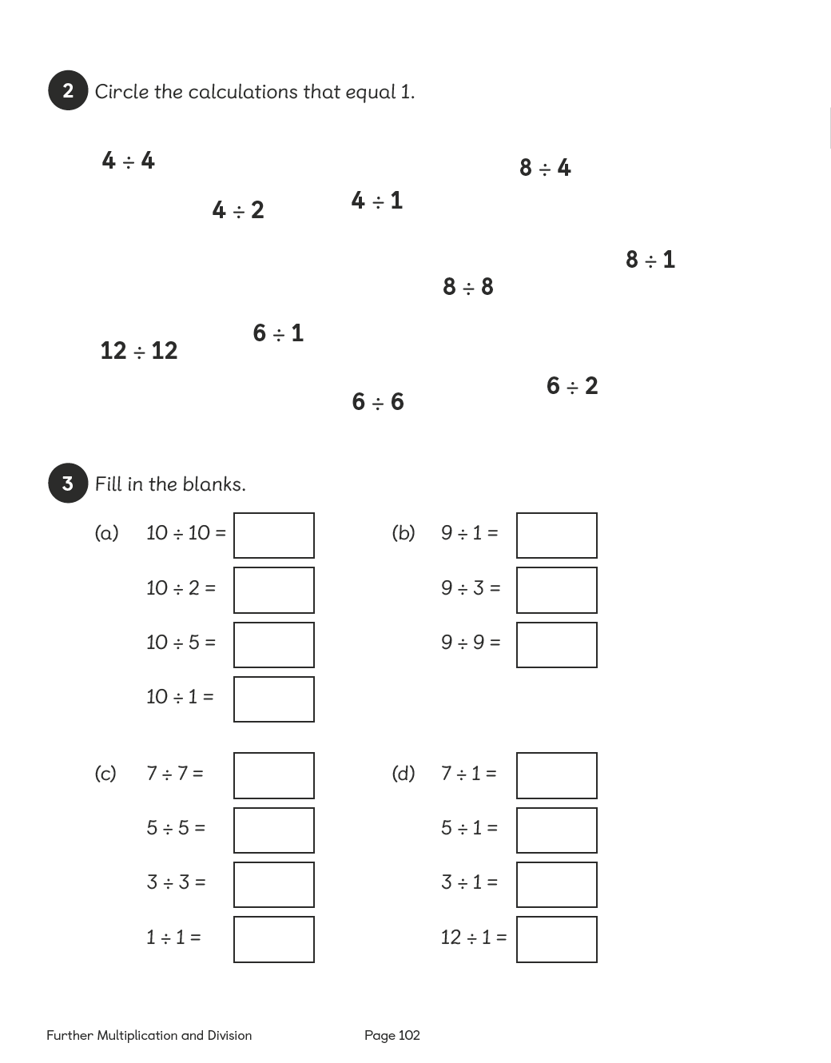

Lesson 3
Top of Form
Multiplying the Same Two Numbers
Pages 155–156
Lesson Objective
To be able to understand commutativity.
National Curriculum
Recognise and use factor pairs and commutativity in mental calculations.
Lesson Approach
To begin this lesson, discuss multiplication and pupils' understanding of what it means. Ask whether 4 + 3 is the same as 3 + 4. What about 2 + 8 and 8 + 2? What is the same and what is different about each of the equations? How about 3 × 6 and 6 × 3? Allow time for a short discussion with partners before displaying the In Focus task.
Ask pupils to discuss the images shown and take feedback before showing them the two methods exemplified in Let's Learn. What has been done to each picture to make it a different calculation? Has the product changed?
During Guided Practice, pupils are consolidating their understanding of commutativity. Discuss why there is no picture for question 3. Ask pupils to consider which method is better and why.
Misconceptions
Pupils believe that, when you change the position of the numbers in multiplication, the answer also changes.
Formative Assessment
Pupils can multiply numbers to 12.
Pupils can represent multiplication facts using concrete materials.
Pupils can represent multiplication facts using pictures.
Pupils can create a number of equal groups.
Pupils can create groups of a given number.
Pupils can use an array to represent a multiplication problem.
Non-negotiables
Pupils can represent multiplication facts using an array (either in pictures or concrete materials) and record their thinking in a multiplication sentence.
Variation
Examples 1–2: Using an array to find the product of 2 numbers written in different ways, with pictorial support.
Example 3: Exploring when an array is no longer helpful; includes multiplying a 2-digit number by a 1-digit number; no pictorial support.
Resources
Counters (between two)

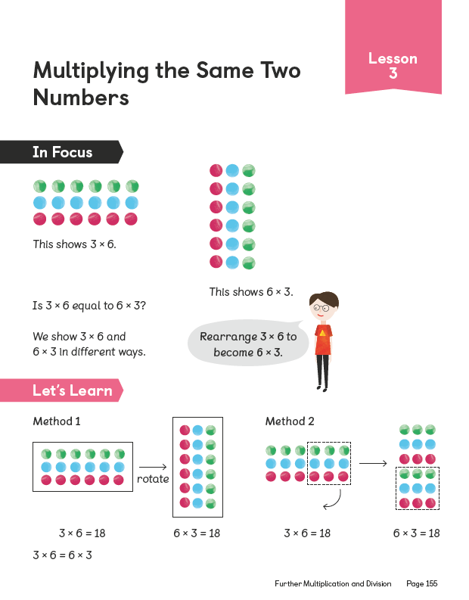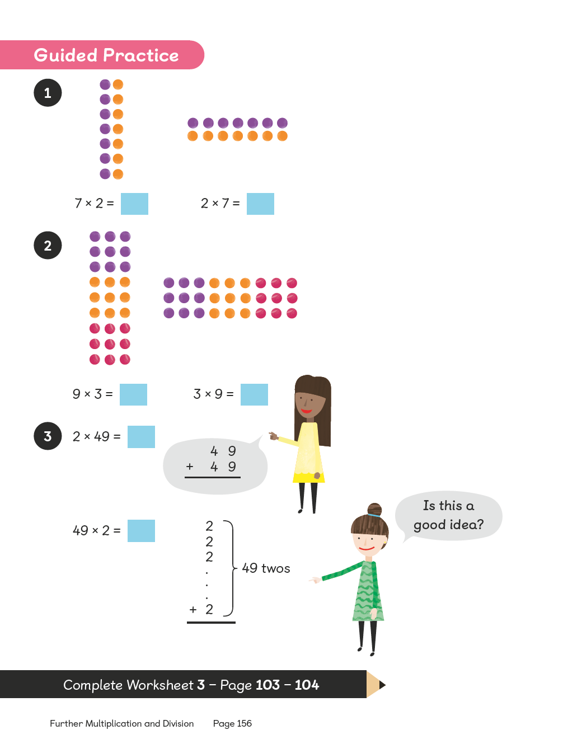
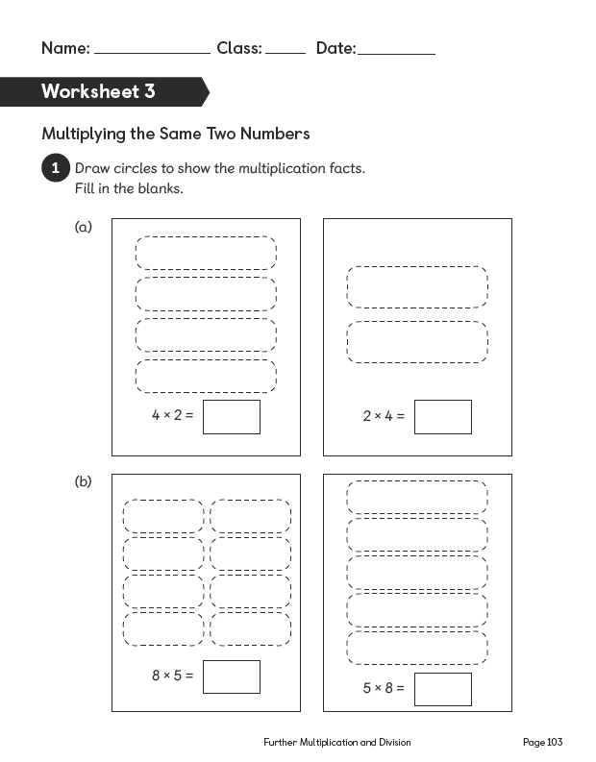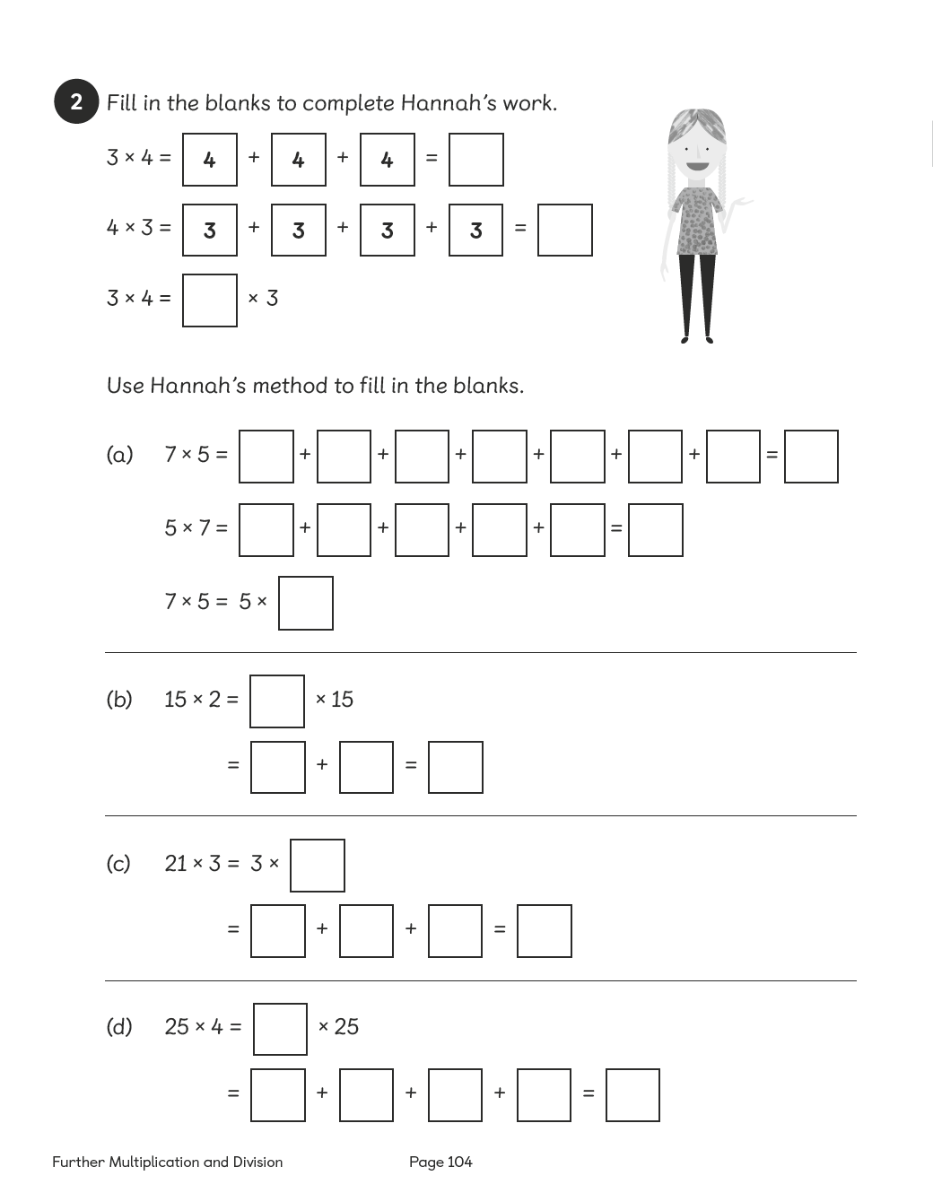

Lesson 4
Top of Form
Multiplying Three Numbers
Pages 157–160
Lesson Objective
To be able to multiply three numbers.
National Curriculum
Use place value, known and derived facts to mentally multiply and divide, including multiplying together three numbers. Recognise and use factor pairs and commutativity in mental calculations.
Lesson Approach
To begin this lesson, recap on learning from the previous lesson before you display the In Focus task. Ask pupils, based on what we already know about multiplication, whether the statement is true or false? Pupils could use true or false cards, a show of hands or whiteboards to respond. Why do you think it is true or false?
Display Let's Learn 1. What part of the calculation does the first image show? Agree that it represents 2 × 5 = 10. Now what is left to calculate? 10 × 6. Model adding 6 to the diagram 10 times. Why are we doing this calculation? Allow pupils to discuss this in pairs. Follow the same process for Let's Learn 2. Then display Let's Learn 3 and ask pupils whether the order in which we do the multiplication matters. If we change the order, do we reach the same product? Why or why not?
Finally, work through Let's Learn 4. Ensure that visual and concrete materials are available to use if necessary to secure pupils' understanding.
During Guided Practice, pupils are multiplying three single-digit numbers.
Misconceptions
Pupils believe that when you change the position of the numbers in multiplication, the answer also changes.
Formative Assessment
Pupils can multiply numbers to 12.
Pupils can represent multiplication facts using concrete materials.
Pupils can represent multiplication facts using pictures.
Pupils can create a number of equal groups.
Pupils can create groups of a given number.
Pupils can use an array to represent a multiplication problem involving three numbers.
Pupils can rearrange the numbers used in a multiplication sentence involving three numbers and obtain the same answer.
Non-negotiables
Pupils can represent multiplication facts using an array (either in pictures or with concrete materials) and record their thinking in a multiplication sentence involving three numbers.
Variation
Example 1: Rearranging three numbers in a multiplication sentence in two different ways, with pictorial support in the form of an array.
Example 2: Rearranging three numbers in a multiplication sentence in two different ways, with pictorial support in the form of a bar model.
Example 3: Multiplying three one-digit numbers; requires deciding which method to use; no pictorial support.
Resources
Counters (between two)

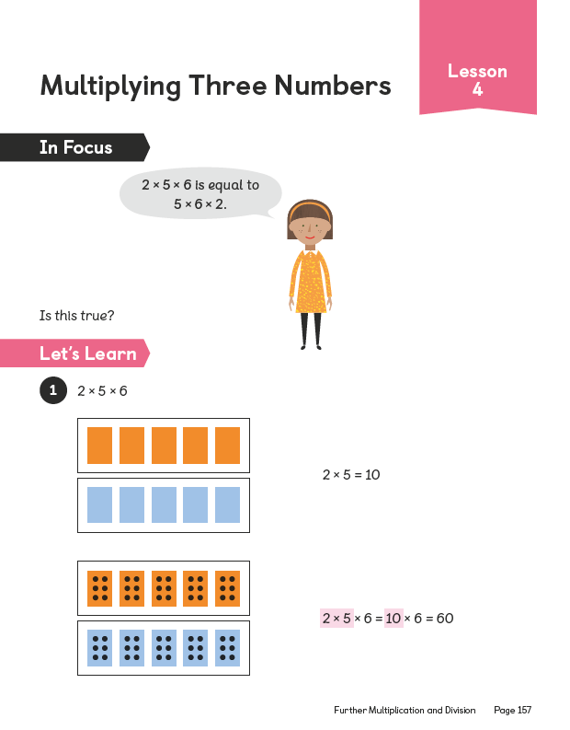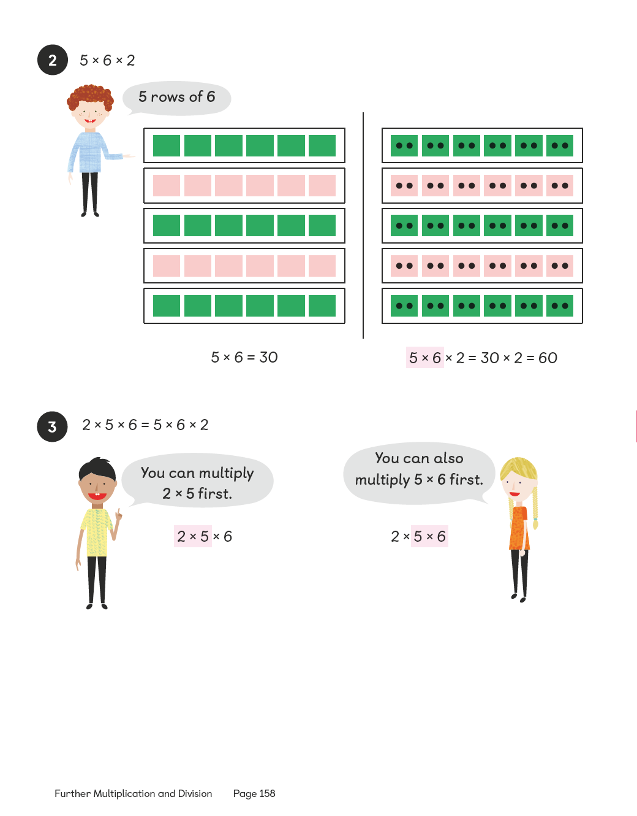
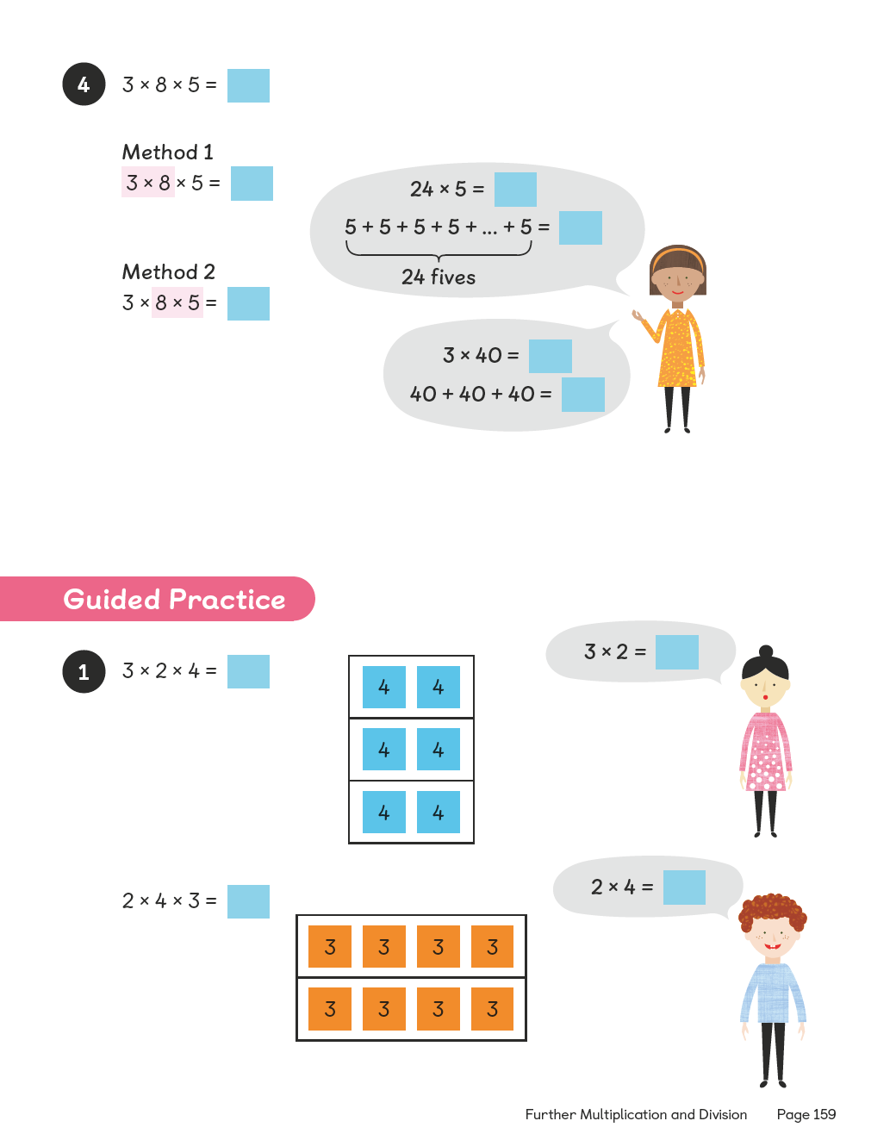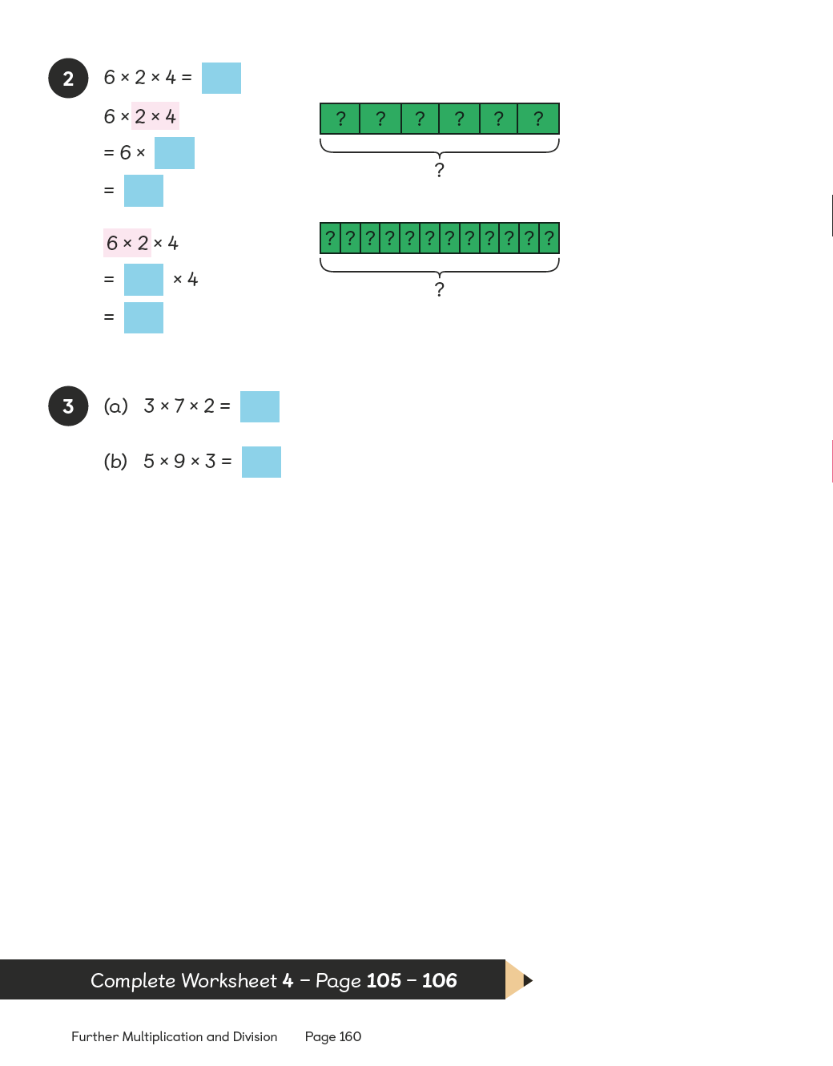

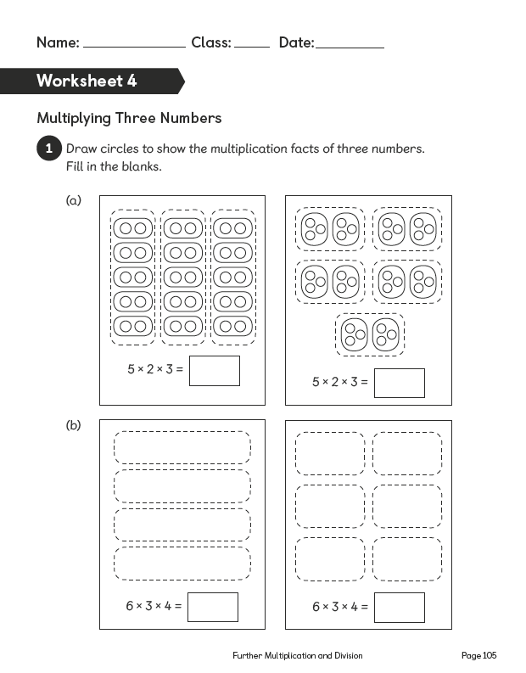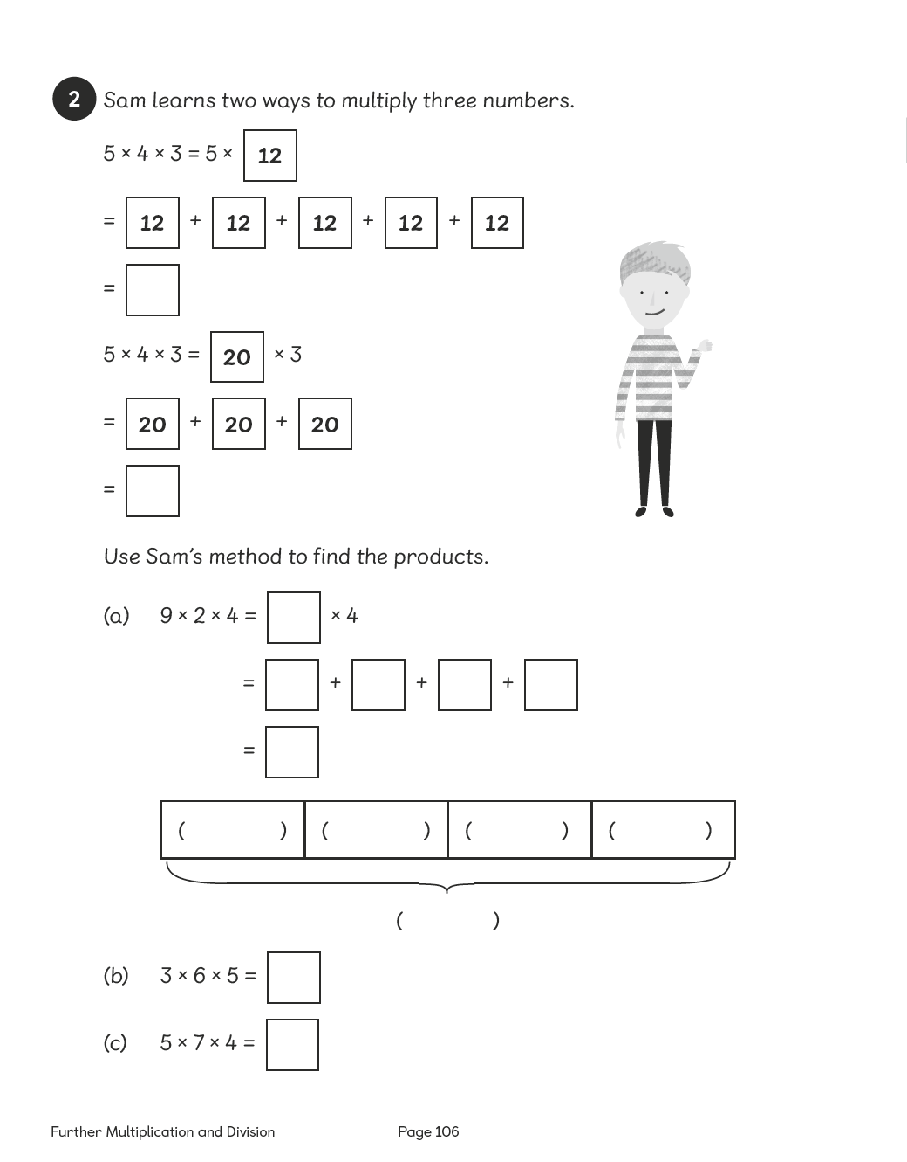

Lesson 5

Multiplying Multiples of 10
Pages 161–163
Lesson Objective
To be able to multiply with multiples of 10.
National Curriculum
Recall multiplication and division facts for multiplication tables up to 12 × 12. Multiply 2-digit and 3-digit numbers by a 1-digit number.
Lesson Approach
To begin this lesson, show pupils the In Focus task and remind them that we are learning about multiplication and division. Ask them how many chocolates are displayed in the box. What is the question asking us? How can we use what we already know to help with this calculation? Ask pupils to share their thoughts.
Demonstrate the calculation or ask a volunteer to calculate using visuals as shown in Let's Learn 1. Which times table should we be thinking of and why? What is the same about the times table fact used? What is different? Remind pupils that the 'product' is the answer when two factors are multiplied. Ask a few questions, such as what is the product of 2 and 4; 5 and 6; 7 and 2?
Display Let's Learn 2 and give pupils time to discuss the methods and invite feedback about each one. Then ask them to decide which method they think is best and justify their answers. In pairs, allow pupils enough time to try each of the three different methods in Let's Learn 3 and then discuss them as a class.
During Guided Practice, pupils are multiplying multiples of 10. Circulate the classroom and listen to the discussion.
Misconceptions
Pupils believe that the rule for multiplying multiples of 10 is to 'add a 0' to the number.
Formative Assessment
Pupils can multiply numbers to 10.
Pupils can multiply by 10.
Pupils can represent multiplication facts using concrete materials.
Pupils can represent multiplication facts using pictures.
Pupils can create a number of equal groups.
Pupils can create groups of a given number.
Pupils can use an array to represent a multiplication problem.
Pupils can rearrange the numbers used in a multiplication sentence and obtain the same answer.
Pupils can use repeated addition as a way of understanding multiplication.
Pupils can multiply the tens as a way of understanding multiplication of multiples of 10.
Non-negotiables
Pupils can use one method involving multiplying a multiple of 10 to solve a question quickly.
Pupils can represent their thinking using number discs or pictures.
Variation
Multiplying multiples of 10.
Example 1: Using three methods, with pictorial support.
Example 2: Requires deciding which method to use; no pictorial support.
Resources
Counters (between two)

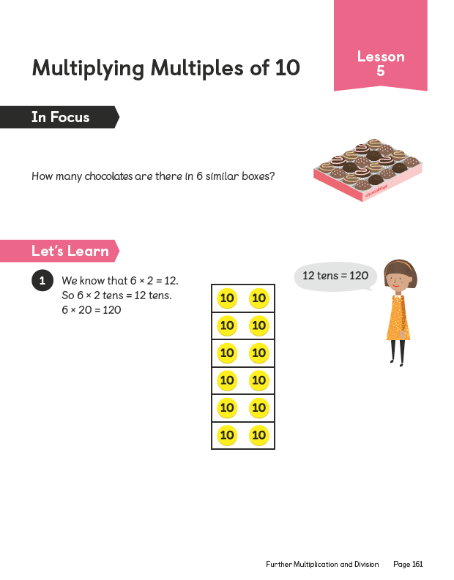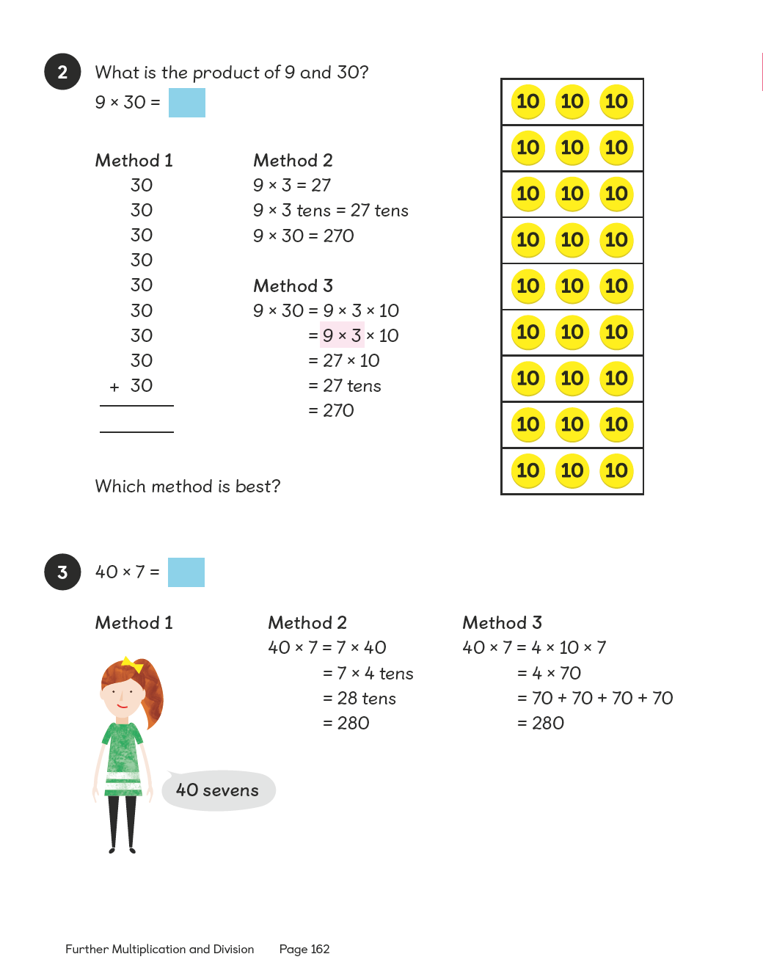
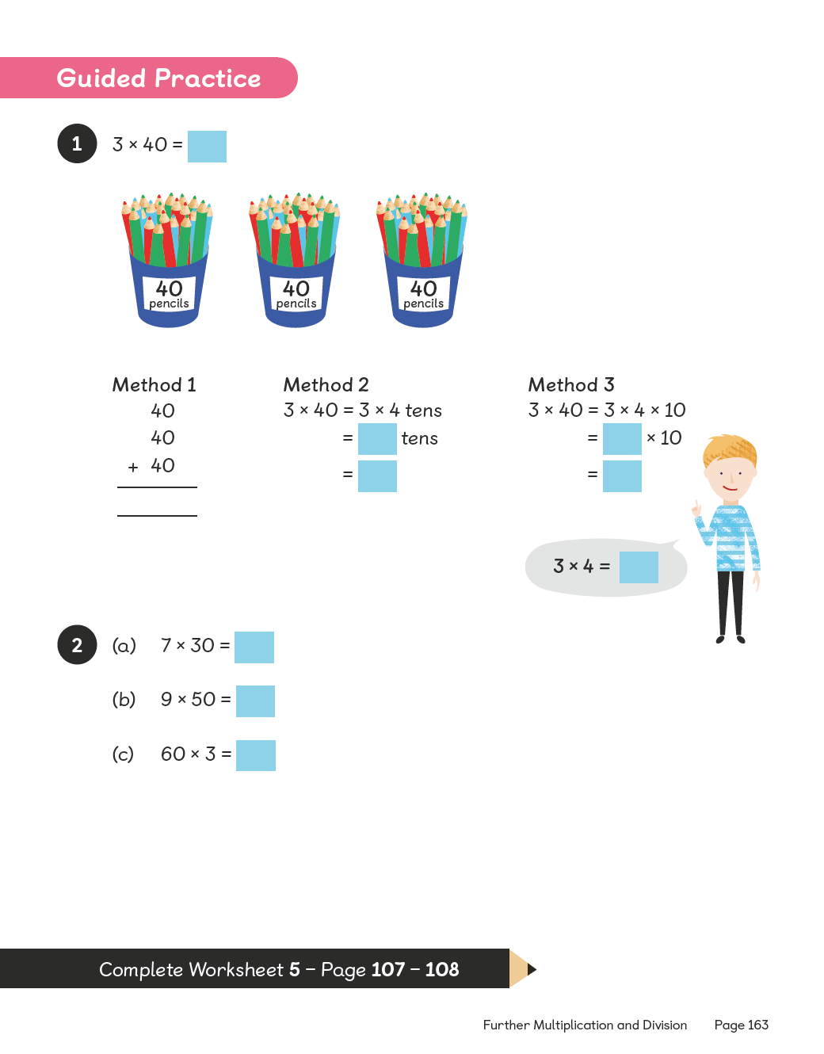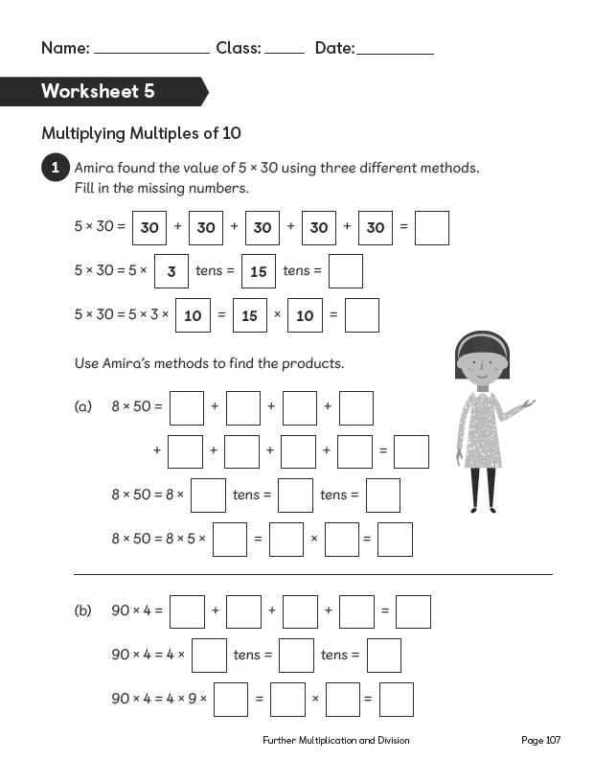
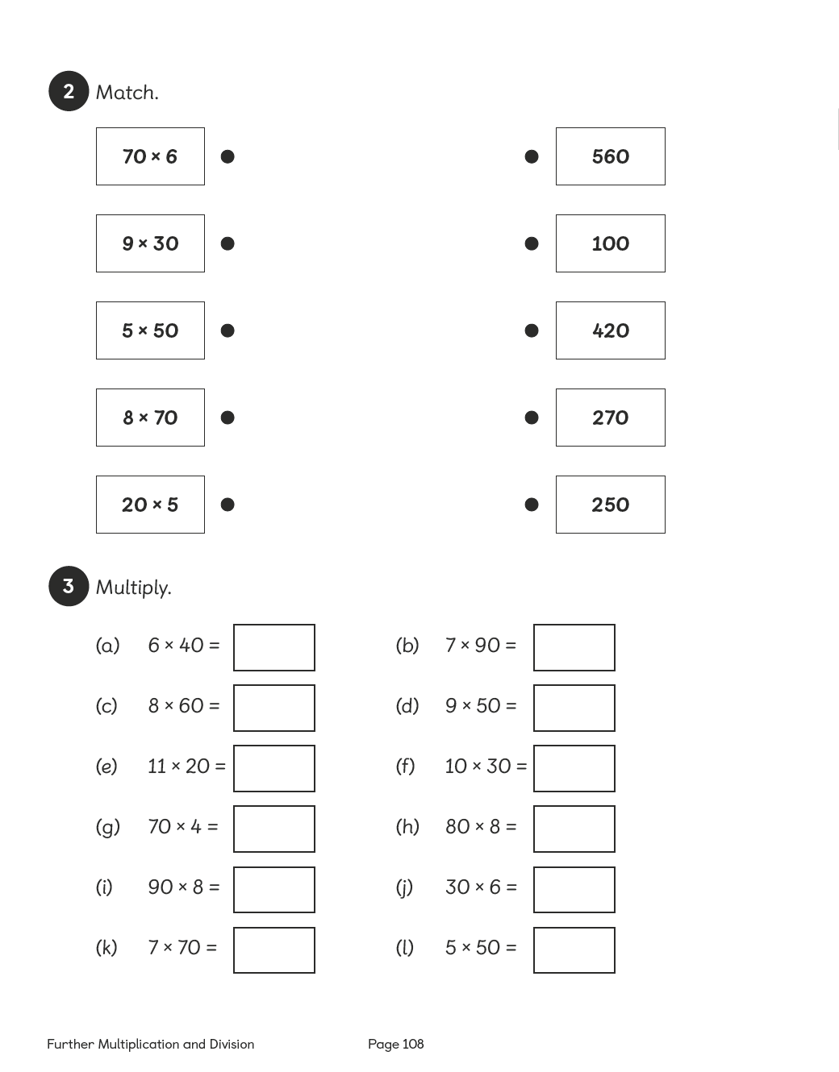

Lesson 6

Multiplying 2-Digit Numbers
Pages 164–167
Lesson Objective
To be able to multiply 2-digit numbers without renaming.
National Curriculum
Multiply 2-digit and 3-digit numbers by a 1-digit number using formal written layout. Use place value, known and derived facts to multiply and divide mentally.
Lesson Approach
To begin this lesson, show pupils the In Focus task. What is the problem asking us to find out? What do we need to know to find the solution? Model calculating the product using the different methods outlined in Let's Learn 1. It is important that pupils can identify what is the same and what is different about each method in order to comprehend compact multiplication, so spend a bit of time discussing this.
Discuss how partitioning a number into a multiple of 10 and ones can help with finding the product and is much faster than using counters. Use number discs to help them see this.
Display Let's Learn 2. What should we partition 23 into? Why? Demonstrate this using the visual examples and record them using both methods. Draw attention to where each of the partial products (60, 9) come from in each example.
During Guided Practice, pupils are multiplying 2-digit numbers by a 1-digit number without renaming. If they are working in pairs, ask them to explain the methods they use as they work out the answers.
Misconceptions
Pupils only use the column method to multiply.
Pupils place the digits in the incorrect place-value column.
Formative Assessment
Pupils can multiply numbers to 10.
Pupils can multiply by 10.
Pupils can represent multiplication facts using concrete materials.
Pupils can represent multiplication facts using pictures.
Pupils can create a number of equal groups.
Pupils can create groups of a given number.
Pupils can use an array to represent a multiplication problem.
Pupils can rearrange the numbers used in a multiplication sentence and obtain the same answer.
Pupils can use number bonds to break apart numbers.
Pupils can use number discs to represent numbers and equations.
Pupils can use bar models to represent numbers in a multiplication sentence.
Pupils can use the column method to solve multiplication questions involving two or more digits.
Non-negotiables
Pupils can use at least one method to quickly solve a question, which involves multiplying 2-digit numbers.
Pupils can represent their thinking using pictures, number discs or bar models.
Variation
Example 1: An array showing the splitting of groups of 12 into groups of 10 is given; column method also shown.
Example 2: Base 10 materials and column method shown.
Example 3: Number bonds, number discs and column method shown.
Example 4: No suggestions for method.
Resources
Laminated part–whole diagrams (between two)
Base 10 materials (between two)
Place-value discs (between two)

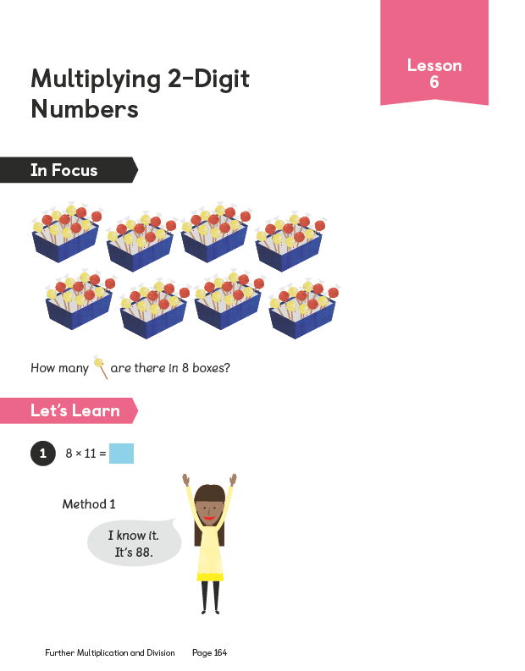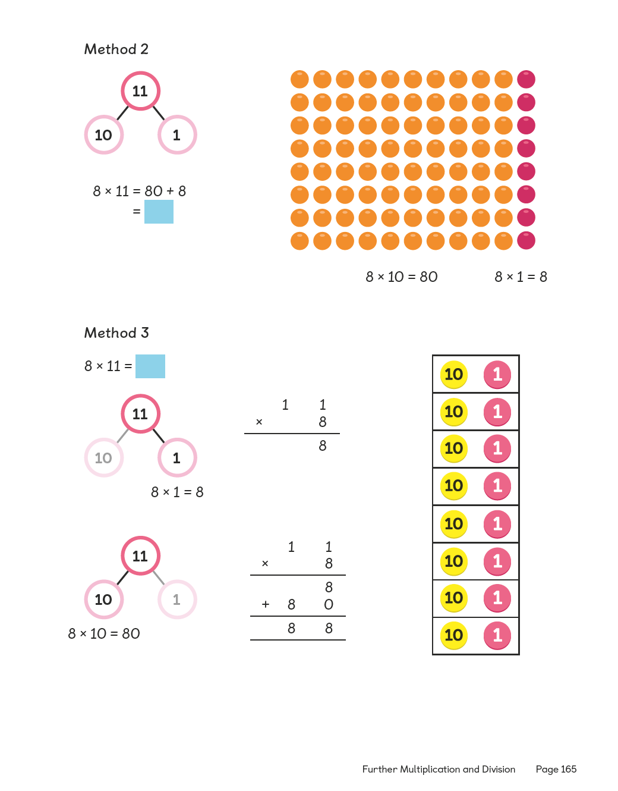

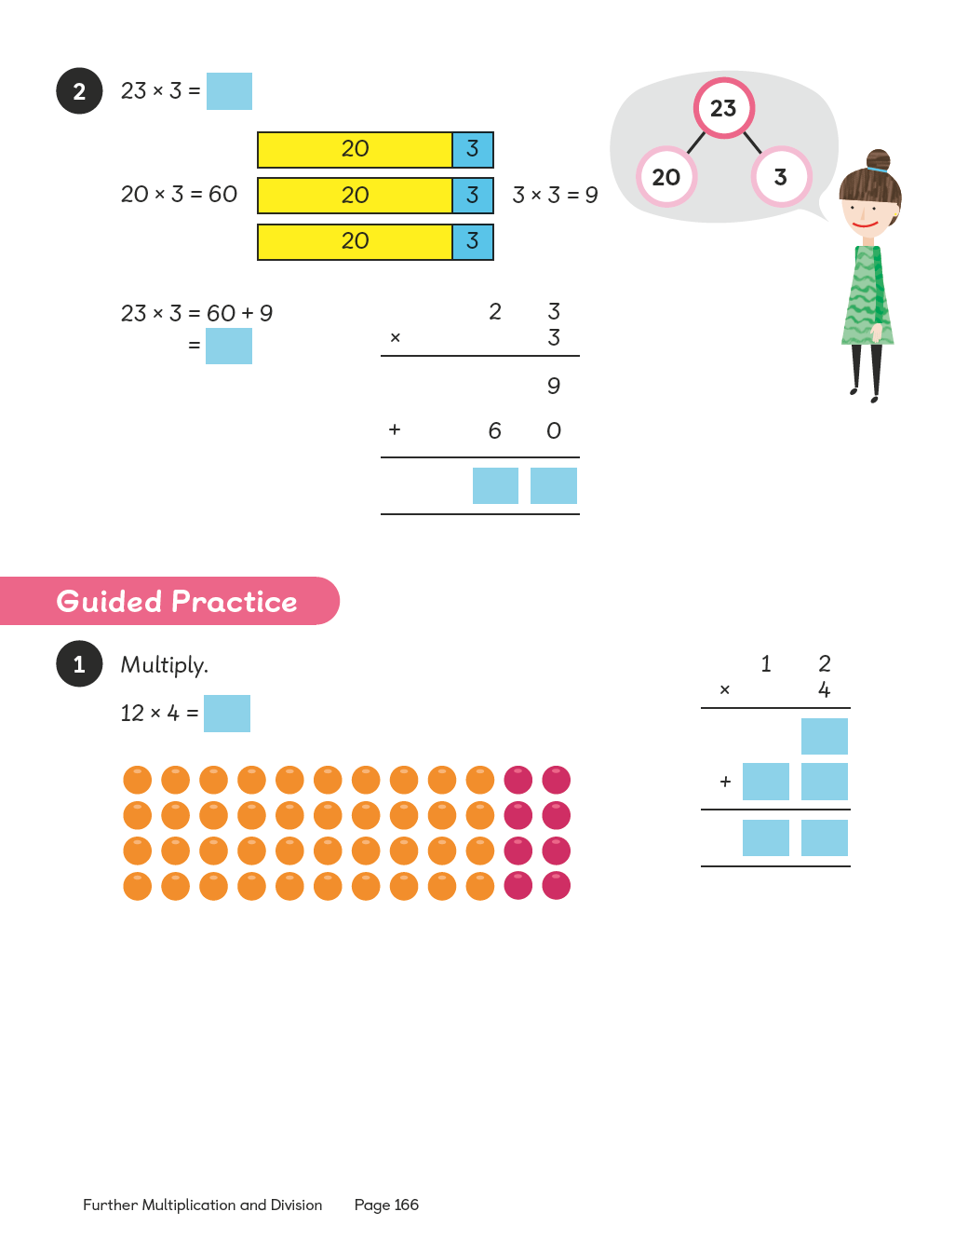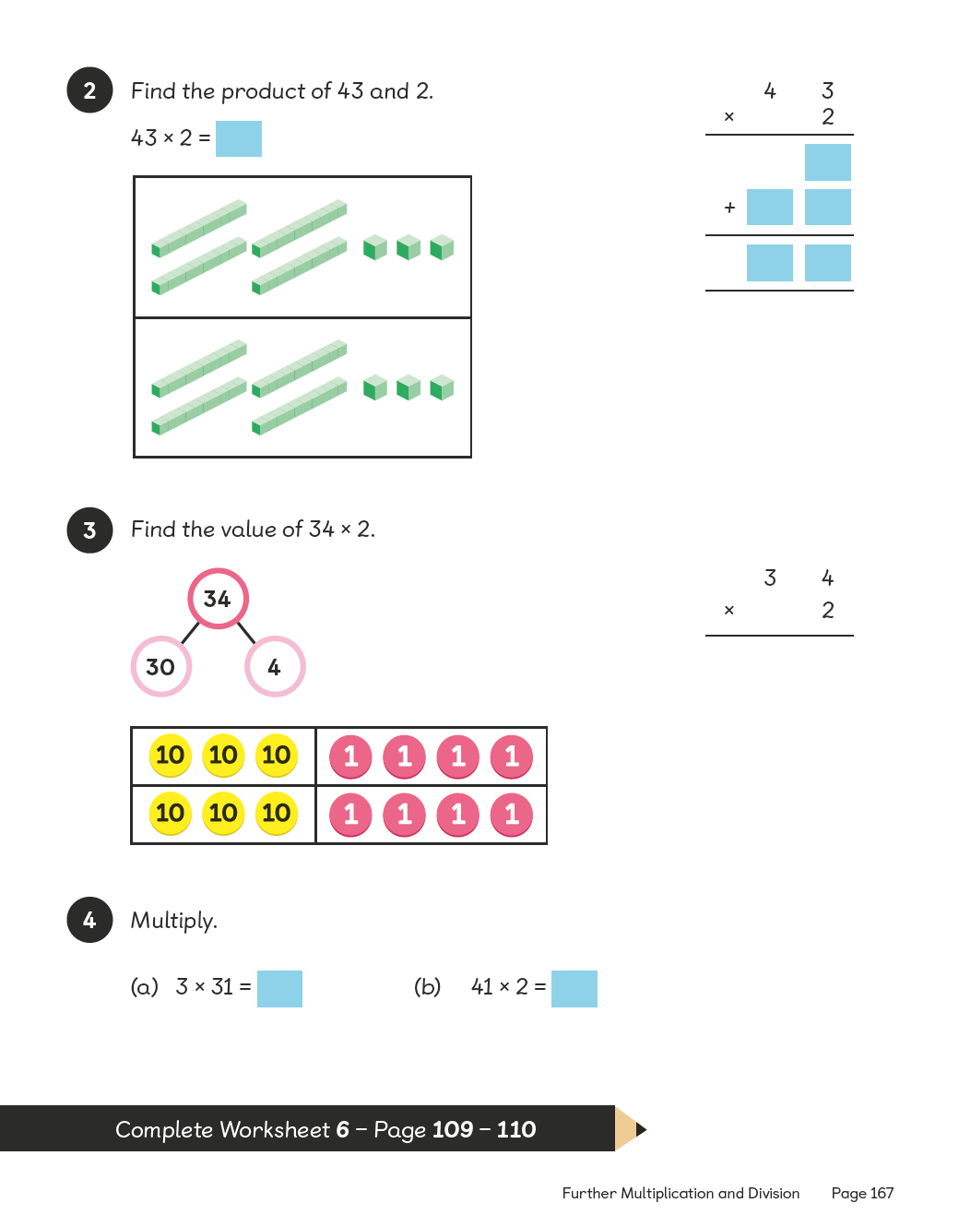
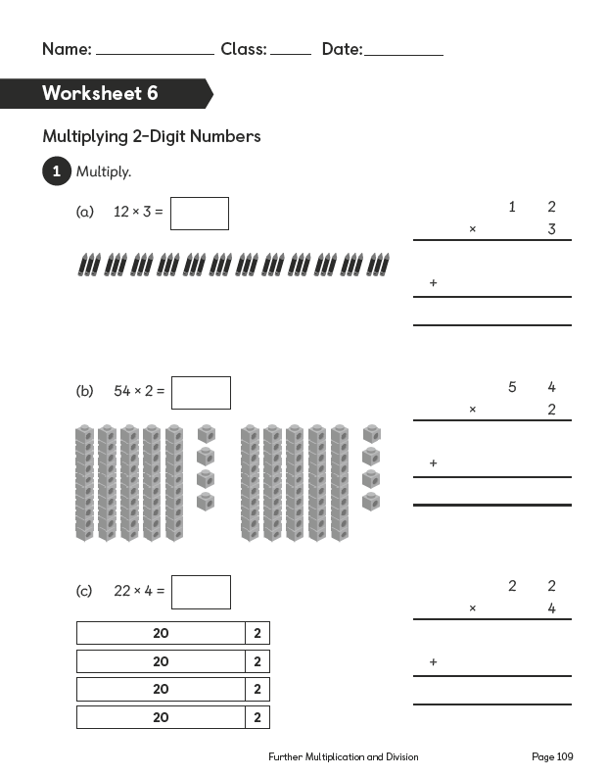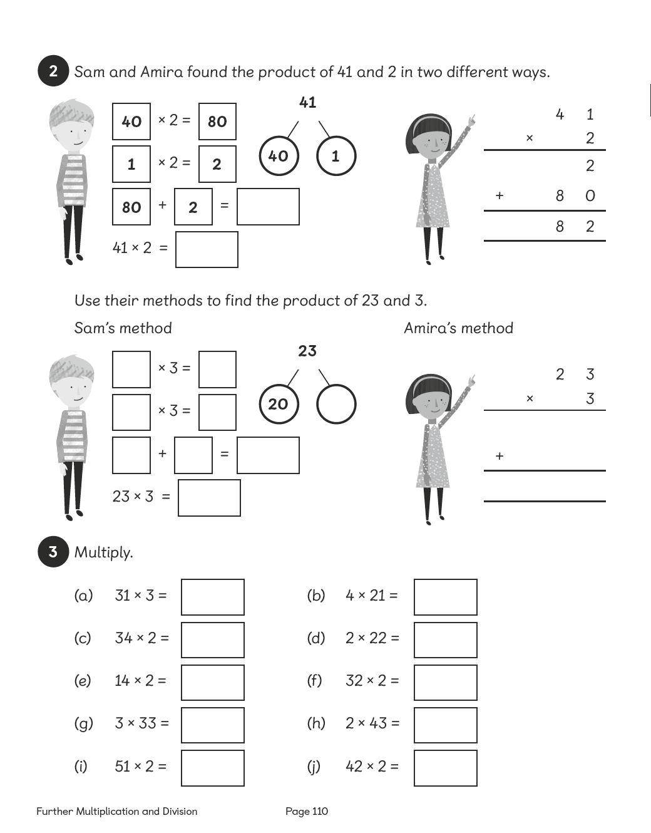

Lesson 7

Multiplying 2-Digit Numbers
Pages 168–170
Lesson Objective
To be able to multiply 2-digit numbers with renaming.
National Curriculum
Multiply 2-digit and 3-digit numbers by a 1-digit number using formal written layout. Use place value, known and derived facts to multiply and divide mentally.
Lesson Approach
To begin this lesson, recap on learning from previous lessons and show pupils the In Focus task. Should we count all of the cups and saucers? What other way could we count? How could we record the calculation that we just did by counting? How many columns are there? How many sets or groups are in each column?
Display Let's Learn 1: 6 × 23. Model calculating using the place-value discs to support the strategy. What is happening in this calculation? Why do we need to rename? What did I do first? What did I do next? Record a step-by-step note of the procedure. Ensure pupils make the link between expanded notation and the compact method for multiplication.
Display Let's Learn 2: 23 × 6. What are the similarities and differences to the first calculation? What do we do first, second and third? Take pupils through the steps to success for calculating. Can advanced learners link the 'grid method' to area?
During Guided Practice, pupils are multiplying 2-digit numbers by 1-digit numbers with renaming.
Misconceptions
Pupils place more than 1 digit in a place-value column when renaming is needed.
Formative Assessment
Pupils can multiply numbers to 10.
Pupils can multiply by 10.
Pupils can represent multiplication facts using concrete materials.
Pupils can represent multiplication facts using pictures.
Pupils can use number bonds to break apart numbers.
Pupils can use number discs to represent numbers and equations.
Pupils can use bar models to represent numbers in a multiplication sentence.
Pupils can use the column method to solve multiplication questions involving two or more digits.
Pupils can rename 10 ones as 1 ten, 10 tens as 1 hundred, etc.
Pupils can represent renaming using the column method.
Non-negotiables
Pupils can use one method to solve a question involving multiplying 2-digit numbers quickly.
Pupils can represent their thinking using concrete materials or models.
Variation
Example 1: Multiplying by the tens, then by the ones and adding to find the answer; number discs shown to support breaking apart numbers.
Example 2: Multiplying using expanded notation of the column method.
Example 3: Multiplying using the column method (compact).
Example 4: Term ‘product’ introduced to facilitate multiplication.
Resources
Place-value charts (between two)
Place-value discs (between two)

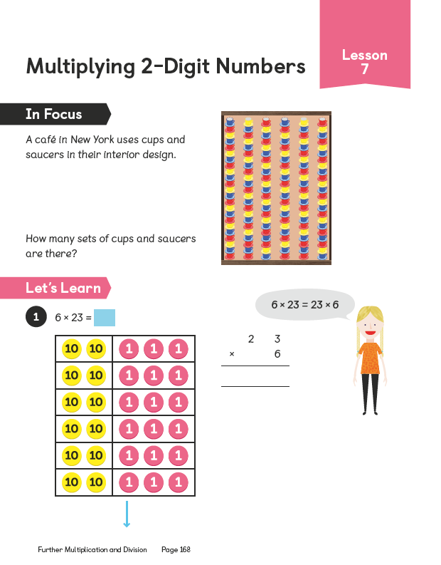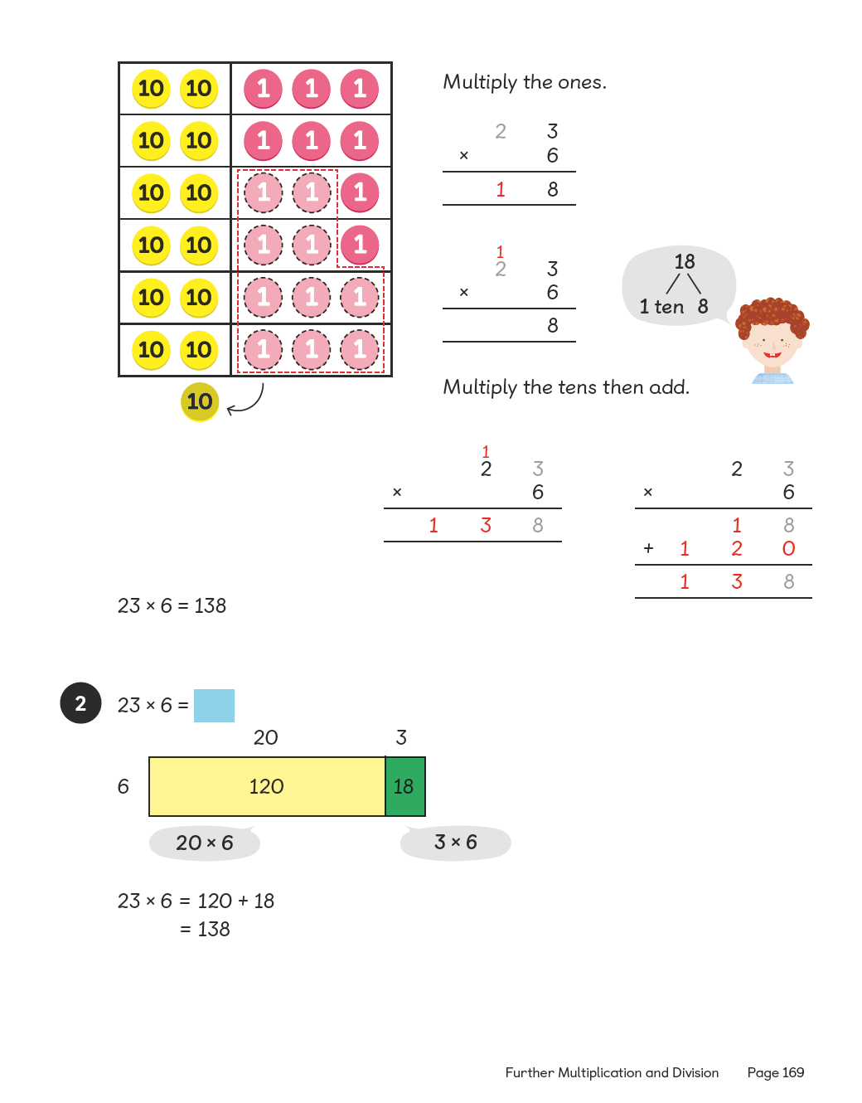

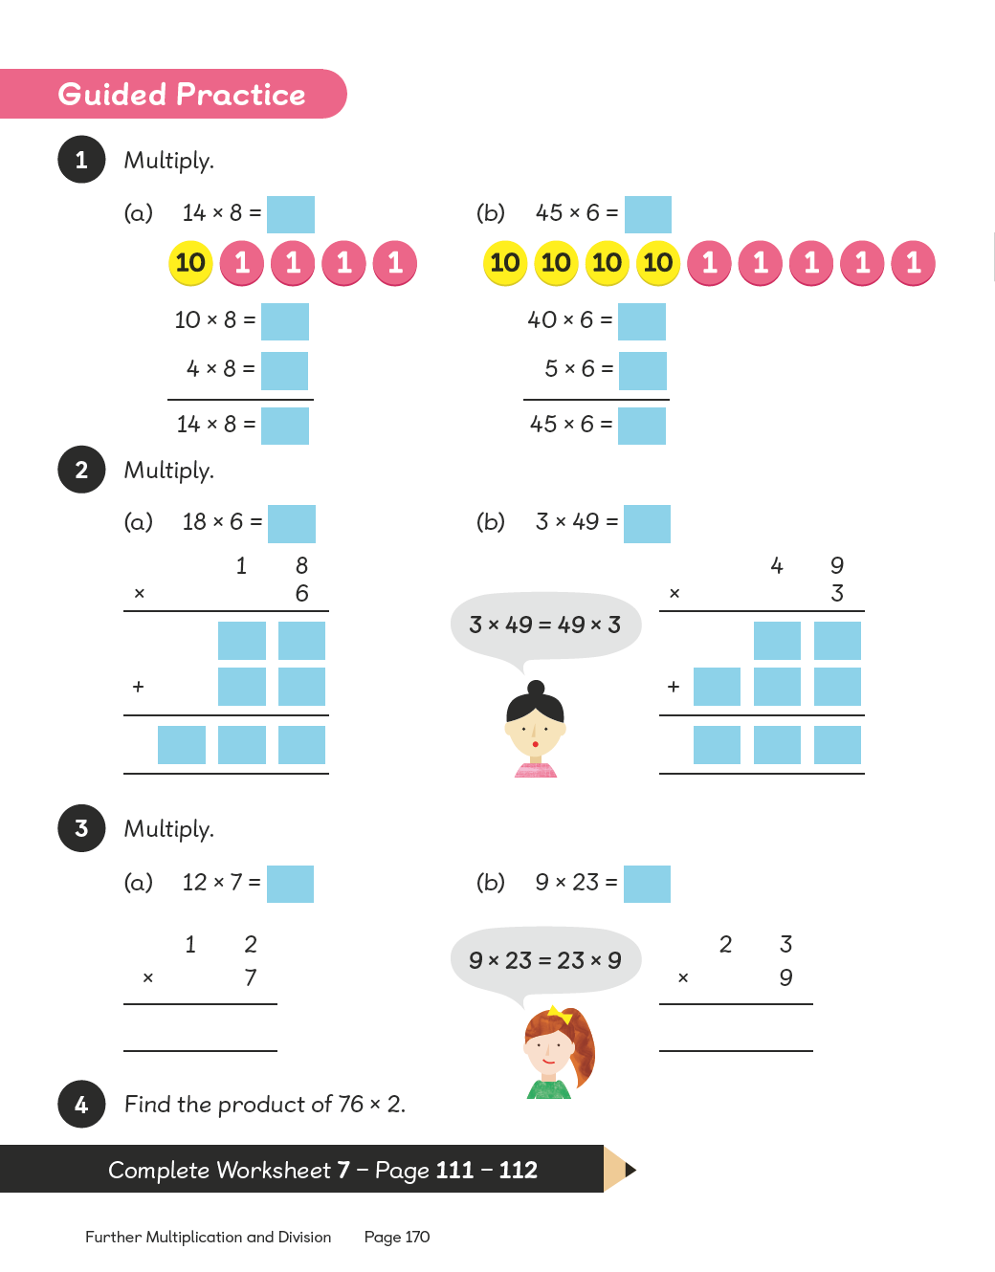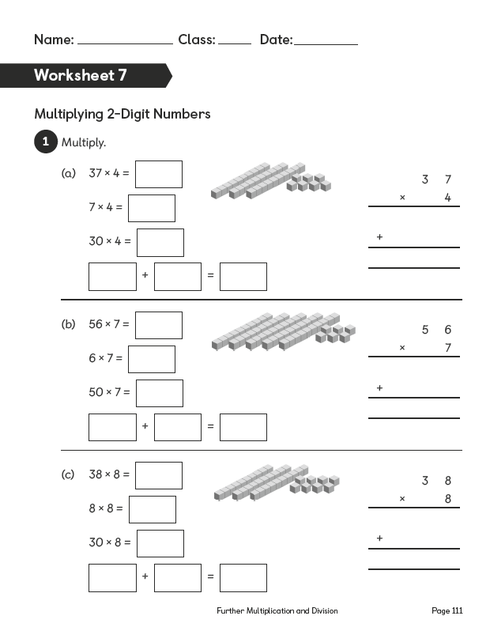

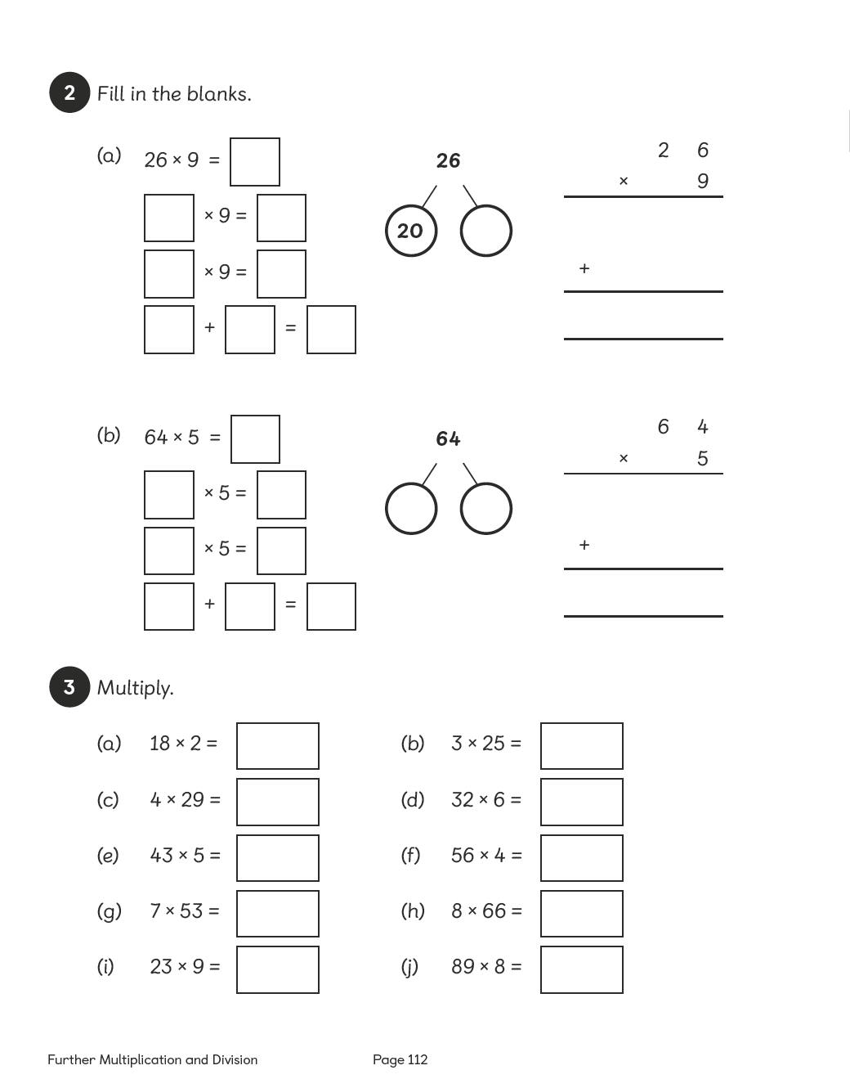

Lesson 8

Multiplying Multiples of 100
Pages 171–172
Lesson Objective
To be able to multiply multiples of 100.
National Curriculum
Multiply 2-digit and 3-digit numbers by a 1-digit number using formal written layout. Use place value, known and derived facts to multiply and divide mentally.
Lesson Approach
To begin this lesson, recap on how we know how to multiply multiples of 10, i.e. use a times table fact and then make it 10 times bigger. Show pupils the In Focus task and give them time to discuss the problem before taking feedback. What do we know? What do we want to find out? How will we calculate the answer? Talk through how we can find the solution using the method outlined in Let's Learn 1.
Display Let's Learn 2 and allow pupils time to discuss the different methods, select the 'best' one and justify their choice. Give them time to practise the different methods in Let's Learn 3 in pairs. Ask volunteers to model calculations for the class.
During Guided Practice, pupils are multiplying multiples of 100. Remind them of the term 'product' and its meaning before they start.
Misconceptions
Pupils believe that the rule for multiplying multiples of 100 is to ‘add 00’ to the number to be multiplied.
Formative Assessment
Pupils can multiply numbers to 10.
Pupils can multiply by 100.
Pupils can represent multiplication facts using concrete materials.
Pupils can represent multiplication facts using pictures.
Pupils can create a number of equal groups.
Pupils can create groups of a given number.
Pupils can use an array to represent a multiplication problem.
Pupils can rearrange the numbers used in a multiplication sentence and obtain the same answer.
Pupils can use repeated addition as a way of understanding multiplication.
Pupils can multiply the hundreds as a way of understanding multiplication of multiples of 100.
Pupils can multiply the hundreds digit by the multiplier and then multiply by 100 (e.g. 9 × 300 = 9 × 3 × 100).
Non-negotiables
Pupils can use at least one method to solve a question involving multiplying a multiple of 100 quickly.
Pupils can represent their thinking using concrete materials, pictures or bar models.
Variation
Example 1: Using two methods to solve the problem involving multiplying a 1-digit number by a multiple of 100; primarily pictorial in nature.
Example 2: Using the term 'product' to facilitate multiplication; no pictorial guide and no methods suggested.
Resources
Place-value charts (between two)
Place-value discs (between two)

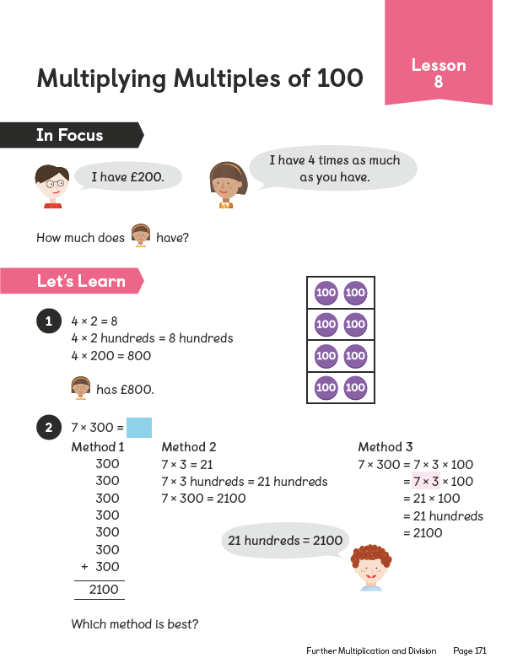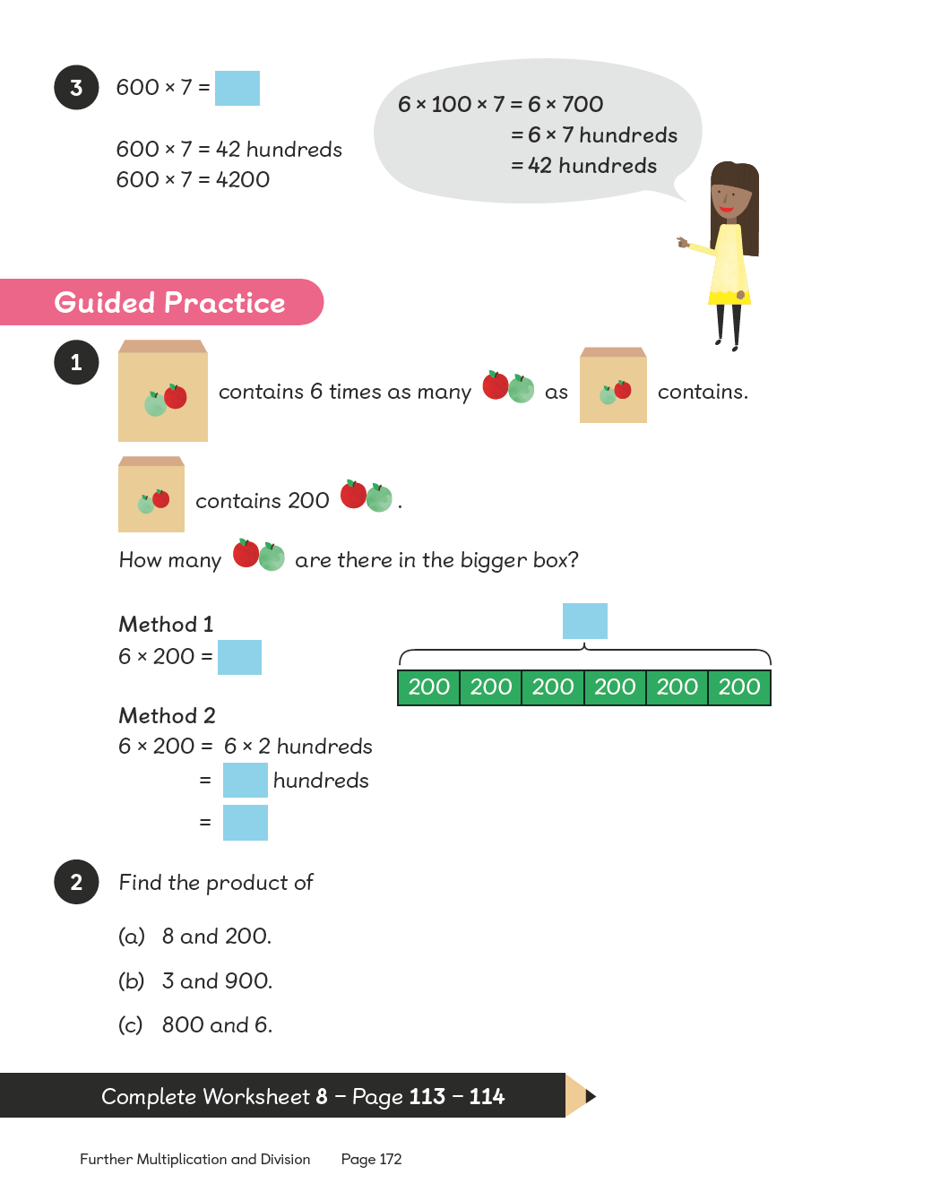
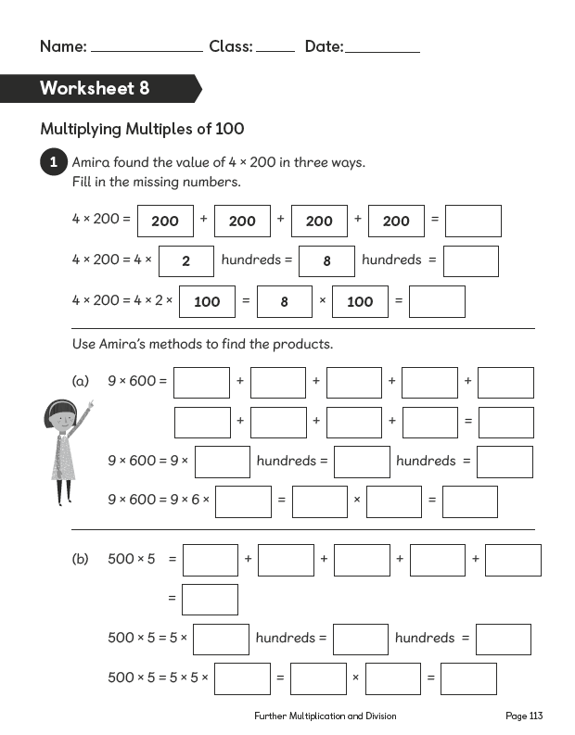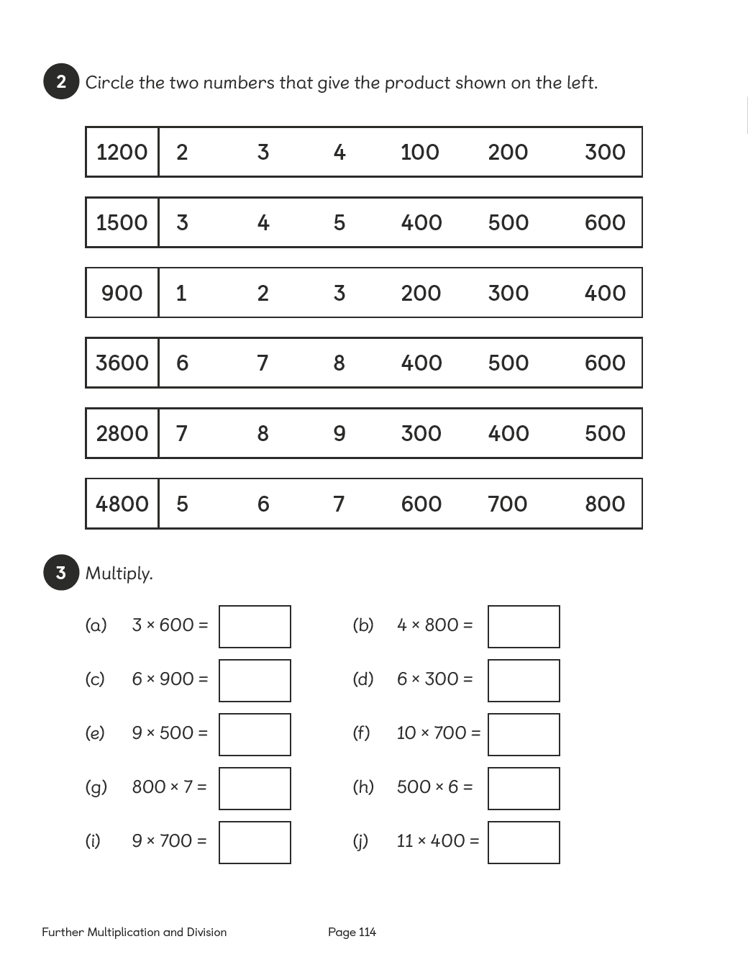

Lesson 9

Multiplying 3-Digit Numbers
Pages 173–175
Lesson Objective
To be able to multiply 3-digit numbers without renaming.
National Curriculum
Multiply 2-digit and 3-digit numbers by a 1-digit number using formal written layout. Use place value, known and derived facts to multiply and divide mentally.
Lesson Approach
To begin this lesson, remind pupils of how to multiply a multiple of 100 by a 1-digit number. State that remembering this will be useful in this lesson. Show pupils the In Focus task and give them time to discuss it. Ask the class how we can use what we already know to help us solve this problem. Talk through calculating the product using the examples and images in Let's Learn 1. What does each bar on the model represent? How does drawing the bar model help us to understand what we have to do? How can we calculate the price?
Work through Let's Learn 2. Record each step, which can be used during Guided Practice. Repeat the same process while thinking aloud for Let's Learn 3, allowing pupils time to work through the question on whiteboards in pairs.
During Guided Practice, pupils are multiplying 3-digit numbers by 1-digit numbers without renaming. The steps recorded during Let's Learn 2 can be displayed for reference.
Misconceptions
Pupils only use the column method to multiply.
Pupils place the digits for the answer in the incorrect place-value column.
Formative Assessment
Pupils can multiply numbers to 10.
Pupils can multiply by 100.
Pupils can represent multiplication facts using concrete materials.
Pupils can represent multiplication facts using pictures.
Pupils can use an array to represent a multiplication problem.
Pupils can rearrange the numbers used in a multiplication sentence and obtain the same answer.
Pupils can use number bonds to break apart numbers.
Pupils can use materials and number discs to represent numbers and equations.
Pupils can use bar models to represent numbers in a multiplication sentence.
Non-negotiables
Pupils can use at least one method to solve a question involving multiplying a multiple of 100 quickly.
Pupils can represent their thinking using concrete materials, pictures or bar models.
Variation
Example 1: Number discs and partitioning of the 3-digit number used as the primary methods.
Example 2: Column method used as primary method where ones, tens and hundreds each have an individual line (expanded notation).
Example 3: Column method used where only one line is used for ones, tens and hundreds (compact).
Example 4: No method suggested.
Resources
Place-value charts (between two)
Place-value discs (between two)

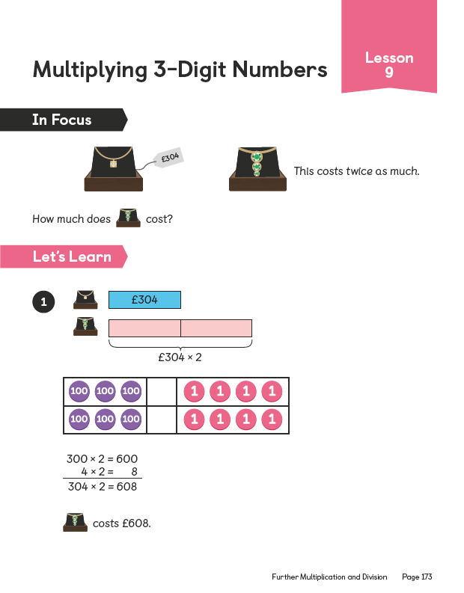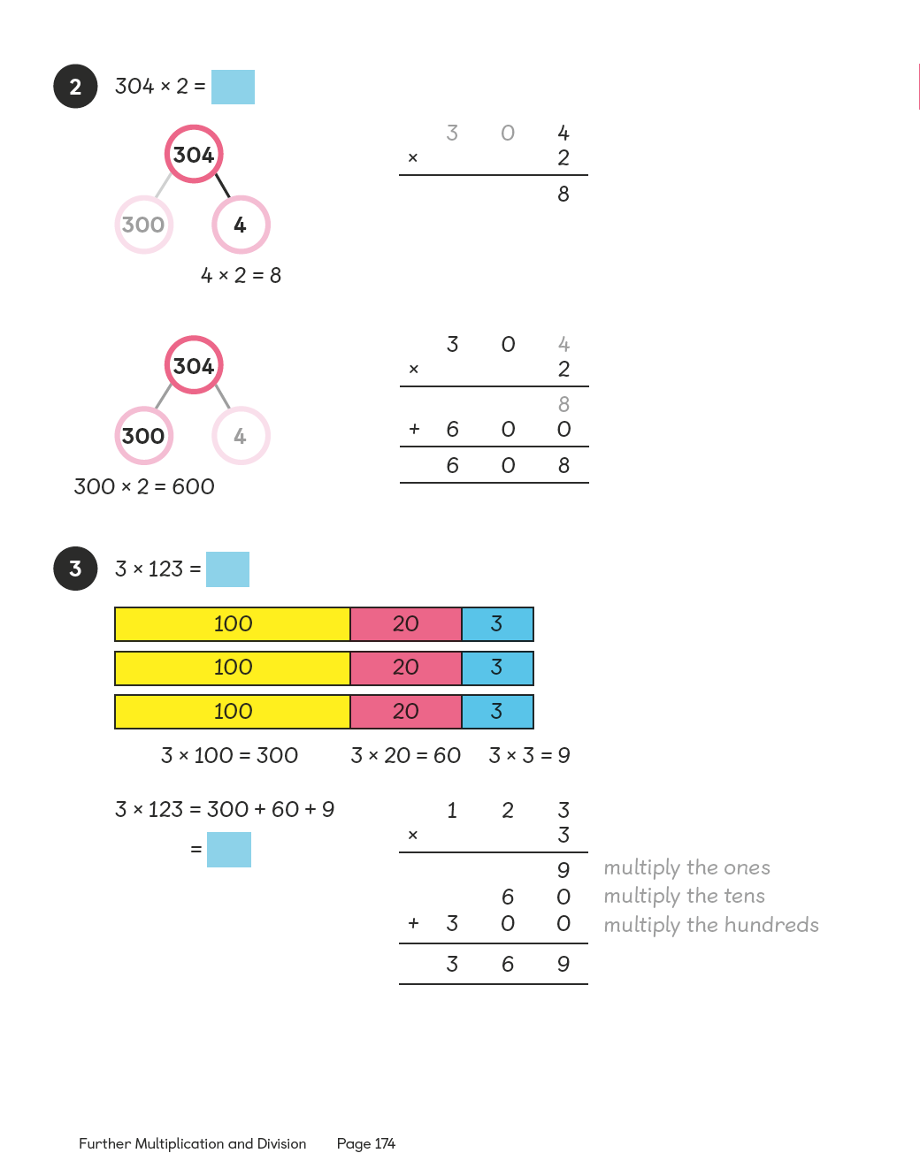
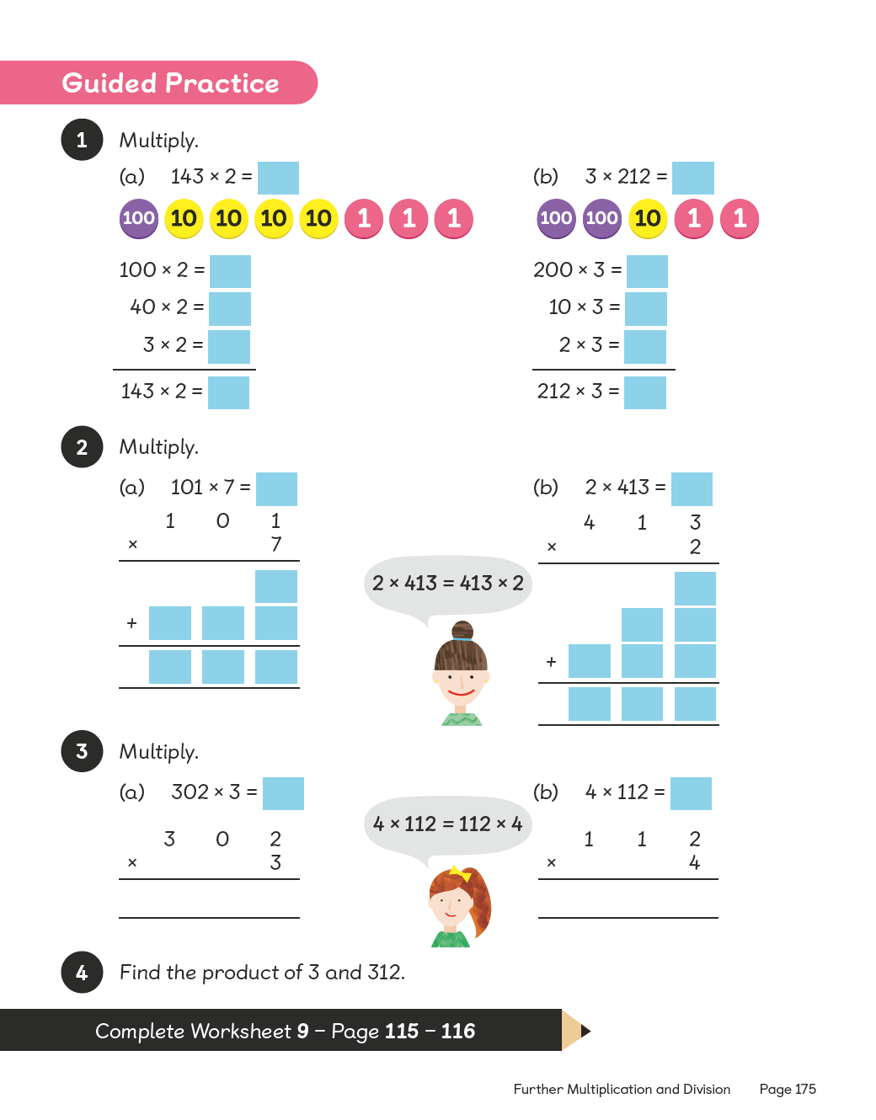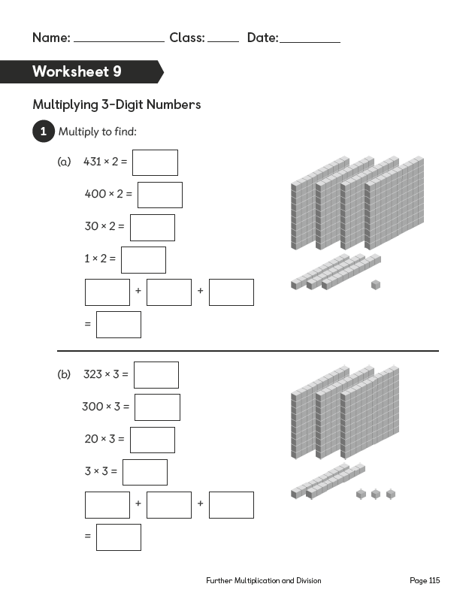
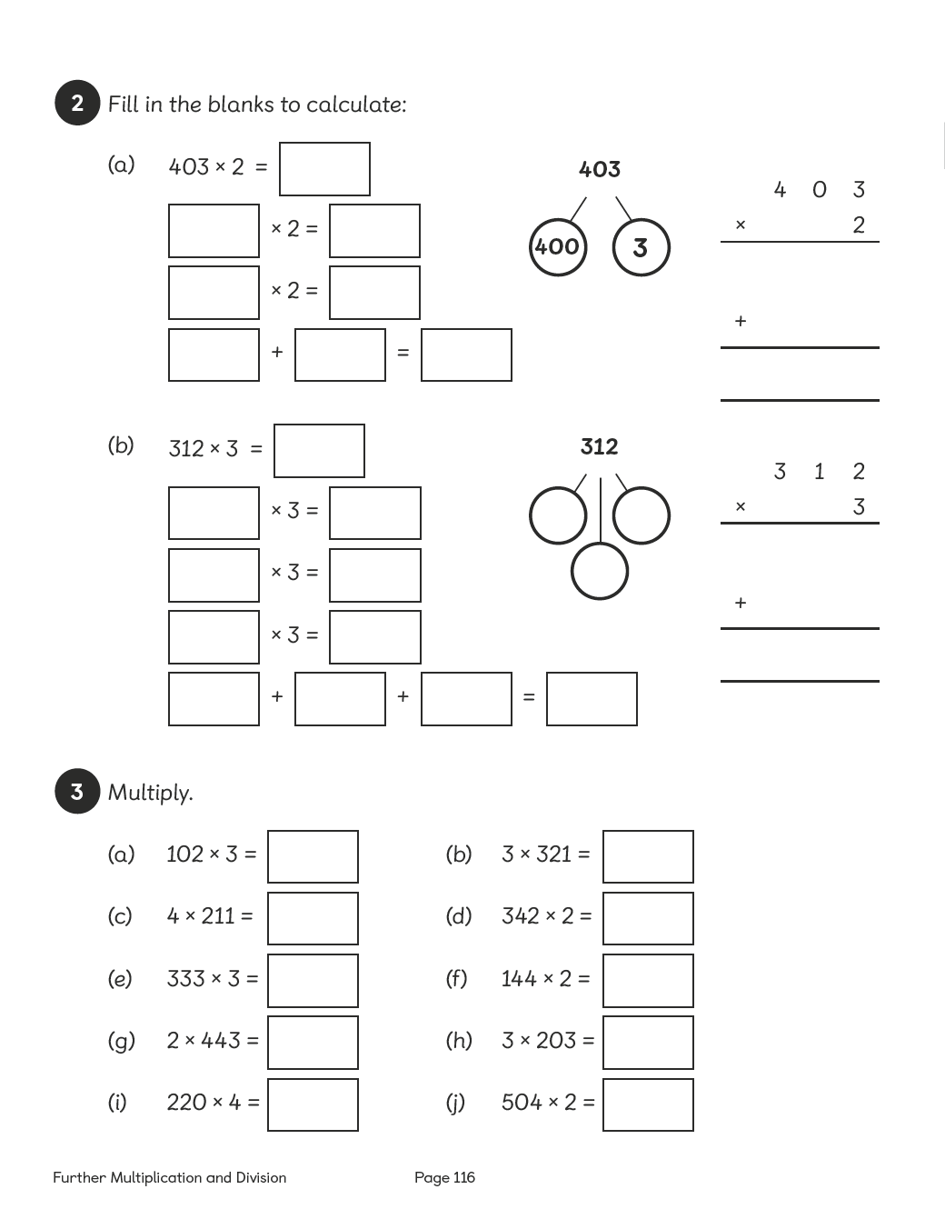

Lesson 10

Multiplying 3-Digit Numbers
Pages 176–179
Lesson Objective
To be able to multiply 3-digit numbers with renaming.
National Curriculum
Multiply 2-digit and 3-digit numbers by a 1-digit number using formal written layout. Use place value, known and derived facts to multiply and divide mentally.
Lesson Approach
To begin this lesson, recap on the steps to success from previous lessons on multiplying by 3-digit numbers. Show pupils the In Focus task and pose the questions: What is the problem asking us to find out? What do we already know? Model calculating using suggestions from the class and think aloud as you calculate: First we multiply the ones, then the tens, then the hundreds. Then we add them together.
Display Let's Learn 2 and talk through the method of breaking the number into a number bond before multiplying. It could be useful to make a 'mistake' that the pupils need to fix at this point, for example, misplace the digits or reverse the digits of the partial product. When we multiply the ones, what is our product? Can all 36 ones stay in the ones column? What should we do? Allow pupils to discuss this in pairs, then multiply the tens and then the hundreds of the number.
Allow time for pairs to work through Let's Learn 3 together so they can practise the different methods. Ask a volunteer from the class to demonstrate the method they have used. Has anyone used a different method, but obtained the same product? Has anyone used a different method and obtained a different product? It is important pupils spend time discussing and comparing in order to understand the procedure fully.
During Guided Practice, pupils are pupils are multiplying 3-digit numbers by 1-digit numbers with renaming.
Misconceptions
Pupils only use the column method to multiply.
Pupils place the digits for the answer in the incorrect place-value column.
Formative Assessment
Pupils can multiply numbers to 10.
Pupils can multiply by 100.
Pupils can represent multiplication facts using concrete materials.
Pupils can represent multiplication facts using pictures.
Pupils can use an array to represent a multiplication problem.
Pupils can rearrange the numbers used in a multiplication sentence and obtain the same answer.
Pupils can use number bonds to break apart numbers.
Pupils can use materials and number discs to represent numbers and equations.
Pupils can use bar models to represent numbers in a multiplication sentence.
Pupils can use the column method to solve multiplication questions involving 2 or more digits.
Non-negotiables
Pupils can use number bonds to solve a question involving multiplying 3-digit numbers quickly.
Pupils can represent their thinking in the column method.
Variation
Examples 1–2: Number discs shown to break apart the numbers before multiplying the ones, tens then hundreds.
Example 3: Column method shown, where the ones, tens and hundreds each have an individual line (expanded notation).
Example 4: Column method shown where renaming is used on one line (compact).
Example 5: No method suggested.
Resources
Place-value charts (between two)
Place-value discs (between two)

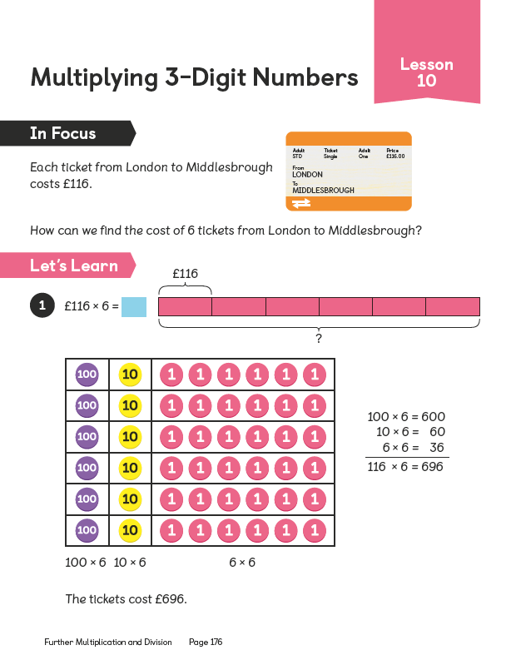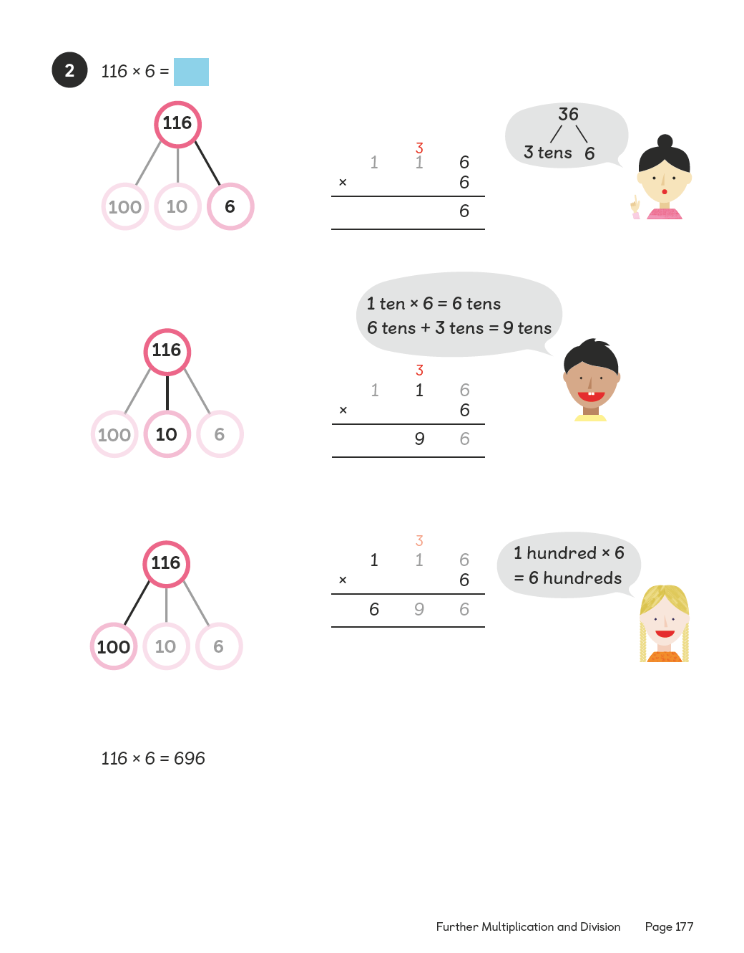
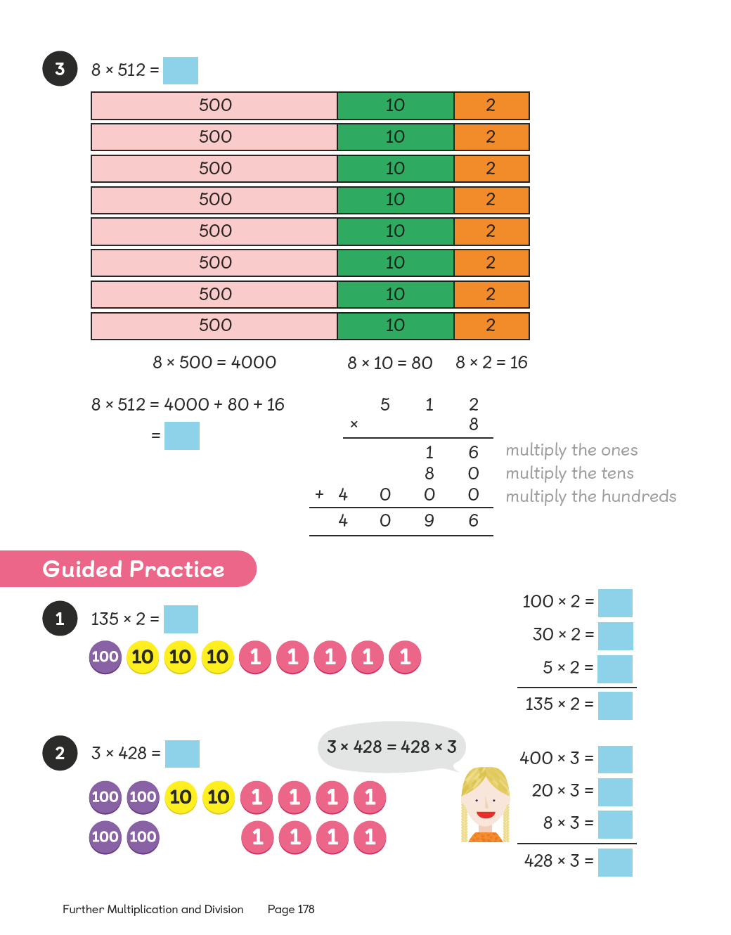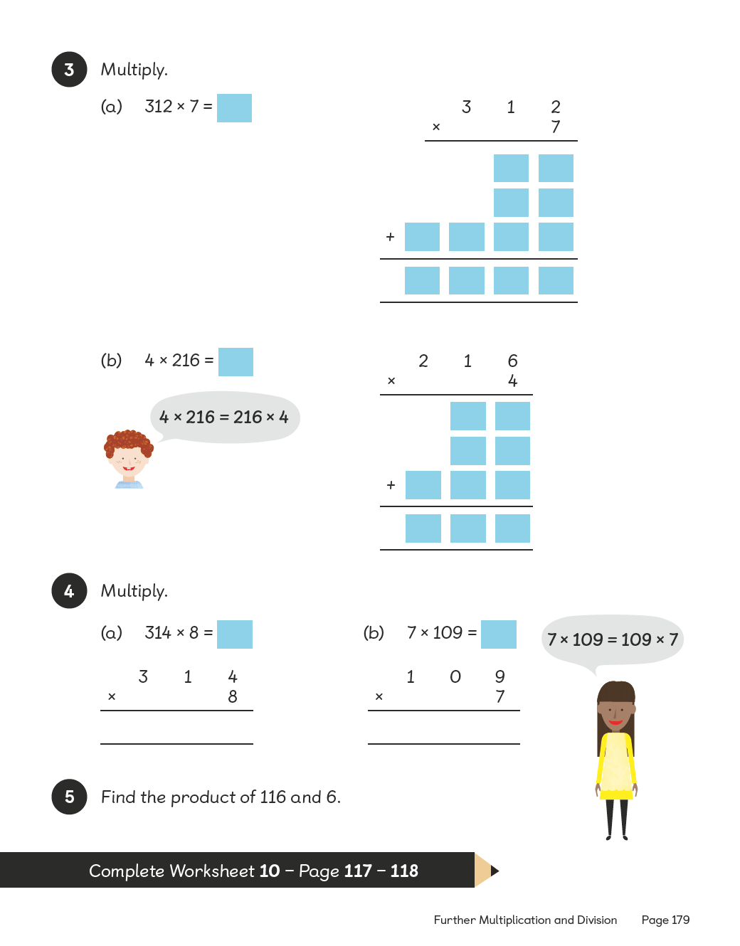
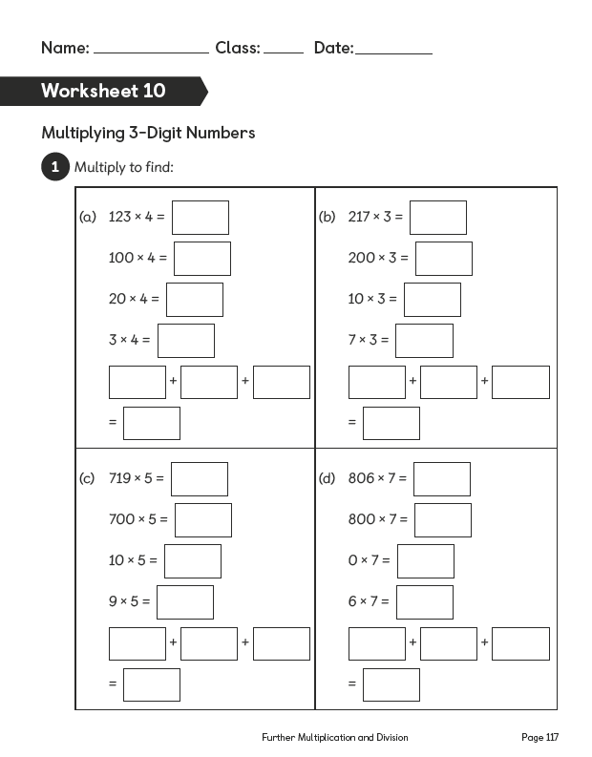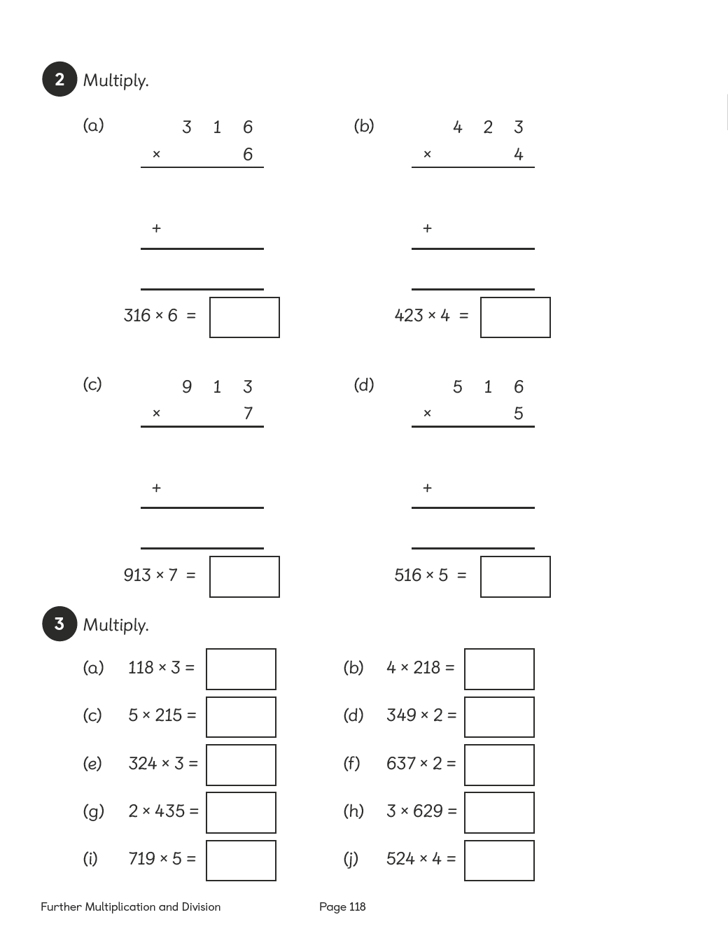

Lesson 11

Multiplying 3-Digit Numbers
Pages 180–185
Lesson Objective
To be able to multiply 3-digit numbers with renaming.
National Curriculum
Multiply 2- and 3-digit numbers by a 1-digit number using formal written layout. Solve problems involving multiplying and adding, including using the distributive law to multiply 2-digit numbers by 1 digit.
Lesson Approach
To begin this lesson, revisit the steps to success for multiplying a 3-digit number by a 1-digit number. Discuss renaming; when it may occur and what to do. Show pupils the In Focus task and ask them to discuss it with their partners before feeding back. What do we need to calculate? How will we know what size container to use? Draw out that the calculation is 473 × 4. What methods do we have for this calculation?
Work through Let's Learn 1 to 3 demonstrating the calculations to the class. Discuss why renaming occurs in the tens, but not the ones. How can we find out how much liquid is in 4 bottles if we have already calculated 2? Stress that this is one way of calculating the product and then go through multiplying by 4 directly, using the compact method. Discuss the renaming in the tens and the hundreds and what each of the digits represents. Where does our renamed 10 hundreds go? Why? What would the column heading be?
Draw attention to the bar model in Let's Learn 4. How does this image help us? What method does it represent? Is there only one method? Allow partners to discuss this and feed back.
During Guided Practice, pupils are multiplying 3-digit numbers by 1-digit numbers with renaming. If necessary, allow them to use number discs. Circulate the classroom to provide support.
Misconceptions
Pupils only use the column method to multiply.
Pupils place the digits for the answer in the incorrect place-value column.
Formative Assessment
Pupils can multiply numbers to 10.
Pupils can multiply by 100.
Pupils can represent multiplication facts using concrete materials.
Pupils can represent multiplication facts using pictures.
Pupils can use an array to represent a multiplication problem.
Pupils can rearrange the numbers used in a multiplication sentence and obtain the same answer.
Pupils can use number bonds to break apart numbers.
Pupils can use materials and number discs to represent numbers and equations.
Pupils can use bar models to represent numbers in a multiplication sentence.
Pupils can use the column method to solve multiplication questions involving 2 or more digits.
Pupils can use renaming when multiplying numbers that render products greater than 10 in one column.
Non-negotiables
Pupils can use number bonds to solve a question involving multiplying 3-digit numbers quickly.
Pupils can represent their thinking in the column method.
Variation
Example 1: Number discs are used to show how to break apart the numbers; numbers reversed in second question.
Example 2: Column method shown, where the ones, tens and hundreds each have an individual line (expanded notation); numbers reversed in second question.
Example 3: Creating a multiplication equation that has a product less than 1000.
Resources
Laminated part–whole diagrams (between two)
Place-value charts (between two)
Place-value discs (between two)

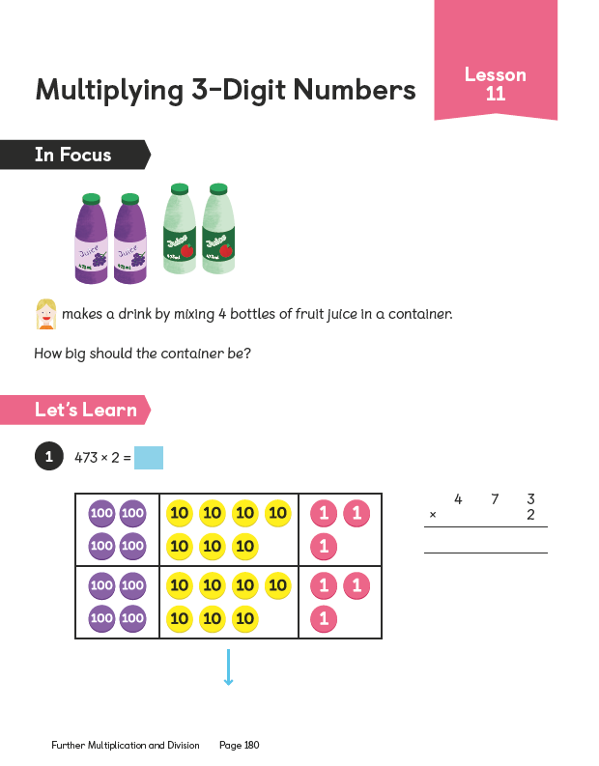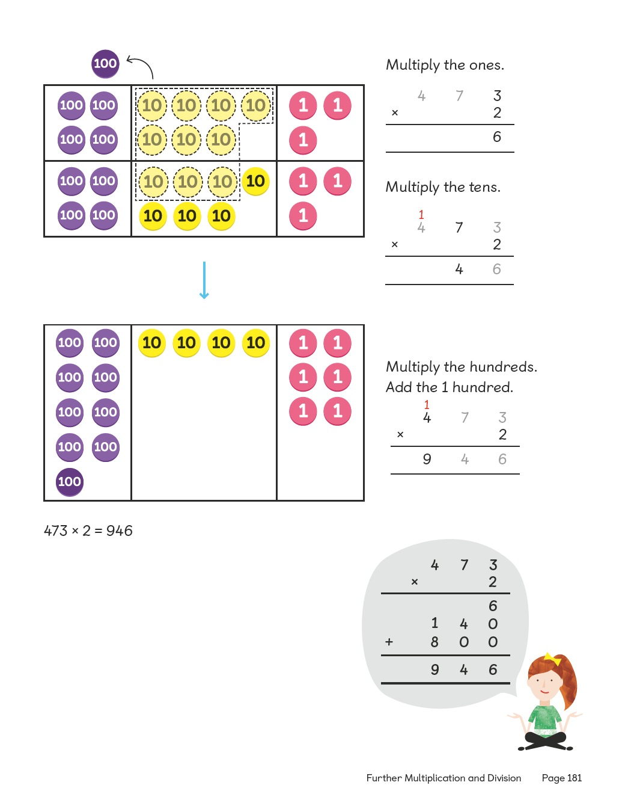
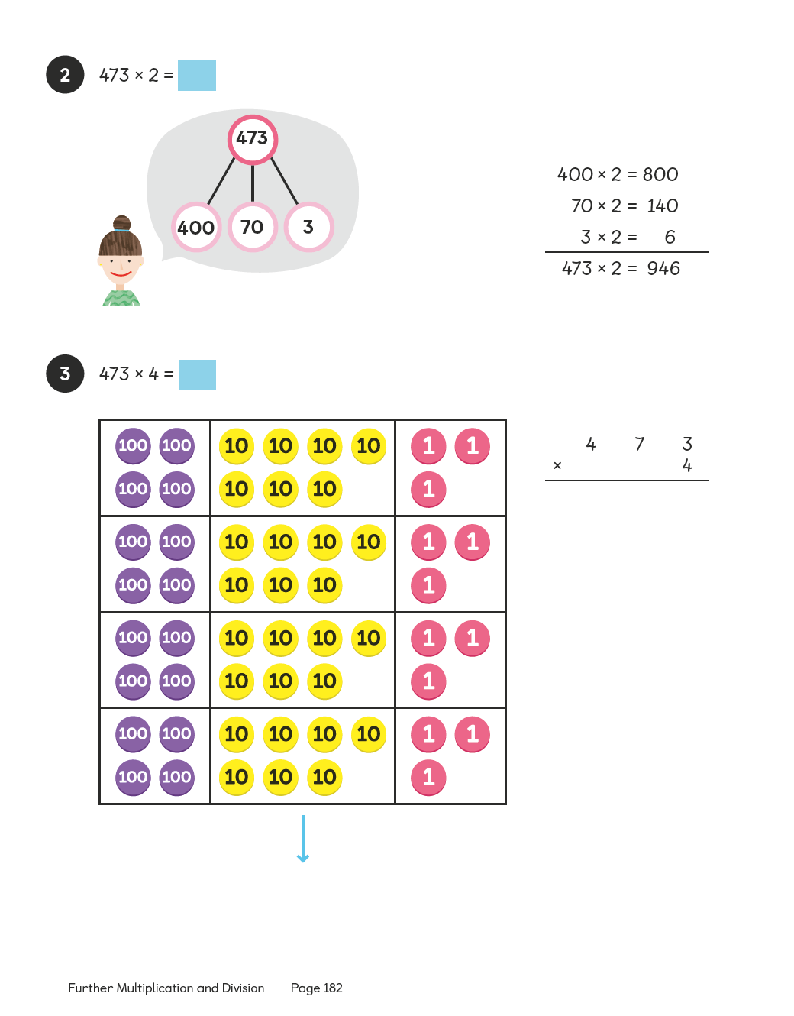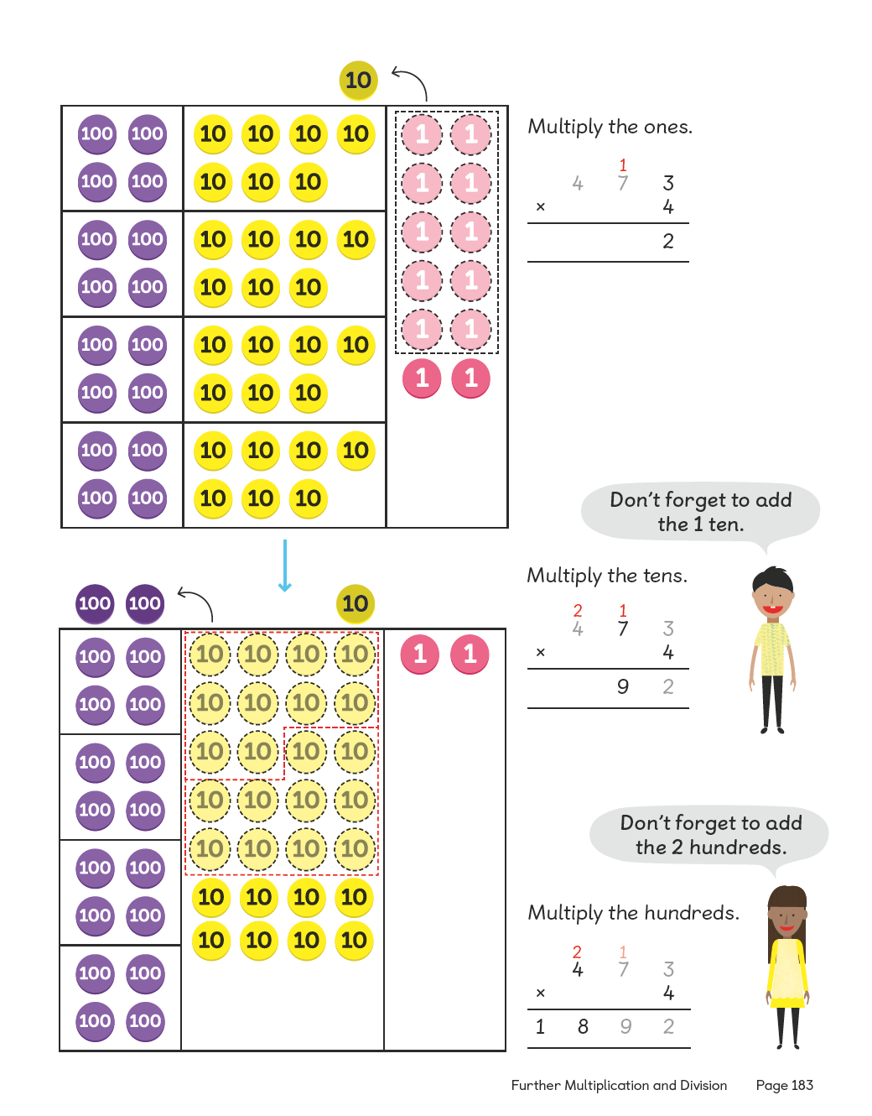
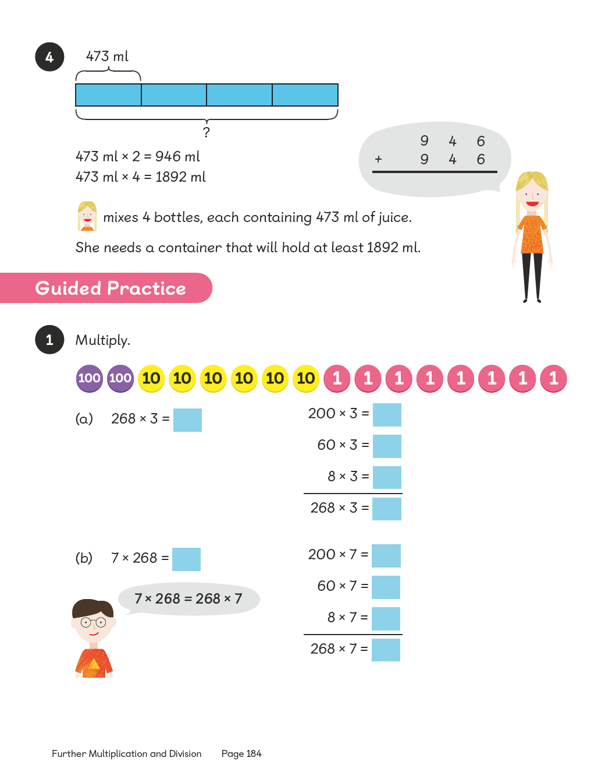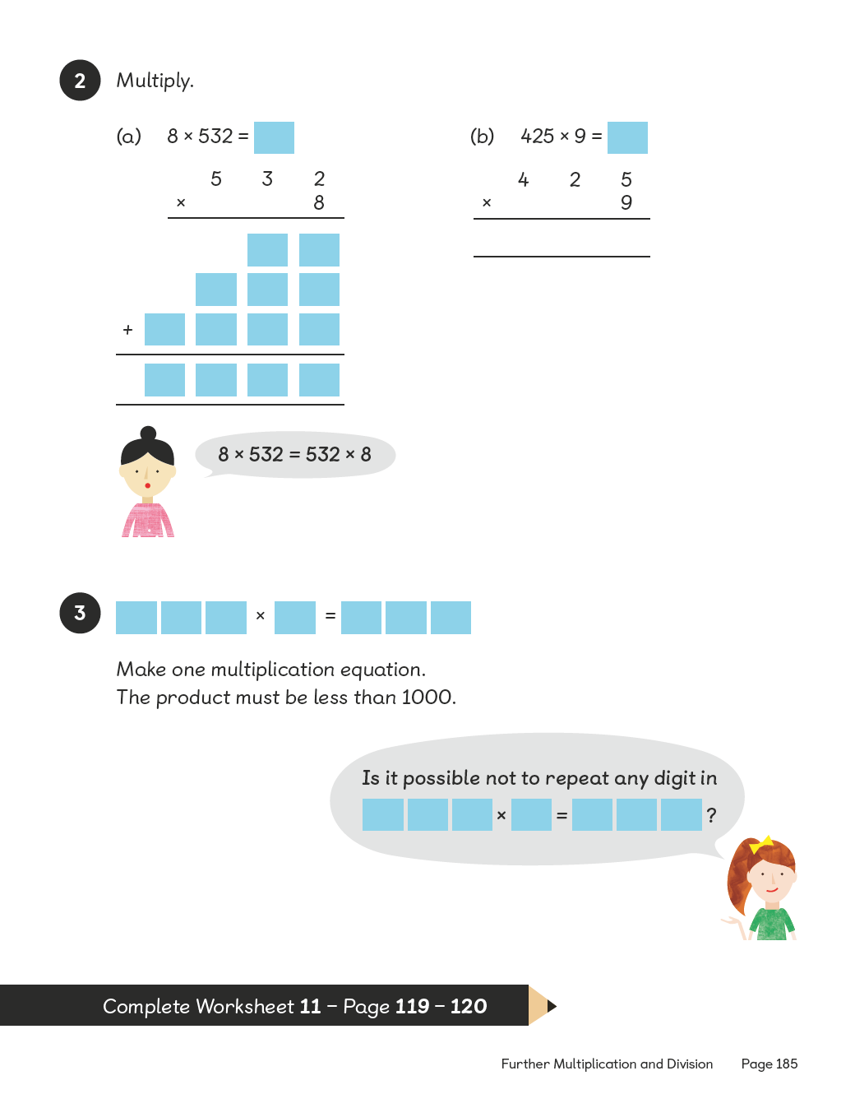
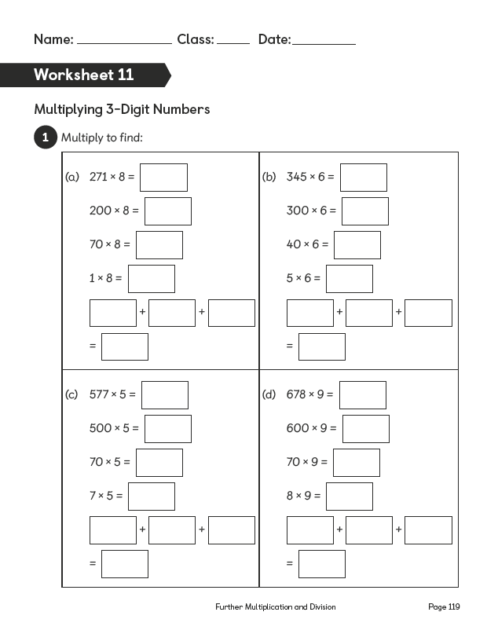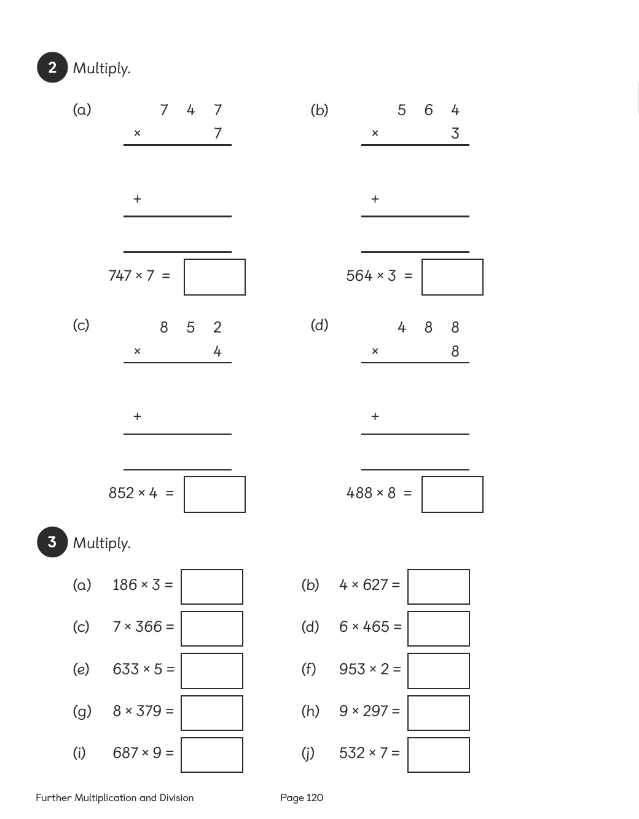

Lesson 12

Dividing 2-Digit Numbers
Pages 186–188
Lesson Objective
To be able to divide 2-digit numbers.
National Curriculum
Recall multiplication and division facts for multiplication tables up to 12 × 12. Use place value, known and derived facts to multiply and divide mentally.
Lesson Approach
To begin this lesson, revisit and discuss division with pupils to gauge their understanding of the operation in terms of grouping, sharing, repeated subtraction and inverse operations. Display the In Focus task and ask the class: What is the problem asking us to calculate? What do we know already? Draw a bar model, talking aloud to help identify the operation in the problem.
Use the steps outlined in Let's Learn to model the calculation. How can we use what we know about multiplying multiples of 10 and inverse operations to help us with this problem? What did I do first, second, third? Record the steps to success.
Next, talk pupils through the methods in Let's Learn 3. Ensure each step is clearly explained by thinking aloud: First, we need to share 6 tens between 2, each gets 3 tens. I have shared all of my tens so none are left. We can show this in my calculation by recording 6 tens – 6 tens = 0 tens. Now I need to share the 8 ones between 2 people: 8 divided by 2 equals 4. Have I shared all of my ones? How do I show there are 0 ones left to share? How many postcards do the children each get? What is the quotient? Is there any remainder?
During Guided Practice, pupils are dividing 2-digit numbers. They can choose which method to use and use number discs if they need to.
Misconceptions
Pupils confuse place value when using long division.
Formative Assessment
Pupils can divide numbers to 10.
Pupils can divide multiples of 10.
Pupils can represent division facts using concrete materials.
Pupils can represent division facts using pictures.
Pupils can create a number of equal groups.
Pupils can create groups of a given number.
Pupils can use number bonds to break apart numbers.
Pupils can use number discs to represent numbers and equations.
Pupils can use bar models to represent numbers and division sentences.
Pupils can use long division to solve division questions involving 2 or more digits.
Non-negotiables
Pupils can use number bonds to break apart 2-digit numbers before dividing.
Pupils can represent their answers using the column method.
Variation
Example 1: Number discs suggested as the key method but not shown; no pictorial support.
Example 2: Number discs shown and arranged into groups of the divisor; term 'quotient' is used.
Resources
Place-value charts (between two)
Place-value discs (between two)

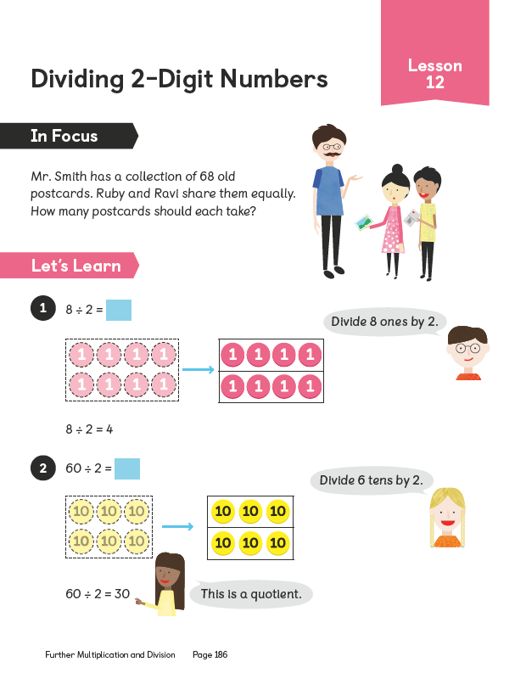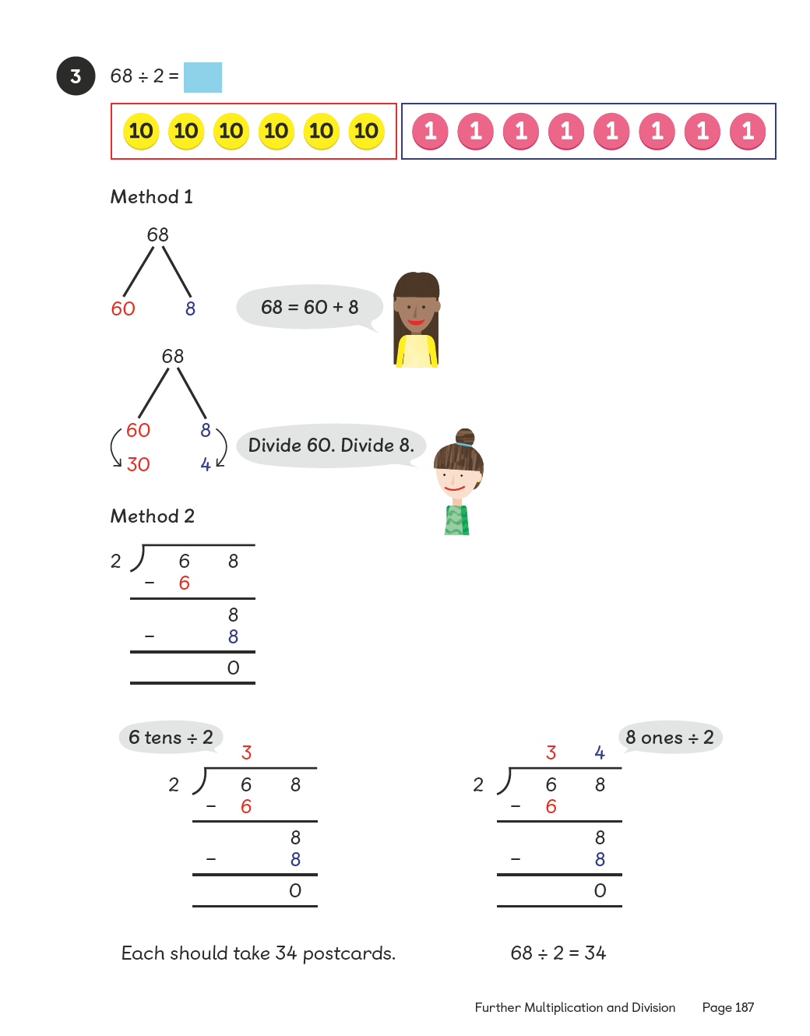
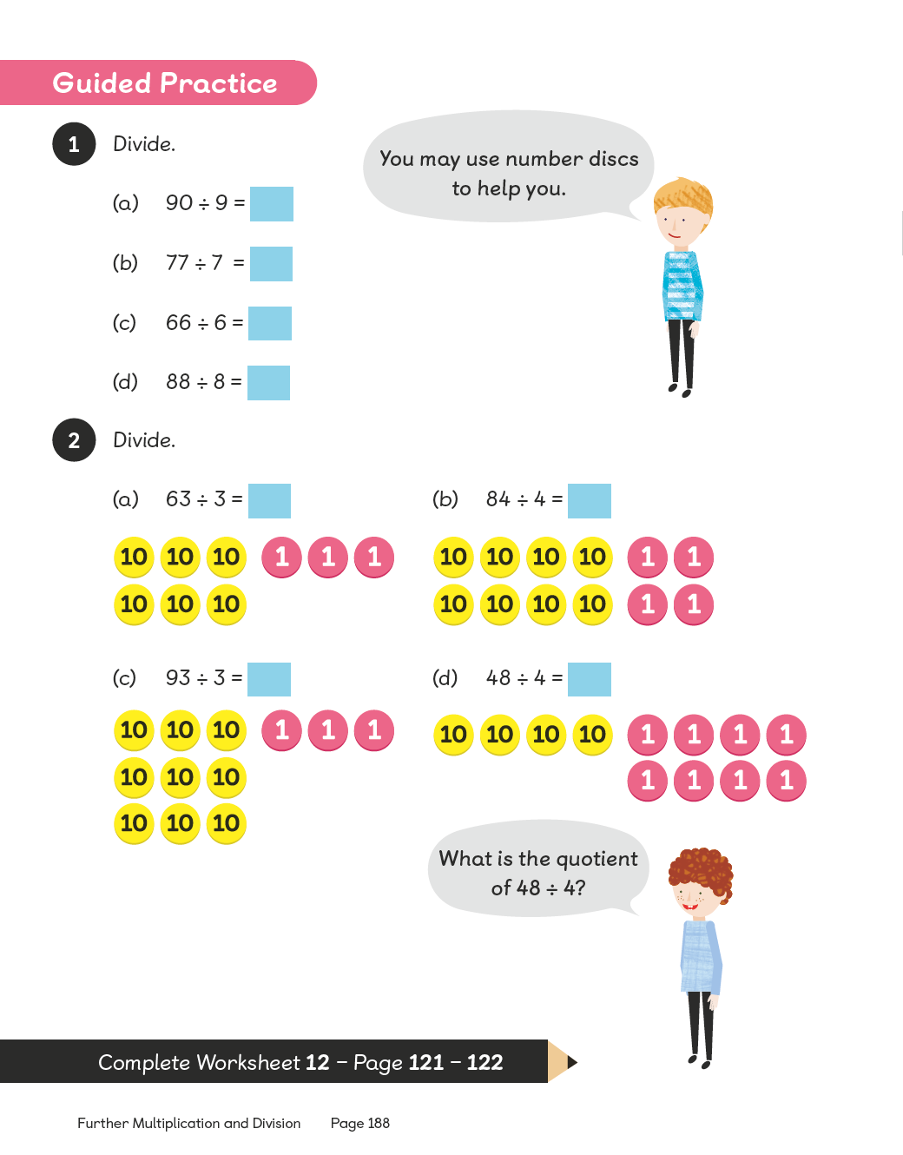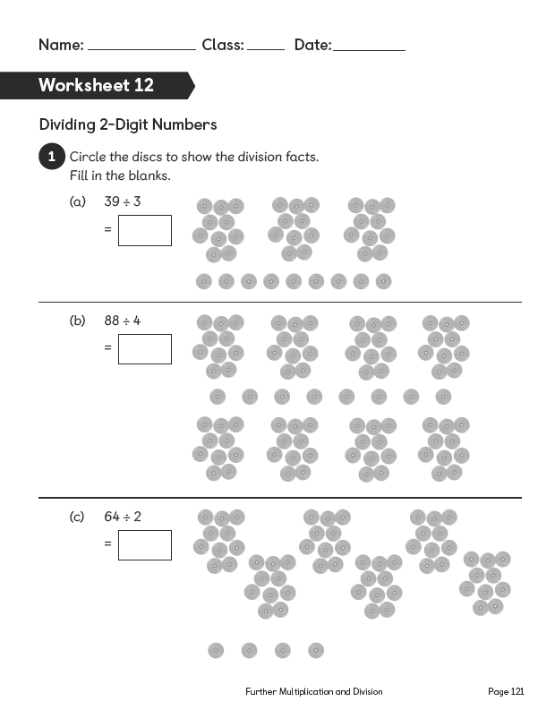
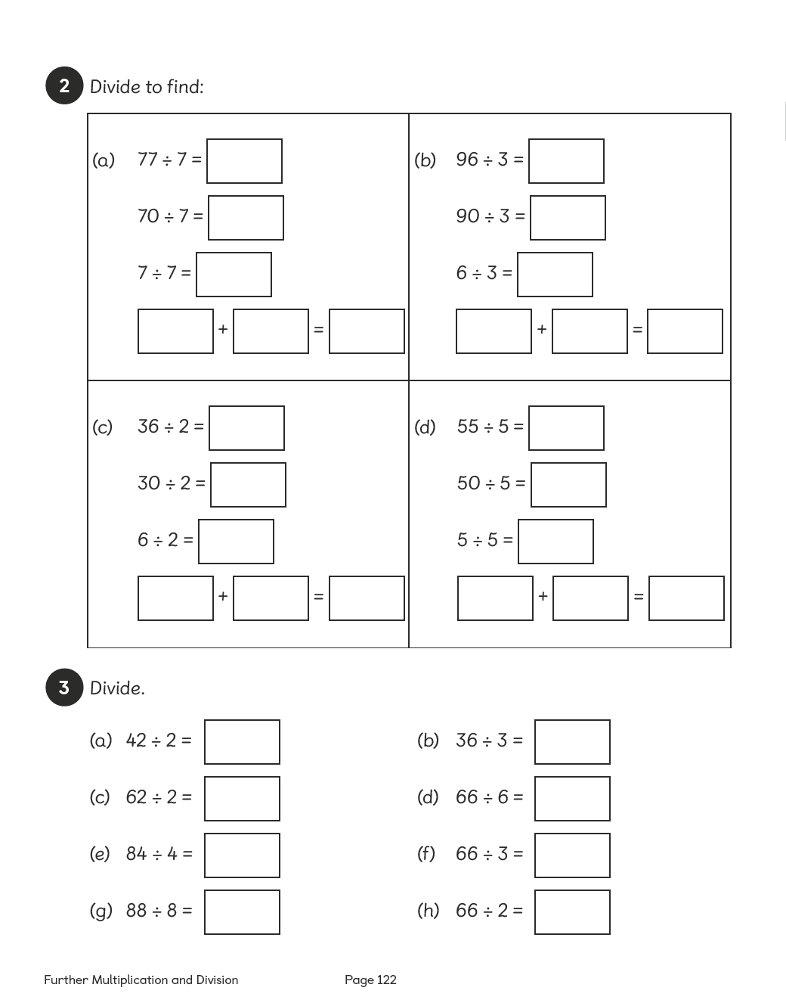

Lesson 13

Dividing 3-Digit Numbers
Pages 189–191
Lesson Objective
To be able to divide 3-digit numbers.
National Curriculum
Recall multiplication and division facts for multiplication tables up to 12 × 12. Use place value, known and derived facts to multiply and divide mentally.
Lesson Approach
To begin this lesson, remind pupils of strategies used to divide a 2-digit number by a 1-digit number. Revisit the steps to success generated in the previous lesson. Ask pupils to start thinking about how we could modify the criteria for this lesson.
Show pupils the In Focus task and ask them whether it is a grouping or a sharing problem and why. How can we calculate the answer? Allow time for partner discussion and take some feedback before working through Let's Learn 1 to 3. Recap dividing ones, tens and hundreds.
Follow the same process of thinking aloud as in the previous lesson for modelling strategies for division in Let's Learn 4. Discuss using partitioning and number bonds to split the number, explicitly linking prior knowledge of multiplication tables and dividing 2-digit numbers to the new learning. What is the same and what is different between the division of 2-digit and 3-digit numbers? Provide pupils with a few examples so they can try their chosen division strategies in pairs, e.g. 246 ÷ 2; 396 ÷ 3.
During Guided Practice, pupils are dividing 3-digit numbers. They should choose the method for division they feel the most confident with when calculating.
Misconceptions
Pupils confuse place value when using long division.
Formative Assessment
Pupils can divide numbers to 10.
Pupils can divide multiples of 10.
Pupils can represent division facts using concrete materials.
Pupils can represent division facts using pictures.
Pupils can create a number of equal groups.
Pupils can create groups of a given number.
Pupils can use number bonds to break apart numbers.
Pupils can use number discs to represent numbers and equations.
Pupils can use bar models to represent numbers and division sentences.
Pupils can use long division to solve division questions involving 2 or more digits.
Non-negotiables
Pupils can use number bonds to break apart 3-digit numbers before dividing.
Pupils can represent their answers using the column method.
Variation
Example 1: Number discs suggested as the key method but not shown. No pictorial support.
Example 2:
(a) and (b) Number discs shown and arranged into groups of the divisor.
(c) and (d) No suggested methods.
Resources
Place-value charts (between two)
Place-value discs (between two)

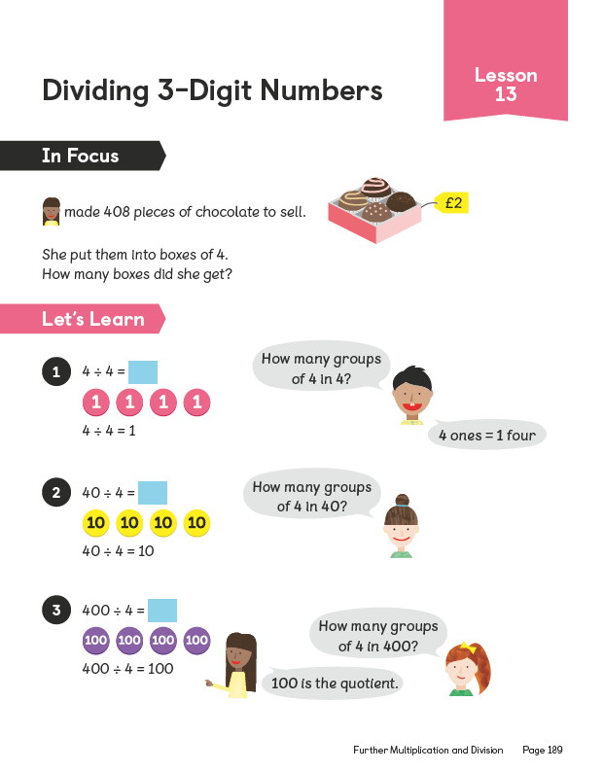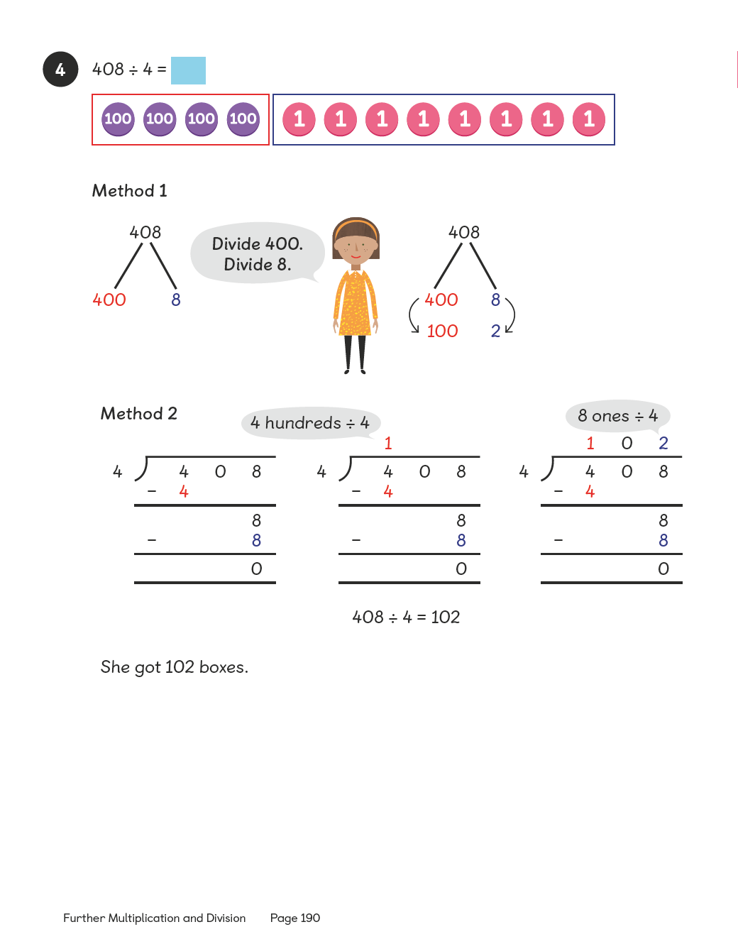
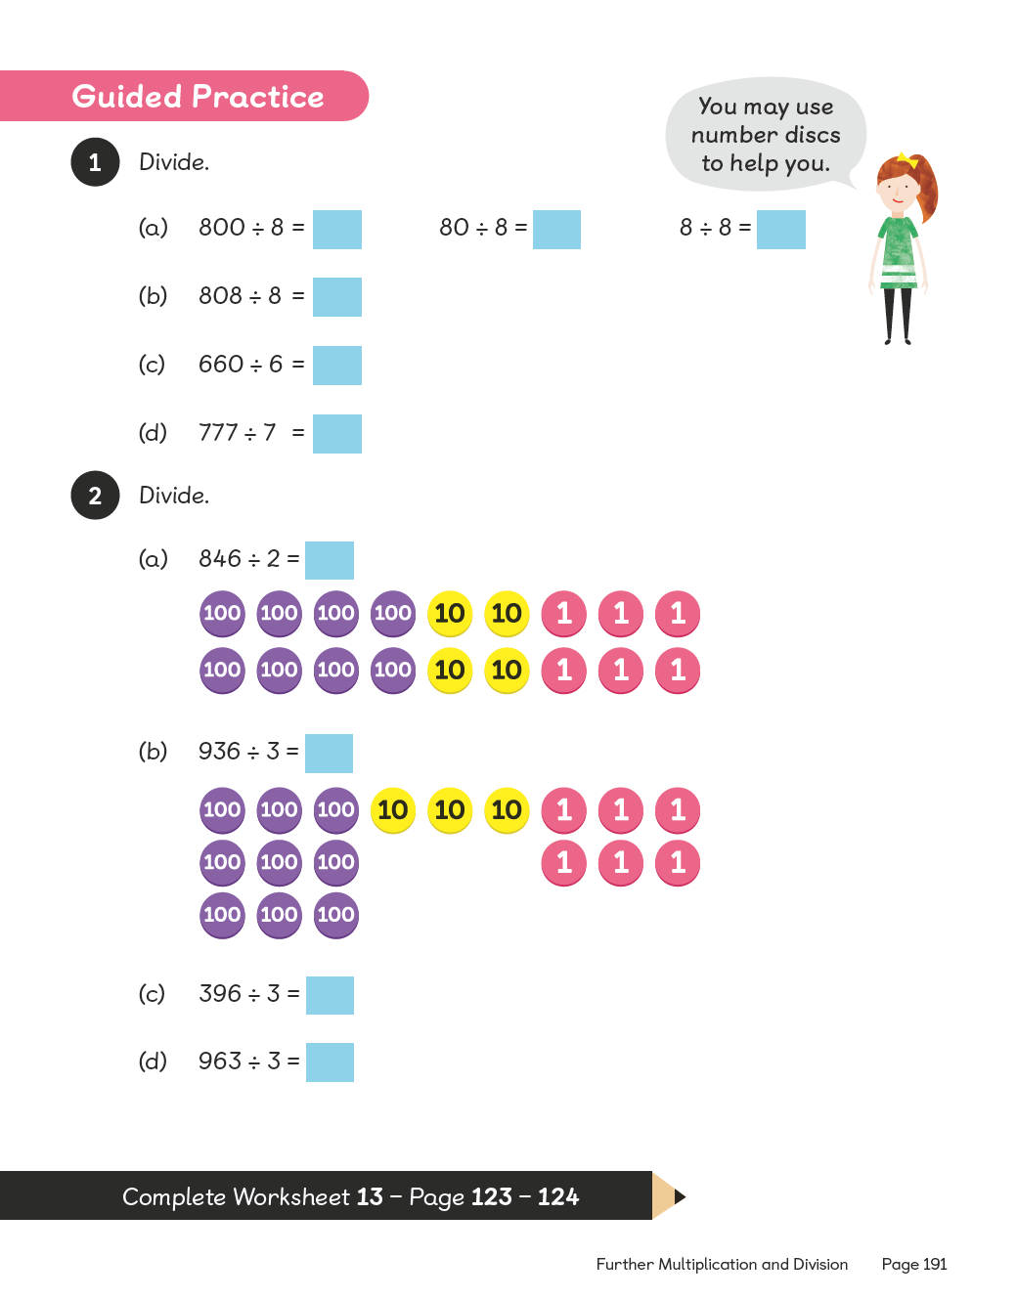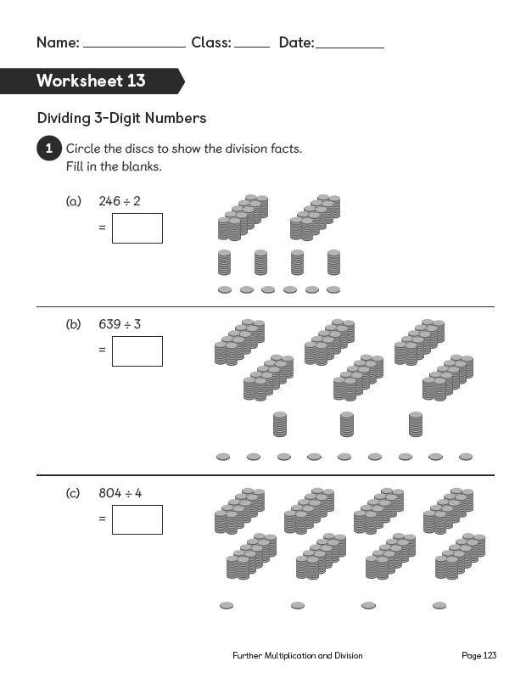
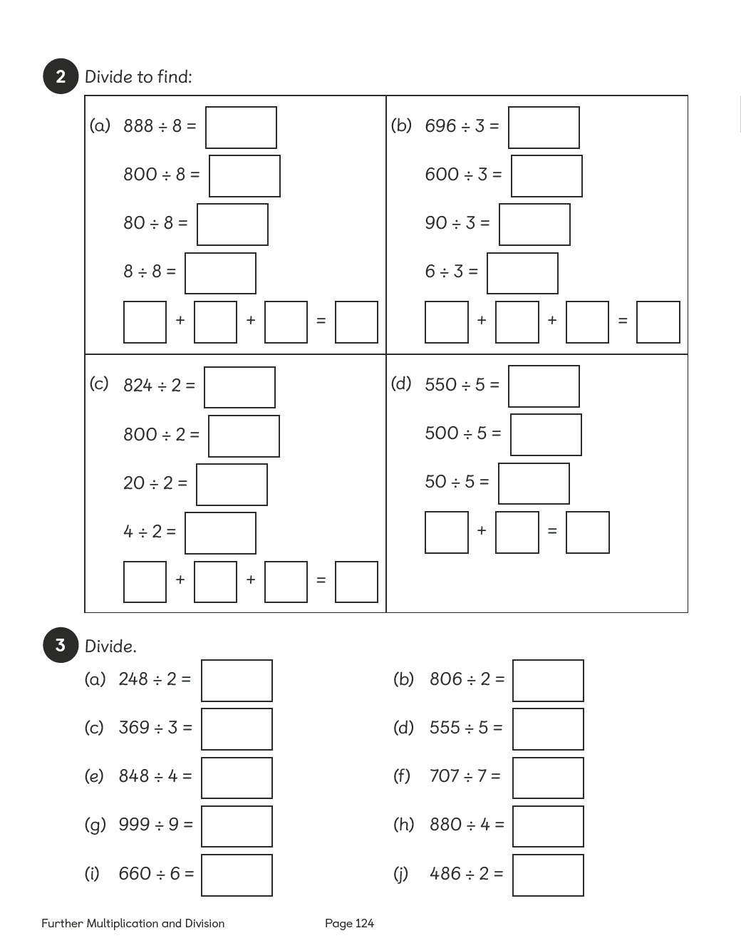

Lesson 14

Dividing 2-Digit Numbers
Pages 192–194
Lesson Objective
To be able to divide 2-digit numbers with a remainder.
National Curriculum
Recall multiplication and division facts for multiplication tables up to 12 × 12. Use place value, known and derived facts to multiply and divide mentally.
Lesson Approach
To begin this lesson, show pupils the In Focus task and give them time to discuss it in pairs. Do pupils use 6 times table facts or are they still relying heavily on the image to justify or make conjectures?
Using Let's Learn, Method 1, demonstrate calculating the quotient using the partitioning method. Ask pupils: What is a remainder? When have we seen it before? Is there any other way we can record the remainder? Then work through Method 2, thinking aloud at each step: What is the remainder? How do we know? How do we record a remainder? Have we answered the question in the problem? What do we need to think about? Draw out that pupils need to think about the context of the problem and round up or down appropriately, according to which objects the problem is dealing with.
During Guided Practice, pupils are dividing the same 2-digit number by a 1-digit number. In pairs, pupils can discuss the 2 methods and use number discs if required.
Misconceptions
Pupils confuse place value when using long division.
Pupils do not know how to use/represent remainders when working with the number bond method.
Formative Assessment
Pupils can divide numbers to 10.
Pupils can divide multiples of 10.
Pupils can represent division facts using concrete materials.
Pupils can represent division facts using pictures.
Pupils can create a number of equal groups.
Pupils can create groups of a given number.
Pupils can use number bonds to break apart numbers.
Pupils can use number discs to represent numbers and equations.
Pupils can use bar models to represent numbers and division sentences.
Pupils can use long division to solve division questions involving 2 or more digits.
Pupils can identify a remainder when working with number bonds.
Pupils can find multiples of the divisor in the number being divided (e.g. 60 ÷ 3, 60 can be split into 30 and 30).
Non-negotiables
Pupils can use number bonds to break apart 2-digit numbers before dividing.
Pupils can represent their answers using the column method.
Variation
Dividing the number 98 into 2, 3, 4, 5 and 6 groups to look for equal groups without remainders; using number bonds and long division.
Resources
Place-value charts (between two)
Place-value discs (between two)

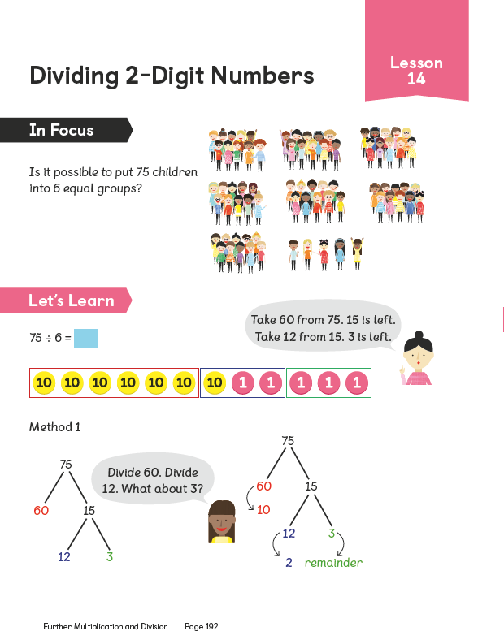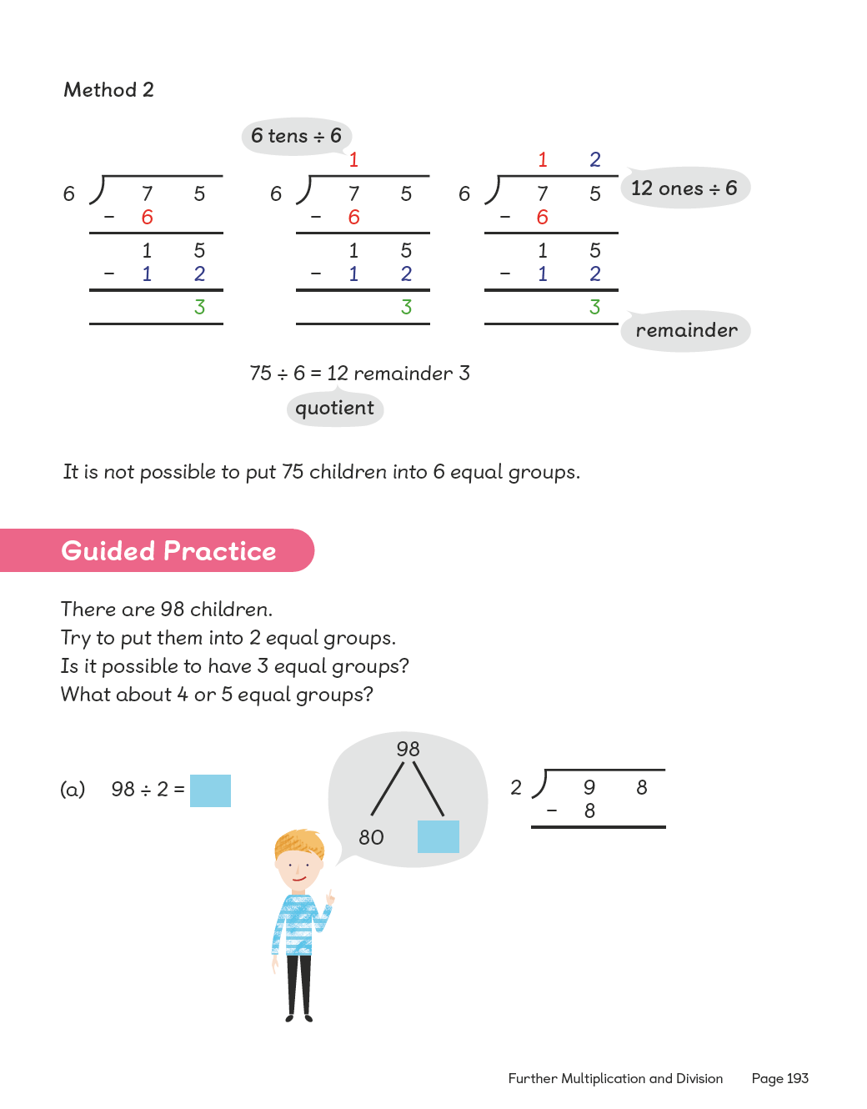
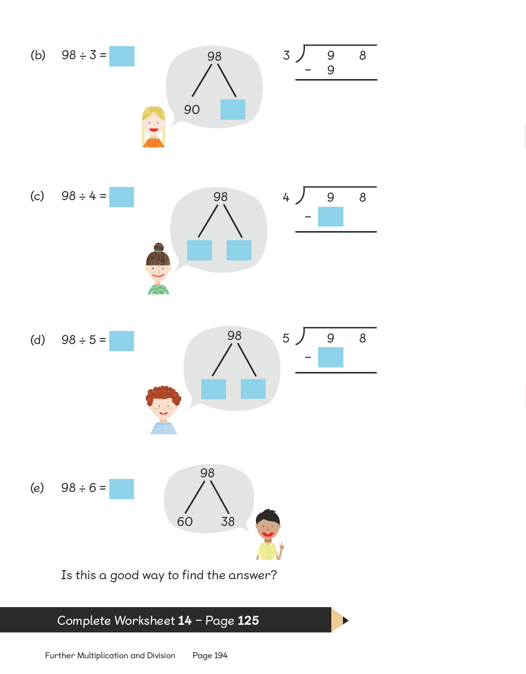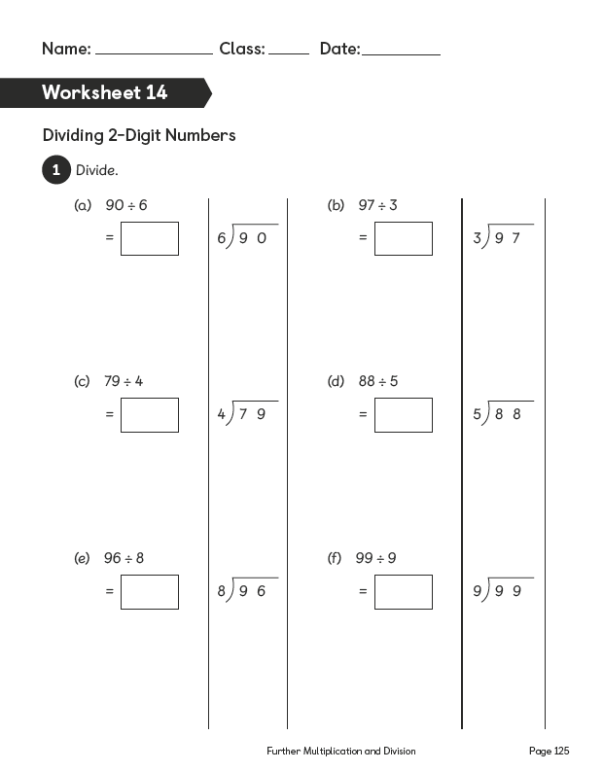

Lesson 15

Dividing 3-Digit Numbers
Pages 195–196
Lesson Objective
To be able to divide 3-digit numbers with renaming.
National Curriculum
Recall multiplication and division facts for multiplication tables up to 12 × 12. Use place value, known and derived facts to multiply and divide mentally.
Lesson Approach
To begin this lesson, show pupils the In Focus task and allow them time to discuss it. Pose questions such as: How will what we already know help us to calculate the quotient? Is this trickier? Why? What do we already know from the problem? What is the problem asking us to find out? Is this a grouping or sharing problem? Allow some time for class feedback.
Display Let's Learn, Method 1, and show pupils the partitioning method to carry out the division. Then talk through Method 2, ensuring that each step is fully understood by them. Point to different parts of the calculation and ask them to explain how/why it is there and link this back to Method 1.
During Guided Practice, pupils are dividing 2-digit and 3-digit numbers. Before they begin, draw attention to the questions in number 2 that can be partitioned into 3 parts to help with division.
Misconceptions
Pupils confuse place value when using long division.
Pupils do not know how to use/represent remainders when working with the number bond method.
Formative Assessment
Pupils can divide numbers to 10.
Pupils can divide multiples of 10 and 100.
Pupils can represent division facts using concrete materials.
Pupils can represent division facts using pictures.
Pupils can create a number of equal groups.
Pupils can create groups of a given number.
Pupils can use number bonds to break apart numbers.
Pupils can use number discs to represent numbers and equations.
Pupils can use bar models to represent numbers and division sentences.
Pupils can use long division to solve division questions involving 2 or more digits.
Pupils can identify a remainder when working with number bonds.
Pupils can find multiples of the divisor in the number being divided (e.g. 60 ÷ 3, 60 can be split into 30 and 30).
Non-negotiables
Pupils can use number bonds to break apart 3-digit numbers before dividing.
Pupils can represent their answers using the column method.
Variation
Example 1: Number discs, number bonds and long division shown; decision-making needed to break apart numbers.
Example 2: No suggested methods.
Resources
Place-value discs (between two)

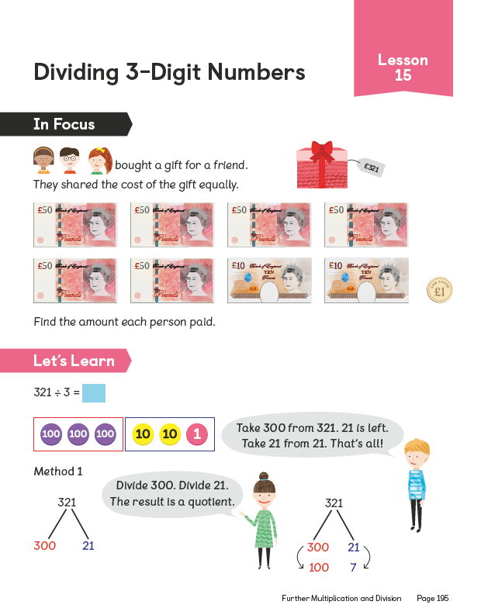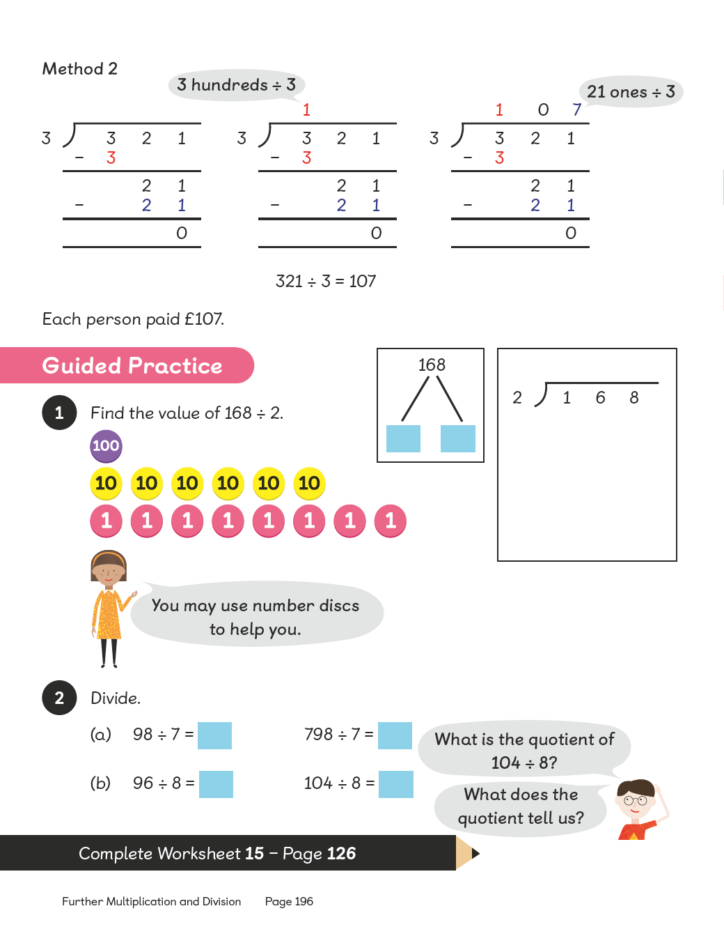
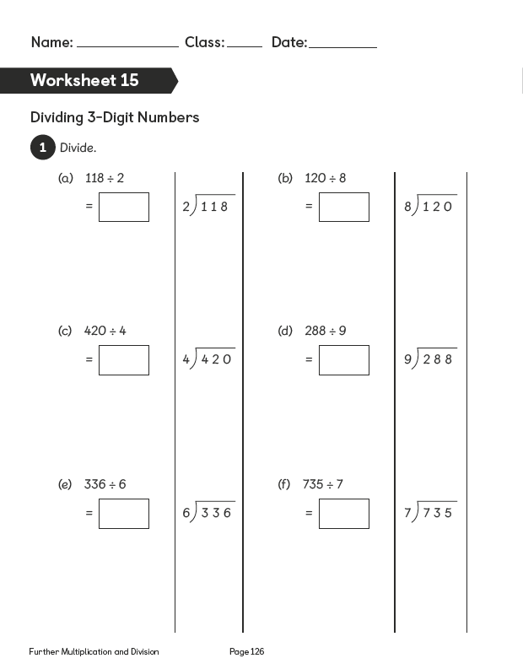

Lesson 16

Dividing 3-Digit Numbers
Pages 197–199
Lesson Objective
To be able to divide 3-digit numbers with a remainder.
National Curriculum
Recall multiplication and division facts for multiplication tables up to 12 × 12. Use place value, known and derived facts to multiply and divide mentally.
Lesson Approach
To begin this lesson, show pupils the In Focus task. Discuss previous learning and the methods we can use to calculate the quotient. Invite a volunteer to show the class Method 1 in Let's Learn 1 for calculating division. Ask them questions as they work through the method. Why have you partitioned in that way? What other ways could this calculation have been done? Have you answered the question?
Demonstrate or invite another volunteer to show Method 2 to the class, linking Methods 1 and 2. Identify the parts of each method that are the same. Where is this part in Method 1? What does it show? Why did we subtract 9 ones? Have we grouped all of the ones? How many are left over? Does it make another group? Why not? Ensure that pupils explain using subject-specific terminology, such as equal groups, quotient and remainder.
Work through Let's Learn 2. Can pupils predict what the quotient and remainder will be?
During Guided Practice, pupils are dividing the same 3-digit number by a 1-digit number. Allow them to work in pairs and discuss the solutions with their partners.
Misconceptions
Pupils confuse place value when using long division.
Pupils do not know how to use/represent remainders when working with the number bond method.
Formative Assessment
Pupils can divide numbers to 10.
Pupils can divide multiples of 10 and 100.
Pupils can represent division facts using concrete materials.
Pupils can represent division facts using pictures.
Pupils can create a number of equal groups.
Pupils can create groups of a given number.
Pupils can use number bonds to break apart numbers.
Pupils can use number discs to represent numbers and equations.
Pupils can use bar models to represent numbers and division sentences.
Pupils can use long division to solve division questions involving 2 or more digits.
Pupils can identify a remainder when working with number bonds.
Pupils can find multiples of the divisor in the number being divided (e.g. 60 ÷ 3, 60 can be split into 30 and 30).
Non-negotiables
Pupils can use number bonds to break multiples of 100 before dividing.
Pupils can represent their answers using the column method.
Variation
Dividing a multiple of 100 into 6, 7, 8 and 9 groups using the number bond method to break the number into multiples of the divisor.
Resources
Place-value charts (between two)
Place-value discs (between two)

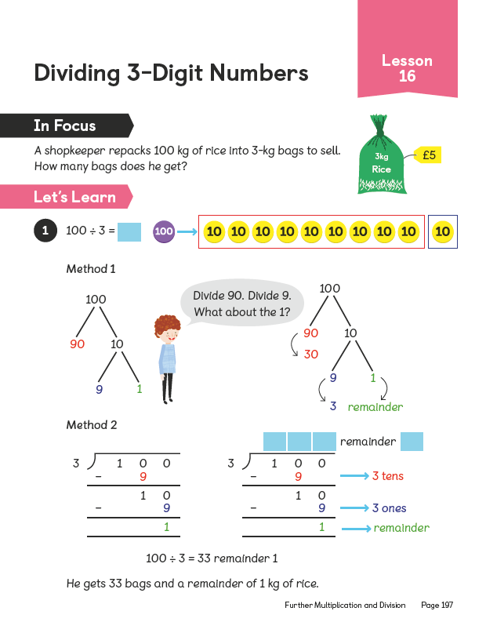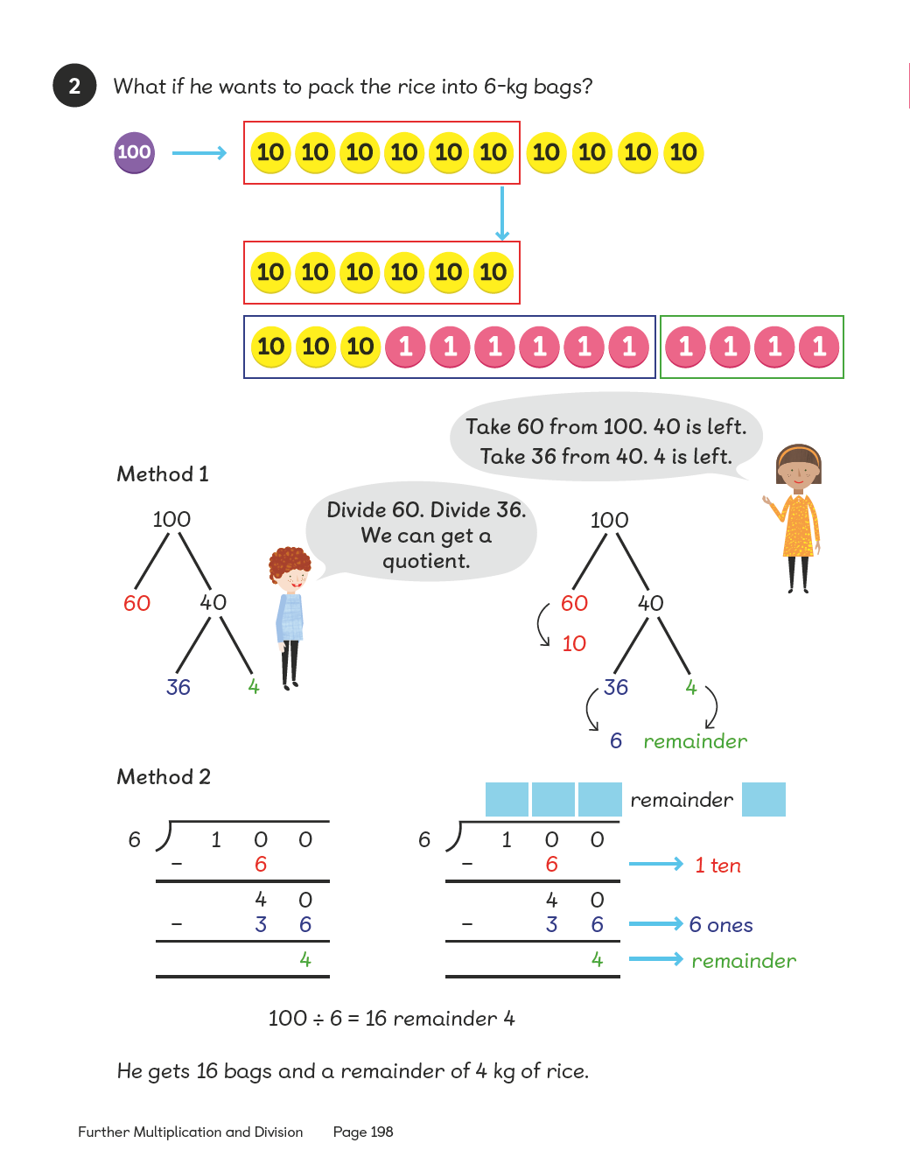

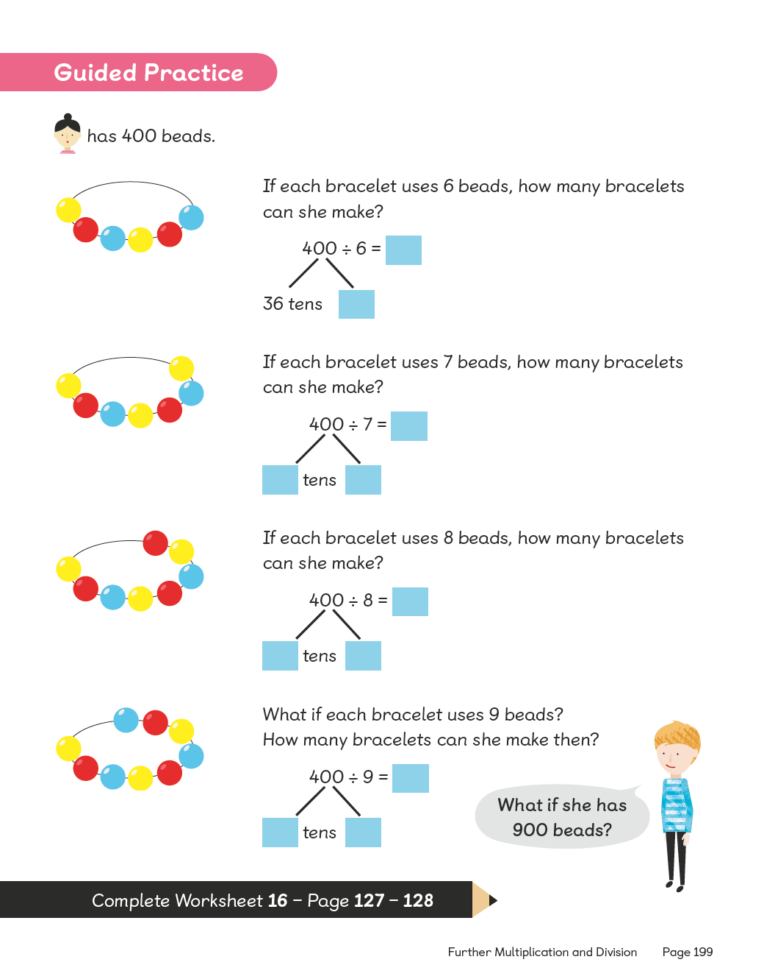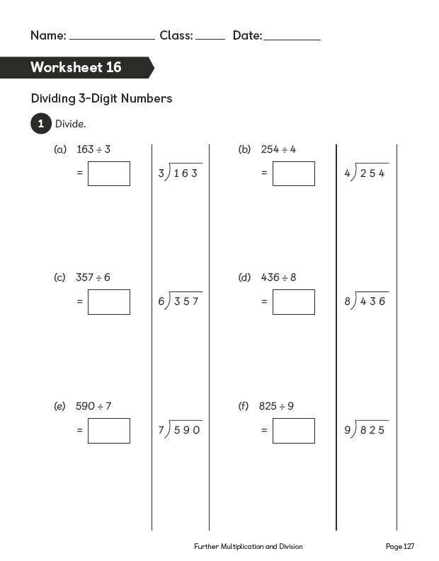
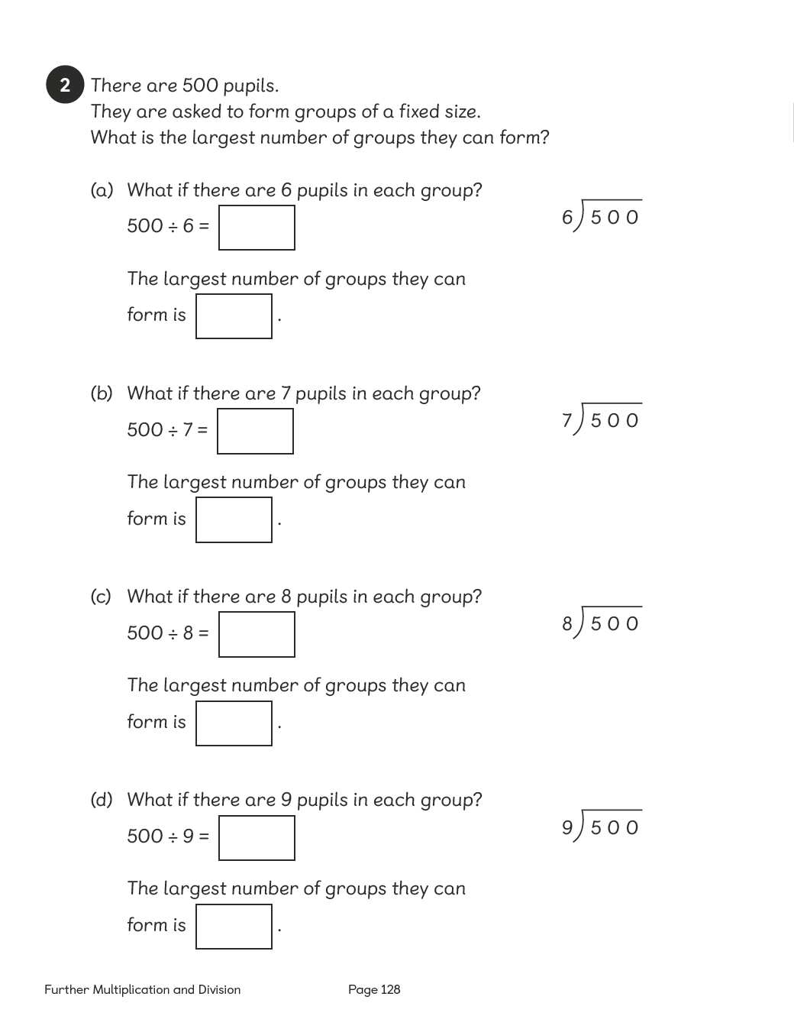

Lesson 17

Solving Word Problems
Pages 200–201
Lesson Objective
To be able to solve word problems involving multiplication and division.
National Curriculum
Solve problems involving multiplying and adding.
Lesson Approach
To begin this lesson, tell pupils they will be using the methods they know for multiplication and division to solve problems. Remind them we use the bar model (comparison) to help us understand what the problem is asking us to do.
Show pupils the In Focus task and ask them whether to use multiplication or division and why. What do we know from the problem? Let's draw it out. What would the first bar represent? What do we already know about the other girl's beads? What are we trying to calculate?
Demonstrate both methods in Let's Learn 1 and allow pupils to discuss each method. How have they both given the same product? How are they different? Which do you prefer and why? Work through Let's Learn 2 together. What is the same and what is different? What do we know? How should we label the bars? What calculation do we need to carry out? Allow pupils to discuss.
During Guided Practice, pupils are solving a word problem. Suggest they can use the bar model to help solve the problem. Circulate the classroom to provide support if needed.
Misconceptions
Pupils cannot use bar models to reflect equal groups of large numbers.
Formative Assessment
Pupils can multiply numbers to 10.
Pupils can multiply numbers by multiples of 10 and 100.
Pupils can use bar models to represent numbers and to show proportion and multiple amounts.
Pupils can solve word problems that have multiple steps involving all four operations (+, -, × and ÷).
Pupils can draw bar models to reflect key information from the word problem.
Pupils can label bar models with the correct information from the word problem.
Pupils can determine what convention/operation is needed based on information from the bar models drawn.
Non-negotiables
Pupils can use bar models to represent and solve word problems involving multiplication and division of 3-digit numbers.
Pupils can reflect and record their thinking using formal methods.
Variation
Using comparison bar models to reflect multiple amounts of the same and then part–whole models to reflect the difference from the total; multiplication and subtraction needed.
Resources - No additional resources required for this lesson.

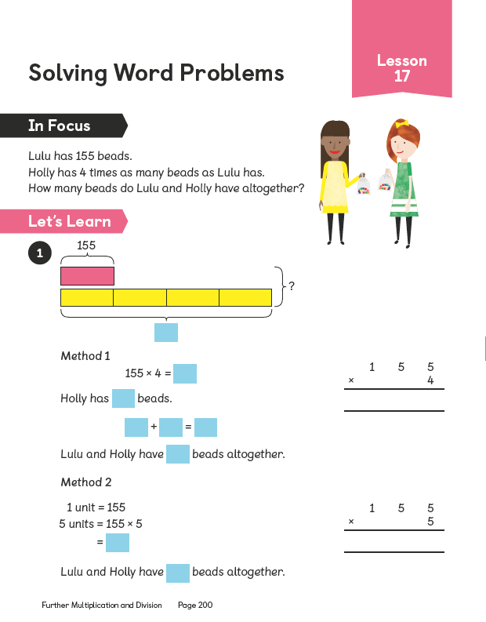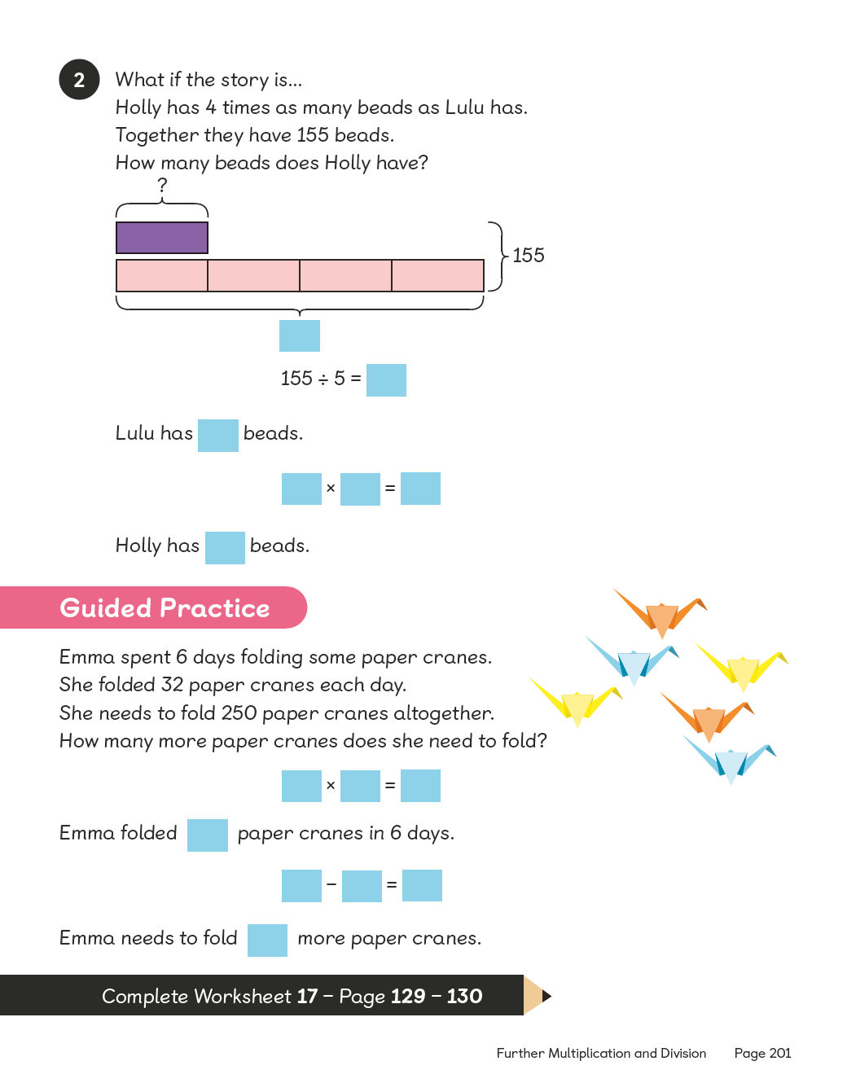
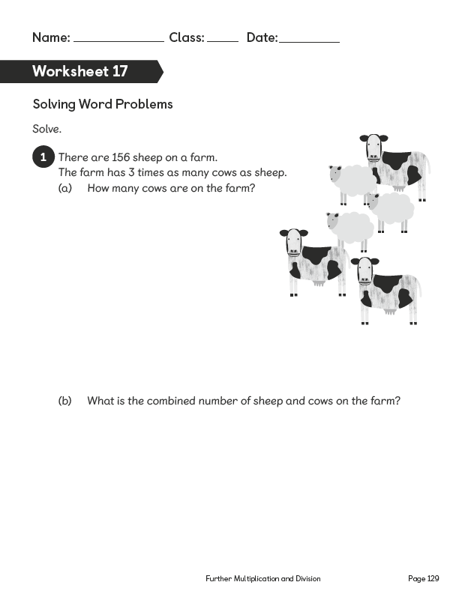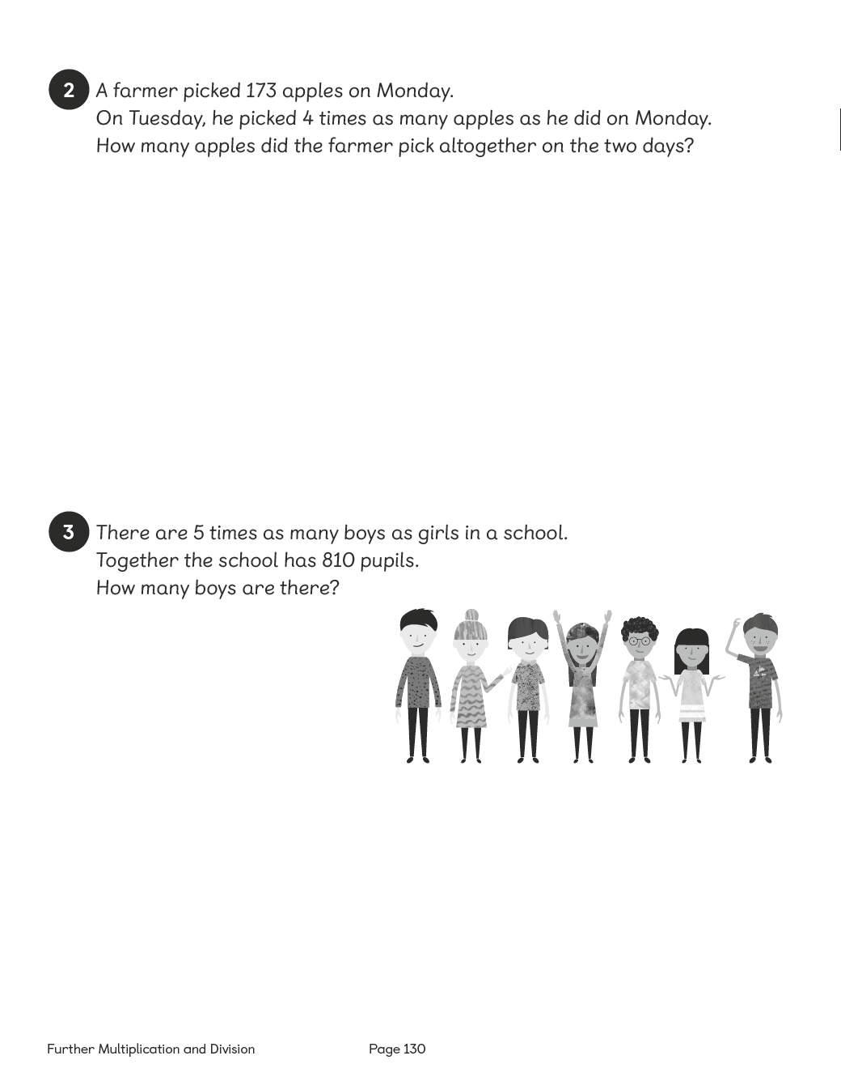

Lesson 18

Solving Word Problems
Pages 202–203
Lesson Objective
To be able to solve word problems involving multiplication and division.
National Curriculum
Solve problems involving multiplying and adding.
Lesson Approach
To begin this lesson, show pupils the In Focus task. Through class discussion, break the problem into manageable chunks. We know that 3 boys have 557 marbles. Ravi has 3 times as many as Elliott; that means we should draw 1 part to represent Elliott's marbles and 3 parts to represent Ravi's marbles in a comparison model. Do we agree? What else do we know? Elliott has 2 fewer marbles than Charles, which means that Charles has 2 more than Elliott. Do we agree? Why?
Ask pupils to discuss this with their partners before showing them how to add all of the information from the problem to the bar model. We are trying to calculate how many marbles Elliott has. How many equal groups do we have? What should we do with these equal groups to find the value of one equal group? Allow time for discussion and feedback. Invite a volunteer to demonstrate the method at the front of the class. Has anyone done it a different way? How many marbles does Elliott have? How can we use this information to calculate the number of marbles that the other boys have? Allow pupils to work out the answer and complete the missing information in Let's Learn.
During Guided Practice, pupils are solving word problems. Introduce the questions and ensure that pupils understand the step-by-step process. Allow them to work out the solutions with their partners. Circulate the classroom to provide support if needed.
Misconceptions
Pupils cannot use bar models to show equal groups of large numbers.
Formative Assessment
Pupils can divide numbers to 10.
Pupils can divide numbers by multiples of 10 and 100.
Pupils can use bar models to reflect proportion and multiple amounts.
Pupils can solve word problems that have multiple steps involving all four operations (+, -, × and ÷).
Pupils can draw bar models to reflect key information from the word problem.
Pupils can label bar models with the correct information from the word problem.
Pupils can determine what convention/operation is needed based on information from the bar models drawn.
Non-negotiables
Pupils can use bar models to represent and solve word problems involving multiplication and division of 3-digit numbers.
Pupils can reflect and record their thinking using formal methods.
Variation
Example 1: Using division and addition to solve the problem; multiple bars to reflect amounts provided as support.
Example 2: Using division and multiplication to solve the problem; number bond diagram provided as support.
Example 3: Using subtraction and division to solve the problem.
Resources - No additional resources required for this lesson.

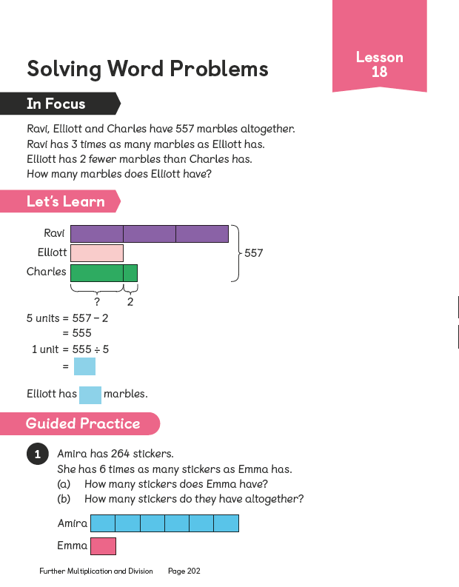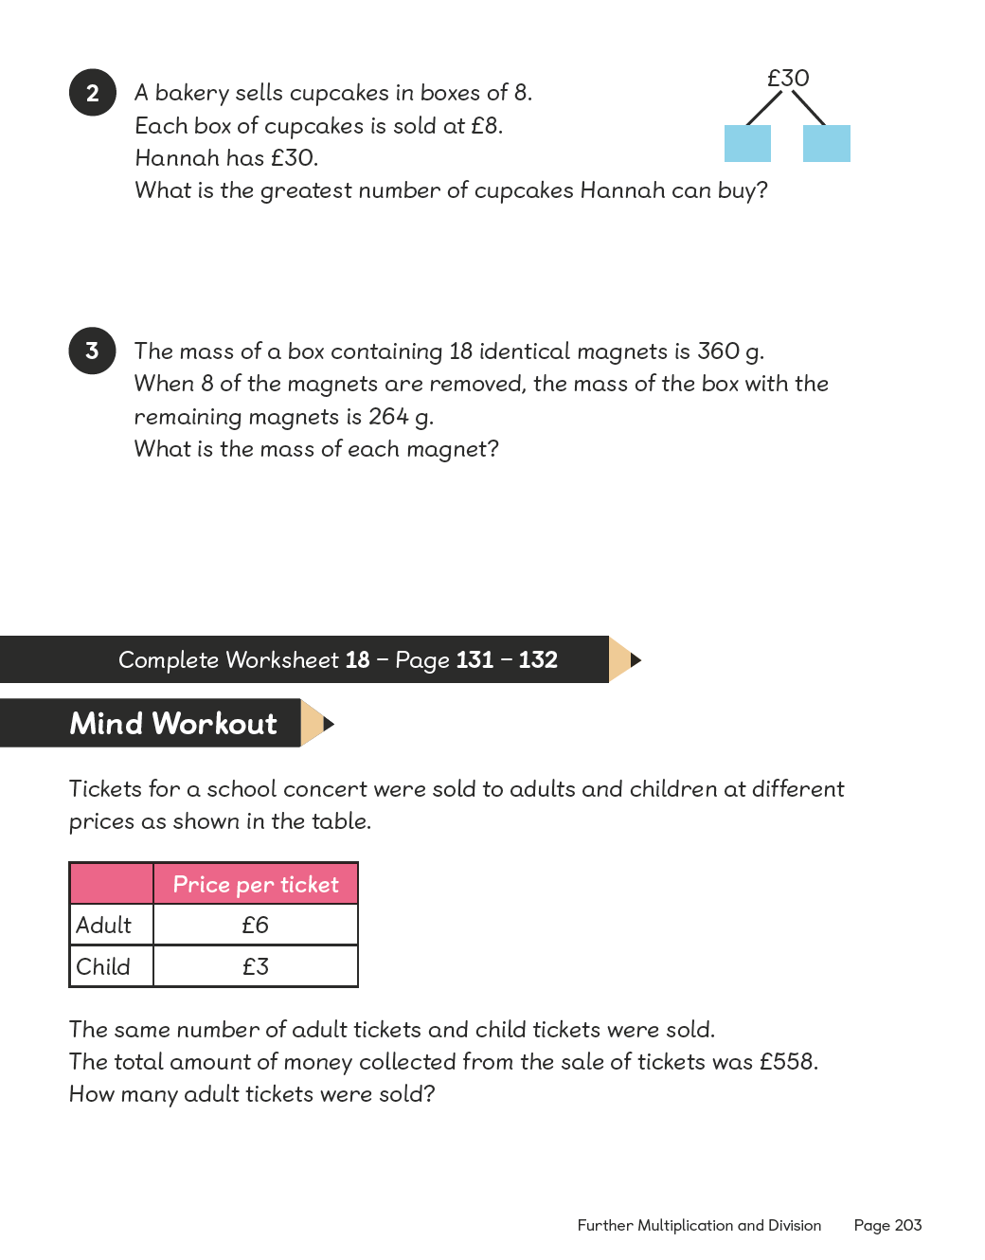
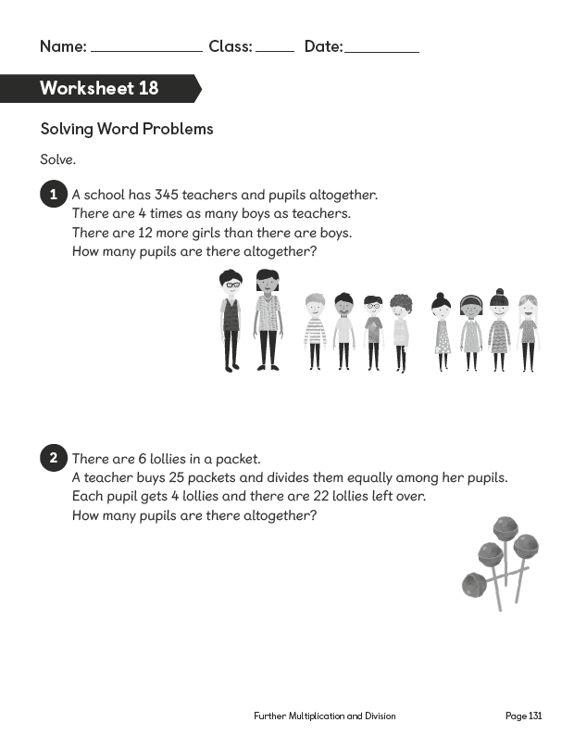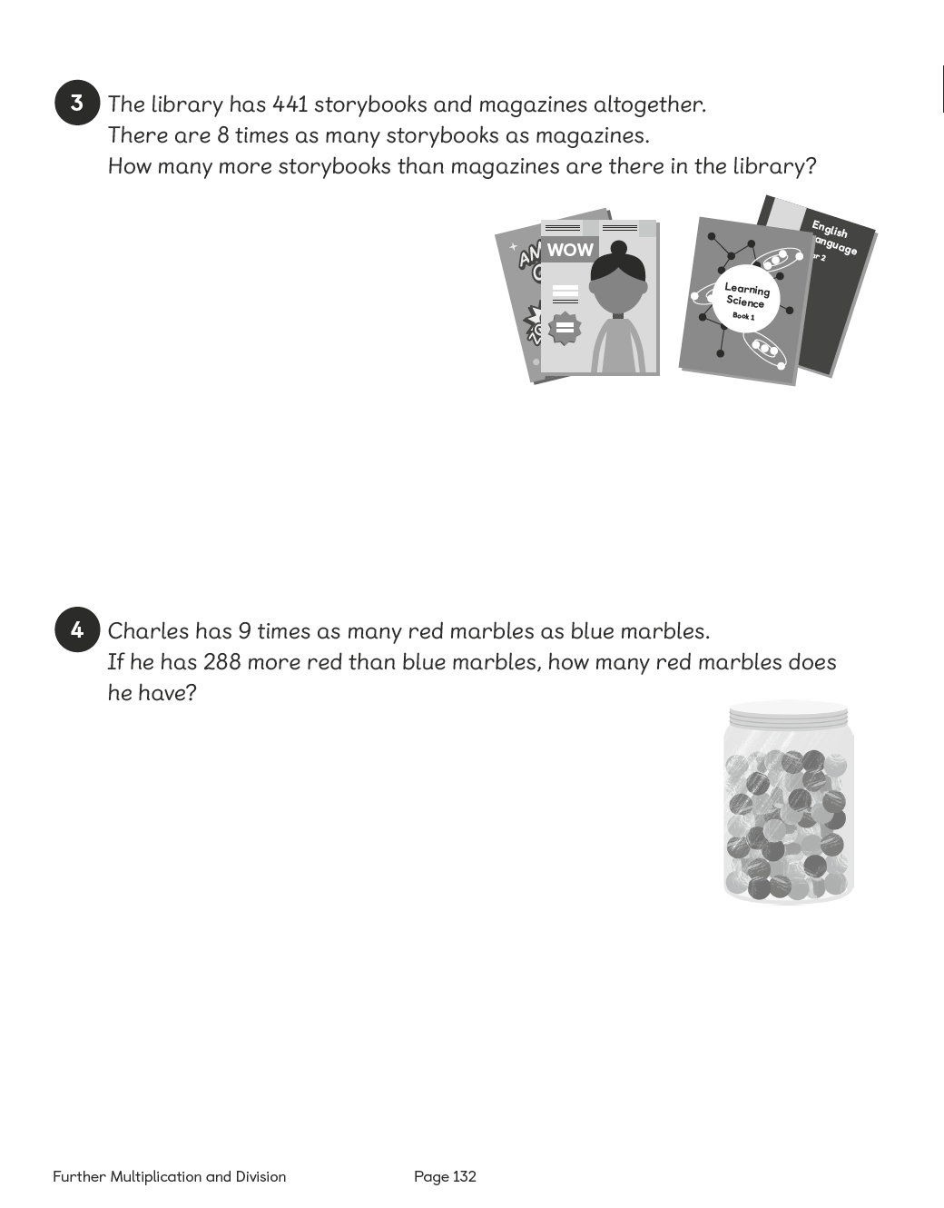

Lesson 19

Chapter Consolidation
Pages 203–204
Lesson Objective
To be able use knowledge of multiplication and division to solve problems.
Lesson Approach
Mind Workout
Pupils work out the solution to the word problem and explain their thinking and reasoning to their partners.
Maths Journal
Pupils complete the word problem and then ask their classmates to solve it.
Self Check
Pupils complete this as a chapter summary and discuss what to do with their teacher if any boxes are not ticked.

