Chapter 5 - Graphs

Chapter Details
Chapter title: Graphs
Start page: 205
Number of lessons: 6
Chapter description:
In this chapter, pupils will learn how to interpret picture graphs and bar graphs. They will be introduced to line graphs and how they are used to measure change over time. They will interpret line graphs and use information collated in a table to draw a line graph. Pupils will make predictions based on trends identified in data.
Resources
Laptop/tablet with spreadsheet software (between four)
Markers (between four)
Newspapers (between four)
Sugar paper (between four)

Textbook 4A
Lesson 1 – Drawing and Reading Picture Graphs and Bar Graphs
To be able to draw and read picture graphs and bar graphs.

Lesson 2 – Drawing and Reading Bar Graphs
To be able to draw and read bar graphs.

Lesson 3 – Drawing and Reading Line Graphs
To be able to draw and read line graphs.

Lesson 4 – Drawing and Reading Line Graphs
To be able to draw and read line graphs.

Lesson 5 – Drawing and Reading Line Graphs
To be able to draw and read line graphs.

Lesson 6 – Chapter Consolidation
To be able to use knowledge of graphs to solve problems.

Lesson 1
Top of Form
Drawing and Reading Picture Graphs and Bar Graphs
Pages 206–210
Lesson Objective
To be able to draw and read picture graphs and bar graphs.
National Curriculum
Interpret and present discrete and continuous data using appropriate graphical methods, including bar charts.
Lesson Approach
To begin this lesson, show pupils the In Focus task and present the following questions: What information is given in the table? Who would this information be useful to and why? What other ways could this data be presented? Allow pupils time to discuss this in pairs, then display the picture graph from Let's Learn 1. Is it easy to read? Why or why not? How could it be improved? Ask pupils to make suggestions.
Display Let's Learn 2. Is this a better representation of the data? What is the scale? Is it easy to show the given numbers of cupcakes? What if the scale is 8? Is it a good choice? Then display Let's Learn 3 and ask pupils which one of the 4 representations is easiest to read.
Finally, display Let's Learn 4 and ask pupils to identify what is the same and what is different in the 4 bar graphs. Does the order matter in bar graphs?
Introduce Guided Practice and establish that the scale is different from the examples shown earlier. How would this affect how the data looks on the graph? Allow pupils to complete this in pairs and circulate the classroom to provide support if needed.
Misconceptions
Pupils believe that one picture is always equal in value to 1.
Pupils choose inappropriate scales to measure values.
Pupils read values in between scales inaccurately.
Formative Assessment
Pupils can represent information from a table in a picture graph.
Pupils can select an appropriate value scale based on the information collected.
Pupils can use concrete materials to create a picture graph and a bar graph.
Pupils can use and interpret pictorial representations of data in a picture graph and bar graph.
Pupils can determine the most effective way to present a given set of data.
Pupils can label the axes on a bar graph.
Pupils can present data accurately on a bar graph.
Non-negotiables
Pupils can use and read pictorial representations of data in a picture graph and bar graph.
Pupils can create a bar graph from a set of data.
Variation
Example 1: Completing a bar graph based on a set of data given in table form.
Example 2: Interpreting a graph to determine the least and the most.
Example 3: Adding data from the graph.
Example 4: Interpreting data to determine whether it is possible to divide the total into groups of equal number.
Example 5: Inferring and interpreting data with explanation.
Resources
No additional resources required for this lesson.
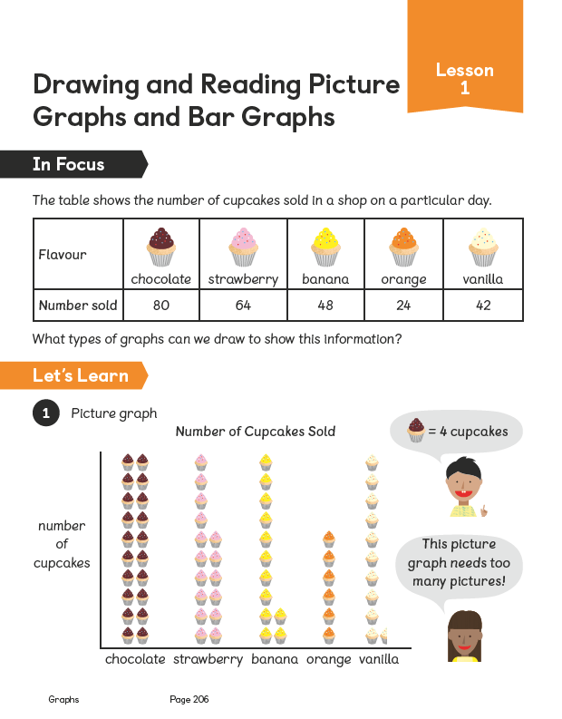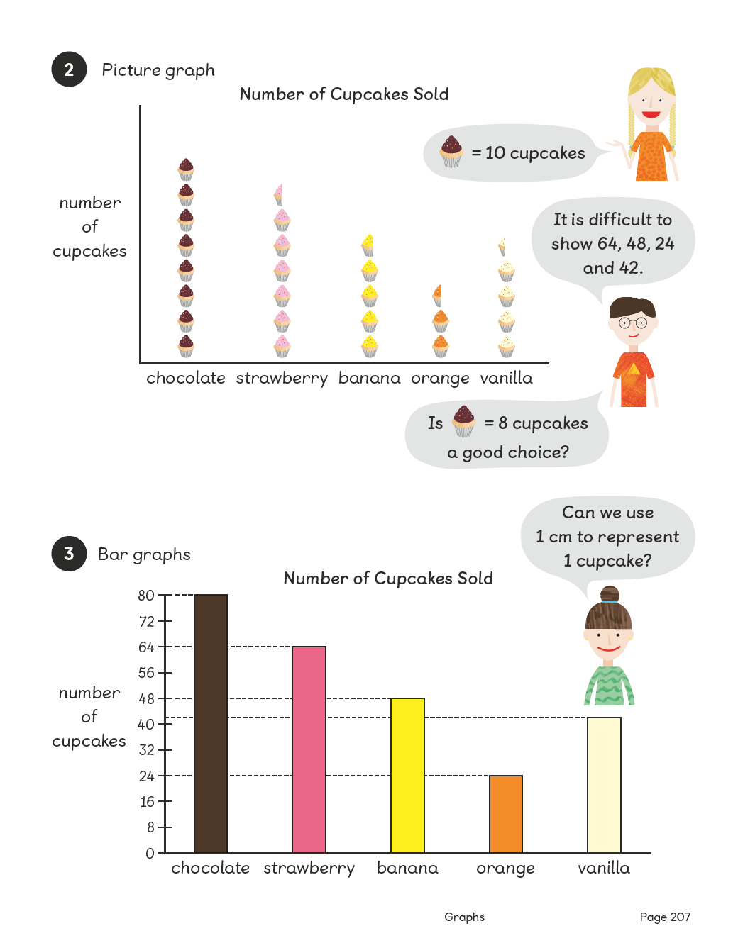
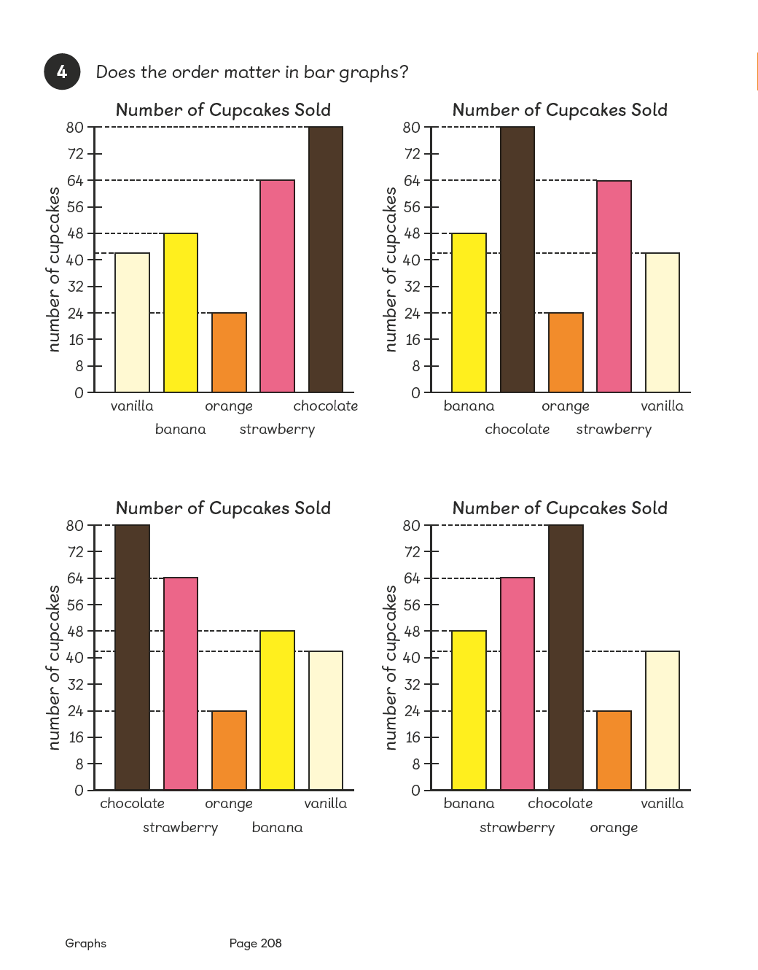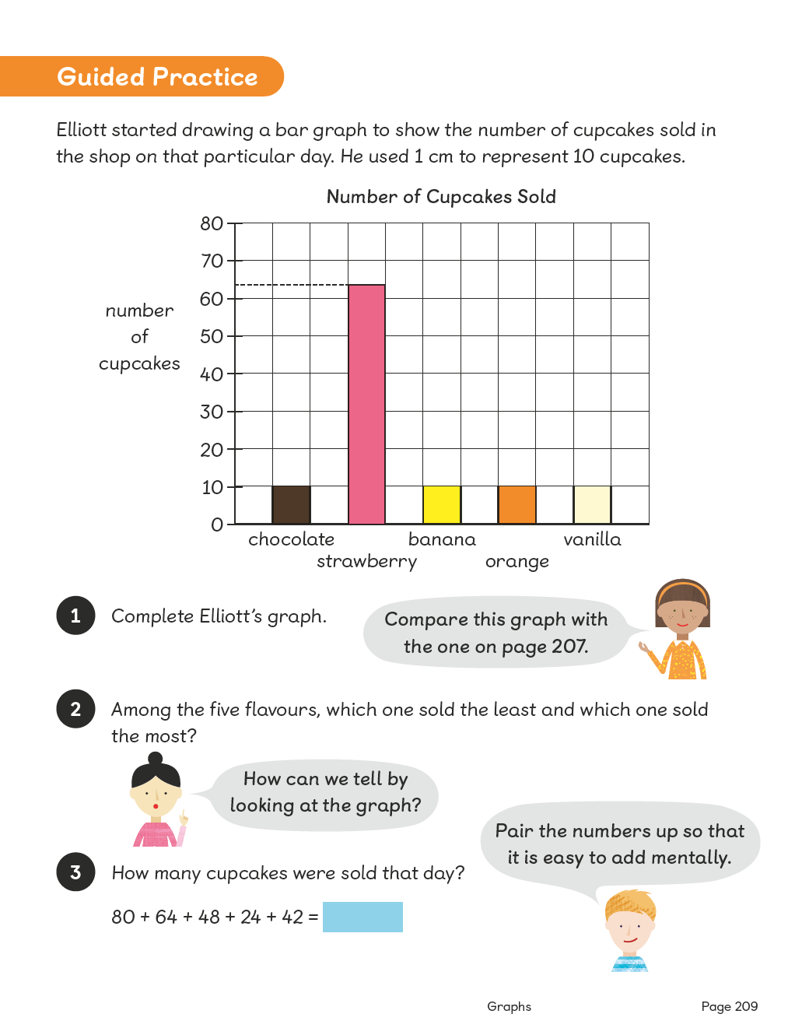
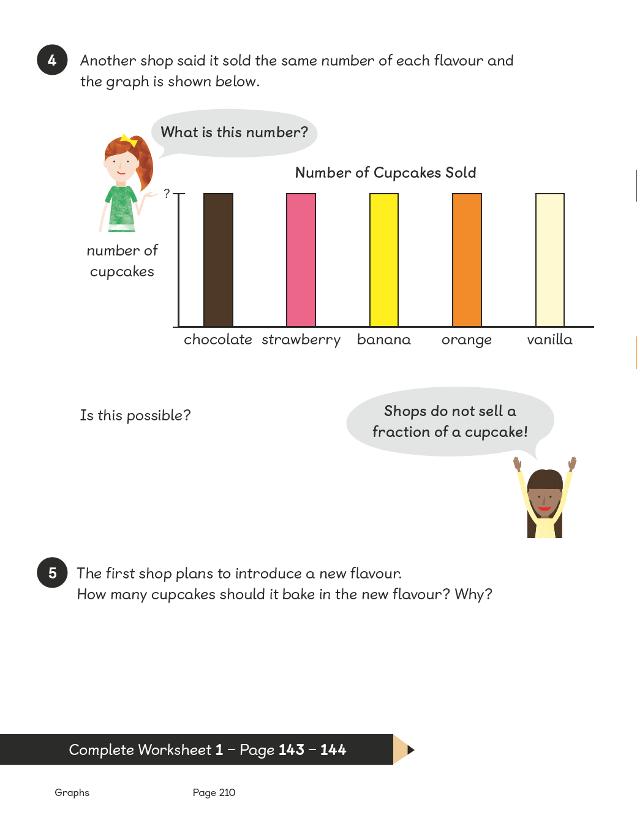
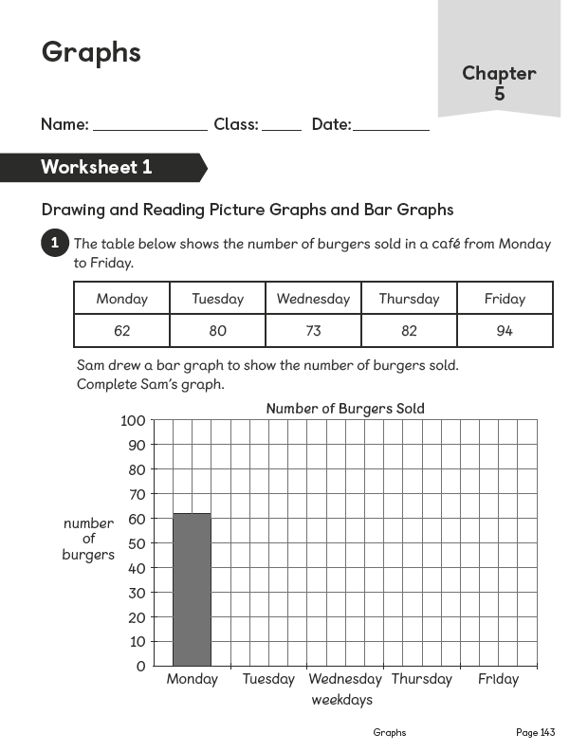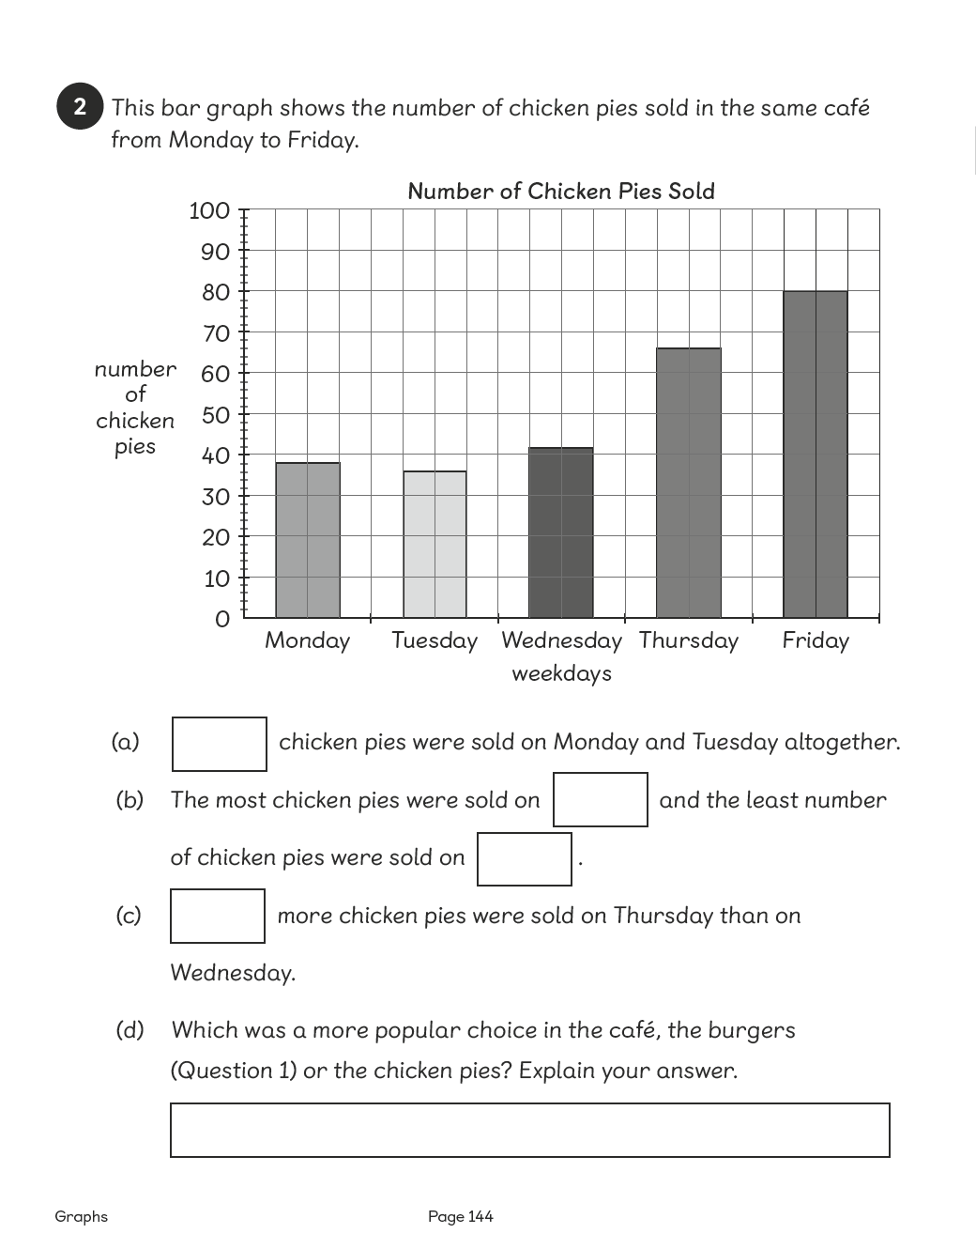

Lesson 2
Top of Form
Drawing and Reading Bar Graphs
Pages 211–213
Lesson Objective
To be able to draw and read bar graphs.
National Curriculum
Interpret and present discrete and continuous data using appropriate graphical methods, including bar charts.
Lesson Approach
To begin this lesson, show pupils the In Focus task and give them time to discuss it with their partners. Invite volunteers to model recording numbers in a table. How can we record this information in a bar graph? What would the scale be and why? Ask pupils to work with their partners and take some feedback. Then display Let's Learn 2 and ask if their graphs are similar or different from this one.
During Guided Practice, pupils are reading and interpreting bar graphs to answer the given questions. Encourage them to work in pairs.
Additional Activity
During Activity Time, pupils work in groups of 4. Provide each group with information pamphlets that include bar graphs and tables; a financial newspaper would be good for this. Pupils look for charts, graphs and scales from the given materials and create information/story posters. Then the groups present their work to the rest of the class.
Misconceptions
Pupils choose inappropriate scales to measure values.
Pupils read values in between scales inaccurately.
Formative Assessment
Pupils can represent data from a table in a bar graph.
Pupils can select an appropriate value scale based on the data.
Pupils can use concrete materials to create a bar graph.
Pupils can use and interpret pictorial representations of data in a bar graph.
Pupils can determine the most effective way to present a given set of data.
Pupils can label the axes on a bar graph.
Pupils can present data accurately on a bar graph.
Pupils can compare data from one bar graph with another.
Non-negotiables
Pupils can create a bar graph from a set of data.
Pupils can interpret data and determine simple information from a graph, such as largest/greatest/the most and smallest amounts and difference.
Variation
Example 1: Reading a bar graph to determine the highest marks.
Example 2: Reading a bar graph to determine the lowest marks.
Example 3: Looking for the difference between the highest and the lowest marks.
Example 4: Changing or using the current scale to look for 1/2 on the scale.
Example 5: Calculating the difference between current (as shown in the graph) and possible future marks (additional information given in the question).
Example 6: Interpreting and comparing data on two separate graphs with similar scales.
Resources
Sugar paper (between four)
Markers (between four)
Newspapers (between four)

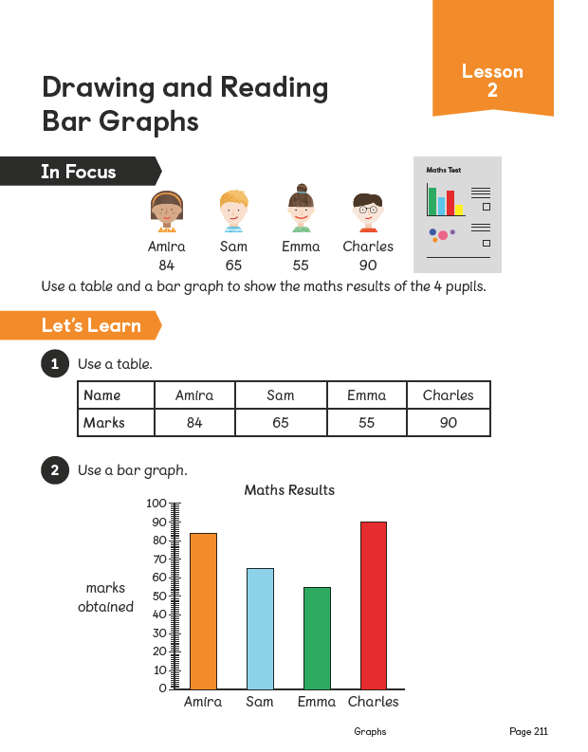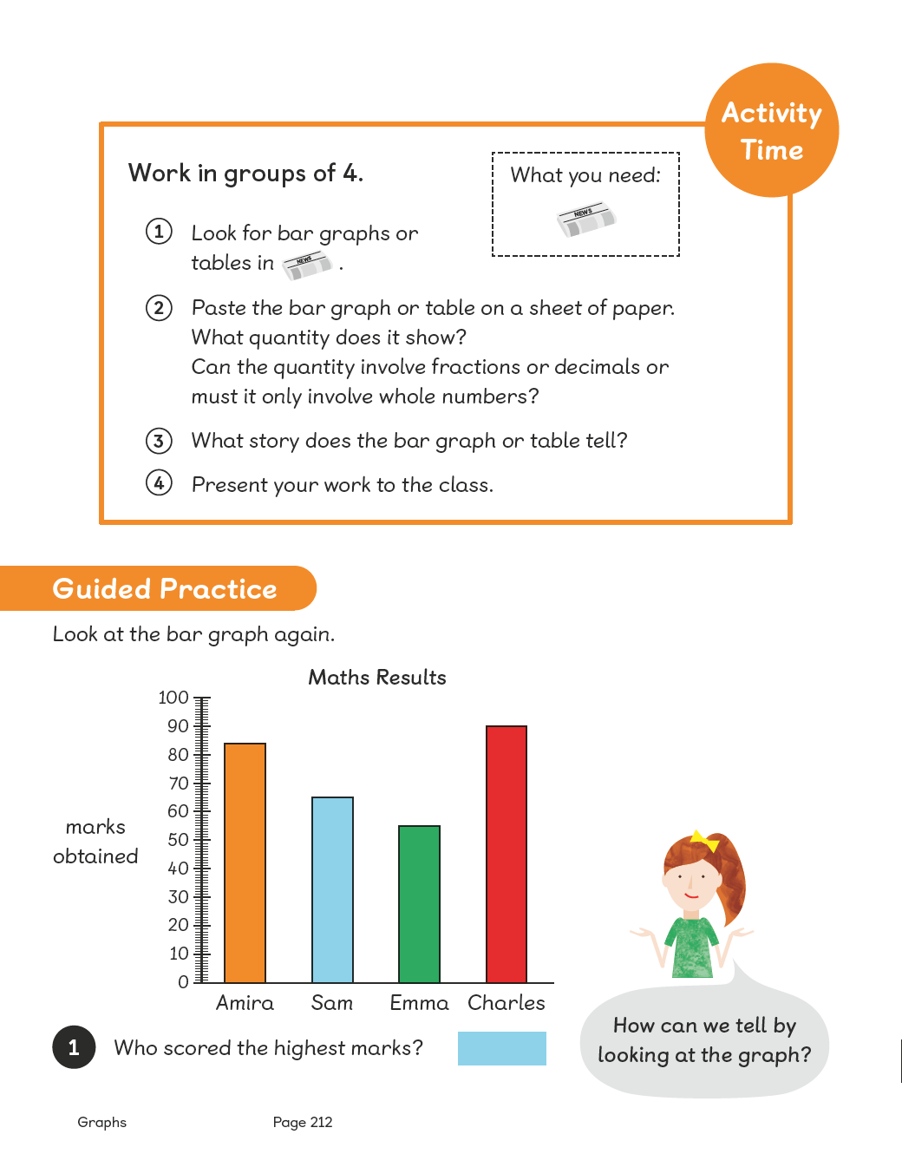
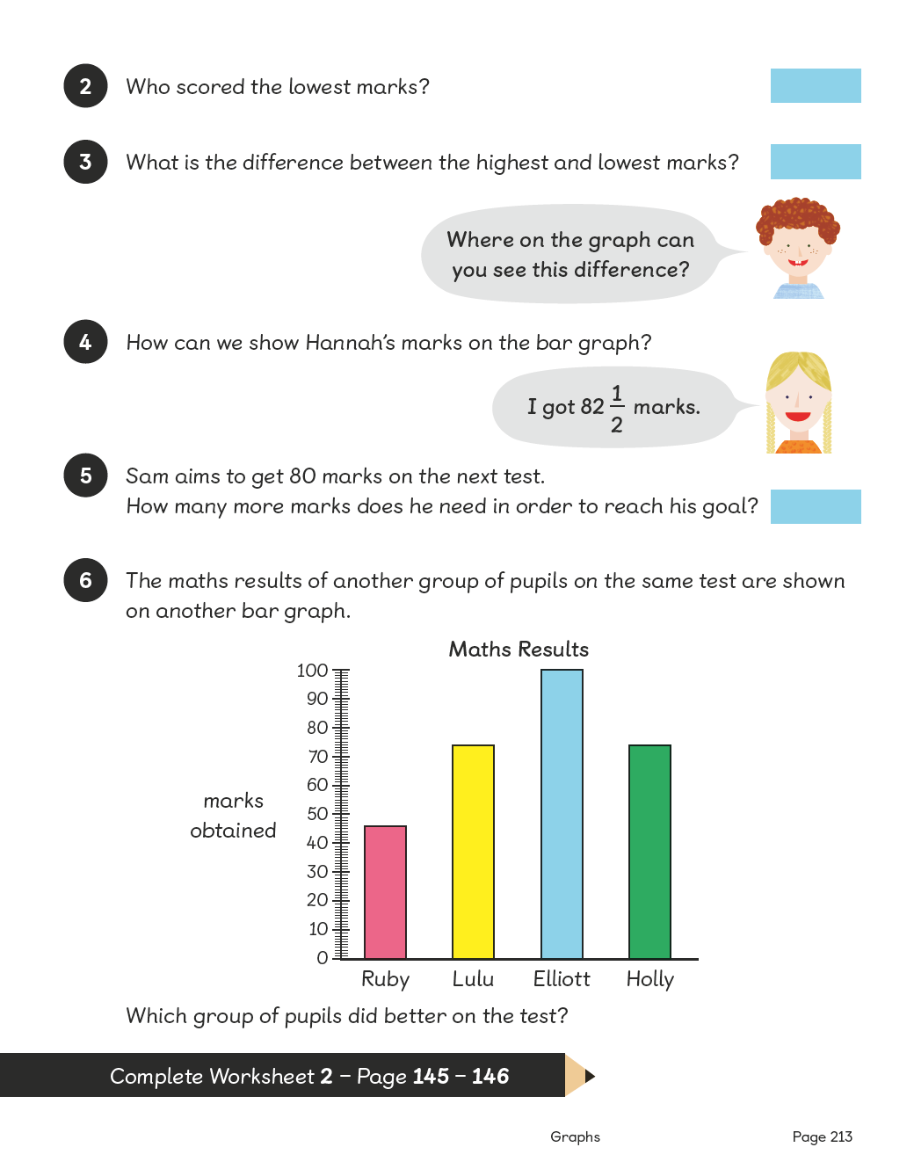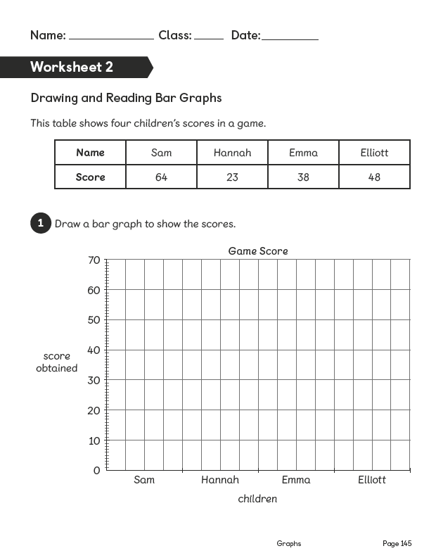
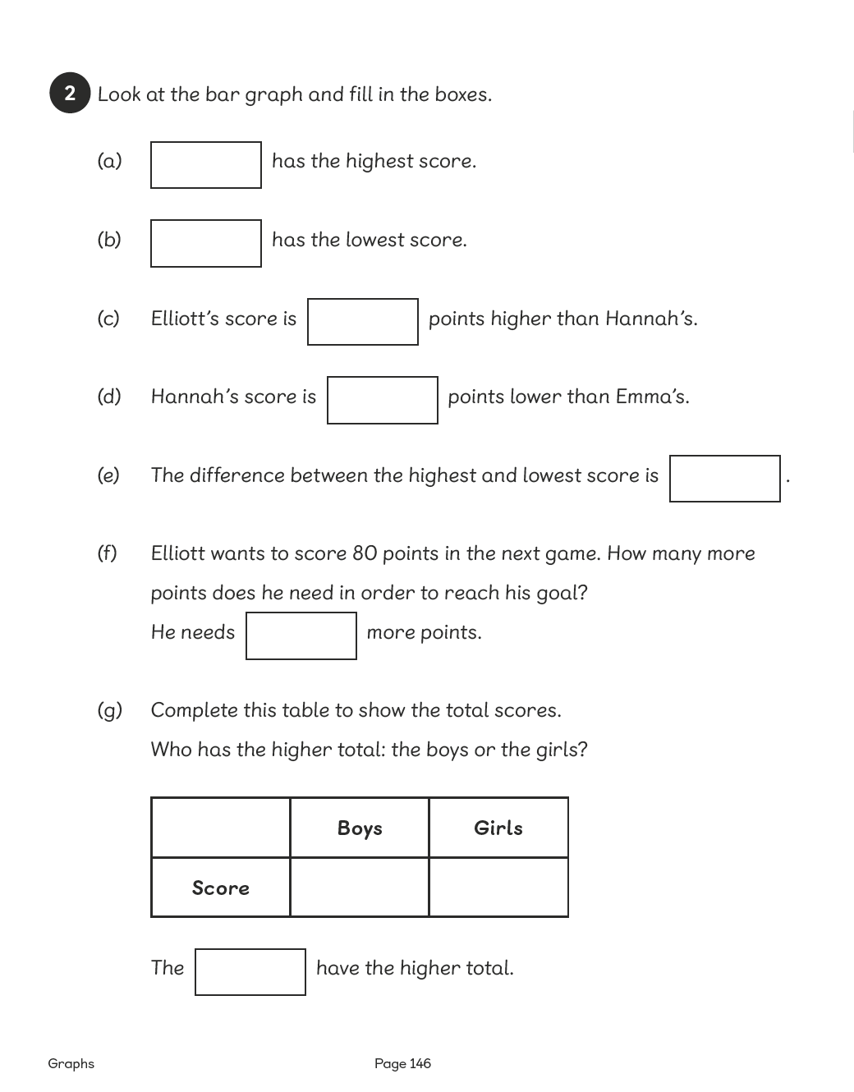

Lesson 3
Top of Form
Drawing and Reading Line Graphs
Pages 214–216
Lesson Objective
To be able to draw and read line graphs.
National Curriculum
Interpret and present discrete and continuous data using appropriate graphical methods, including bar charts.
Lesson Approach
To begin this lesson, show pupils the In Focus task and give them time to discuss in pairs what the information in the table shows. What statements can be made about the entrance fee over the years? Why has that happened? Can we represent this information in a different way? Would a bar graph be helpful? Why or why not? What would the scale on the y axis be?
Work through Let's Learn 1 and 2. Discuss what a line graph is and why we use it. What trends or patterns can you see straight away on the line graph? Then discuss the problems with the scale in Let's Learn 3. Why is it incorrect? Does it matter? Why does it matter? What do you think will happen to the fee in 2015? How do you know? What about for 2010? How do you know?
Introduce Guided Practice and highlight the importance of equal steps on a scale. Discuss answers as a class after pupils have completed the questions.
Misconceptions
Pupils order the information inappropriately or ineffectively.
Pupils create inconsistencies in the scale.
Pupils read values in between scales inaccurately.
Formative Assessment
Pupils can represent data from a table in a bar graph.
Pupils can select an appropriate value scale based on the data.
Pupils can use and interpret pictorial representations of data in a bar graph.
Pupils can determine the most effective way to present a given set of data.
Pupils can label the axes on a graph.
Pupils can present data accurately on a graph.
Pupils can compare data from one graph with another.
Pupils can create a line graph based on information in a bar graph.
Pupils can interpret the data from a line graph to show change over time.
Non-negotiables
Pupils can create a line graph from a set of data.
Pupils can determine simple information from the graph, such as change over time and the trend.
Variation
Example 1: Finding a data point on a line graph, which requires matching the data point on the two axes.
Example 2: Determining difference/change in price by either reading the difference directly from the graph or subtracting the two readings.
Example 3: Finding errors in data and presentation, which requires checking the year intervals.
Resources
No additional resources required for this lesson.
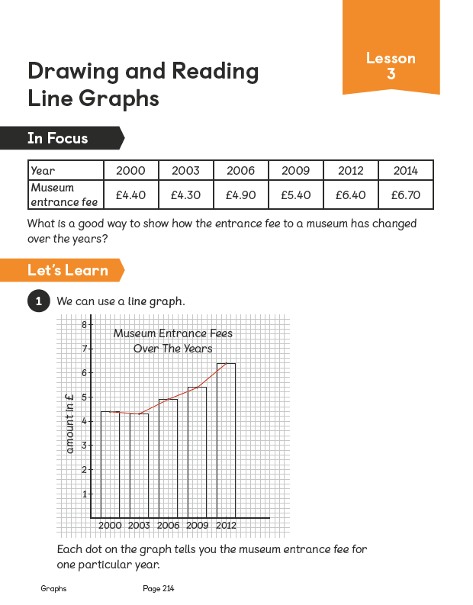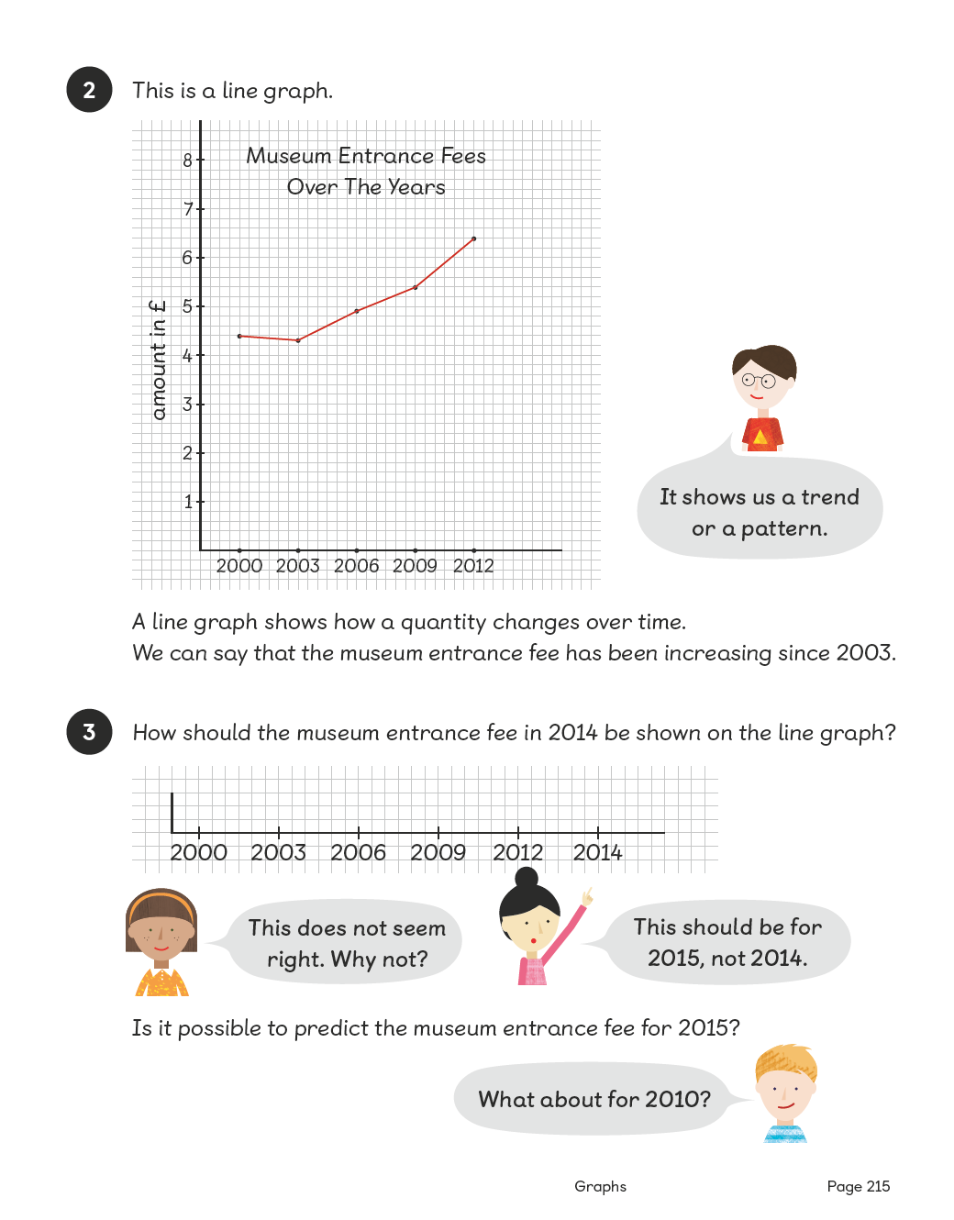
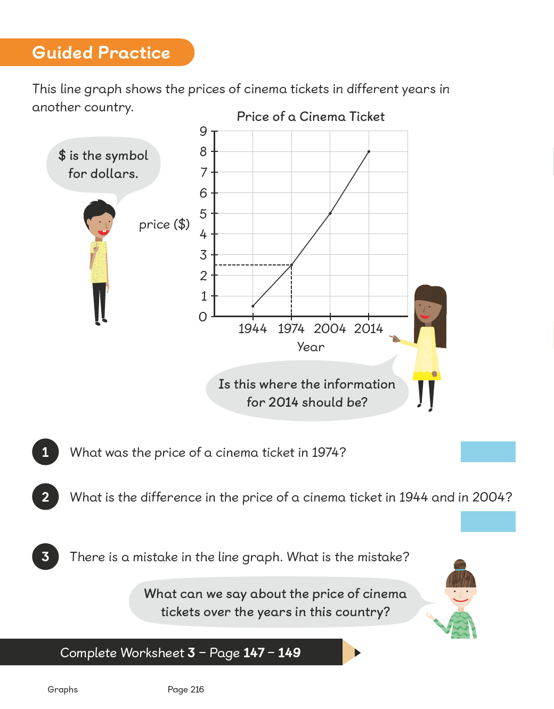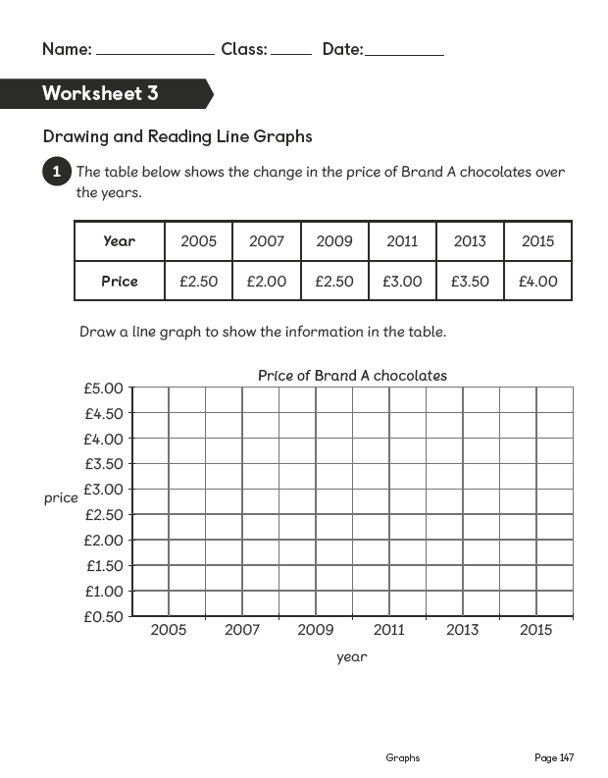
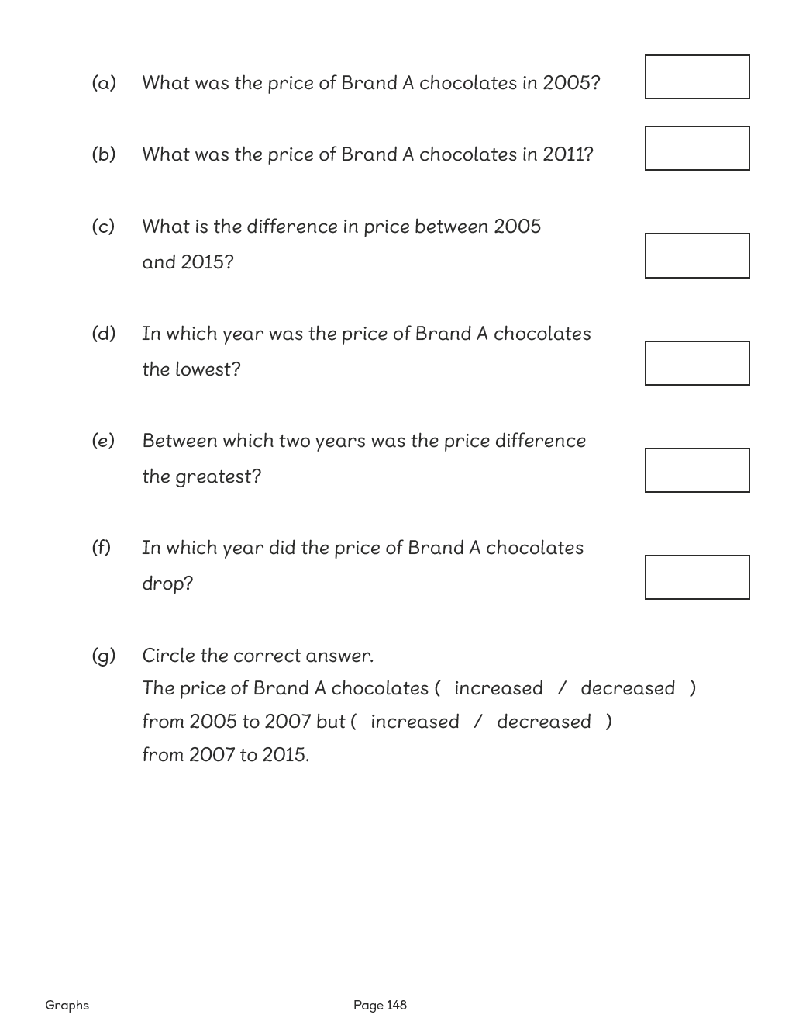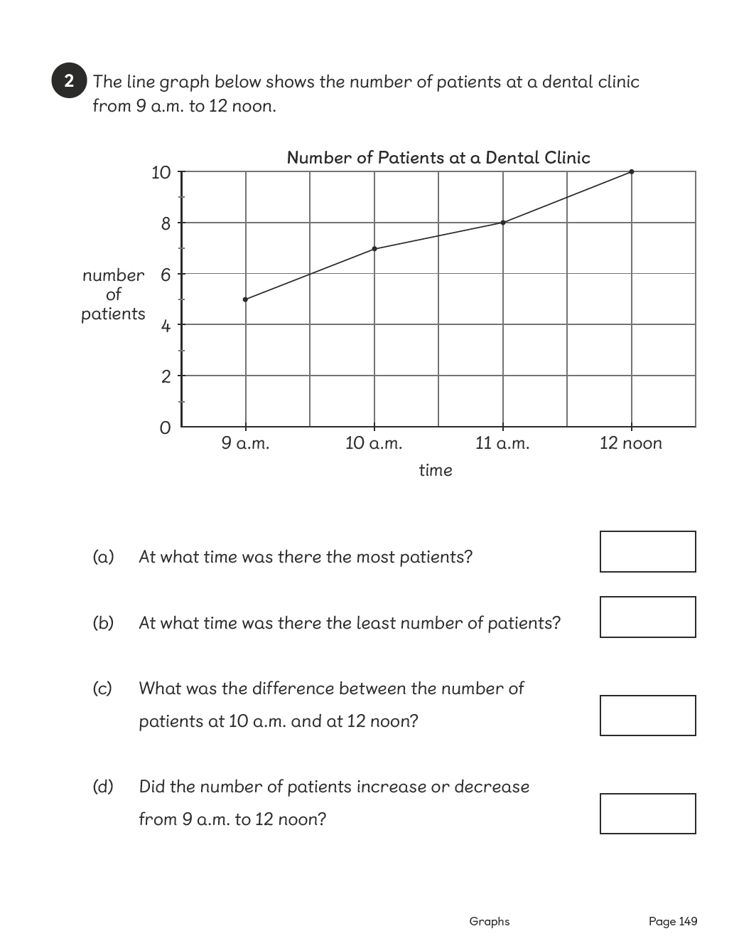

Lesson 4
Top of Form
Drawing and Reading Line Graphs
Pages 217–218
Lesson Objective
To be able to draw and read line graphs.
National Curriculum
Interpret and present discrete and continuous data using appropriate graphical methods, including bar charts.
Lesson Approach
To begin this lesson, recap on learning from the previous lesson on line graphs. Reiterate that a line graph shows a trend in data over a period of time. Then show pupils the In Focus task and give them time to discuss it in pairs. Can we draw a line graph for this data? How do you know? How would you organise the information before drawing the graph?
Invite a volunteer to construct a table with the information. What information would you put in the columns? What time would you assign to the start of the experiment and why? Now we have organised our information, what do we do next? How should we label the axes?
Model plotting the graph from class suggestions. What trends are clear from the data? Is it as you would expect? Why or why not? What was the approximate temperature of the water after 15 minutes? After how many minutes was the temperature at 20 ºC? Ensure that pupils are able to interpret and read data from the graph to answer these questions.
During Guided Practice, pupils are reading and interpreting a line graph to answer the given questions.
Misconceptions
Pupils order the information inappropriately or ineffectively.
Pupils create inconsistencies in the scale.
Pupils read values in between scales inaccurately.
Formative Assessment
Pupils can represent data from a table in a line graph.
Pupils can select an appropriate value scale based on the data.
Pupils can use and interpret pictorial representations of data in a line graph.
Pupils can determine the most effective way to present a given set of data.
Pupils can label the axes on a graph.
Pupils can present data accurately on a graph.
Pupils can compare data from one graph with another.
Pupils can create a line graph based on data from a table.
Pupils can interpret the data from a line graph to show change over time.
Non-negotiables
Pupils can create a line graph from a set of data.
Pupils can determine simple information from the graph, such as change over time, the trend and a specific data point.
Variation
Example 1: Finding a data point – the start of the experiment.
Example 2: Determining the change in temperature after the first 20 minutes and then the next 20 minutes.
Example 3: Identifying trends of change in temperature after 40 minutes.
Example 4: Inferring from the graph, an unknown data.
Resources
No additional resources required for this lesson.
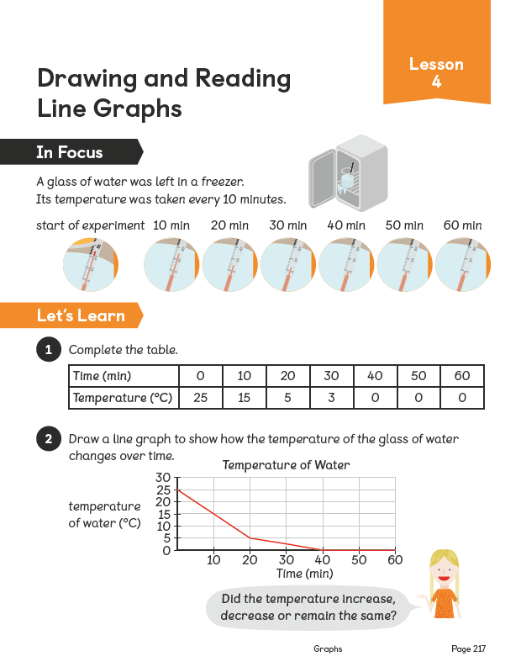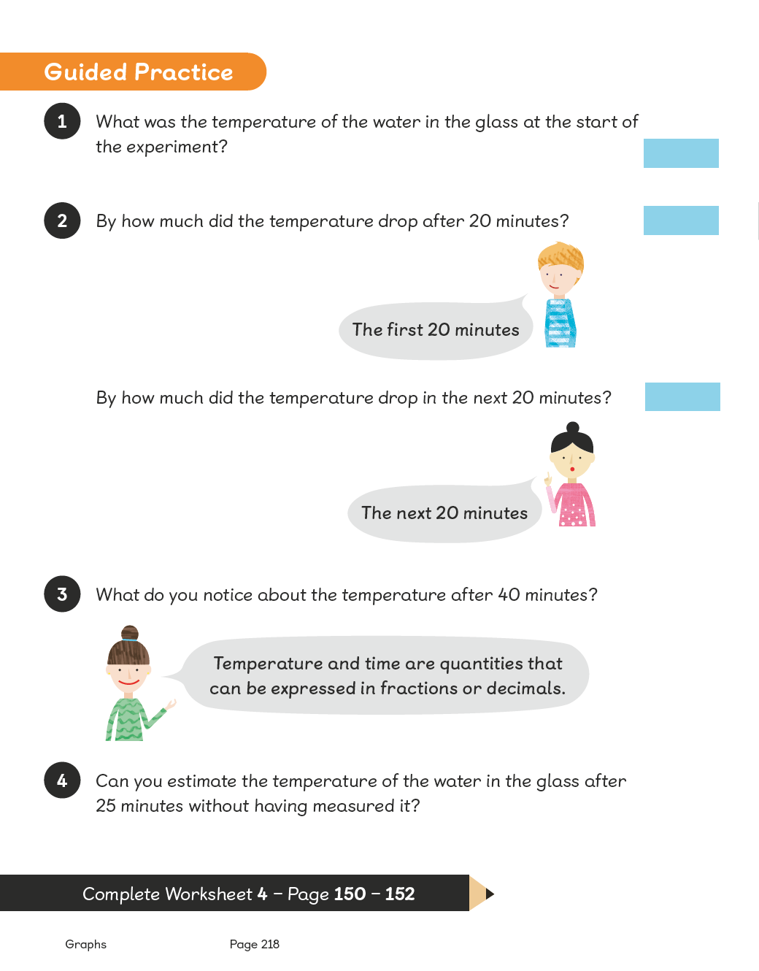
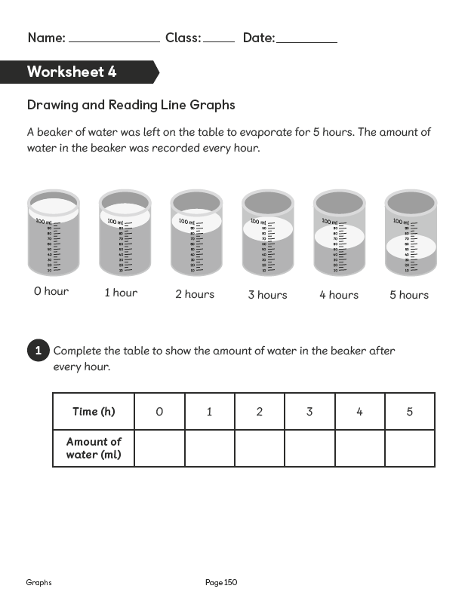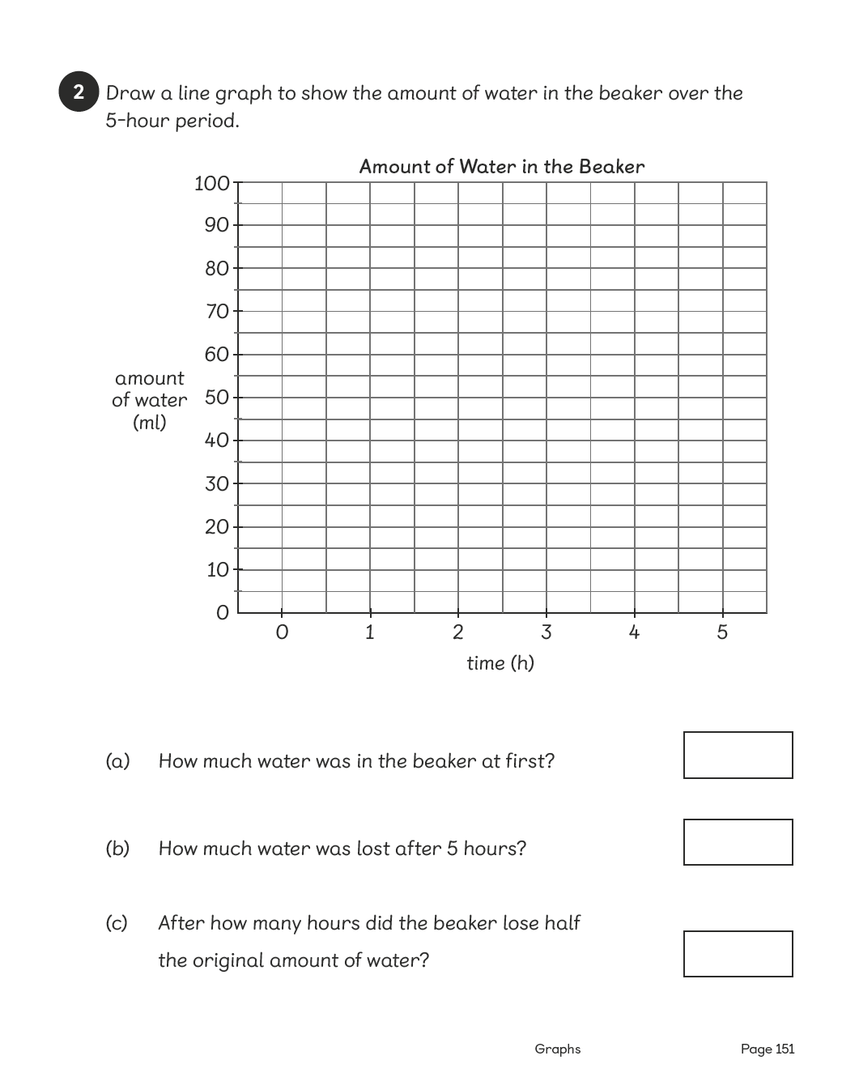
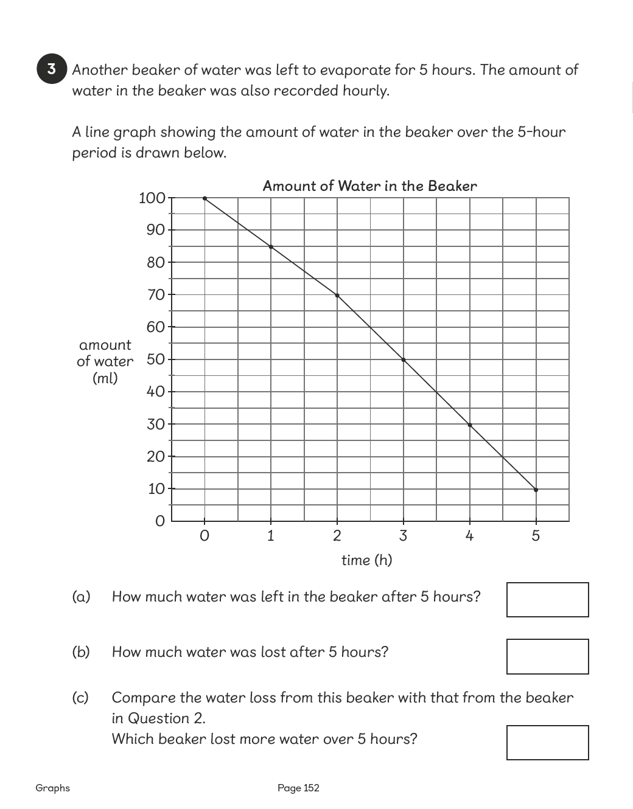

Lesson 5
Top of Form
Drawing and Reading Line Graphs
Pages 219–222
Lesson Objective
To be able to draw and read line graphs.
National Curriculum
Interpret and present discrete and continuous data using appropriate graphical methods, including bar charts. Solve comparison problems using information presented in bar charts.
Lesson Approach
To begin this lesson, allow pupils time to recap on prior learning with partners and then take feedback. When are line graphs useful? Who do you think would use them? Why? Then show the class the In Focus task and give them time to discuss trends, scales and predictions. What level of rainfall in centimetres do you think there was in June? Why? Why was the least amount of rainfall in August? What information would you use to predict what the rainfall will be in September next year?
Display the graph from London for the same period and ask pupils to discuss in pairs what is the same and what is different. Draw out that the scales look different, but they are the same. What makes them look different? Compare rainfall in the same months for the two countries. Ask questions involving difference – 'most' and 'least' amounts – always asking for evidence from the graph.
Complete the table in Let's Learn using the data from the two graphs. Encourage pupils to make general statements using the information available. After Activity Time, discuss with the class when to use line graphs and bar graphs.
During Guided Practice, pupils are drawing two line graphs and then interpreting the information to answer the given questions.

Watch the Film
Additional Activity
Distribute tablets or laptops to groups of 4 and guide pupils on how to enter the information provided into a spreadsheet. Pupils create a bar graph and a line graph with the information entered and decide on the best graph to present the information. They repeat this process with another set of data.
Misconceptions
Pupils order the information inappropriately or ineffectively.
Pupils create inconsistencies in the scale.
Pupils read values in between scales inaccurately.
Formative Assessment
Pupils can represent data from a table in a line graph.
Pupils can select an appropriate value scale based on the data.
Pupils can use and interpret pictorial representations of data in a line graph.
Pupils can determine the most effective way to present a given set of data.
Pupils can label the axes on a graph.
Pupils can present data accurately on a graph.
Pupils can compare data from one graph with another.
Pupils can create a line graph based on data from a table.
Pupils can interpret the data from a line graph to show change over time.
Pupils can predict future data based on the line graph.
Pupils can represent more than one set of information on a line graph.
Non-negotiables
Pupils can create a line graph from a set of data.
Pupils can determine simple information from the graph, such as change over time, the trend and a specific data point.
Variation
Drawing two line graphs on the same grid for comparison.
Example 1: Finding the difference between two lines of data at a specific data point (month of August).
Example 2: Finding specific information about difference – the greatest difference in rainfall between the two countries.
Resources
Laptop/tablet with spreadsheet software (between four)

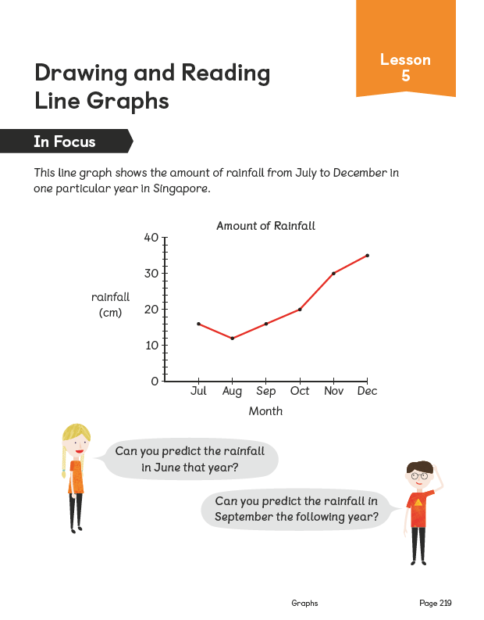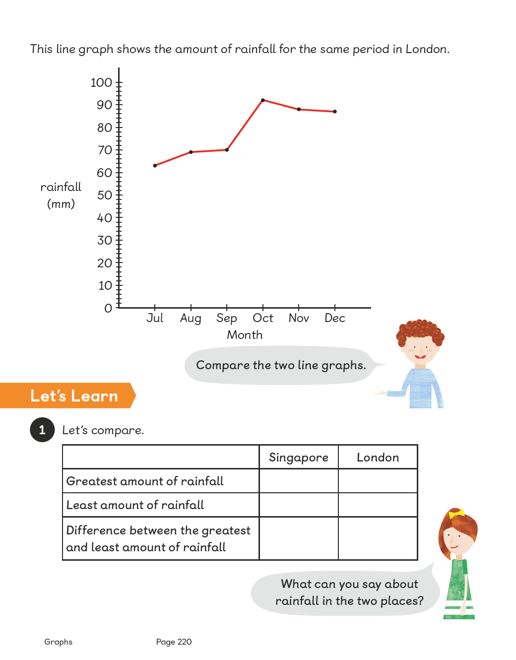
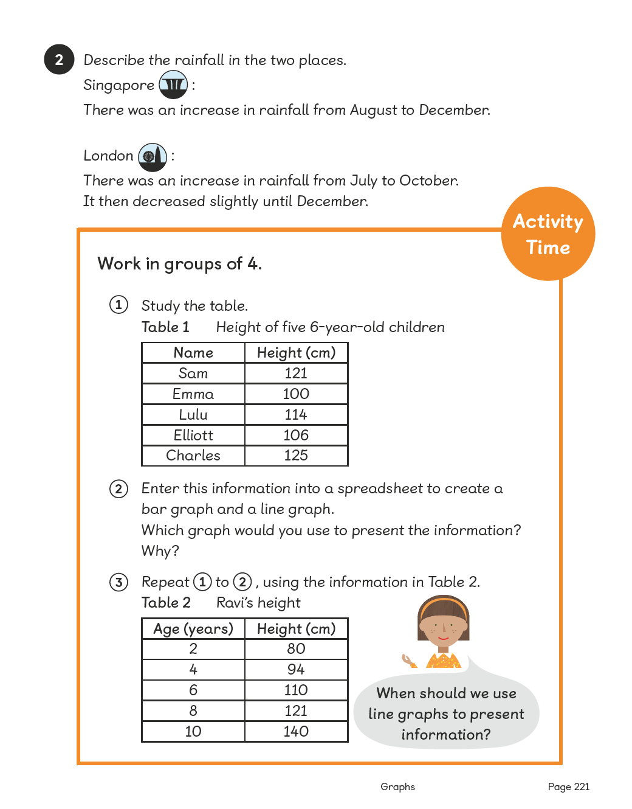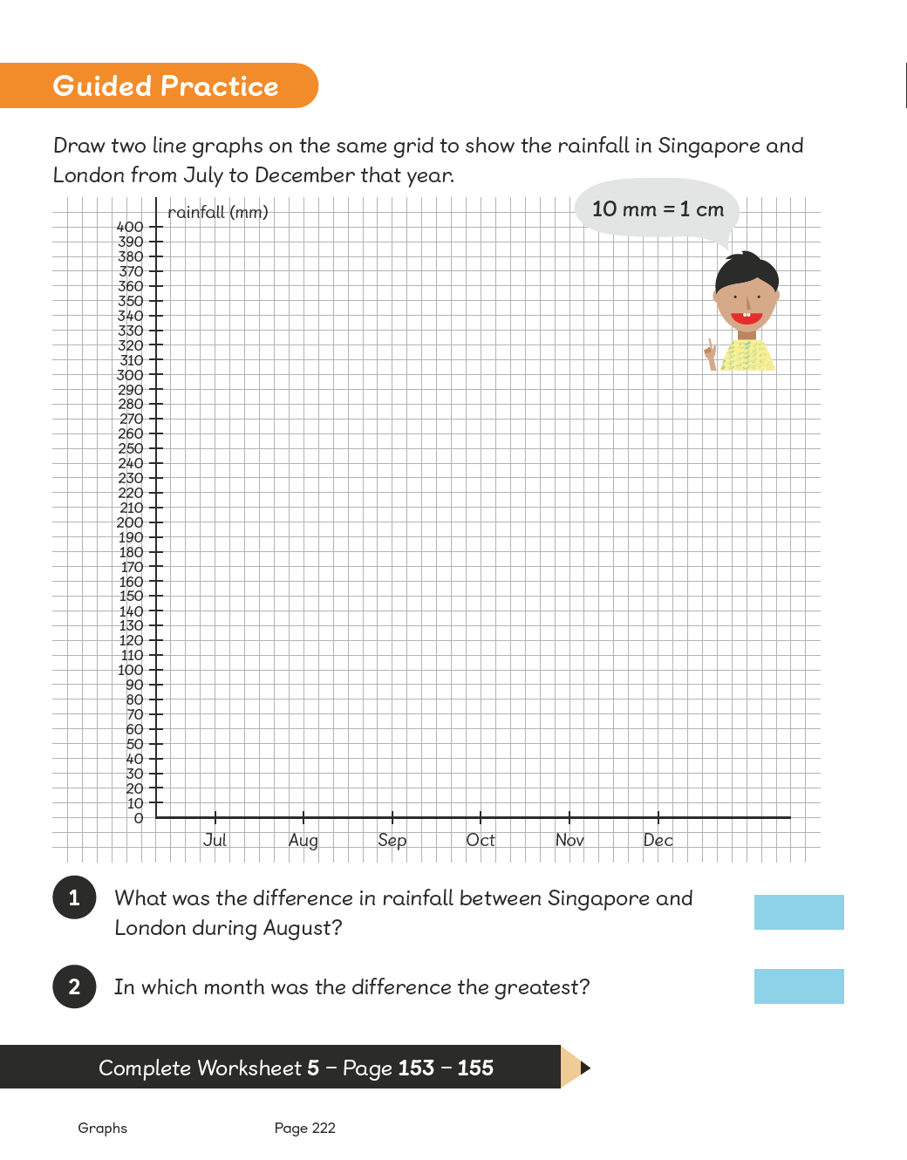
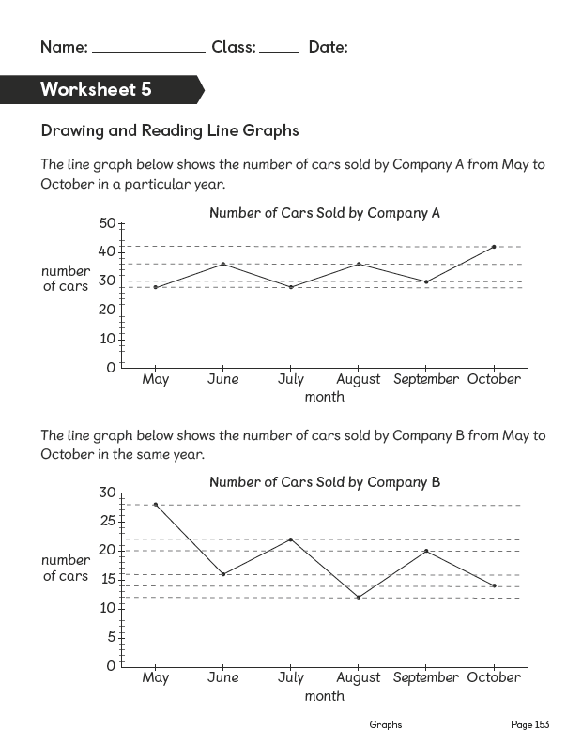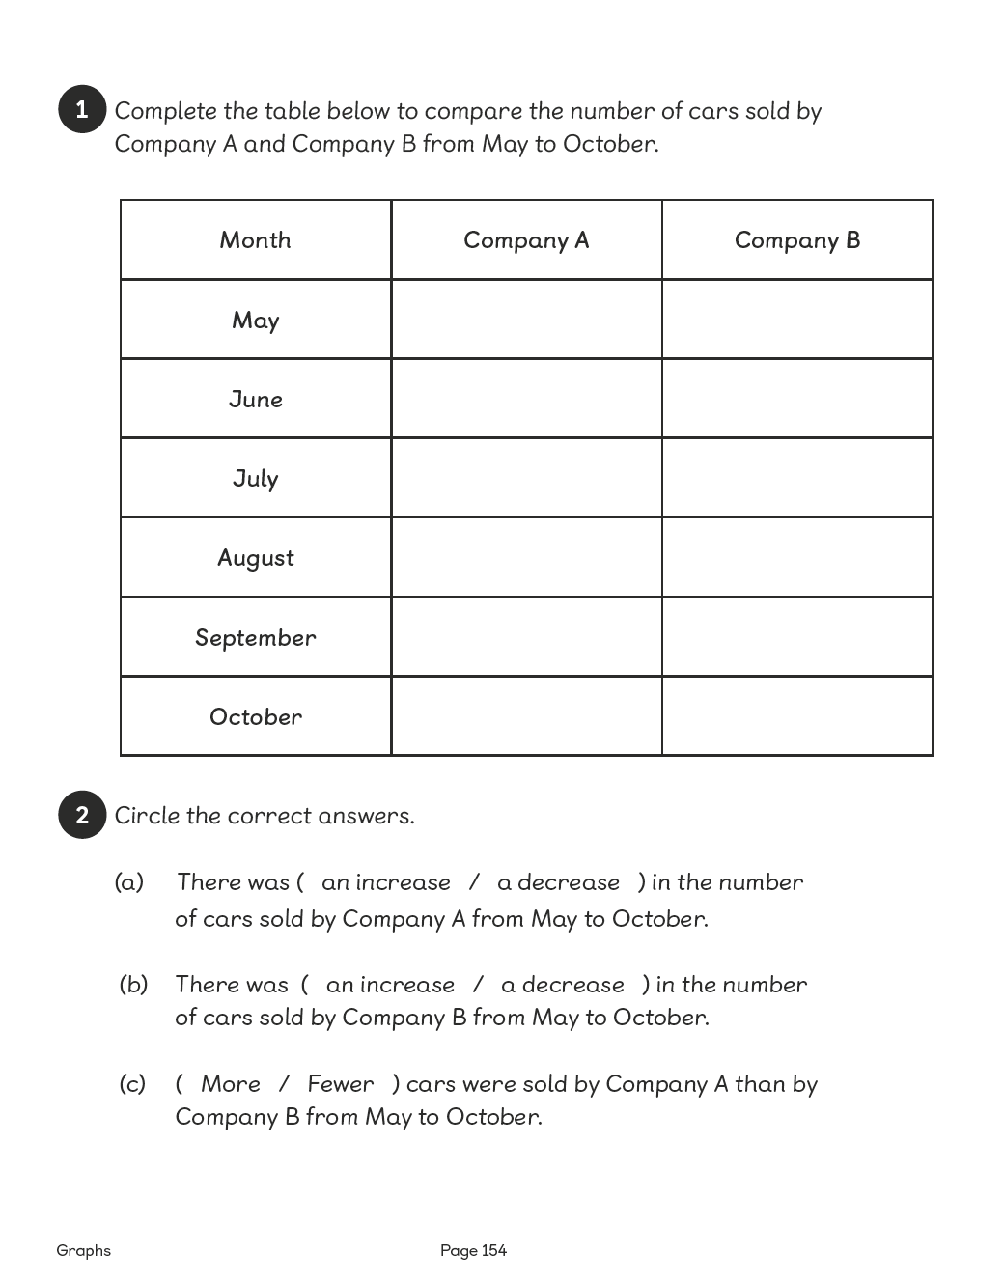
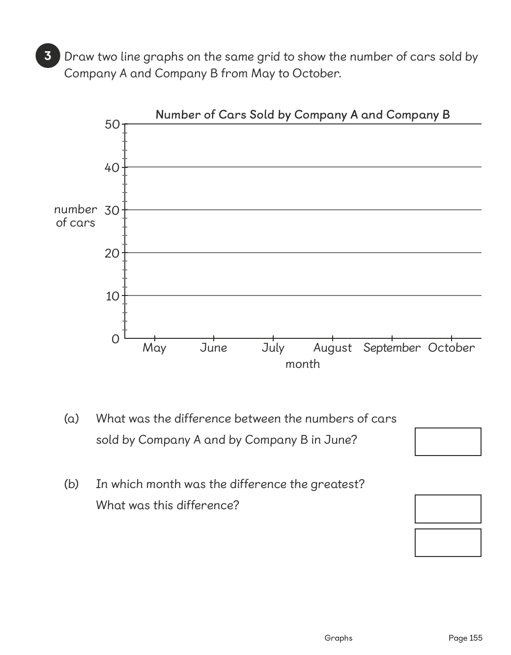

Lesson 6
Top of Form
Chapter Consolidation
Pages 223–224
Lesson Objective
To be able to use knowledge of graphs to solve problems.
Lesson Approach
Mind Workout
Pupils complete the tasks and explain their thinking and reasoning to their partners.
Maths Journal
Pupils use the data in the given table to answer the question and draw a line graph to explain their answer.
Self Check
Pupils complete this as a chapter summary and discuss what to do with their teacher if any boxes are not ticked.
Bottom of Form

