Chapter 6

Chapter Details
Chapter title: Fractions
Start page: 225
Number of lessons: 14
Chapter description:
In this chapter pupils will be introduced to hundredths. They will learn about mixed number fractions and improper fractions. They will learn how to convert between mixed numbers and improper fractions. They will learn how to add and subtract fractions and will solve addition and subtraction word problems.
Resources
0; 1; 3; 5 and 8 digit cards (between two)
Blank 100-square
Blank number line (increments marked)
Blank number lines (increments marked)
Fraction cards (between two)
Six-sided dice

Textbook 4A
Chapter 6 – Fractions

Lesson 1 – Counting in Hundredths
To be able to count in hundredths.

Lesson 2 – Writing Mixed Numbers
To be able to write mixed numbers.

Lesson 3 – Showing Mixed Numbers on a Number Line
To be able to show mixed numbers on a number line.

Lesson 4 – Finding Equivalent Fractions
To find equivalent fractions.

Lesson 5 – Finding Equivalent Fractions
To be able to find equivalent fractions (further practise).

Lesson 6 – Simplifying Mixed Numbers
To be able to simplify mixed numbers.

Lesson 7 – Simplifying Improper Fractions
To be able to simplify improper fractions.

Lesson 8 – Adding Fractions
To be able to add fractions with the same denominator.

Lesson 9 – Adding Fractions
To be able to add fractions with the same denominator and record answers as mixed numbers.

Lesson 10 – Adding Fractions
To be able to add fractions with the same denominator and record the answers in the simplest form.

Lesson 11 – Subtracting Fractions
To be able to subtract a fraction from a whole number.

Lesson 12 – Subtracting Fractions
To be able to subtract a fraction from a mixed number.

Lesson 13 – Solving Word Problems
To be able to solve word problems involving fractions.

Lesson 14 – Chapter Consolidation
To be able to use knowledge of fractions to solve problems.

Lesson 1
Top of Form
Counting in Hundredths
Pages 226–228
Lesson Objective
To be able to count in hundredths.
National Curriculum
Count up and down in hundredths; recognise that hundredths arise when dividing an object by 100 and by dividing tenths by 10.
Lesson Approach
To begin this lesson, ask pupils what they already know about fractions. Display the term 'hundredth' and ask them what they think it means. Allow time for partner discussion and take feedback. Then show pupils the In Focus task and give them time to discuss it in pairs.
Display the image from Let's Learn 1 and count along the number line in hundredths. How many hundredths would there be in a whole? How many hundredths would be half way? What about a quarter of the way? What fraction is equivalent? Work through Let's Learn 2 to 4 asking questions such as: How many hundredths are ___ chocolates worth? How many hundredths are left?
Display Let's Learn 5 and 6. Ask pupils to count in hundredths forwards and backwards to complete the number lines.
During Guided Practice, pupils are determining hundredths from pictures, and completing a number line and number patterns in hundredths. Discuss the questions as a class before pupils complete it in pairs.
Misconceptions
Pupils see one item as a whole rather than one piece of 100 that makes up the whole.
Formative Assessment
Pupils can count to 100.
Pupils can use concrete materials to count to 100 in groups of 2, 5, 10.
Pupils can use pictorial representations to help count to 100 in efficient ways.
Pupils can use a number line to represent hundredths.
Pupils can count forwards in hundredths.
Pupils can count backwards in hundredths.
Pupils can see hundredths as numbers between whole numbers.
Pupils can determine hundredths from a picture and on a number line.
Pupils can see hundredths in a number pattern.
Non-negotiables
Pupils can use pictorial representations to determine hundredths from a picture.
Pupils can use a number line to determine hundredths.
Pupils can count forwards and backwards in hundredths with the help of concrete materials or a number line.
Variation
Example 1: Determining hundredths from a picture.
Example 2: Completing a number line starting from zero where every second hundredth is missing for the first 5 hundredths.
Example 3: Completing number patterns of hundredths, forwards and backwards, from unconventional starting points.
Resources
Blank number line (increments marked)
Blank 100-square

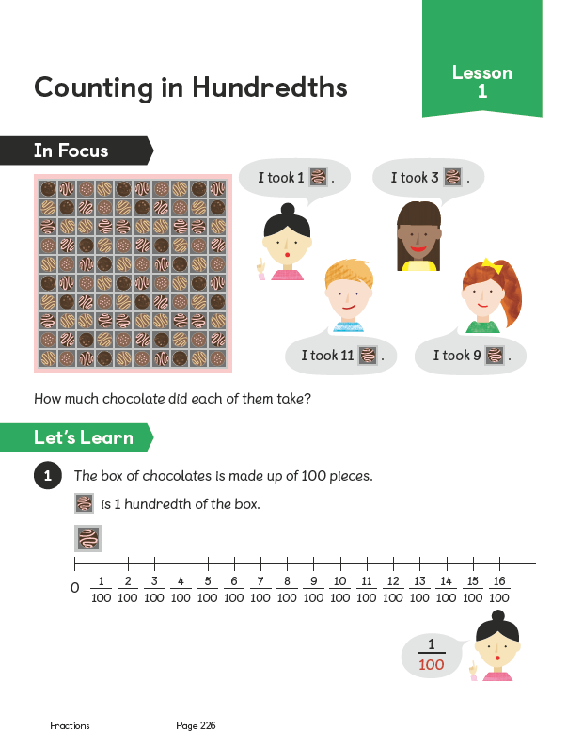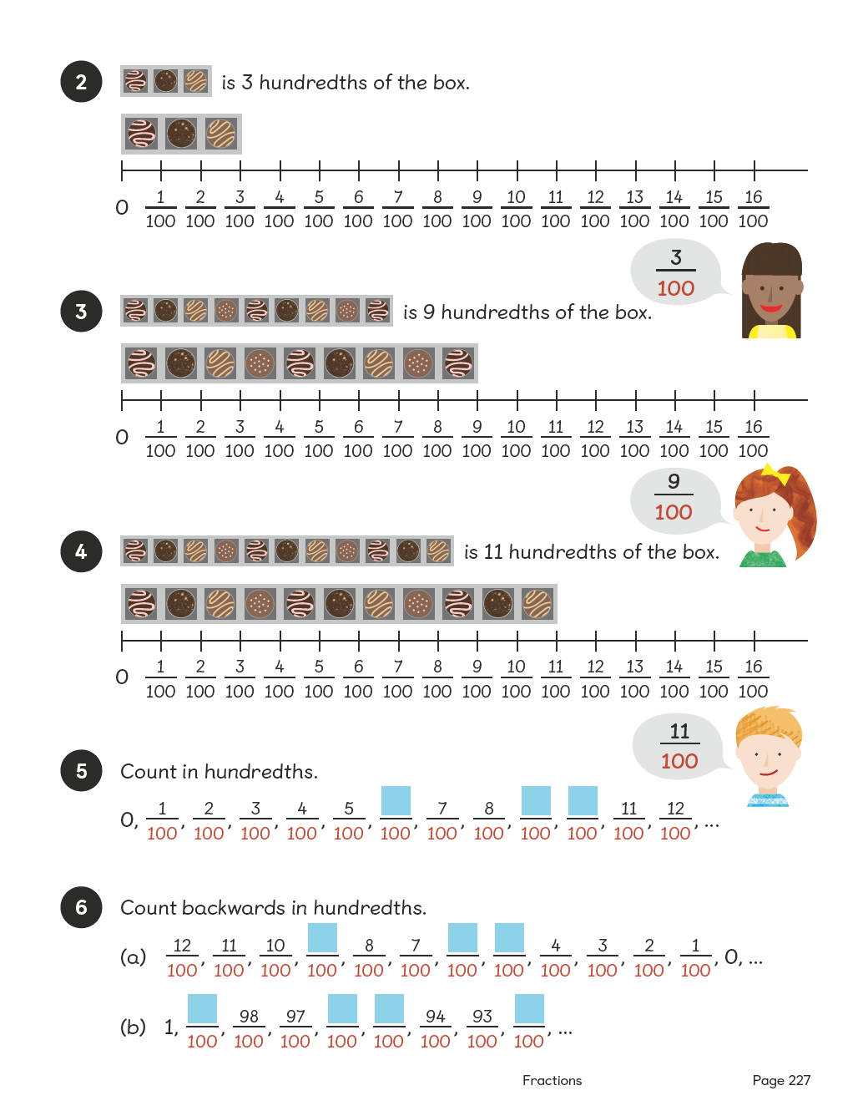
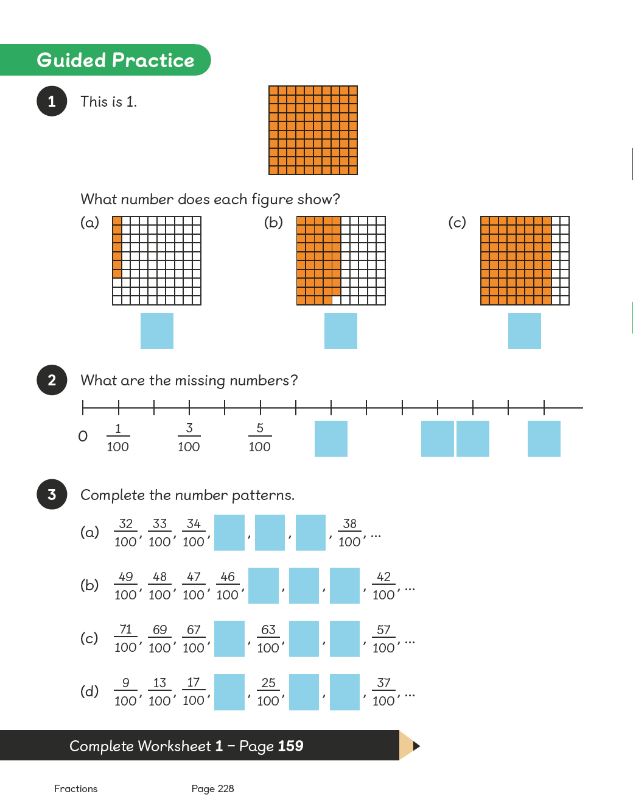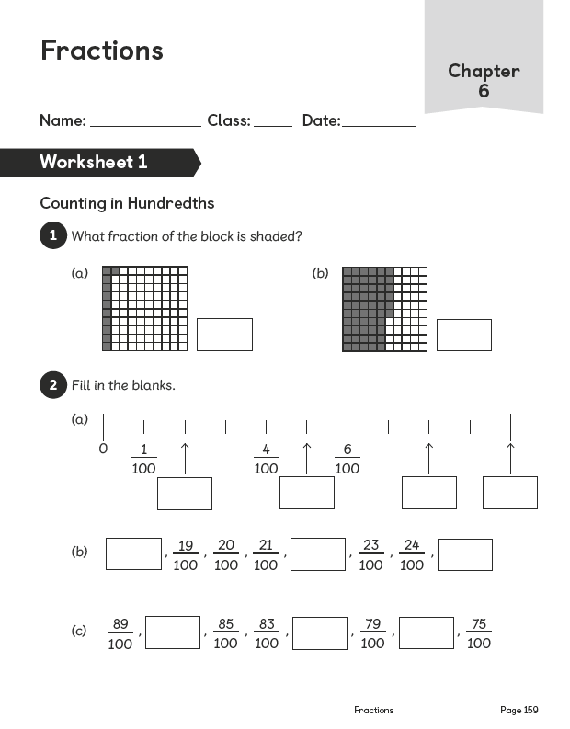

Lesson 2
Top of Form
Writing Mixed Numbers
Pages 229–231
Lesson Objective
To be able to write mixed numbers.
National Curriculum
Solve problems involving increasingly harder fractions to calculate quantities, and fractions to divide quantities, including non-unit fractions where the answer is a whole number.
Lesson Approach
To begin this lesson, ask the class what fractions they already know and what they know about fractions. You could note down the responses on the learning wall to revisit at the end of the chapter and add learning in a different colour.
In the last lesson, when we counted in hundredths, how did it sound? i.e. one hundredth, two hundredths, three hundredths, etc. How can we count in halves, quarters, etc.? Give pupils time to discuss this in pairs and then take feedback.
Display the In Focus task and ask pupils to talk to their partners about sixths. How many sixths are equivalent to a whole or one? So, how many sixths would there be in 2 wholes, 3 wholes, etc.? Demonstrate working this out using the guidance in Let's Learn 1. It would be useful to record the fraction as an improper fraction as well as a mixed number to reinforce understanding. Ensure that pupils understand how to record a mixed number fraction to avoid 25/6.
Work through Let's Learn 2 and 3 together. When we are counting in mixed numbers, why do we never say '1 and 6/6' or '2 and 6/6'? Ensure pupils are able to count on in sixths using mixed numbers.
During Guided Practice, pupils are practising writing mixed numbers. Before they begin, allow pupils time to look through and discuss any questions they may have about them.
Misconceptions
Pupils confuse terminology between mixed numbers and improper fractions.
Pupils count the parts and the wholes as having the same value. (For example, looking at the In Focus image, a pupil might say there are 7 cakes.)
Pupils count only the fractional parts and leave out the wholes.
Formative Assessment
Pupils can count in fractions.
Pupils can recognise a whole and recognise parts of a whole.
Pupils can write fractions using numbers.
Pupils can add fractions to whole numbers to form a mixed number.
Pupils can use the term 'mixed number' to represent a number which has a whole number and a fraction.
Pupils can recognise a whole in pictures.
Pupils can represent a whole in pictures.
Pupils can use concrete materials to recognise and represent a whole.
Pupils can recognise parts of a whole in pictures.
Pupils can represent parts of a whole in pictures.
Pupils can recognise mixed numbers in pictures.
Pupils can represent mixed numbers in pictures.
Pupils can use concrete materials to recognise and represent parts of a whole.
Non-negotiables
Pupils can use concrete materials and pictorial representations to recognise and represent mixed numbers.
Pupils can write a mixed number to represent a picture.
Pupils can recognise, in a variety of examples, what constitutes a whole and parts of a whole.
Variation
Example 1: Writing a mixed number from a picture; the whole is not clearly identified.
Example 2: Writing mixed numbers from pictures; the whole has been identified.
Example 3: Writing a mixed number from a picture; the whole and fractional parts have not been identified.
Resources
No additional resources required for this lesson.
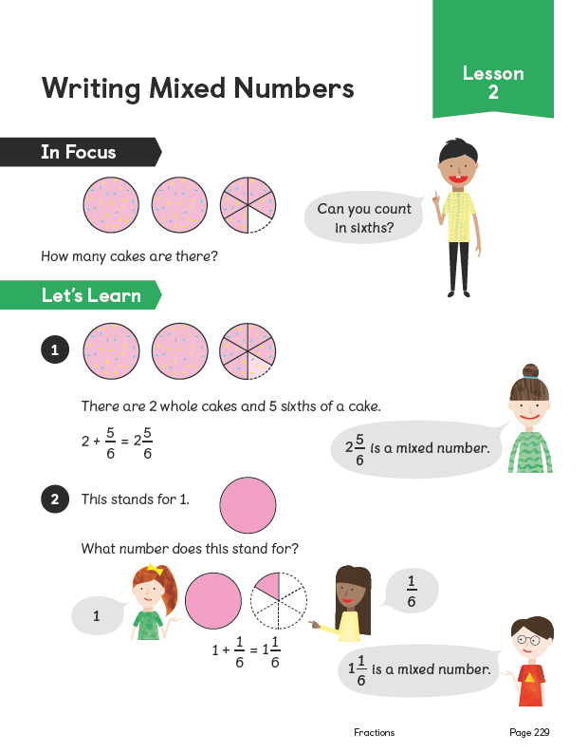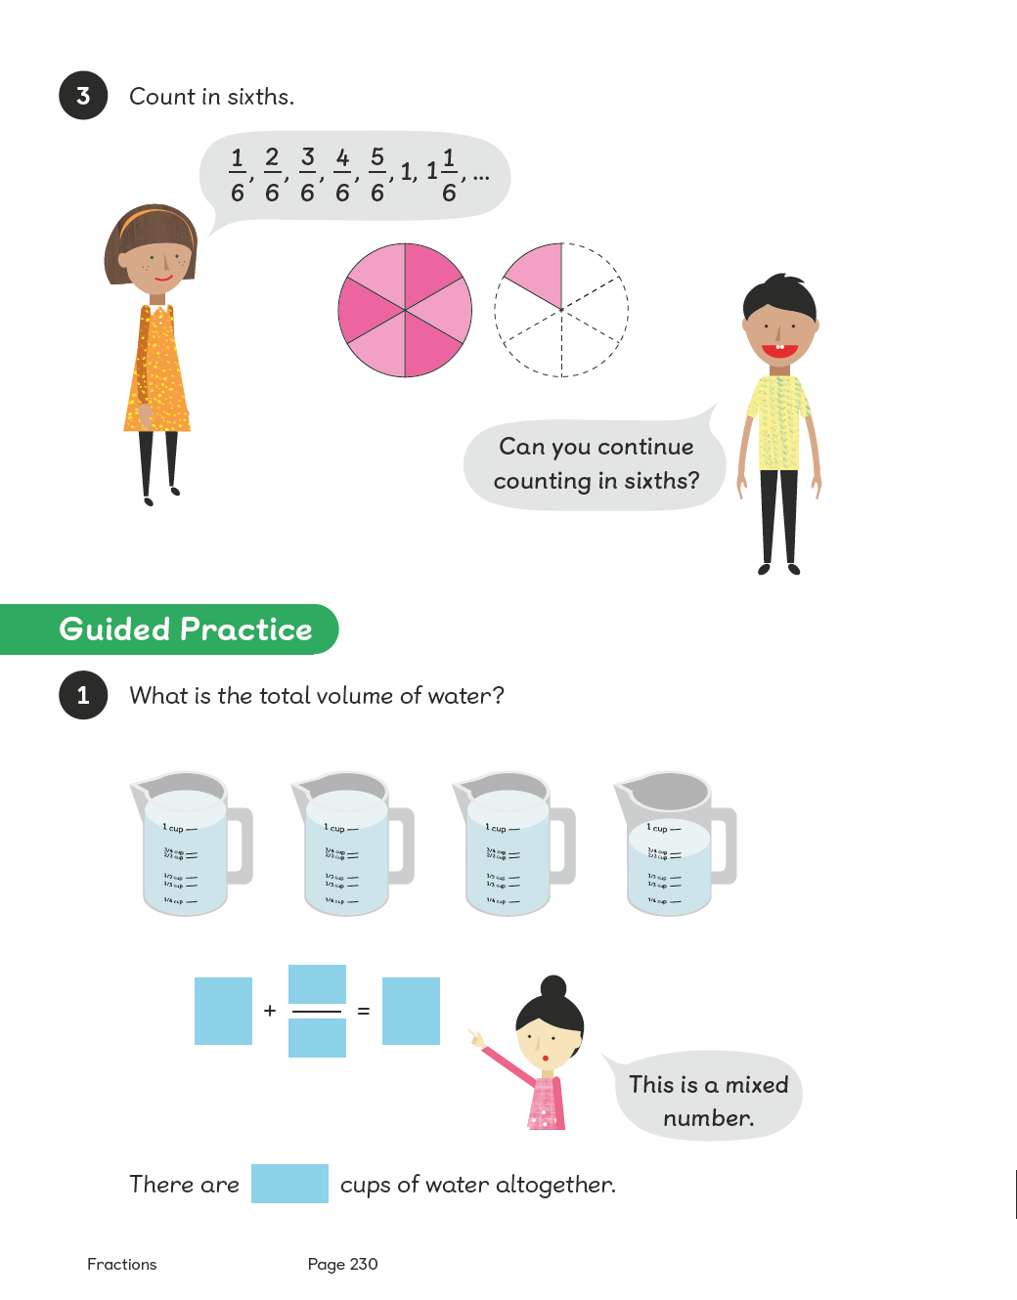
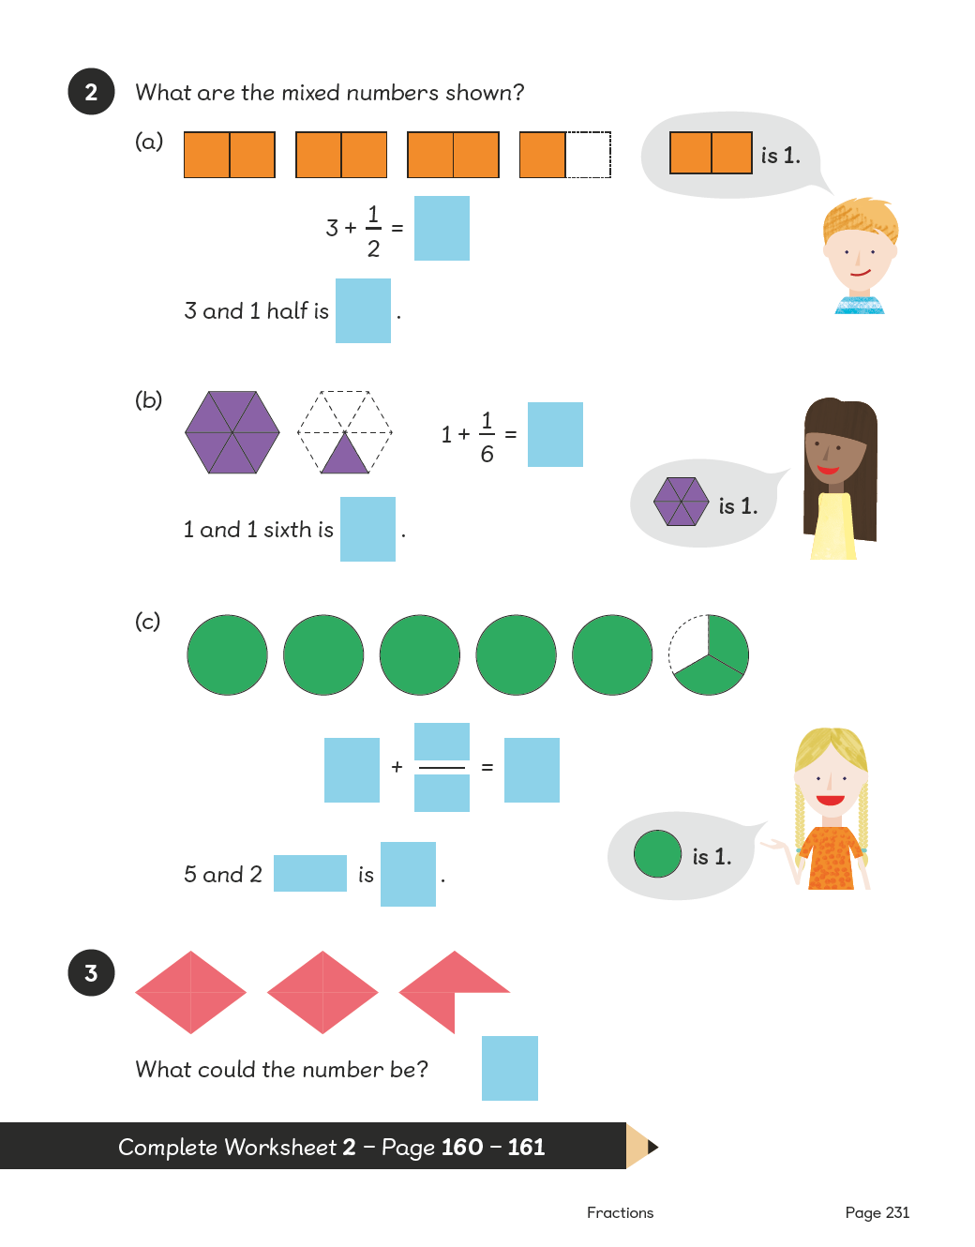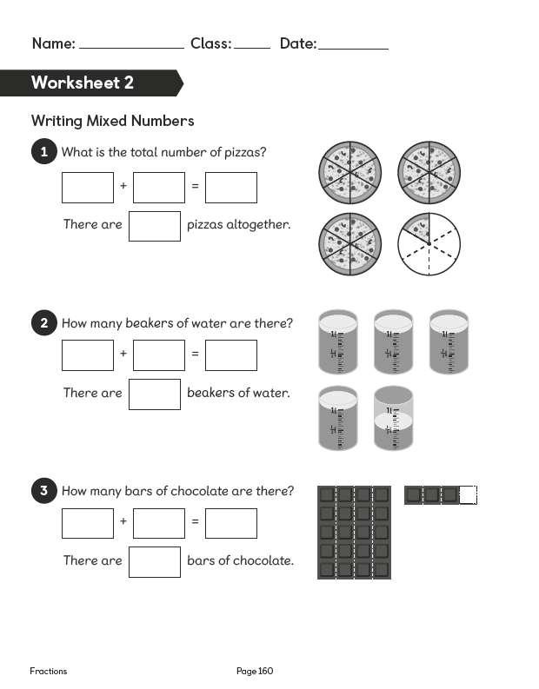
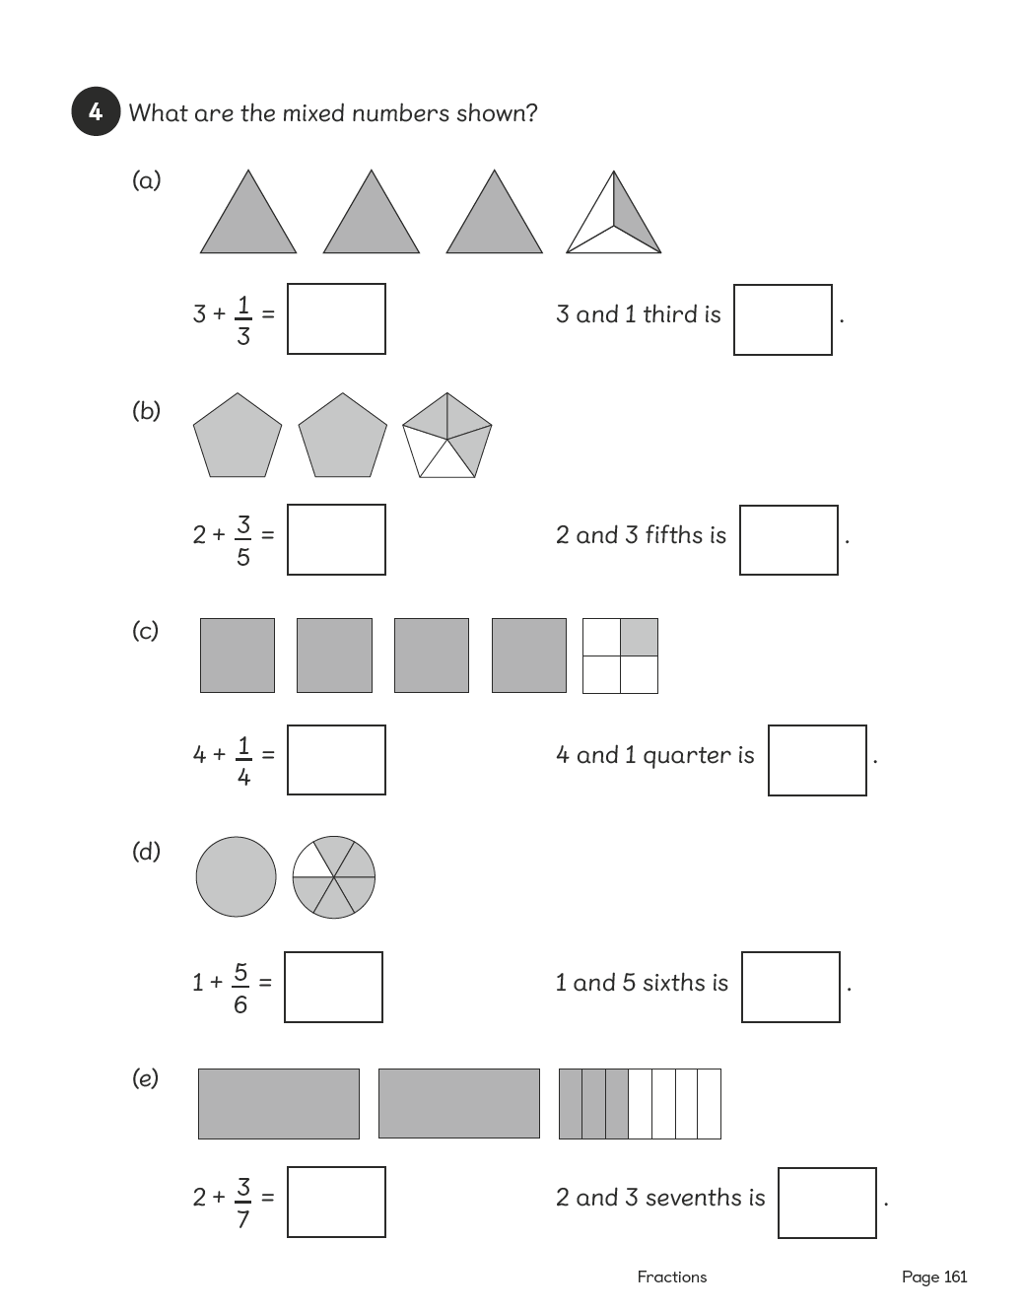

Lesson 3
Top of Form
Showing Mixed Numbers on a Number Line
Pages 232–234
Lesson Objective
To be able to show mixed numbers on a number line.
National Curriculum
Solve problems involving increasingly harder fractions to calculate quantities.
Lesson Approach
To begin this lesson, remind pupils about what they learnt from the previous lesson on mixed numbers. Allow them to discuss this and agree on the definition of a 'mixed number'. Then show pupils the In Focus task and allow pupils to discuss the combinations of the amounts of chocolate Ruby could take. Encourage them to record their thoughts on whiteboards in pairs. State that we can also record the chocolate taken by adding it to a number line.
Display Let's Learn 1 and model placing the 3 1/2 bars of chocolate on the number line. What fraction should we count in? How do you know? Check by counting forwards and backwards and show how we record it as a mixed number.
Display Let's Learn 2. What is different about this number line? Why does it have to be different from the one shown in number 1? How much chocolate does Charles take? How much does he leave? Talk through the process as you move the chocolate onto the number line, counting forwards and backwards to check. Demonstrate recording the algorithm.
During Guided Practice, pupils are identifying mixed numbers on a number line.
Additional Activity
During Activity Time, pupils work in pairs. One pupil picks a fraction card and rolls the dice to create a mixed number. Then they draw a picture to show the mixed number and place it on a number line. Their partner checks their answer. They switch roles before repeating the activity.
Misconceptions
Pupils represent each piece as a whole amount on the number line.
Formative Assessment
Pupils can count in fractions.
Pupils can recognise a whole and parts of a whole.
Pupils can write fractions using numbers.
Pupils can add fractions to whole numbers to form a mixed number.
Pupils can use the term 'mixed number' to represent a number, which has a whole number and a fraction.
Pupils can recognise a whole in pictures.
Pupils can represent a whole in pictures.
Pupils can use concrete materials to recognise and represent a whole.
Pupils can recognise parts of a whole in pictures.
Pupils can represent parts of a whole in pictures.
Pupils can recognise mixed numbers in pictures.
Pupils can represent mixed numbers in pictures.
Pupils can use concrete materials to recognise and represent parts of a whole.
Pupils can use a number line to represent whole numbers.
Pupils can use a number line to represent fractions.
Pupils can use a number line to represent mixed numbers, including both wholes and parts of the whole.
Non-negotiables
Pupils can use concrete materials and pictorial representations to recognise and represent mixed numbers.
Pupils can record their findings on a pre-constructed number line.
Pupils can write a mixed number to represent a picture.
Variation
Example 1: Completing number lines using fractions and mixed numbers with pictorial support.
Example 2: Completing a number line, with given mixed numbers; some fractions have a different number of pieces to those represented on the number line. No pictorial support.
Resources
Six-sided dice
Fraction cards (between two)
Blank number lines (increments marked)
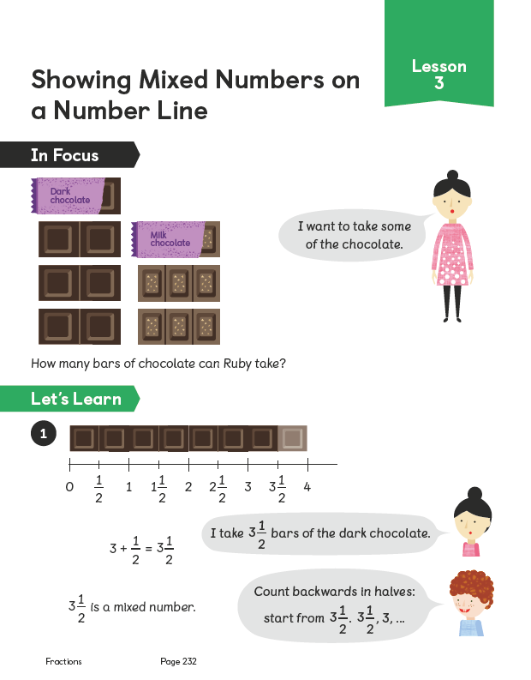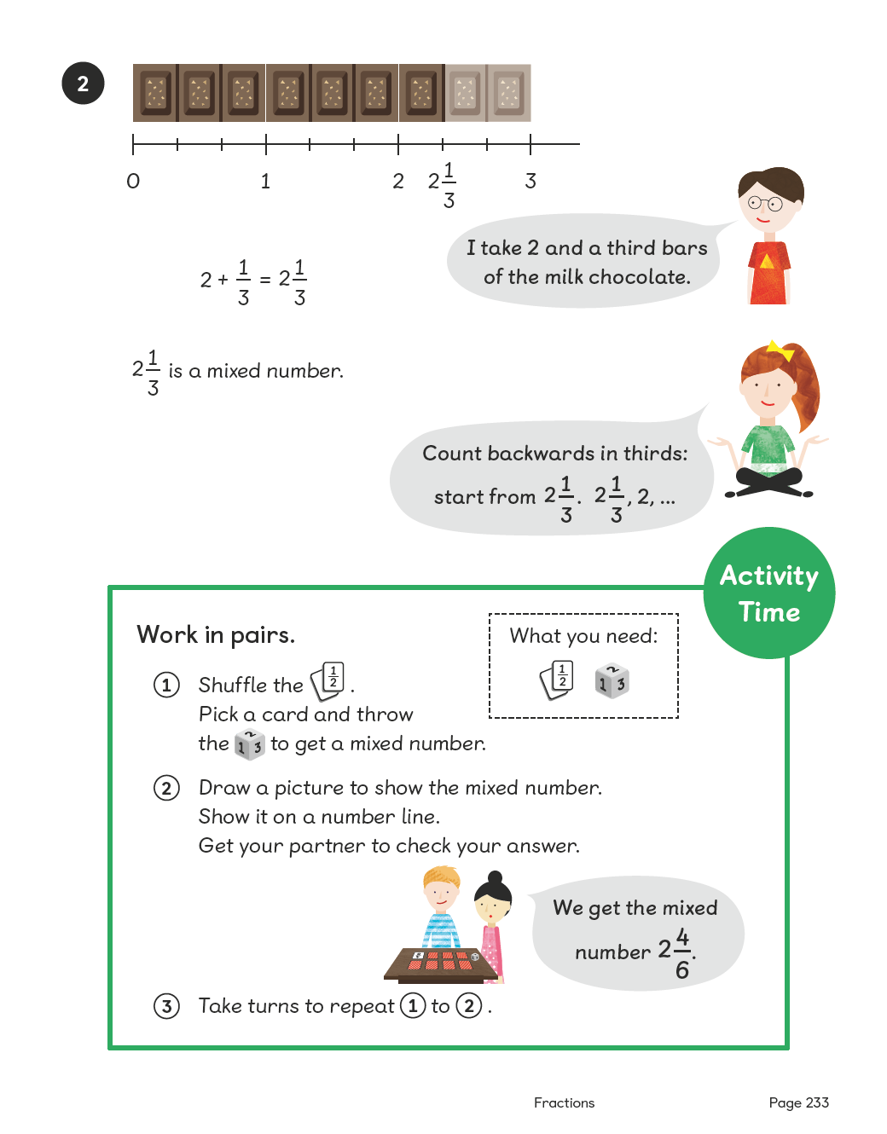

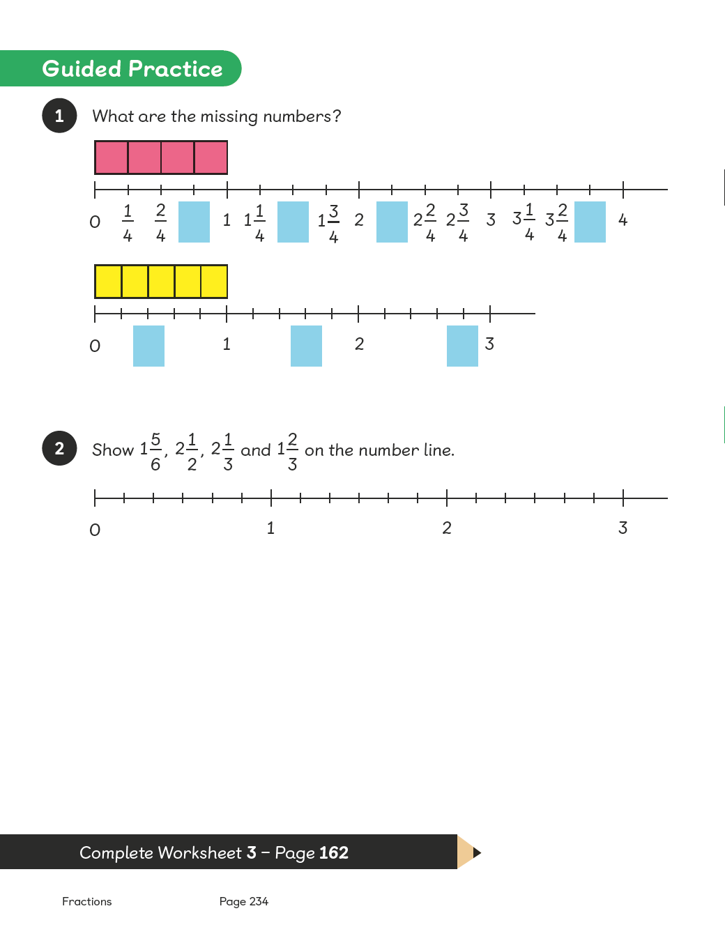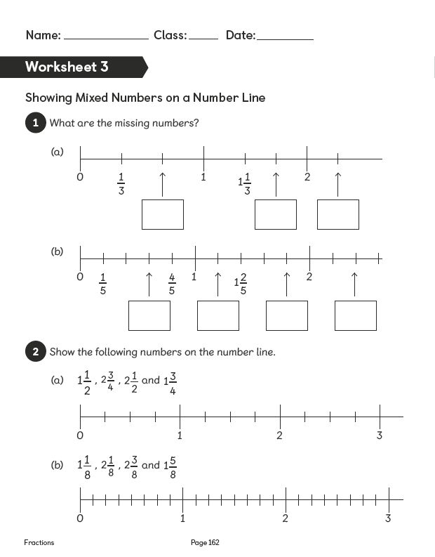

Lesson 4
Top of Form
Finding Equivalent Fractions
Pages 235–237
Lesson Objective
To find equivalent fractions.
National Curriculum
Recognise and show families of common equivalent fractions using diagrams.
Lesson Approach
Recap on learning from previous lessons. Display the term 'equivalent' and let pupils discuss its meaning. Display the In Focus task and allow some time for discussion. Then take suggestions prompting pupils' thoughts with questions such as, 'How do you know?' Encourage pupils to use their knowledge of multiplication and division facts in their explanations.
Display the image from Let's Learn 1. Show pupils that ¹⁄₂ = ²⁄₄ = ⁴⁄₈ using a fraction wall. How could halving and doubling also help prove this? Display Let's Learn 2 and allow partners to use/draw on the fraction wall and use tables to establish why ¹⁄₂ = ²⁄₄. Display ¹⁄₄ = ²⁄₈ = ³⁄₄.
Allow pupils to discuss in pairs and listen to their conjectures. Do pupils think they are equivalent or not, and why? Model using a fraction wall: I can see that ¹⁄₄ and ²⁄₈ are equivalent as they are the same size; now I'll compare ¹⁄₄and ³⁄₄. They are not equivalent as ³⁄₄ is greater than ¹⁄₄ so ¹⁄₄ < ³⁄₄. The sentences should read ¹⁄₄ = ²⁄₈ and ¹⁄₄ < ³⁄₄.
Introduce Activity Time; pupils should undertake this in groups before completing the Guided Practice in pairs.
Additional Activity
During Activity Time, pupils work in pairs using digit cards to create sets of equivalent fractions. They should try to make as many equivalent fractions as possible.
Misconceptions
Pupils see fractions with greater denominators as larger.
Pupils see fractions with greater numerators as larger.
Pupils see fractions with the same numerator/denominator as equal.
Pupils see equivalent fractions as unequal as numerators and/or denominators are different.
Formative Assessment
Pupils can name fractions from pictorial representations.
Pupils can draw bars to represent fractions.
Pupils can see equivalence in pictures.
Pupils can create equivalence using concrete materials.
Pupils can determine 'greater than' and 'less than' in fractions using pictures.
Pupils can use pictures to turn halves into quarters, thirds into sixths, etc.
Pupils can use pictures to turn quarters into halves, sixths into thirds, etc.
Non-negotiables
Pupils can use pictures to find equivalent fractions.
Pupils can draw pictures to show equivalence.
Pupils can find missing numerators or denominators in equivalent fractions.
Variation
Example 1: Finding equivalence to ¹⁄₃ using pictorial representations; finding both numerators and denominators.
Example 2: Finding equivalence to ¹⁄₅ using pictorial representations; finding numerators, denominators and complete fractions.
Resources
0; 1; 3; 5 and 8 digit cards (between two)
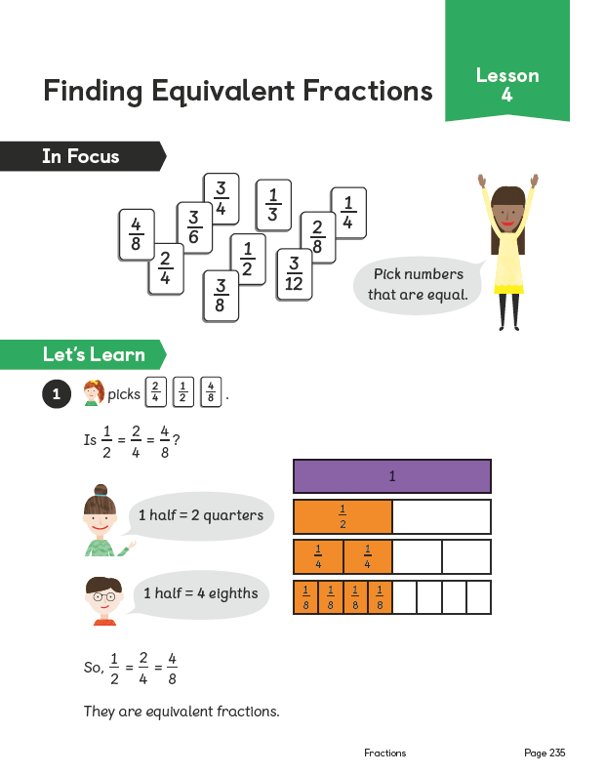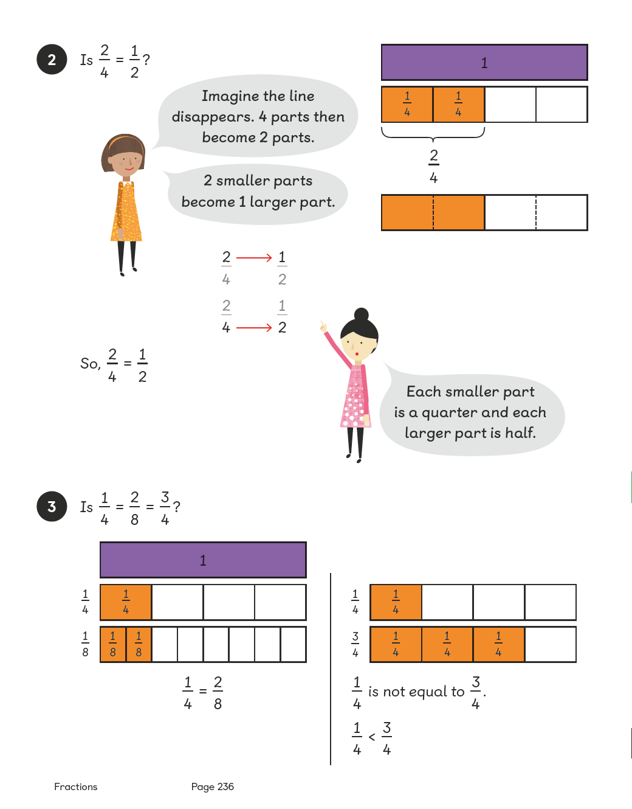
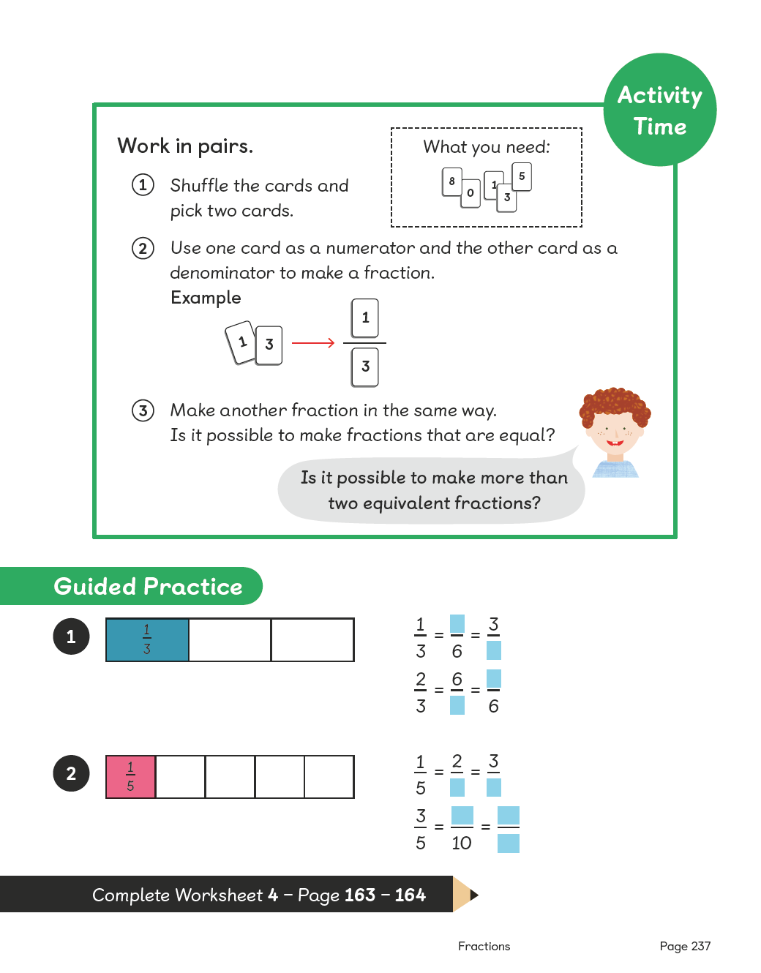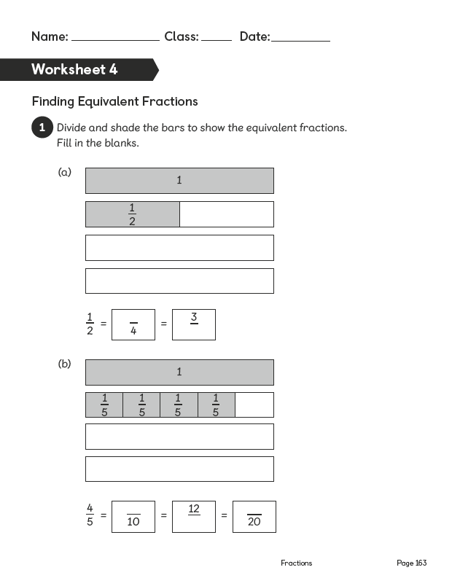
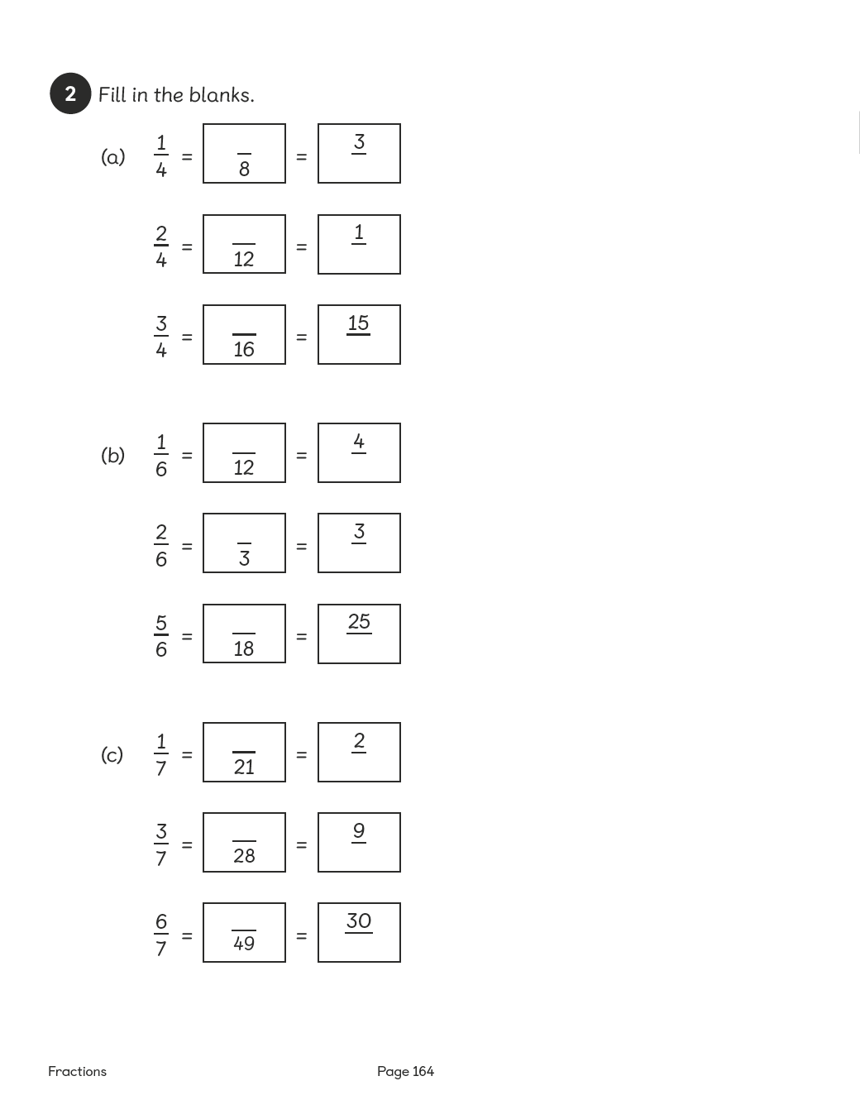

Lesson 5
Top of Form
Finding Equivalent Fractions
Pages 238–240
Lesson Objective
To be able to find equivalent fractions (further practise).
National Curriculum
Recognise and show, using diagrams, families of common equivalent fractions.
Lesson Approach
To begin this lesson, recap on the concept of the term 'equivalence' and its definition. Can pupils give a few examples of equivalent fractions from the previous lesson?
Show pupils the In Focus task and ask them what they think. Display ¹⁄₂ = ?⁄₁₀. How can we use our 2 times table or 10 times table to help us? What has happened to change the denominator (2 to 10)? What if we did the same to the numerator: ¹⁄₂ = ⁵⁄₀? Let's check this is correct using the fraction wall and the image in Let's Learn 1.
Display ¹⁄₄ = ?⁄₁₀. Ask pupils if this possible? Why or why not? Let's check using the fraction wall image. Then display the image from Let's Learn 2. How about ¹⁄₄ = ?⁄₁₀₀? What can we do to the denominator to make it 100? Can we also do this with the numerator? What fraction do we end up with? Can anyone think of some rules that we can display for finding equivalent fractions?
During Guided Practice, pupils are finding equivalent fractions.
Misconceptions
Pupils see fractions with greater denominators as larger.
Pupils see fractions with greater numerators as larger.
Pupils see fractions with the same numerator/denominator as equal.
Pupils see equivalent fractions as unequal as numerators and/or denominators are different.
Formative Assessment
Pupils can name fractions from pictorial representations.
Pupils can draw bars to represent fractions.
Pupils can see equivalence in pictures.
Pupils can create equivalence using concrete materials.
Pupils can determine 'greater than' and 'less than' in fractions using pictures.
Pupils can use pictures to turn halves into quarters, thirds into sixths, etc.
Pupils can use pictures to turn quarters into halves, sixths into thirds, etc.
Pupils can use multiplication to find equivalent fractions.
Non-negotiables
Pupils can use pictures to find equivalent fractions.
Pupils can draw pictures to show equivalence.
Pupils can use multiplication to find simple equivalence (quarters to eighths, fifths to tenths, etc.).
Pupils can use multiplication to find missing numerators or denominators in equivalent fractions.
Variation
Example 1: Using multiplication to find equivalence from fifths to tenths.
Example 2: Using multiplication to find equivalence from twentieths to hundredths.
Resources
No additional resources required for this lesson.
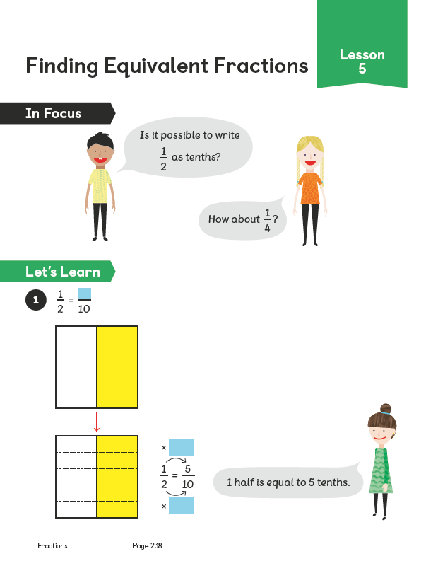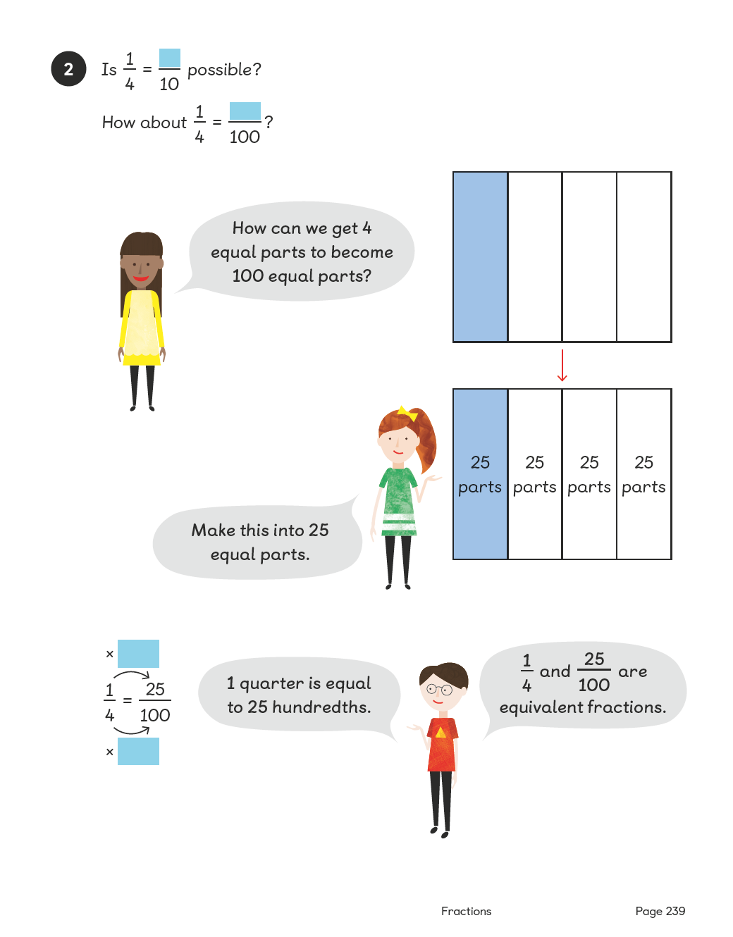
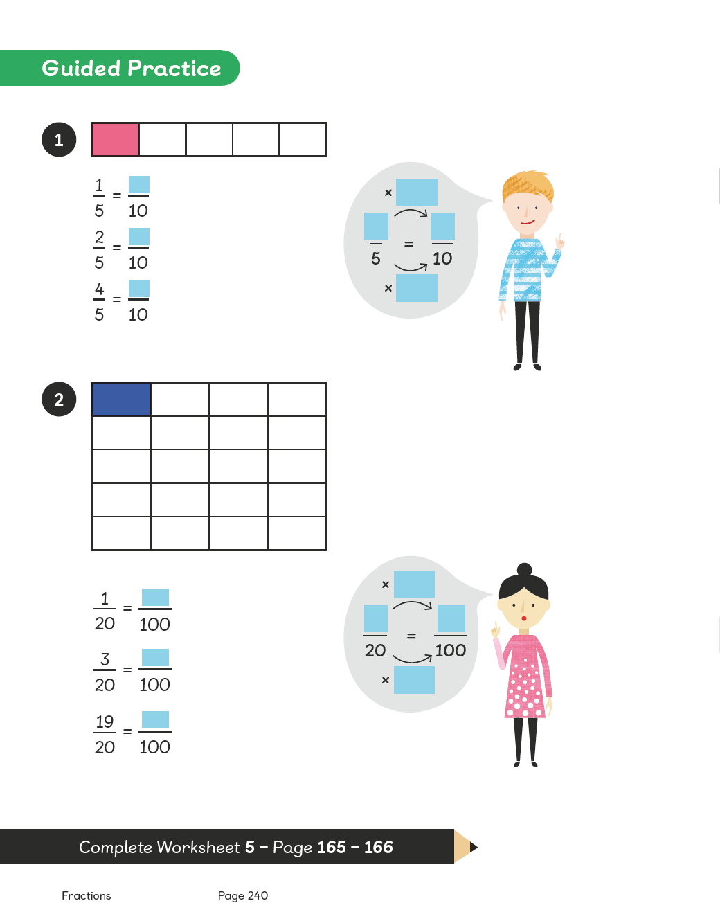
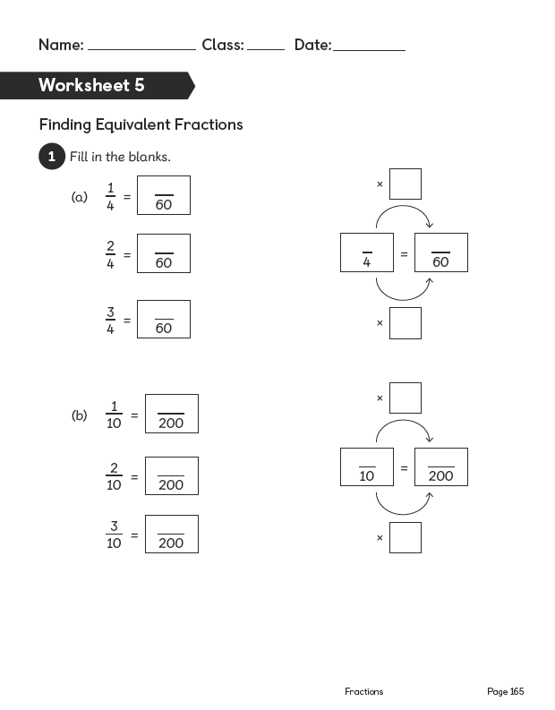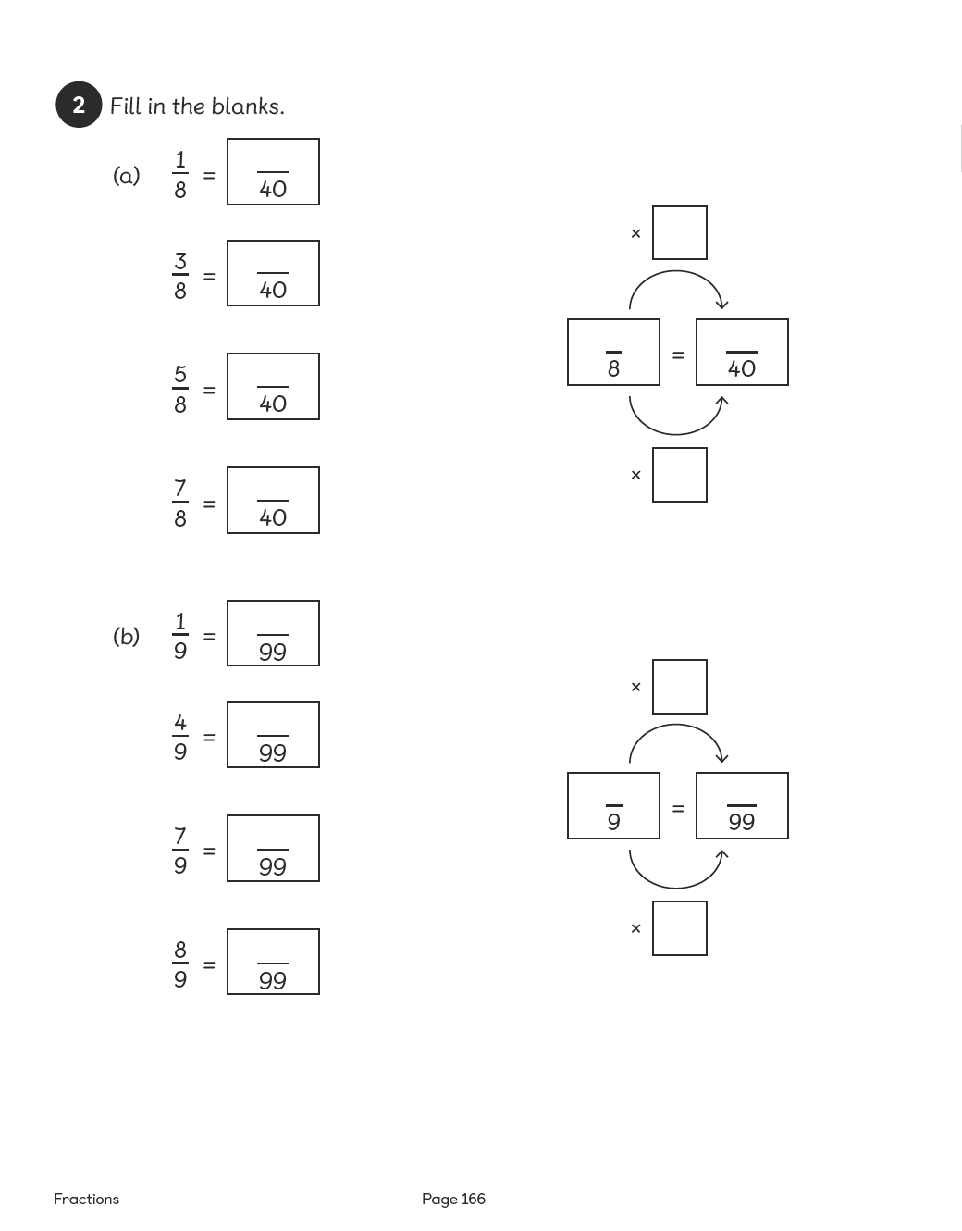

Lesson 6
Top of Form
Simplifying Mixed Numbers
Pages 241–243
Lesson Objective
To be able to simplify mixed numbers.
National Curriculum
Solve problems involving increasingly harder fractions to calculate quantities, and fractions to divide quantities. Recognise and show families of common equivalent fractions using diagrams.
Lesson Approach
To begin this lesson, remind pupils what a mixed number is. Display 4 ²⁄₃, 6 ⁵⁄₈and 9 ⁴⁄₁₂. After reading the mixed numbers, ask pupils to talk about them with their partners. Then show them the In Focus task and give them time to discuss it.
Display Let's Learn 1. How many whole cakes does Ravi take? What fraction does he take? How do we know that it is twelfths? How many twelfths does he take altogether? How much cake does he take altogether?
Display Let's Learn 2. How much cake does Emma take? How do you know? Allow some partner discussion and feedback. Look at the image of 1 ⁴⁄₁₂. Does ⁴⁄₁₂ look equivalent to another fraction? Can anyone explain why it is equivalent, using your knowledge of times tables? Demonstrate dividing by 4 to calculate the numerator and denominator. Let pupils know that this process is known as simplifying the fraction.
Display Let's Learn 3. Allow partners to discuss how much cake Hannah has and give them time to attempt to identify the equivalent fraction. Then show or invite a volunteer to show the class how to complete the calculation.
During Guided Practice, pupils are simplifying mixed numbers and identifying mixed numbers in their simplest form.
Misconceptions
Pupils change only the numerator or denominator to simplify a fraction, e.g.⁵⁄₁₂ = ⁵⁄₆, ⁴⁄₁₂ = ²⁄₁₀. Pupils leave out the whole numbers when simplifying mixed numbers.
Formative Assessment
Pupils can name fractions from pictorial representations.
Pupils can draw pictures to represent fractions.
Pupils can see equivalence in pictures.
Pupils can create equivalence using concrete materials.
Pupils can determine 'greater than' and 'less than' in fractions using pictures.
Pupils can use pictures to turn halves into quarters, thirds into sixths, etc.
Pupils can use pictures to turn quarters into halves, sixths into thirds, etc.
Pupils can use multiplication to find equivalent fractions.
Pupils can use division to find equivalent fractions.
Pupils can use division to simplify fractions.
Pupils can recognise a whole and parts of a whole, and combine them to form a mixed number.
Non-negotiables
Pupils can use pictures to find equivalent fractions.
Pupils can use division to find simple equivalence.
Variation
Example 1: Simplifying the fraction in mixed numbers using bar models.
Example 2: Simplifying mixed numbers using a bar model of the fraction.
Example 3: Finding mixed numbers in their simplest form without pictorial support.
Resources
No additional resources required for this lesson.
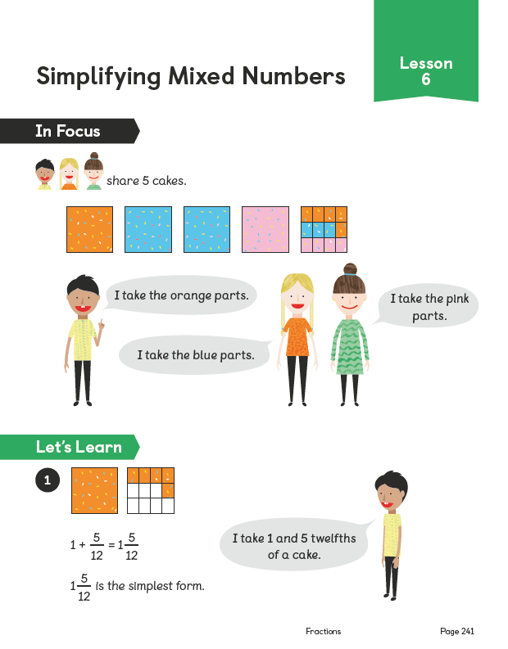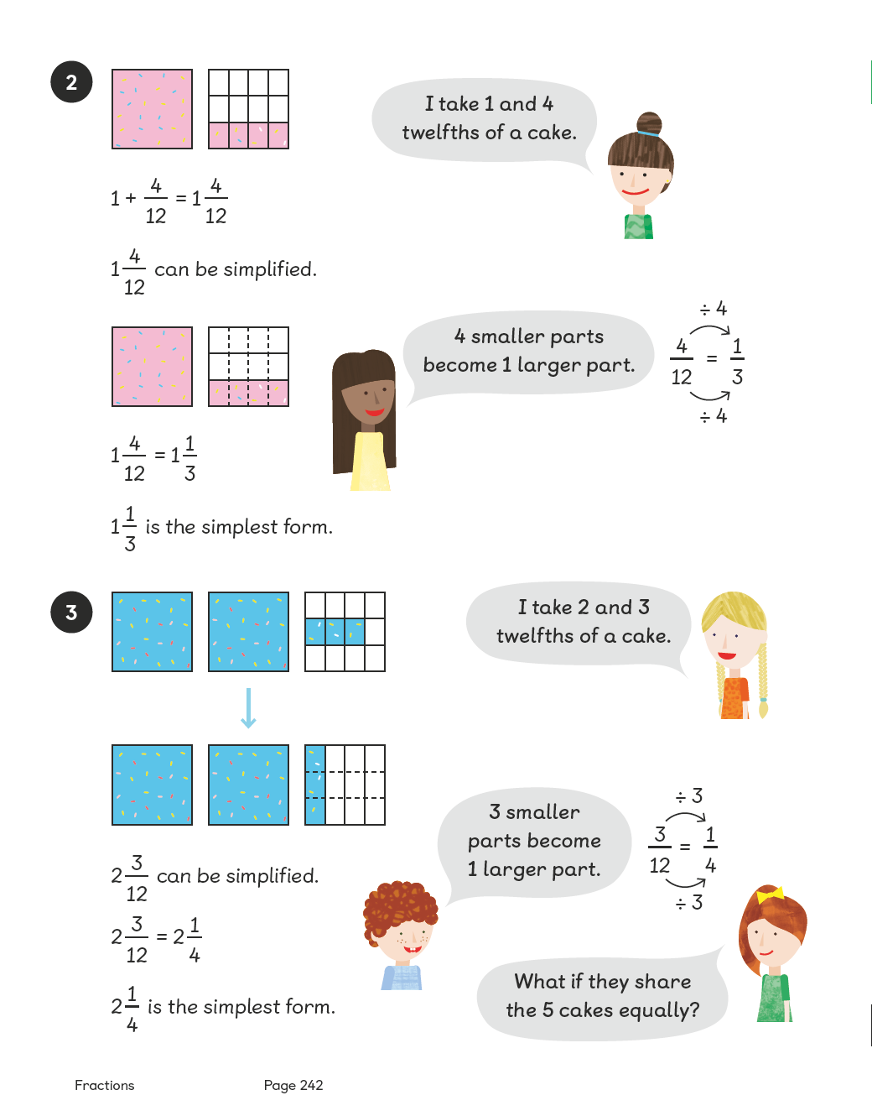
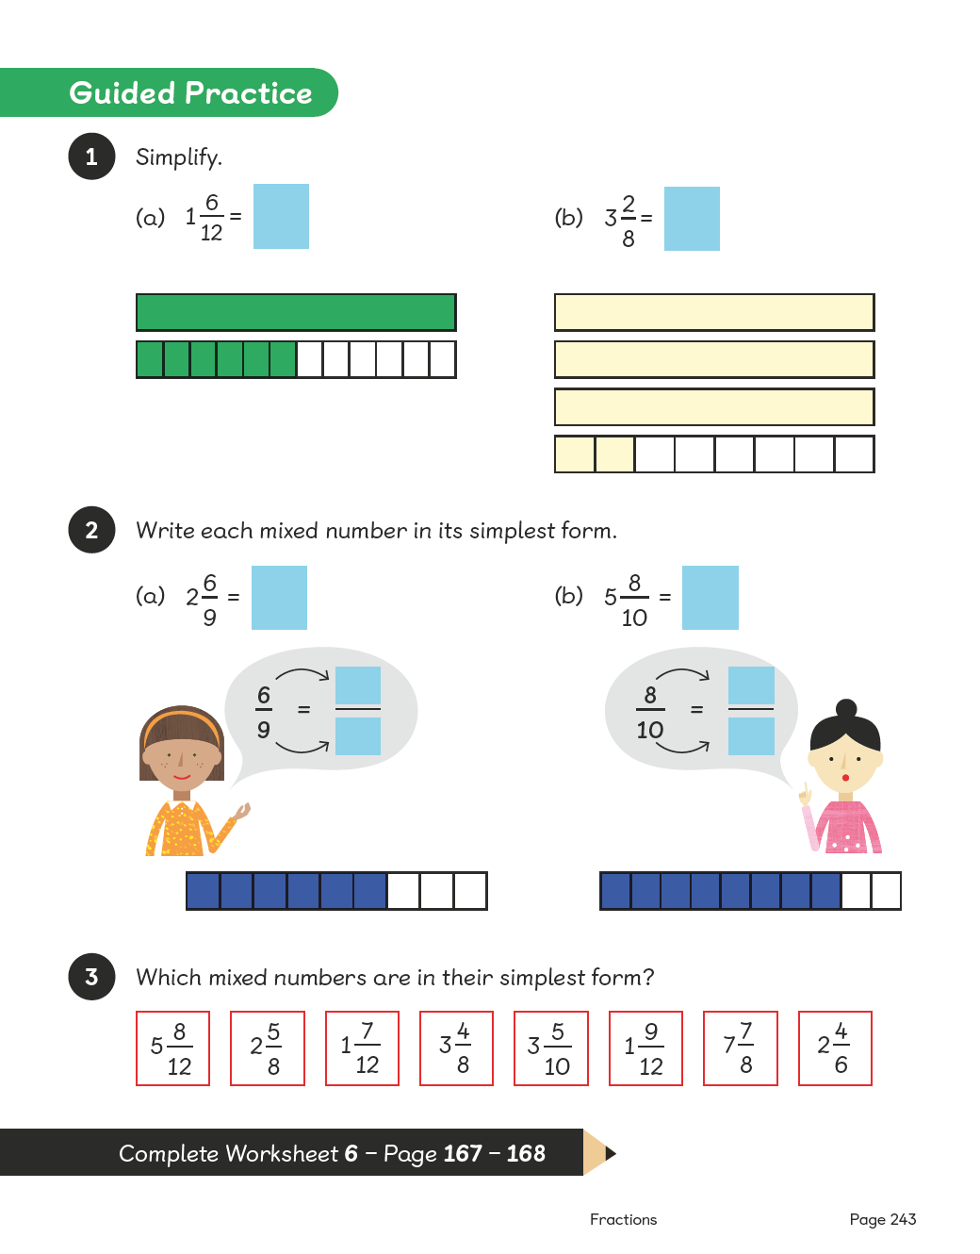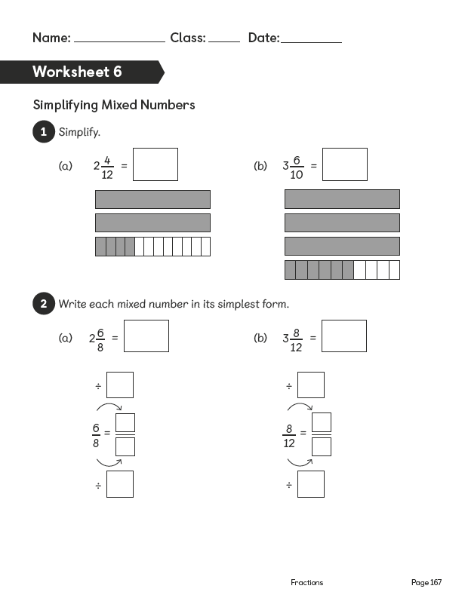
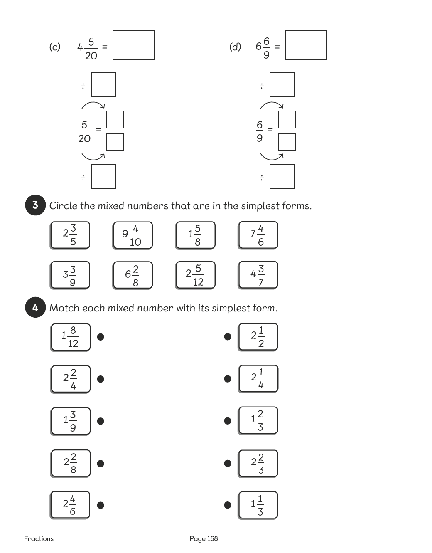

Lesson 7
Top of Form
Simplifying Improper Fractions
Pages 244–247
Lesson Objective
To be able to simplify improper fractions.
National Curriculum
Recognise and show families of common equivalent fractions using diagrams.
Lesson Approach
To begin this lesson, recap on how we can use multiplication and division to help simplify fractions. Invite a volunteer to demonstrate to the class how to simplify 4 ²⁄₆. Show pupils the In Focus task and ask them what they notice about the scale. What is the problem asking us to calculate? How can we use what we know about equivalence and simplifying to help?
Display the image of thirds and sixths from Let's Learn 1. What does the first bar show? What does the second bar show? How many sixths are equivalent to ²⁄₃ or to 1 whole? So, how many sixths are shown altogether? Have we answered the question? How many ¹⁄₆ cups can we fill? What if the cup was ¹⁄₃? Allow pupils time to discuss this with their partners and then take feedback. Show or ask a volunteer to show the class how to calculate how many thirds there are altogether. Can any pupil relate the answer to how many sixths and to how many thirds there are?
Display the first image in Let's Learn 2. What fractions are we learning about now? How many halves in 1 ¹⁄₂? How do we know? Display the second image. How many quarters make 1 ¹⁄₂? Pupils can use the visual prompt or knowledge of equivalent fractions to calculate this. Invite a volunteer to feedback to the class. So far we know that 1 ¹⁄₂ = ³⁄₂ and 1 ¹⁄₂ = ⁶⁄₄. How about 1 ¹⁄₂ = ?⁄₈? Can anyone spot a pattern? Ask pupils to discuss this and feedback using mathematical vocabulary. Then display the third image. Can anyone use the picture to prove how many eighths make 1 ¹⁄₂? Does it work for the pattern we spotted earlier? I wonder how many sixteenths would make 1 ¹⁄₂?
Lead pupils to conclude that ¹²⁄₈, ⁶⁄₄ and ³⁄₂ are equivalent and can be simplified to be the same.
During Guided Practice, pupils are simplifying improper fractions.
Misconceptions
Pupils divide the numerator and denominator by different numbers for ease of simplification.
Pupils divide either the numerator or denominator when simplifying.
Formative Assessment
Pupils can name fractions from pictorial representations.
Pupils can draw pictures to represent fractions.
Pupils can see equivalence in pictures.
Pupils can create equivalence using concrete materials.
Pupils can use pictures to turn halves into quarters, thirds into sixths, etc.
Pupils can use pictures to turn quarters into halves, sixths into thirds, etc.
Pupils can use multiplication and division to find equivalent fractions.
Pupils can use division to simplify fractions.
Pupils can recognise a whole and parts of a whole and combine them to form a mixed number.
Non-negotiables
Pupils can use pictures to find equivalent fractions.
Pupils can use multiplication to find equivalence.
Pupils can use division to find simple equivalence.
Variation
Example 1: Simplifying an improper fraction by turning sixths into thirds using pictorial representation as support.
Example 2: Simplifying an improper fraction by turning quarters into halves using pictorial representation as support.
Example 3: Simplifying fractions; requires recognising whether improper fractions are in their simplest form; one example is already simplified.
Resources
No additional resources required for this lesson.
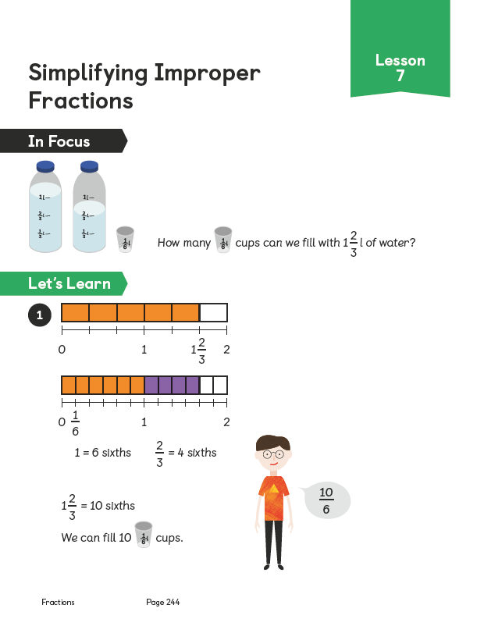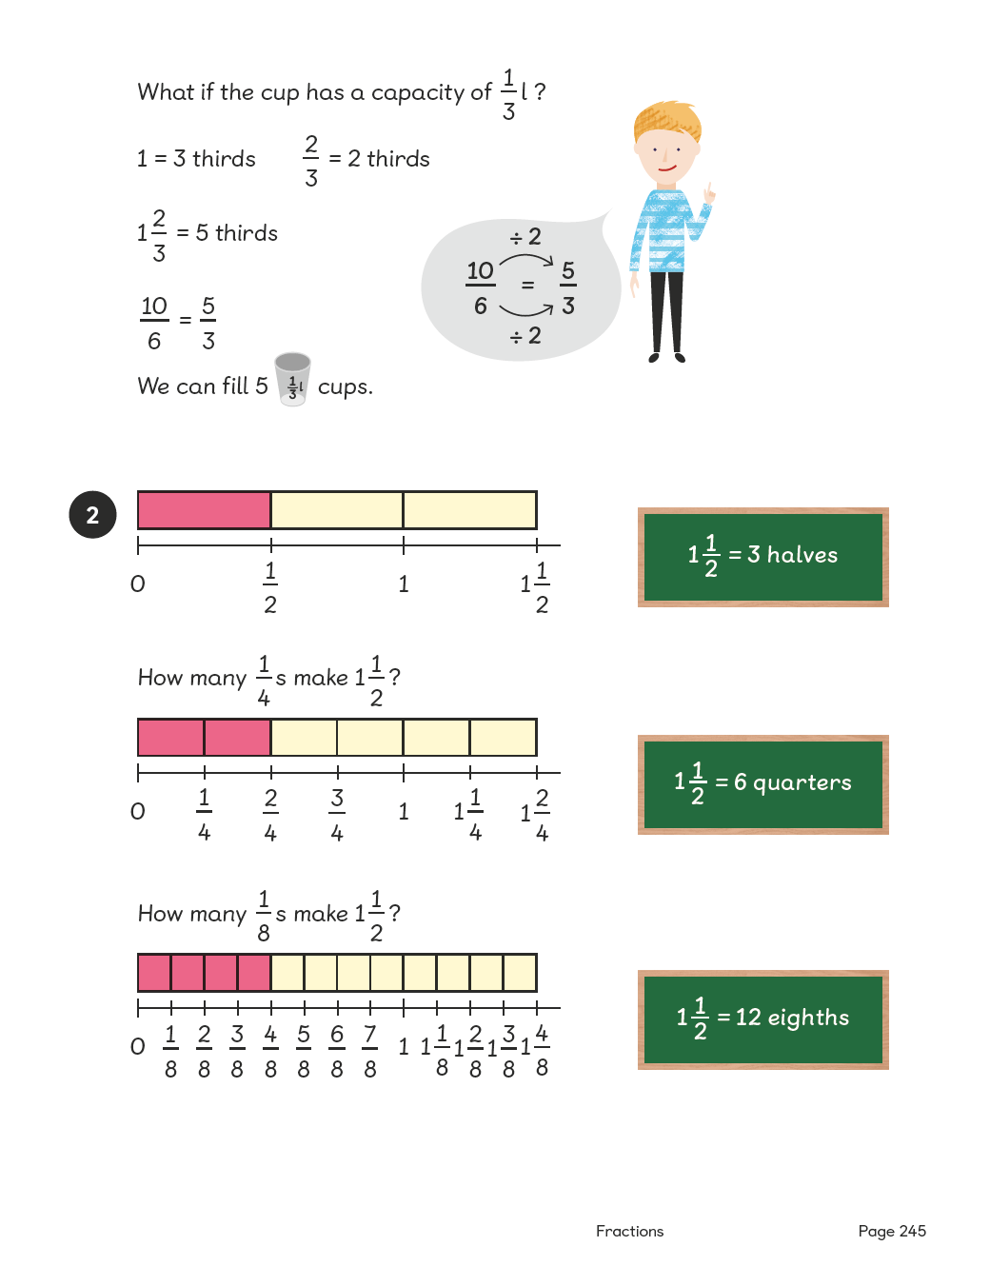
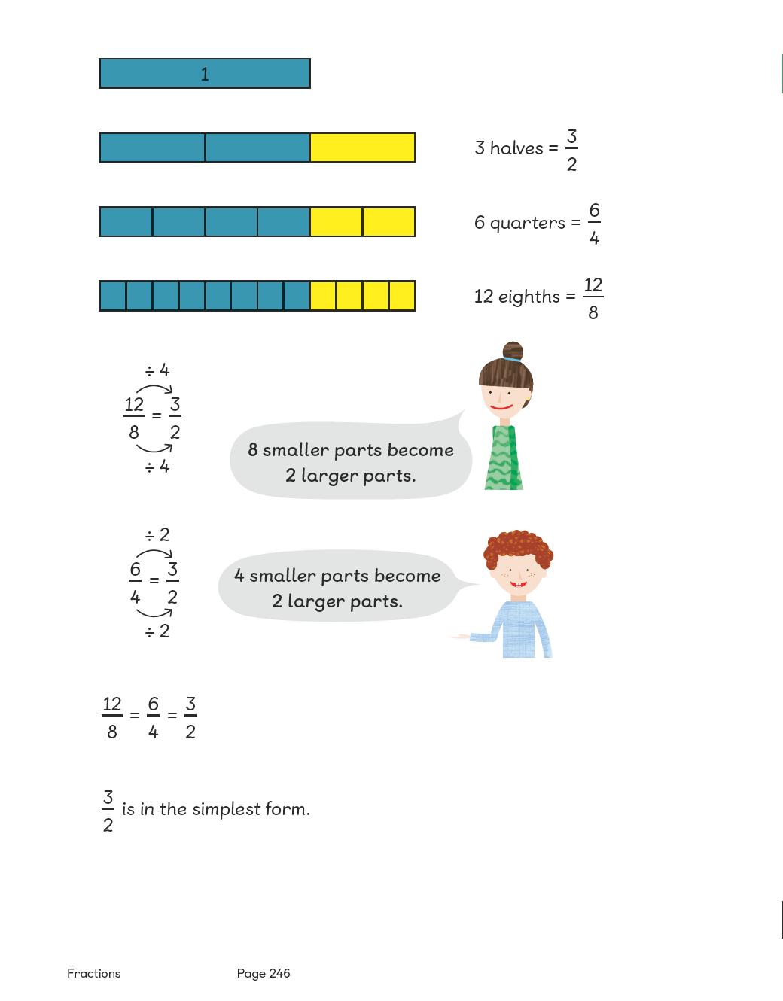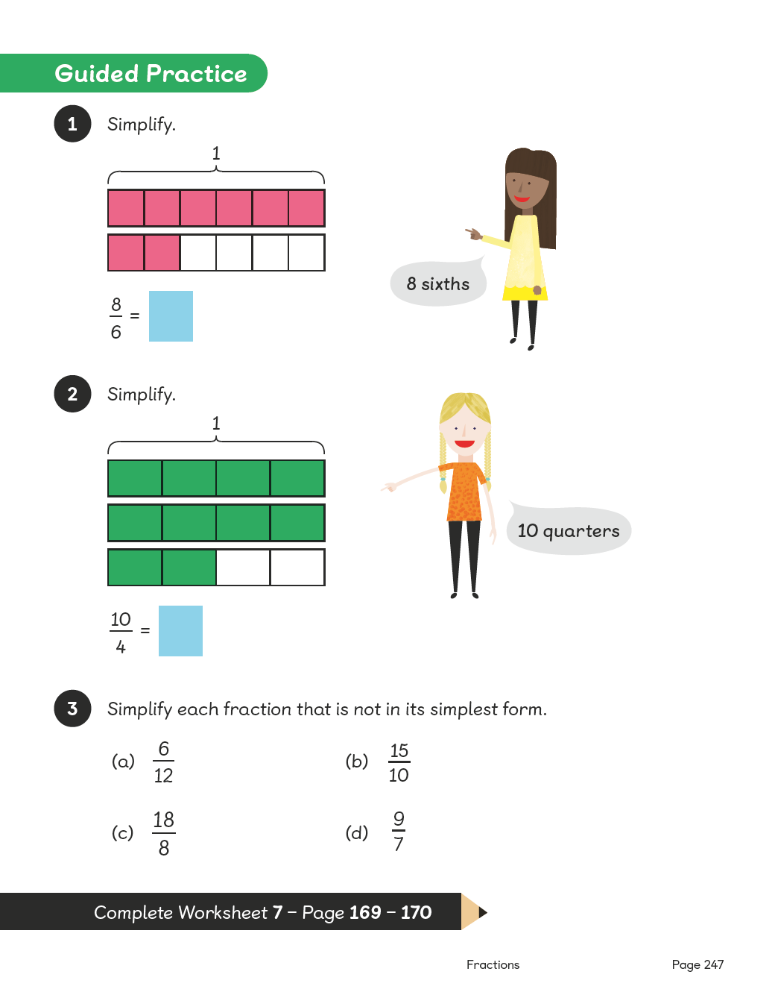

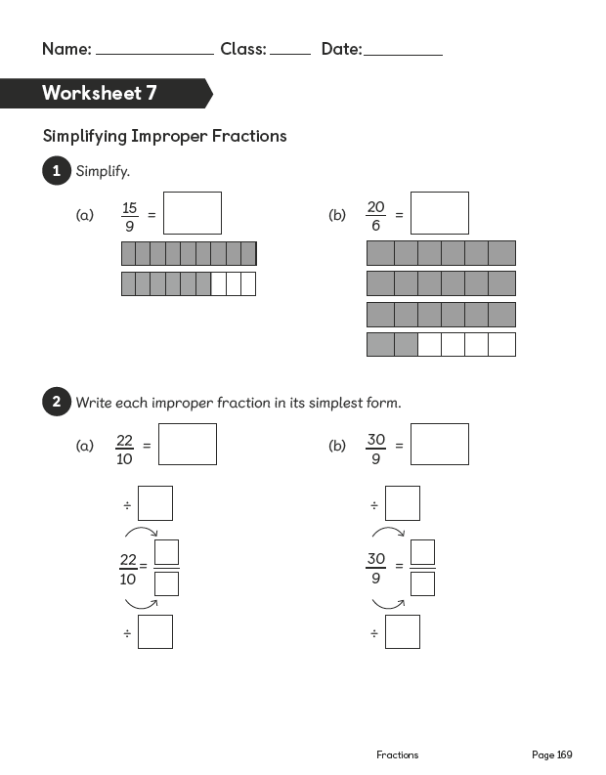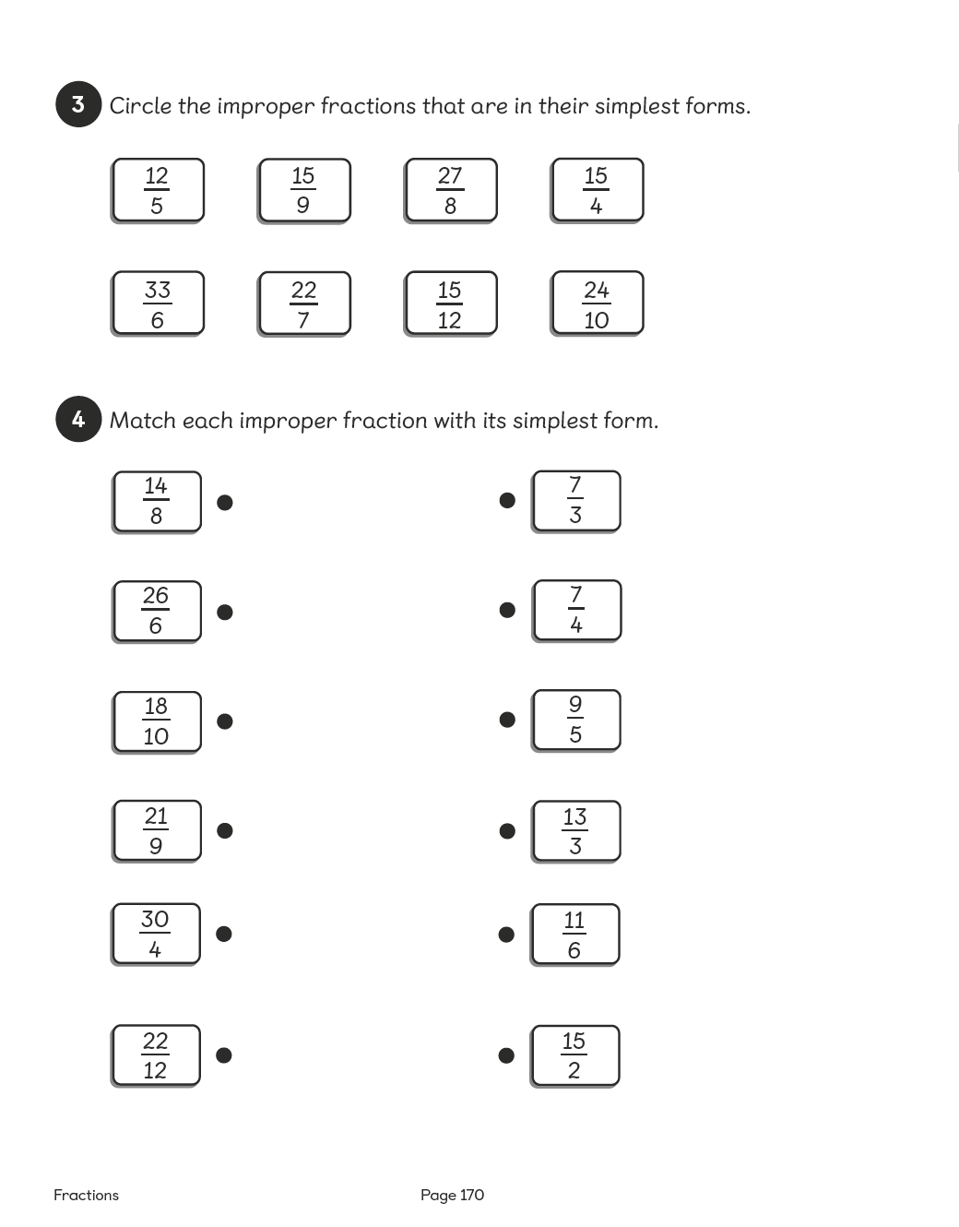

Lesson 8
Top of Form
Adding Fractions
Pages 248–249
Lesson Objective
To be able to add fractions with the same denominator.
National Curriculum
Add fractions with the same denominator.
Lesson Approach
To begin this lesson, show pupils the In Focus task. State that the focus for this lesson will be on adding fractions together. What fractions can we spot in the problem? What is the problem asking us to find out? How many fifths in 1 whole. So what totals are we looking for? Show the class how to calculate the addition sentences using the images in Let's Learn 1. Draw attention to the use of the mathematical symbols, < and >, to express the comparison.
Look at the image in Let's Learn 2. Does this show more than a whole? How much more? How many fifths are there altogether and how can we simplify this? What other combinations can we use to make more than a whole? Encourage partner work on whiteboards. Repeat the process for Let's Learn 3.
During Guided Practice, pupils are adding fractions with the same denominator. Invite them to ask questions and feed back.

Watch the Film
Misconceptions
Pupils add the numerators and denominators.
Pupils do not see denominators as a name.
Formative Assessment
Pupils can add fractions of the same name (denominator).
Pupils can use pictures to support adding fractions of the same name.
Pupils can use concrete materials to support adding fractions of the same name.
Pupils can create mixed numbers from adding fractions.
Pupils can create improper fractions from adding fractions.
Pupils can use 'greater than' and 'less than' to compare and describe fractions, mixed numbers and improper fractions.
Pupils can simplify fractions to their simplest form from mixed numbers and improper fractions.
Non-negotiables
Pupils can use pictures to draw fraction bars and add fractions of the same name.
Pupils can show fractions in their simplest form.
Variation
Creating mixed numbers from adding fractions; fraction bars are provided as pictorial support.
Example 1: The amount for the whole is given.
Example 2: Requires breaking one of the fractions to create a whole first.
Resources
No additional resources required for this lesson.
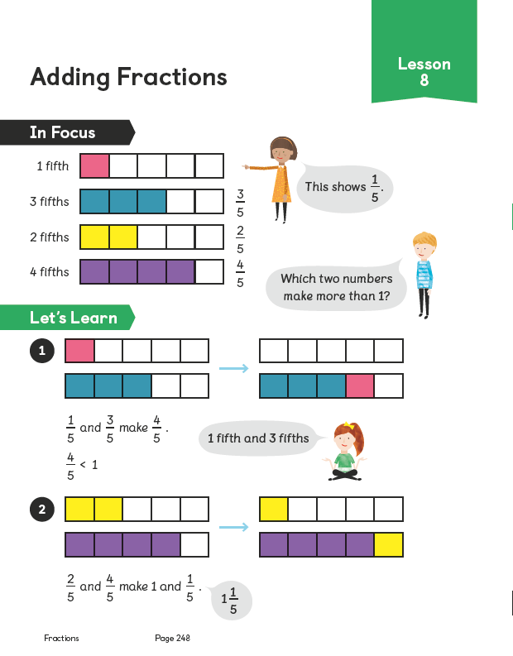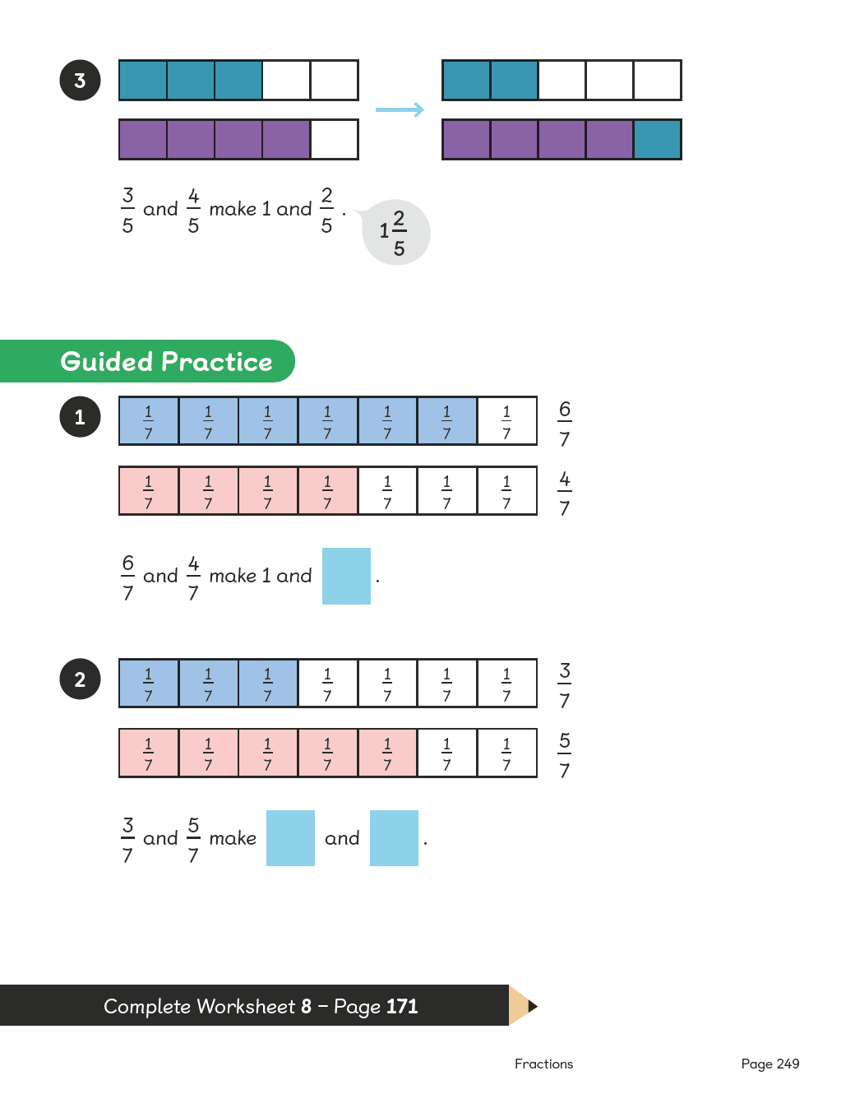
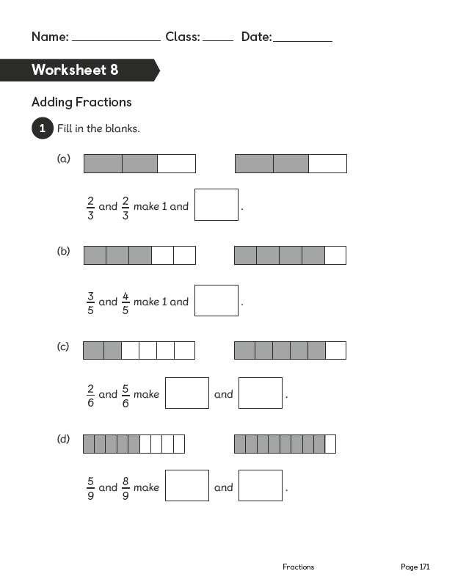

Lesson 9
Top of Form
Adding Fractions
Pages 250–251
Lesson Objective
To be able to add fractions with the same denominator and record answers as mixed numbers.
National Curriculum
Add fractions with the same denominator.
Lesson Approach
To begin this lesson, recap on the previous lesson. What were we learning to do?
Show pupils the In Focus task. What is the problem asking us to do? How can we calculate the total of the 2 fractions? Work through Let's Learn to show the class how to do this. Record ⁴⁄₅ + ³⁄₅ = ⁷⁄₅. Tell pupils you want to know how many wholes and how many fifths this total is equivalent to. Ask them to look at the calculation: ⁴⁄₅ + ³⁄₅. How many fifths do we need to make a whole? Can we partition ³⁄₅ into parts? We will partition it into ¹⁄₅ and ²⁄₅, so now we can add ⁴⁄₅ and ¹⁄₅ to make 1 whole and then add on ²⁄₅. Have we answered the question?
During Guided Practice, pupils are adding fractions with the same denominator. Tell them they can draw/colour fraction bars to help with the calculations if necessary. Circulate the classroom to provide support if needed.

Watch the Film
Misconceptions
Pupils add the numerators and denominators.
Pupils do not see denominators as a name.
Formative Assessment
Pupils can add fractions of the same name (denominator).
Pupils can use pictures to support adding fractions of the same name.
Pupils can use concrete materials to support adding fractions of the same name.
Pupils can create mixed numbers from adding fractions.
Pupils can create improper fractions from adding fractions.
Pupils can use 'greater than' and 'less than' to compare and describe fractions, mixed numbers and improper fractions.
Pupils can simplify fractions to their simplest form from mixed numbers and improper fractions.
Pupils can use number bonds to make 1 whole when adding fractions.
Non-negotiables
Pupils can use pictures to draw fraction bars and add fractions of the same name.
Pupils can show fractions in their simplest form.
Pupils can break apart a fraction using number bonds to make 1 whole.
Variation
Example 1: Creating mixed numbers or improper fractions, with pictorial support.
Example 2: Creating an improper fraction and a mixed number, without pictorial support.
Example 3–4: Creating mixed numbers when 1 whole is given, without pictorial support.
Resources
No additional resources required for this lesson.
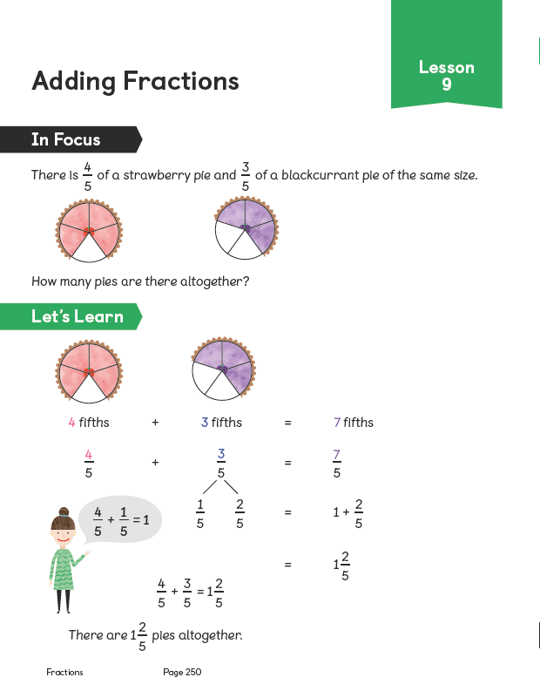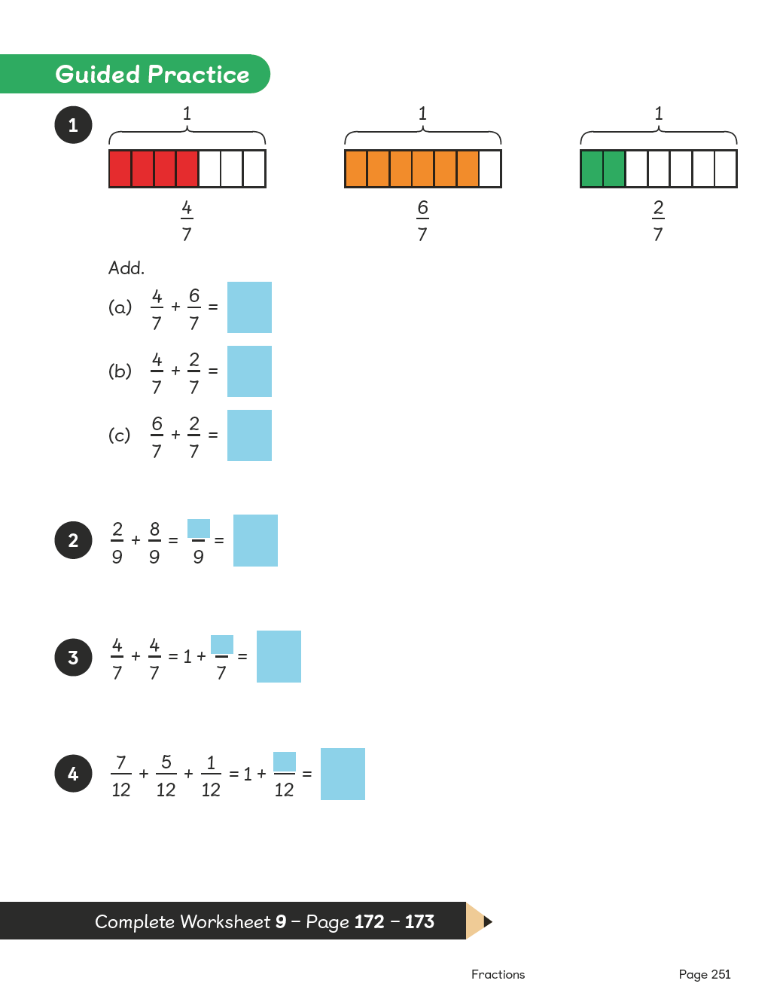
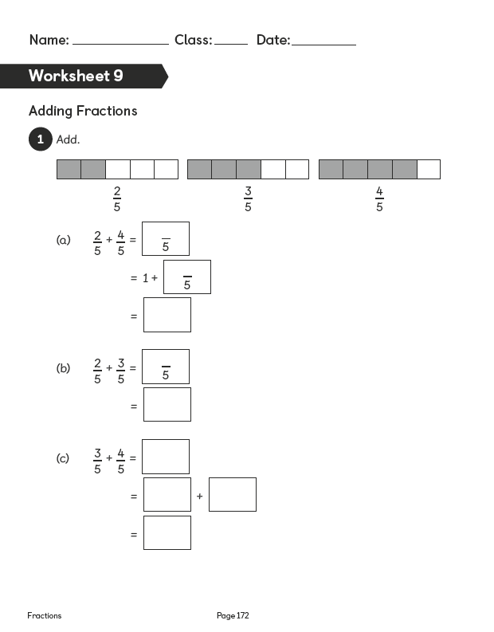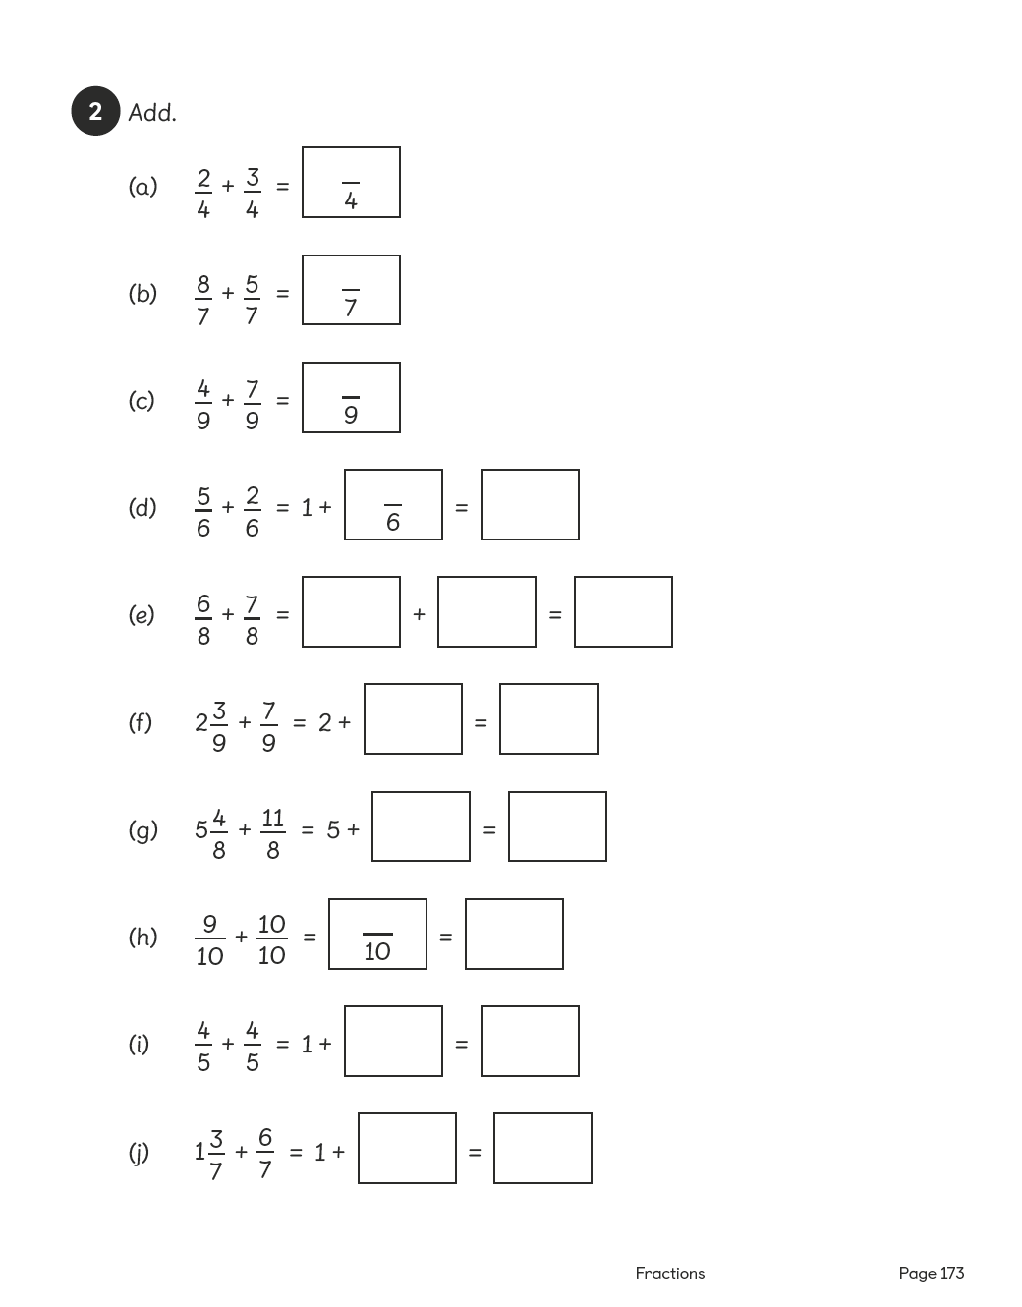

Lesson 10
Top of Form
Adding Fractions
Pages 252–253
Lesson Objective
To be able to add fractions with the same denominator and record the answers in the simplest form.
National Curriculum
Add fractions with the same denominator.
Lesson Approach
To begin this lesson, remind pupils of their experiences of adding fractions from the previous lessons. Then show them the In Focus task and discuss what should be done to solve the problem.
Demonstrate or invite a volunteer to show the class how to calculate ³⁄₄ + ³⁄₄= ⁶⁄₄. How many wholes and how many quarters are in ⁶⁄₄? Is this the simplest form? Invite volunteers to use a fraction wall and knowledge of equivalence to convert it to its simplest form. Work through Let's Learn and invite questions from pupils.
During Guided Practice, pupils are adding fractions with the same denominator. Circulate the classroom to provide support where necessary.

Watch the Film
Misconceptions
Pupils add the numerators and denominators.
Pupils do not see denominators as a name.
Formative Assessment
Pupils can add fractions of the same name (denominator).
Pupils can use pictures to support adding fractions of the same name.
Pupils can use concrete materials to support adding fractions of the same name.
Pupils can create mixed numbers from adding fractions.
Pupils can create improper fractions from adding fractions.
Pupils can use 'greater than' and 'less than' to compare and describe fractions, mixed numbers and improper fractions.
Pupils can simplify fractions to their simplest form from mixed numbers and improper fractions.
Pupils can use number bonds to make 1 whole when adding fractions.
Pupils can use pictures to convert improper fractions into mixed numbers in their simplest form.
Non-negotiables
Pupils can use pictures to draw and add fractions of the same name.
Pupils can simplify fractions to their simplest form from mixed numbers or improper fractions.
Pupils can break apart a fraction using number bonds to make 1 whole.
Variation
Example 1: Simplifying improper fractions obtained from adding two fractions of the same name; pictorial support given in the form of fraction bars.
Example 2: Creating a mixed number from an improper fraction obtained by adding two fractions with the same denominator; requires simplifying the mixed number; pictorial support given in the form of fraction bars.
Example 3: Simplifying a mixed number obtained from adding a mixed number and a fraction with the same denominator.
Resources
No additional resources required for this lesson.
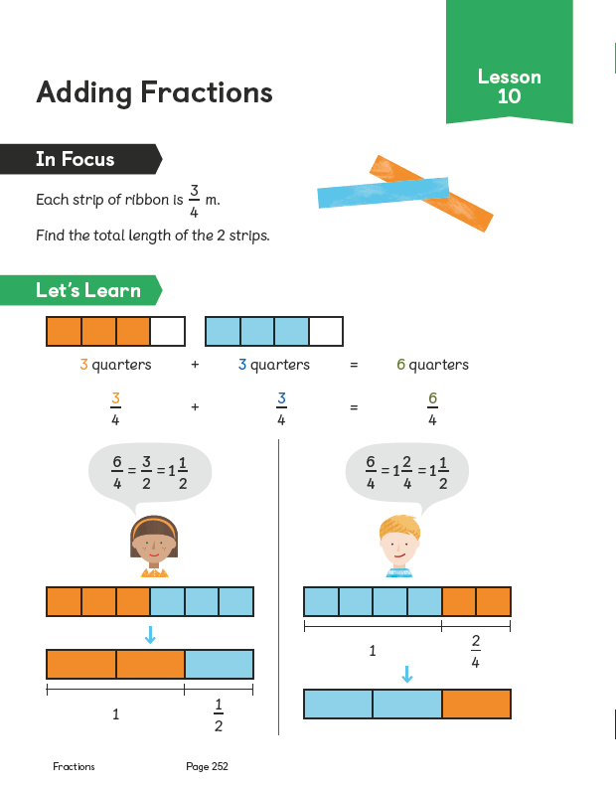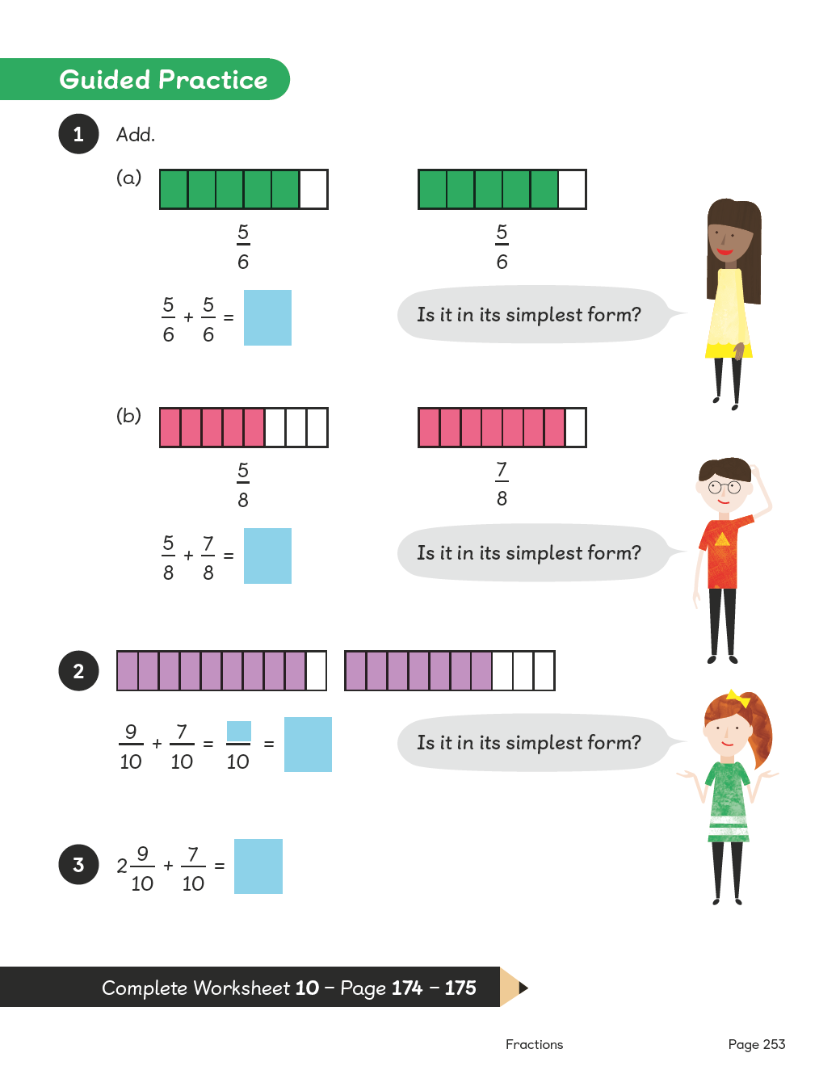
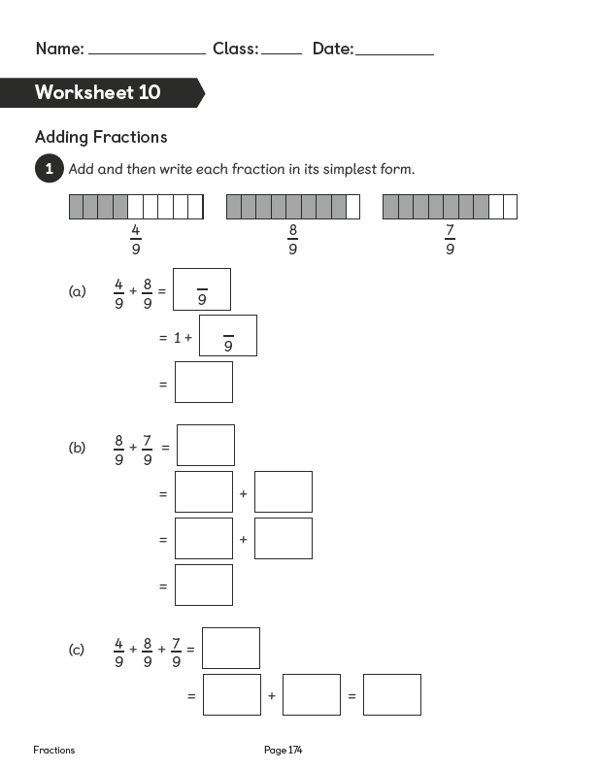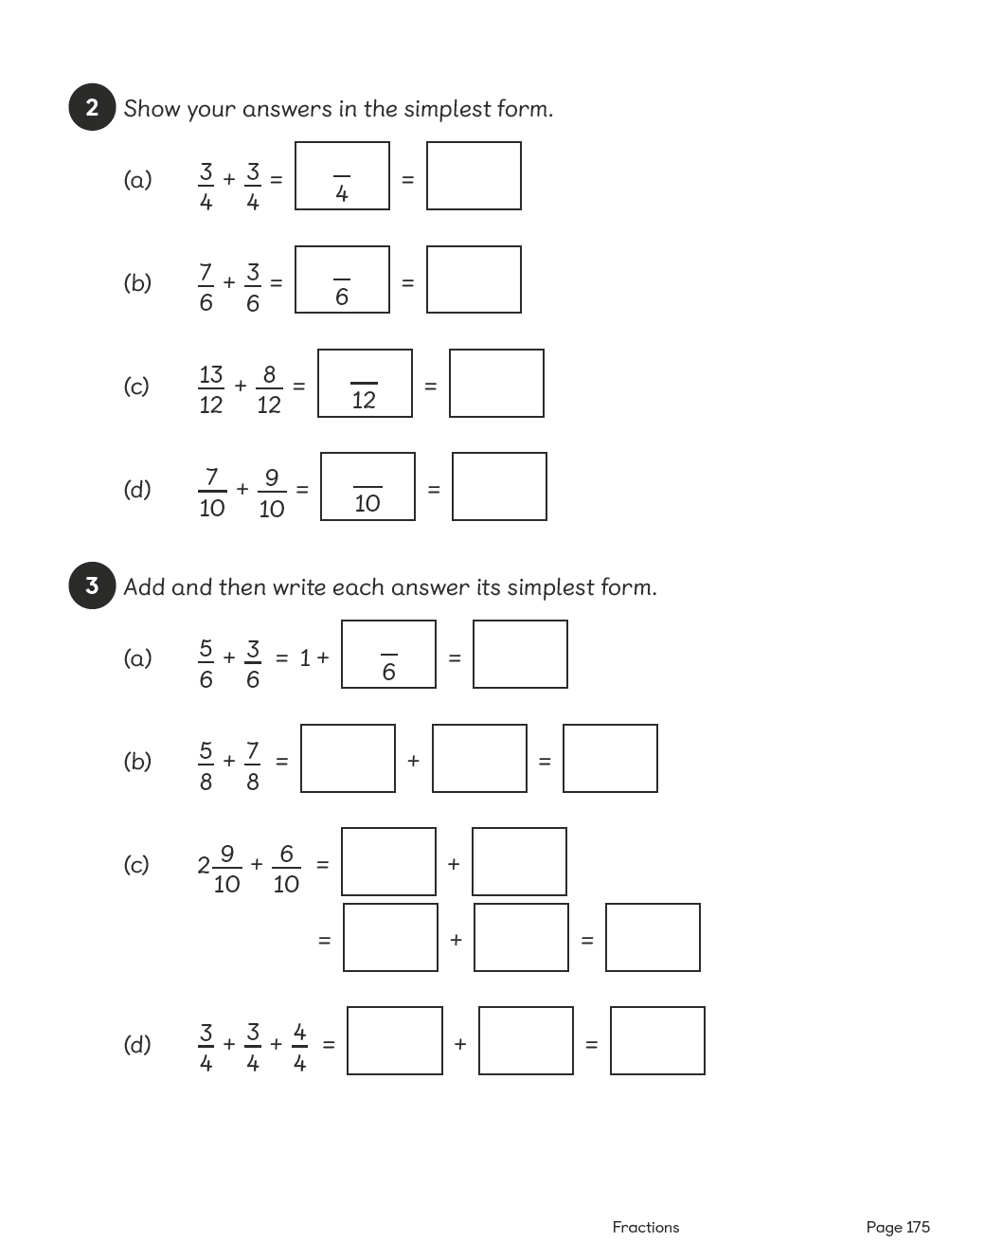

Lesson 11
Top of Form
Subtracting Fractions
Pages 254–255
Lesson Objective
To be able to subtract a fraction from a whole number.
National Curriculum
Subtract fractions with the same denominator.
Lesson Approach
To begin this lesson, show pupils the In Focus task and ask them if they think it is an addition problem. Give them some time to discuss this with their partners. What do we know from the problem?
Show the class how to complete the calculation using the images and steps taken in Let's Learn 1. How many whole bars of chocolate are there? How many pieces are in each bar? Do we need to change both whole bars into twelfths to perform the calculation? Why or why not? Is there another way that we could generate the same answer?
Invite a volunteer to show the class how 2 wholes can be converted to twelfths. Then use that to show the calculation: ²⁴⁄₁₂ – ⁵⁄₁₂ as shown in Let's Learn 2. Is this the same calculation as before? What is different? Allow pupils time to discuss the method that they find most suits them.
During Guided Practice, pupils are subtracting fractions from whole numbers. Remind them they can choose one method or practise both. Circulate the classroom to provide support.
Misconceptions
Pupils subtract the numerators and denominators.
Pupils do not see denominators as a name.
Pupils have trouble turning whole numbers into mixed numbers or improper fractions (3 = 2 and ⁴⁄₄ or ¹²⁄₄).
Formative Assessment
Pupils can subtract fractions of the same name (denominator).
Pupils can use pictures to support subtracting fractions of the same name.
Pupils can use concrete materials to support subtracting fractions of the same name.
Pupils can create mixed numbers from subtracting fractions.
Pupils can create improper fractions from subtracting fractions.
Pupils can use 'greater than' and 'less than' to compare and describe fractions, mixed numbers and improper fractions.
Pupils can simplify fractions to their simplest form from mixed numbers and improper fractions.
Pupils can turn a whole number into a mixed number (2 = 1 and ³⁄₃).
Pupils can recognise a whole as having an equal numerator and denominator.
Pupils can turn a whole number into a mixed number or an improper fraction.
Pupils can use number bonds to break apart a fraction.
Non-negotiables
Pupils can use pictures and concrete materials to represent whole numbers as fractions (2 = 1 and ⁴⁄₄).
Pupils can subtract fractions from whole numbers using pictures for support and simplify the answers when necessary.
Variation
Example 1: Using two methods to subtract a fraction from a whole number; the term 'difference' is used.
Example 2: Subtracting fractions from whole numbers and representing the solution as a mixed number.
Resources
No additional resources required for this lesson.
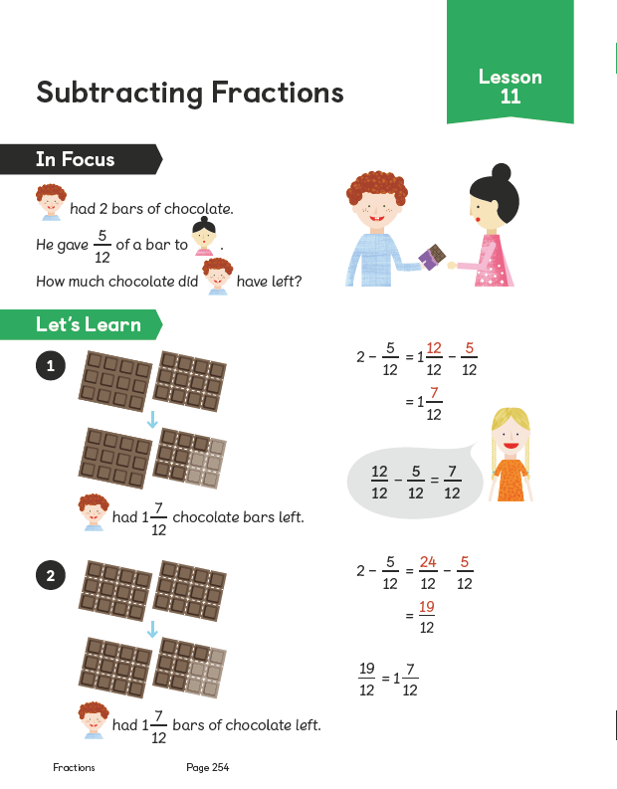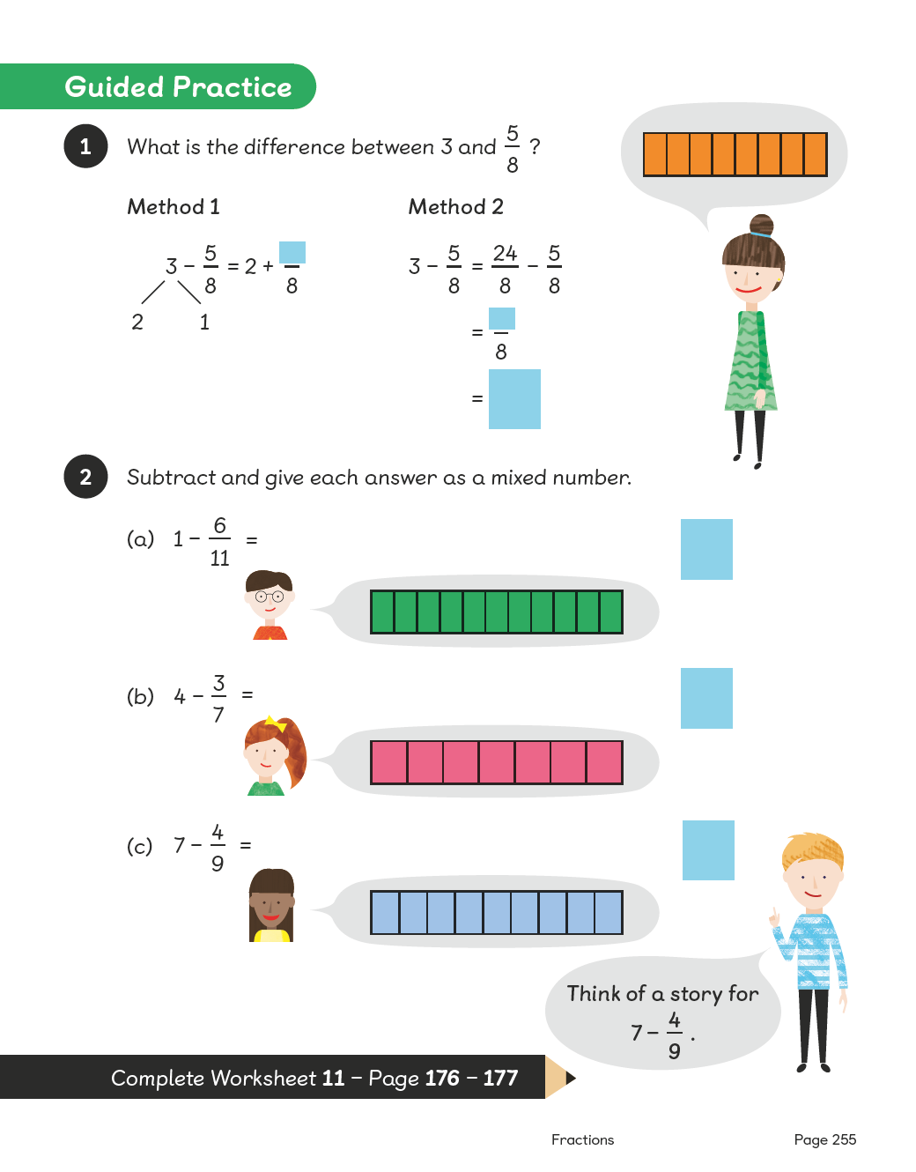
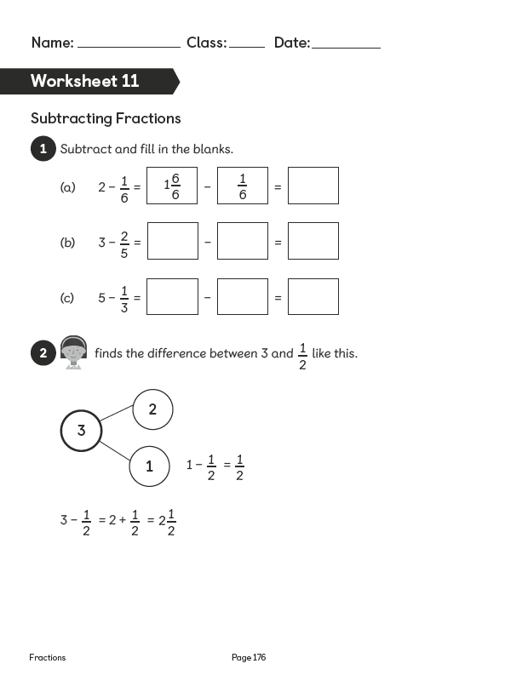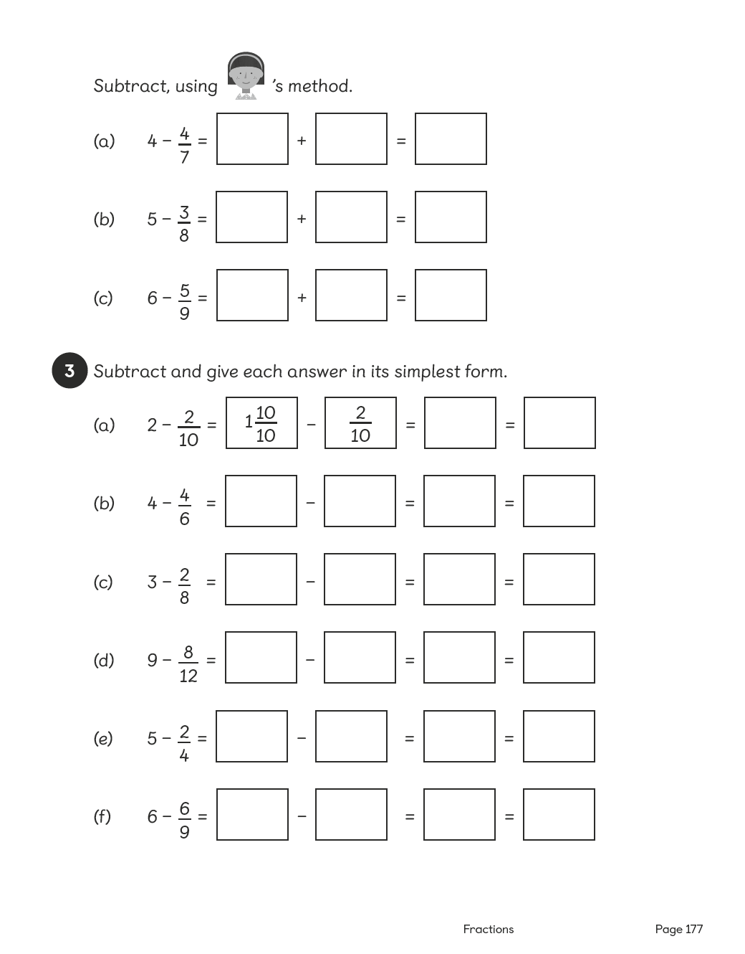

Lesson 12
Top of Form
Subtracting Fractions
Pages 256–257
Lesson Objective
To be able to subtract a fraction from a mixed number.
National Curriculum
Subtract fractions with the same denominator.
Lesson Approach
To begin this lesson, remind pupils of previous learning on subtracting fractions and ask them to discuss this with their partners. Then show them the In Focus task. What is the problem asking us to do? What do we know? What operation do you think we need to perform?
Work through Let's Learn 1, thinking aloud, to show the class the calculation. We know we have 1 ¹⁄₄ kg of flour and we want to remove ³⁄₄ kg. The easiest way to calculate this is to change 1 ¹⁄₄ kg into quarters. 1 whole = ⁴⁄₄; add that to ¹⁄₄ and we get ⁵⁄₄, which is equivalent to 1 ¹⁄₄. Now we can easily calculate ⁵⁄₄ – ³⁄₄ to get ²⁄₄. What do we know about ²⁄₄? Is it the same as another simpler fraction? Can we divide to find the equivalence? Is there another way to calculate the answer to the problem? Give pupils time to discuss this with their partners and then ask volunteers to share their ideas with the class.
If no one demonstrates the method in Let's Learn 2, work through the process thinking aloud: We can partition 1 ¹⁄₄ into 1 whole and ¹⁄₄. We can subtract ³⁄₄from 1 whole because we know that ⁴⁄₄ = 1, so 1 – ³⁄₄ = ⁴⁄₄ – ³⁄₄ = ¹⁄₄. Then we can add on the remaining ¹⁄₄ to give us ²⁄₄ or a half.
During Guided Practice, pupils are subtracting fractions from mixed numbers. Ask them to practise both methods.
Misconceptions
Pupils subtract the numerators and denominators.
Pupils do not see denominators as a name.
Pupils have trouble turning whole numbers into mixed numbers or improper fractions (3 = 2 and ⁴⁄₄ or ¹²⁄₄).
Formative Assessment
Pupils can subtract fractions of the same name (denominator).
Pupils can use pictures to support subtracting fractions of the same name.
Pupils can use concrete materials to support subtracting fractions of the same name.
Pupils can create mixed numbers from subtracting fractions.
Pupils can create improper fractions from subtracting fractions.
Pupils can use 'greater than' and 'less than' to compare and describe fractions, mixed numbers and improper fractions.
Pupils can simplify fractions to their simplest form from mixed numbers and improper fractions.
Pupils can turn a whole number into a mixed number (2 = 1 and ³⁄₃).
Pupils can recognise a whole as having an equal numerator and denominator.
Pupils can turn a whole number into a mixed number or an improper fraction.
Pupils can use number bonds to break apart a fraction.
Non-negotiables
Pupils can use pictures and concrete materials to represent whole numbers as fractions (2 = 1 and ⁴⁄₄).
Pupils can subtract fractions from whole numbers using pictures to support and simplify the answers when necessary.
Variation
Example 1: Turning mixed numbers into improper fractions to subtract; fraction bars provided as pictorial support.
Example 2: Number bonds suggested as the key method.
Resources
No additional resources required for this lesson.
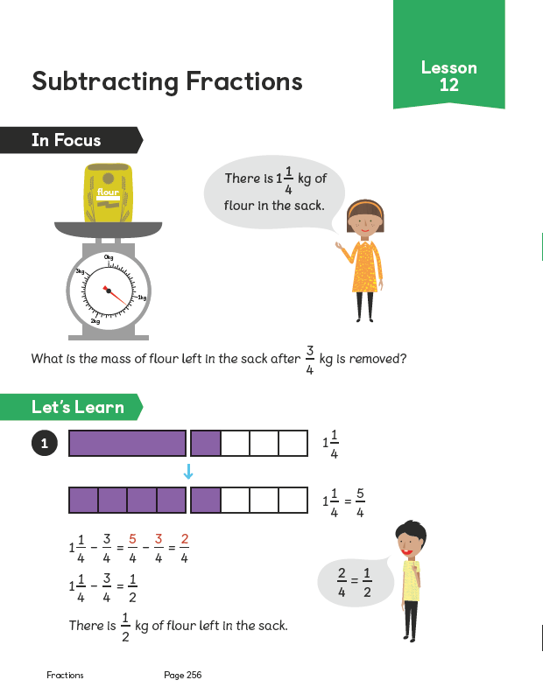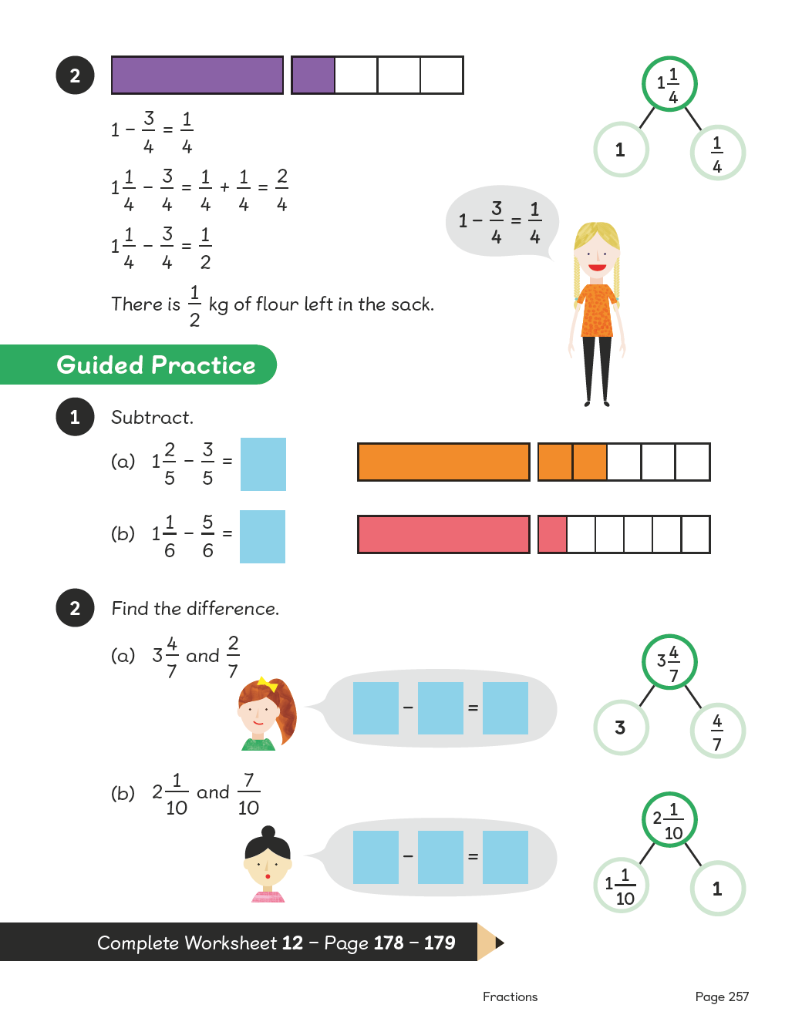

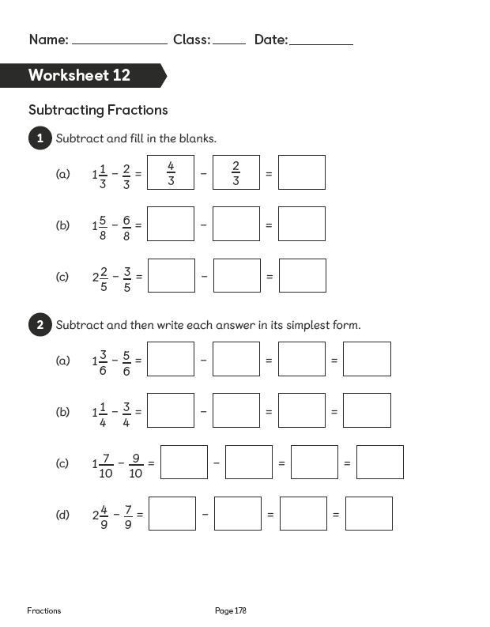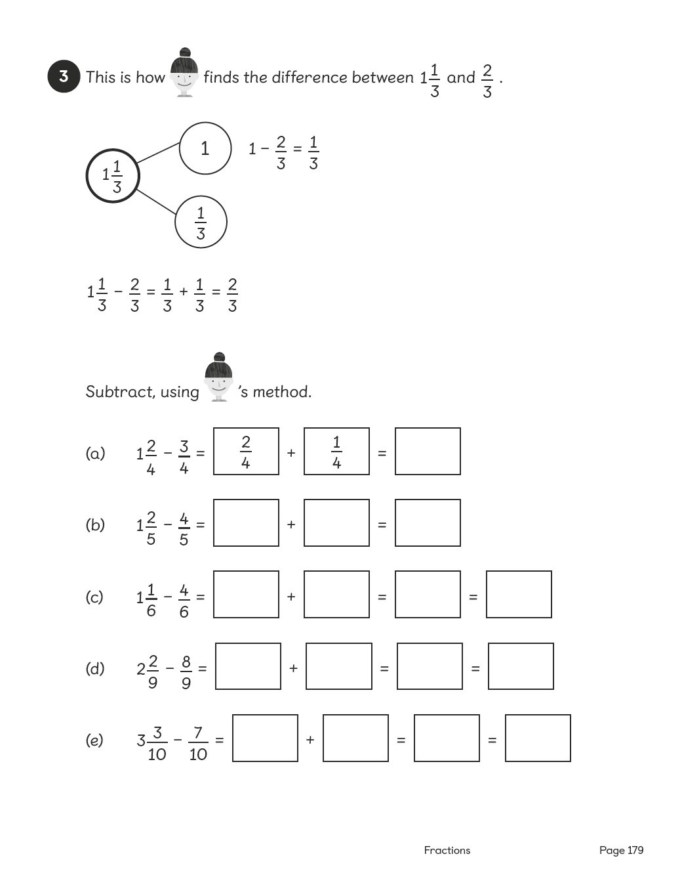

Lesson 13
Top of Form
Solving Word Problems
Pages 258–259
Lesson Objective
To be able to solve word problems involving fractions.
National Curriculum
Solve problems involving increasingly harder fractions to calculate quantities, and fractions to divide quantities, including non-unit fractions where the answer is a whole number.
Lesson Approach
To begin this lesson, show pupils the In Focus task and read it to them. What do we know? What do we want to find out? How far is the race? Draw a bar representing 4 km and mark each kilometre so the bar is divided into 4 parts. How many parts should we break each kilometre into? Why? Each person runs ²⁄₃ km. Mark on a face for each ²⁄₃. How many people do we need? Model counting the faces. How can we explain what I just did using thirds in my explanation? Allow pupils time to discuss this in pairs and encourage them to feedback like this: We know that 1 km = 3 thirds, therefore 4 km must be equivalent to 12 thirds because 3 × 4 = 12. There are six 2 thirds in 4 km, so 6 runners are needed. Use Let's Learn to further illustrate or explain if necessary.
Provide pupils with another question and give them time to try solving it with partners on whiteboards. Take feedback about challenges and successes.
During Guided Practice, pupils are solving word problems involving fractions.
Misconceptions
Pupils do not record all of the key information from the question.
Formative Assessment
Pupils can use pictures to support adding and subtracting fractions.
Pupils can use concrete materials to support adding and subtracting fractions.
Pupils can use bar models to reflect the key information from the question in fractions.
Pupils can use number bonds to break apart fractions into wholes and parts.
Pupils can turn a mixed number into an improper fraction.
Pupils can turn an improper fraction into a mixed number.
Pupils can turn a whole number into a mixed number and an improper fraction.
Non-negotiables
Pupils can use pictorial representations to solve word problems and reflect the key information from the question.
Variation
Example 1: Bar model provided and partially completed for support.
Example 2: Converting thirds to sixths; multiple steps involved; subtraction and number bonds required to solve the problem; pictorial support provided.
Example 3: Using addition and subtraction to solve the problem; no conversion of denominators required; pictorial support provided.
Resources
No additional resources required for this lesson.
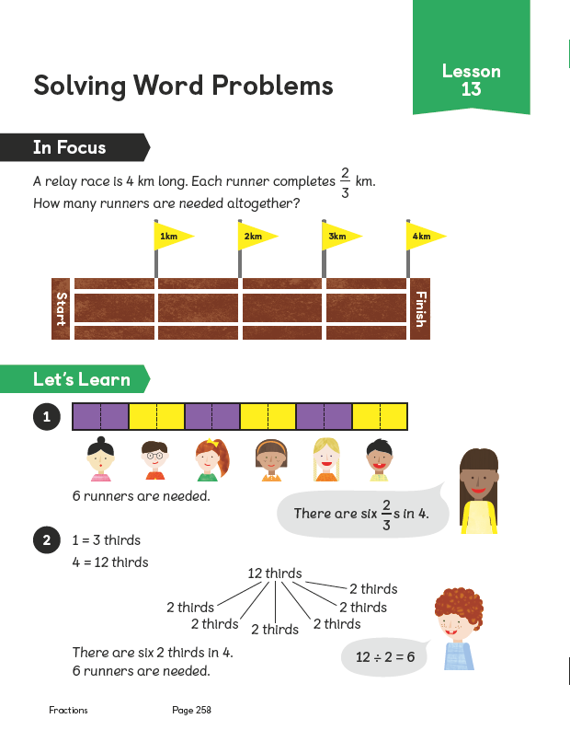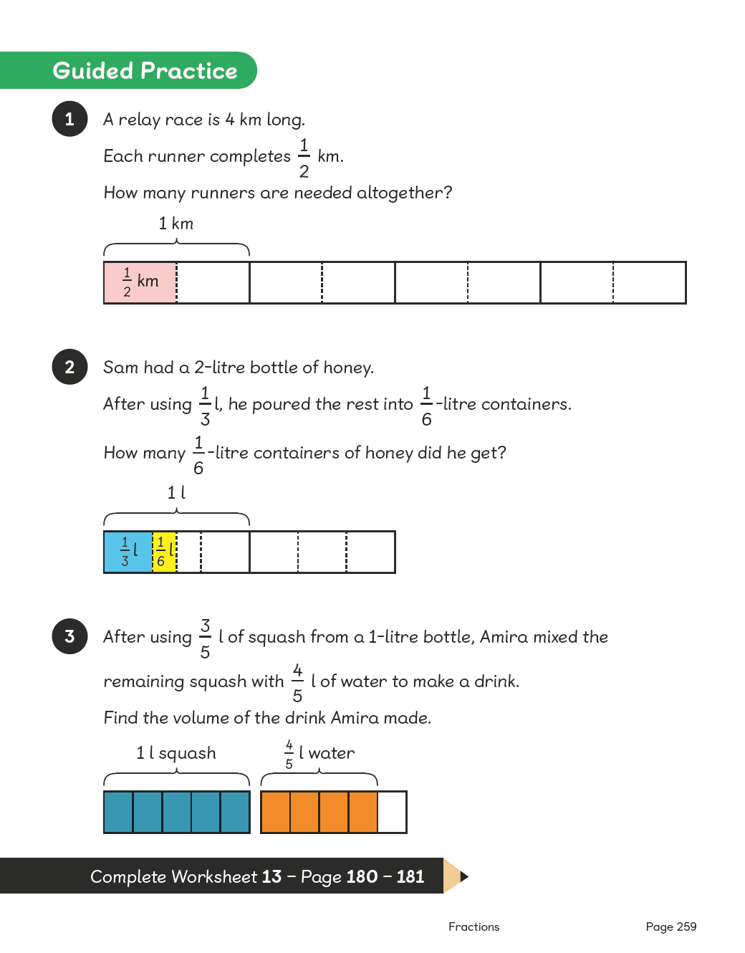
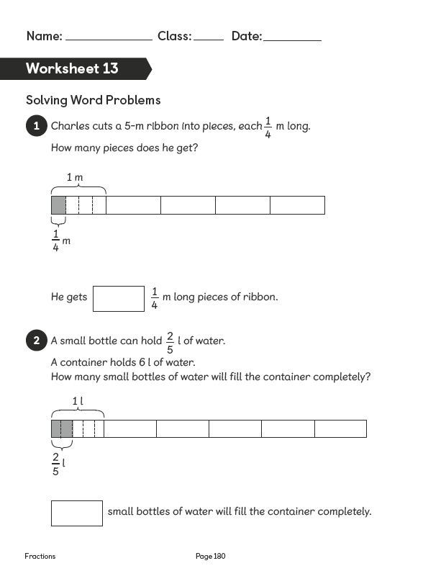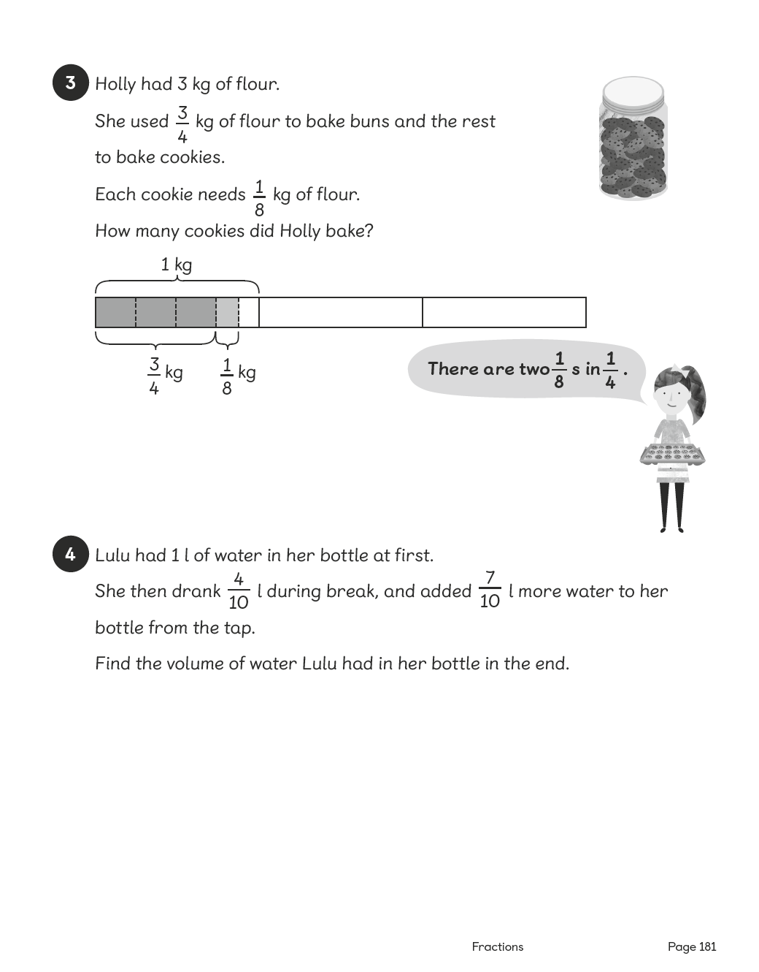

Lesson 14
Top of Form
Chapter Consolidation
Pages 260–260
Lesson Objective
To be able to use knowledge of fractions to solve problems.
Lesson Approach
Mind Workout
Pupils work out their solution to the problem and explain their thinking and reasoning to their partners.
Maths Journal
Pupils think of examples of fractions they see around them and record them in their journals.
Self Check
Pupils complete this as a chapter summary and discuss what to do with their teacher if any boxes are not ticked.
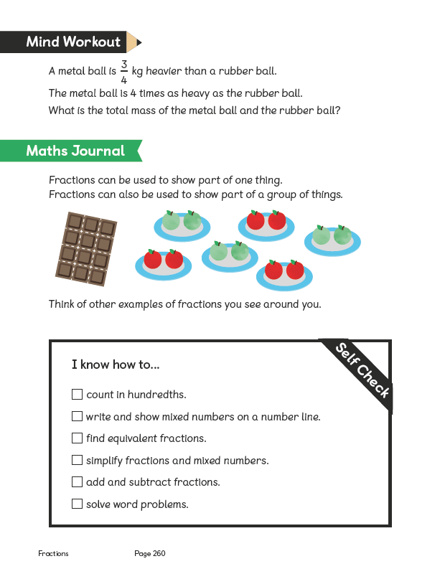
Bottom of Form
Bottom of Form

