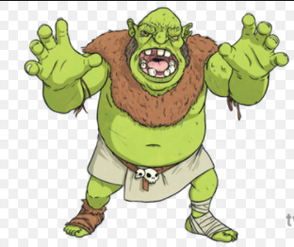

Can you write a character description using the following lenses
Noticing
Smelling
Imagining
Asking
Can you try and include some expanded noun phrases? 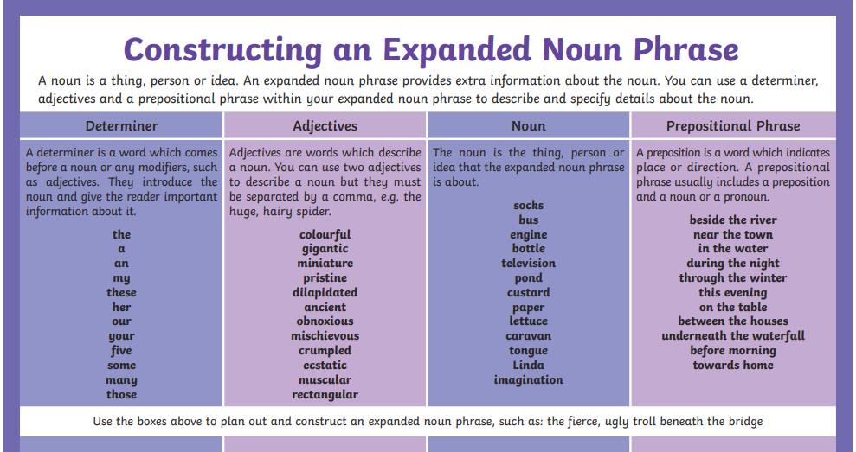drago

