Monday 25th January | PSHE –  Live lesson taught on teams.
Tuesday 26th January | History – gods and goddesses  https://www.historyforkids.net/ancient-greek-gods.html  Look at the different Ancient Greek gods and goddesses. Can you choose your favourites and make your own Top Trumps for them? You could try and play with a sibling or a friend (over video call).  See below for ideas:  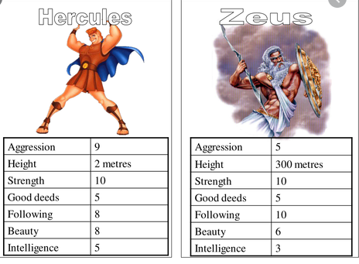
Wednesday 27th January | PE -  Have a look at these fun activities to try out at home!  https://www.ssww.com/blog/at-home-pe-virtual-activity-ideas-for-students/  Don’t forget to send in your pictures
Thursday 28th January | Science – Materials and their Properties  Last week we began to look at the different materials in our houses.  Some materials are manufactured – this means they have been manmade.  Some materials are natural.  Can you complete the worksheet that explains more about the differences between some natural and manufactured materials?  Use the word banks provided on the sheets to help you!  The science worksheet is attached below.
Friday 29th January | ART – Collaging  Using the resources, you have gathered over the last few weeks, can you start to plan your collage? Remember to think about what colours will compliment each other and which ones will clash.  Place each part where you would like it before sticking it down. If you haven’t got any glue try using blue tac or cello tape!  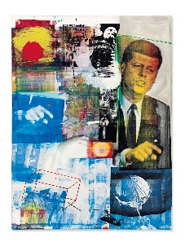

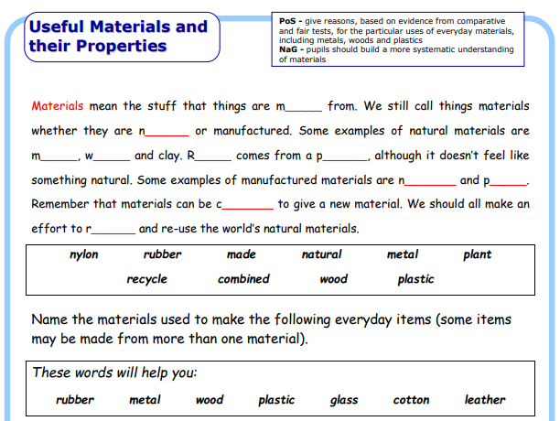
Science Worksheet
