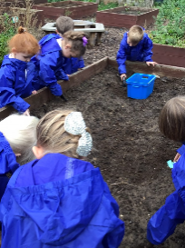

**This half term we are learning:**

* How to halve and double numbers
* How to carry out an egg experiment
* How eggs hatch and what kind of animals are born inside them
* How to care for living things
* How to use non-fiction books to find out information
* How to write a non-fiction fact file
* About the differences in the environment over time (comparing when dinosaurs were alive with where we live now)
* About all of the different technology around school and home
* How to share (using food to share between the dinosaurs)

**How to help your child at home:**

* Practice reading all set 1/set 2 letter sounds and using the letter rhyme to help your child to write the letters correctly
* Encourage your child to zip their coat up independently
* Listen to them read at home and help them practise their tricky words
* Encouraging your child to count objects, saying a number as they touch each object in order
* Encourage your child to practise ordering and recognising numbers to 10
* Encourage your child to write short label and captions, using their fingers to sound out the words
* Talk to your child about the environment they live in and how it is different from other places
* Encourage your children to practise writing their first and last name

**Thank you for all your support!**

Remember to check out our class pages on our school website [www.clapgateprimaryschool.co.uk](http://www.clapgateprimaryschool.co.uk)

**Things to remember:**

* School is closed to all children except those of critical workers
* Please upload and share any home learning activities on Tapestry

We have a new student teacher starting with us this half term called Mrs Gale.

[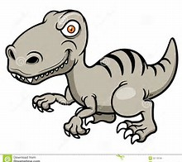](http://www.bing.com/images/search?view=detailV2&ccid=iPhN540l&id=B16CC8CDA3AD7F589D983E087CD7DA62E2FF9F02&q=dinosaur+cartoons&simid=607990877377793856&selectedIndex=224)

[](http://www.bing.com/images/search?view=detailV2&ccid=iPhN540l&id=B16CC8CDA3AD7F589D983E087CD7DA62E2FF9F02&q=dinosaur+cartoons&simid=607990877377793856&selectedIndex=224)

**Reception Newsletter**

**January – February 2021**

**Topic: Dinosaurs**

**Homework Project:**

Over this half term we would like you to create your own dinosaur scene/ dinosaur to showcase at our dinosaur exhibition at the end of the half term. We would like you to post pictures of your finished project on Tapestry in the final week.

**We will also be:**

* Tasting different types of eggs and discussing the flavours
* Observing the ‘hatching’ process of our class egg
* Making our own dinosaurs using paper plates
* Talking about our feelings and emotions and how lockdown has made us feel

Celebrating **Tidy Up** **Star of the Day,**

**Good Work of the Week** and **Class**

**Star of the Week** (both online and in school)