Monday 22nd Feb | Geography– Greece  Live lesson taught on teams.
Tuesday 23rd Feb | PSHE- Keeping Healthy  Research the side effects that smoking has on the body.  Make some notes based on your research and then use them to create a poster to encourage people to stop smoking.  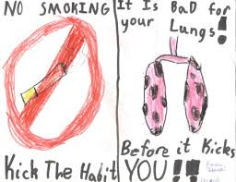  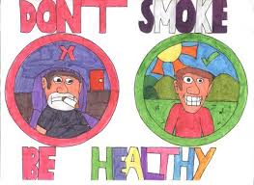
Wednesday 24th Feb | PE – Multi Skills  Have a go at the multi-skills challenges and send photos or videos to your teachers.  https://www.youtube.com/watch?v=AJb_-d0DrgA
Thursday 25th Feb | Art – Printing  Look at the works of famous artists that have created works of art using printing. Is there anything similar or different about their work?  Research famous artists that have used printing – Morris, Warhol, Lichtenstein and Hokusai.  Create a mind map to show what you have found out.
Friday 26th Feb | ICT- Databases  Find out what databases are by completing the following online lesson:  https://www.bbc.co.uk/bitesize/topics/zf2f9j6/articles/z8yk87h

