Monday 8th Feb | Science –  Live lesson taught on Teams
Tuesday 9th Feb | RE – The Parable of the Lost Son – Forgiveness  Watch the video about the Parable of the Lost Son  https://www.bbc.co.uk/bitesize/clips/zsmpvcw  Think about:  What has happened?  What effect did it have on their life?  What did other people think about it?  Why are stories like this still being told all these years later?  When Jesus was crucified he said ‘Father, forgive them, they don’t know what they are doing.’  What do you think he meant by this? Would someone in his position usually say this?  Task – Think about a time in your life when you have shown or been shown forgiveness. Can you write about what happened, how it made you feel, how the other people or person involved felt? Write a paragraph to explain your answers.
Wednesday 10th Feb | PE – Follow the link to the following website.  https://www.nhs.uk/10-minute-shake-up/shake-ups?filter=frozen-fever  Choose three activities to complete from the following website. Please note – some activities can be done ion groups of 2, 3 or 4 so you may wish to ask a parent or sibling to join in!
Thursday 11th Feb | DT – Evaluating Art Work  Please see the attached sheet below.
Friday 12th Feb | French – Weather Map  Can you make your own weather map of the UK using the key vocabulary below? Draw out the UK and then choose different regions to have different weather types.  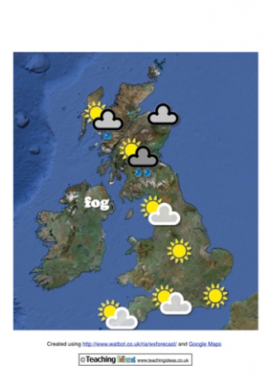  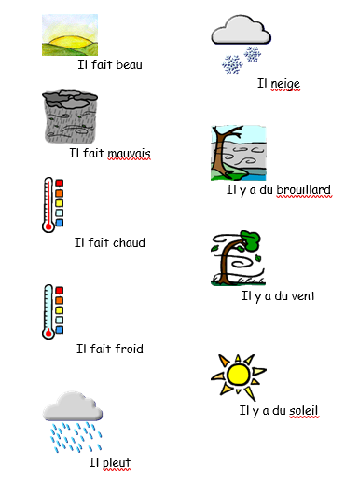

Art Evaluation Sheet
Describe what you have made
______________________________________________________________________________________________________________________________________________________________________________________________________________________________________________
Describe what you like about your work
______________________________________________________________________________________________________________________________________________________________________________________________________________________________________________
How could you improve your work if you did it again?
______________________________________________________________________________________________________________________________________________________________________________________________________________________________________________
How is your work similar to the work of Robert Rauschenburg?
____________________________________________________________________________________________________________________________________________________________________________________________________________________________________________________________________________________________________________________________________________________________________

