|  |  |  |
| --- | --- | --- |
| **Key People** | | |
| Sir Winston Churchill – (1874-1965)   * Prime Minister 1940 - 1945 and 1951 - 1955. * He rallied the nation in defiance of Adolf Hitler * Forged crucial alliances with both the USA and Russia | Adolf Hitler – (1889-1945)   * Leader of the Nazi party * Chancellor of Germany 1933-1945 * Fuhrer of Germany 1934-1945. * Initiated the Holocaust * Responsible for millions of deaths. |
|
|
| **Franklin Roosevelt –** (1882-1945)   * President of USA from 1933-1945 * After the Japanese attacked Pearl Harbor on 7th December 1941, he declared war on the Axis powers. * Roosevelt and the US helped the Allies to win the war | Benito Mussolini **–** (1883-1845)   * leader of Italy’s National Fascist Party. * Italian Prime Minister 1922-1945 * From 1925 he established a dictatorship. * In 1943, Mussolini was dismissed as leader and arrested |
|
|
| Joseph Stalin – (1878-1953)   * Communist dictator of the USSR during WWII. * He had signed a non-aggression pact with Germany in August 1939, but in June 1941, Hitler broke it and the Germans invaded. * USSR’s victories in pushing the Germans back signalled a shift in the war in favour of the Allies. | Anne Frank – (1929-1945)   * As a young Jewish girl, her family were forced into hiding, fleeing Germany for a secret attic in Amsterdam in the Netherlands. * She wrote a diary of her time there. * Anne died of Typhus in Bergen-Belsen concentration camp. The only survivor from her family was Otto, her father, who published her diaries after her death. |
|
|

|  |  |
| --- | --- |
| **Men** | **Women** |
| * Men were fought as soldiers * Protected occupations: Doctors, miners, farmers, scientists, merchant seamen, school teachers, railway and dock workers, utility workers - water, gas, electricity | * In December 1941, the government conscripted single women aged 20-30. * Women’s employment  increased from about 5.1 million in 1939 to just over 7.25 million in 1943. |
| **Children** | |
| * Operation Pied Piper 1st September 1939- Millions of children were evacuated from London. * Kinder transport 1938- The UK took nearly 10,000 [Jewish](https://en.wikipedia.org/wiki/Jewish) children from [Nazi Germany](https://en.wikipedia.org/wiki/Nazi_Germany), Nazi-occupied [Austria](https://en.wikipedia.org/wiki/Federal_State_of_Austria), [Czechoslovakia](https://en.wikipedia.org/wiki/First_Czechoslovak_Republic) and [Poland](https://en.wikipedia.org/wiki/Second_Polish_Republic). * The children were placed in British [foster homes](https://en.wikipedia.org/wiki/Foster_homes), [hostels](https://en.wikipedia.org/wiki/Hostels), schools and farms.  |  | | --- | | **Allies, Axis and Death Tolls** | | |

|  |
| --- |
| **Vocabulary** |
| **Allies –** formally cooperating  **Axis –** fight against allies  **Concentration camp** – a type of prison where large numbers of people are kept during a war and forced to live in bad conditions  **Dictator** – a ruler with total power over a country who has obtained control through force  **Evacuee**- a person sent away from a place of danger  **Holocaust** – destruction or slaughter on a mass scale  **Nazi** – political party led by Hitler  **Swastika** – symbol used to represent  **The Blitz** – Night time bombing raids in British cities by Nazis  **War** – a state of armed conflict between different countries |

|  |  |
| --- | --- |
| **Allies** | **Axis** |
| Soviet Union | Germany |
| France | Japan |
| UK | Italy |
| USA | Hungary |



|  |
| --- |
| **Local Family** |
| * Ivy and Winifred Lambert * Lived in Armley, Leeds during   WW2   * Witnessed many bombings in   Leeds during ‘The Blitz’ |

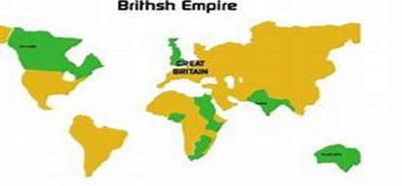

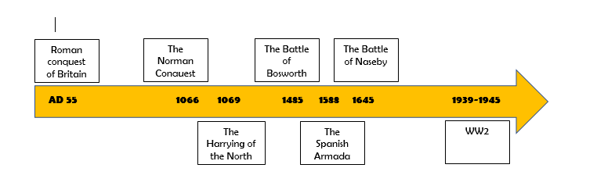



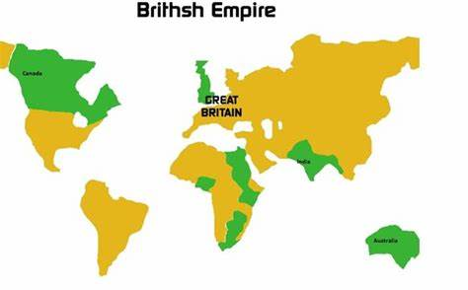 ** France – Allied Power**

** Italy – Axis Power**

** Hungary – Axis Power**

** UK – Allied Power**

** USA – Allied Power**

|  |  |  |  |  |  |
| --- | --- | --- | --- | --- | --- |
| **Main Participating Countries** | | | | | |
| **ALLIED POWERS** | | | AXIS POWERS | | |
| **Country** | **Date Joined** | **Death Toll** | **Country** | **Date Joined** | **Death Toll** |
| FRANCE | 3rd Sep, 1939 | 600,000  1.44% of population in 1939 | GERMANY | 1st Sep, 1939 | approx.  7,200,000  8.5% of population in 1939 |
| UK | 3rd Sep, 1939 | 450,900  0.94% of population in 1939 | ITALY | 11th Jun, 1940 | approx.  500,000  1.14% of population in 1939 |
| SOVIET UNION | 22nd Jun, 1941 | approx. 24,000,000 13.7% of population in 1939 | HUNGARY | 27th Jun, 1941 | 464,000  5.08% of population in 1939 |
| USA | 8th Dec, 1941 | 419,400  0.32% of population in 1939 | JAPAN | 7th Dec, 1941 | approx.  3,000,000  4.1% of population in 1939 |