Year 5
Spring Term
March 2021 – April 2021
Hello and welcome back!!!
This term we will be learning about Greece! This is chance for you to deepen your knowledge in a topic I know you already know about!
The children will be taught by myself, Miss Brockley and Miss Drayson. They will also enjoy art lessons with Miss Webster.
If you have any questions or concerns please feel free to ring me or see me at the end of the school day.
Many thanks, Miss Wood
Geography topic:  This half term we will be exploring Greece. This is a wonderful country with lots of history and beautiful islands. The children will get the chance to explore the geographical features of this country as well as taste some of the food which is popular in Greece. | This half terms learning:  Science  Properties and changes of materials  Computing  Game creation  PSHE  Keeping Healthy  RE  Forgiveness  Music  The Fresh Prince of Bel Air  PE  Gymnastics and Handball  Art  Printing  French  How to say items of clothing in French
Writing lessons:
In our writing lessons the children will be reading The Highway Man. This is narrative poem that I am sure the children will enjoy reading. We will then use this poem to plan and write our onw narrative poem.
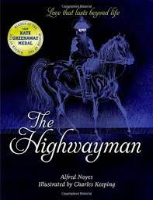
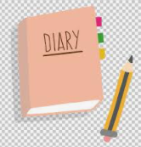  Weekly Calendar:  Monday and Wednesday-  P.E: Please send your children to school in their PE kits on these days.  Friday – Return homework and new homework set.  Please remember to send your child’s book bag into school every day. | You can help by:  - Reading with your child daily and discussing the book they read.  - Sending reading books into school every day.  - Practising all times tables.  - Practising spellings  - Allowing your children to complete research about Greece.

