C t

A warm welcome back to all our children!

We hope you have had a lovely time off and you are as excited as we are to start another fantastic half term full of fun learning opportunities. We started off our learning with a curious find... someone left an egg in our classroom! The children will look after the egg and they will eventually discover that it is in fact a dinosaur egg. We will learn about different types of dinosaurs and their features through fiction and non-fiction texts. At the end of the term the children will meet a very special guest, a life-size T-rex! This is a surprise for the children, make sure you keep it secret 😊

**The children will:**

* Carry out an egg experiment
* Taste different types of eggs and discussing the flavours
* Make their own dinosaurs using paper plates, learning how to use split pins
* Make their own salt dough, measuring the ingredients and kneading the dough to then create dinosaur fossils.
* Take part in a dinosaur hunt
* Create abstract prints using potatoes
* Practise writing their own simple sentences
* Create a dinosaur skeleton using cotton buds
* Investigate living and dead plants and talk about the differences they observe

**This half term we are learning:**

* To have a deep understanding of numbers 9 and 10.
* How to recognise odd and even numbers
* How to automatically recall number bonds to 5 and some to 10
* How to double numbers
* How to use non-fiction books to find out information
* How to write a non-fiction fact file
* How to use finger spaces, capital letters and full stops when writing
* How eggs hatch and what kind of animals are born inside them
* About the differences in the environment over time (comparing when dinosaurs were alive with where we live now)
* The meaning of the term ‘herbivore’, ‘carnivore’ and ‘omnivore’.

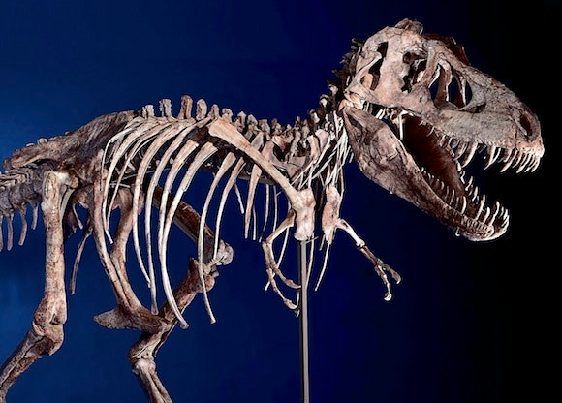

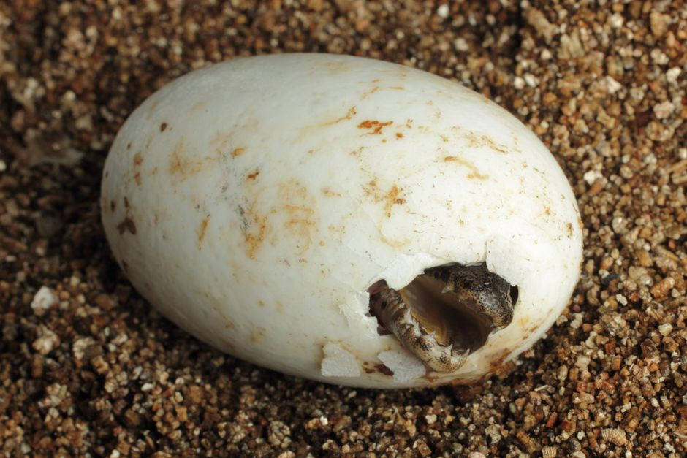

**How to help your child at home:**

* Practice reading all set 1/set 2 letter sounds and using the letter rhyme to help your child to write the letters correctly
* Encourage your child to sound out words themselves when writing and encourage them to write their own sentences
* Listen to them read at home and help them practise their red words
* Encouraging your child to count objects, saying a number as they touch each object in order
* Encourage your child to practise ordering and recognising numbers to 10
* Encourage your child to recall number bonds to 5 (eg 2 and 2 is 4 and 3 and 1 is 4)
* Encourage your child to practise writing their first and last name
* Encourage your child to talk about what they have been learning about in school

**Thank you for all your support!**

Remember to check out our beautiful work on [www.clapgateprimaryschool.co.uk](http://www.clapgateprimaryschool.co.uk)

**Things to remember:**

Children in Reception will have a weekly outdoor learning session. Please bring in a pair of wellies with their name in. We do have a few spare if needed. We have a set of waterproof suits for each child to wear if it is wet but a waterproof coat in school is useful too.

RLK will need their wellies on **Wednesdays** and RPB will need their wellies on **Fridays.**

**Comic Relief day - Friday 18Th March 2022**

**Rufus Birthday – 11th March 2022**

**Easter Disco- 31st March 2022**

**Reception Newsletter**

**March 2022 - April 2022**

**Theme - Dinosaurs**