Year 5
Summer Term
April 2022 – May 2022
Hello and welcome back!
This term we will be learning about The Maya, animals including humans, relationships and much more!
The children will be taught by myself, Miss Webb and Mrs Watson. They will also enjoy PE lessons with Miss Beaumont.
If you have any questions or concerns, please feel free to ring me or see me at the end of the school day.
Many thanks, Miss O’Connell
The Maya:  This half term we will be learning about the Mayans and what their lives were like. We will look at many of their wonderful inventions and discover who their great rulers were. We will also see what life was like for them, where they lived and what impact they have had on today’s world.  The topic will be taught across various subjects including writing, guided reading and history.  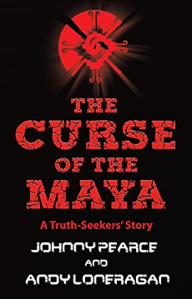  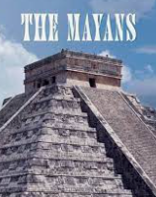 | This half terms learning:  Science  Animals, including humans  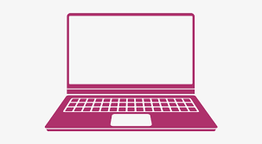  Computing  Vector drawings  PSHE  Relationships  RE  What do Christians think about Old and New Covenants?  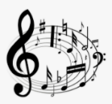  Music  Boomwhackers  PE  Athletics and Cricket  Art  Drawing  French  My Family
Weekly Calendar:  Tuesday  P.E: Please send your children to school in their PE kit on this day.  Friday – Return homework and new homework set.  Please remember to send your child’s book bag into school every day. | You can help by:  - Reading with your child daily and discussing the book they read  - Sending reading books into school every day  - Practising all times tables  - Practising spellings  - Allowing your children to complete research about The Maya

