Year 6
Summer Term
April 2022- May 2022
Hello and welcome back!!
This half term, is going to be a busy and important one. The children will be completing their SAT’s the week beginning Monday 9th May 2022.
There will be plenty of revision to ensure that the children are confident when it comes to sitting their SATs. Your children have worked really hard this year and we are certain that their hard work will pay off
This half term the children will be taught by myself and Mrs Stevens. The children will enjoy art and DT lessons with Mrs Stevens.
As always, if you have any questions or concerns please feel free to pop into school or email me.
Many thanks,
Mrs Phipps
History topic:  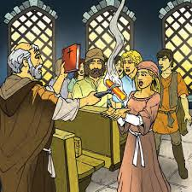  This half term, we will continue our topic ‘Crime and Punishment’. The children have thoroughly enjoyed this topic and I am excited to continue this topic with them! So far they have learnt about Crime and Punishment during The Middle Ages and The Medieval era. | This half terms learning:  Science  Living Things and Their Habitats  Computing  3D Modelling and Webpage Creation  PSHE  Relationships  Music  Steel pans  PE  Athletics and Cricket  Art  Painting  DT  Textiles  French  At school
Writing lessons:
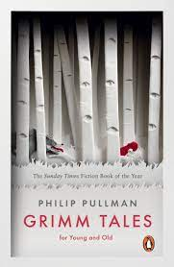
In writing, the children will be writing a non-chronological report about electricity. This piece of writing links to their science topic from last half term, meaning they will have plenty to write about.
We will also be reading stories from Phillip Pullman’s- Grimm Tales. The children will then be planning and writing their own fairytale.
Dates for your diary:  Monday 9th May – Thursday 12th May: SAT’s week.  Friday 13th May: Trip to Middleton Park.  Tuesday 17th May- Wednesday 18th May: Trip to London.  Tuesday 21st June: Year 6 show- Oliver!  Wednesday 22nd June: Year 6 show- Oliver! | Weekly Calendar:  Friday: PE- children need to come to school in their PE kits.  Daily: Please remember to send the children to school with their revision homework.  Daily: Send reading books to school and complete Go Read log.  You can help by:  - Reading with your child daily and discussing the book they read.  - Supporting your children with completing daily homework in reading, maths and SPAG.

