C t
The children will:
- Practise speaking to unfamiliar adults to promote oracy
- Be able to talk about pictures of familiar situations which are in the past (key focus on police officers and dentists)
- Research a well-known scientist- Mary Anning and her study of dinosaurs
- Go on an archaeological dig to find fossils
- Create watercolour paintings of spring flowers
- Go pond dipping and create an observational drawing of what lives in that habitat
- Have a paint fight to celebrate the Festival of Colours
- Have a visit from a nurse to talk about how we look after ourselves and others
- Take part in Helicopter Stories and Poetry Basket

Thank you for all your support!
For more details, please see our website.
www.clapgateprimaryschool.co.uk

Things to remember:
Children in Reception will have a weekly outdoor learning session. Please bring in a pair of wellies with their name on them. We do have a few spares if needed. We have a set of waterproof suits for each child to wear if it is wet, but a waterproof coat in school is useful too.
The children will need their wellies on Thursdays.
Wednesdays will continue to be PE days for Reception.

Reception Newsletter
February – April 2026
Dinosaurs and Celebrations
This half term, we are learning:
- To have a deep understanding of numbers 9 and 10
- To double more numbers
- How to use the internet to research key facts
- How to recognise odd and even numbers
- How to tell the difference between length and height
- About palaeontologists and fossils
- How to use a capital letter, finger spaces and a full stop when writing a sentence
- About Easter and Eid celebrations
- To use our own ideas to write a short phrase or sentence in meaningful contexts that others can read with support
- That dinosaurs are now extinct
- About life cycles of chicks and dinosaurs

Welcome back to Reception! We will be starting this half-term by exploring everything about Dinosaurs and Eggs! We will then do a week on ‘People Who Help Us’, and a children’s pediatric nurse will visit the school to talk with the children about basic first aid and the importance of washing their hands and staying safe. For the final four weeks, our teaching will focus on chicks and hatching eggs, as well as traditional tales like Sleeping Beauty. We will focus on the fictional element of dinosaurs, then discover dinosaurs and make a comparison, and we will read some fictional dinosaur stories. We have a very exciting half-term planned. It’s going to be ROARsome! In week 3, we will be celebrating Mother’s Day and inviting mothers to join us for story time! Finally, we will be learning all about different celebrations like Easter and Eid.
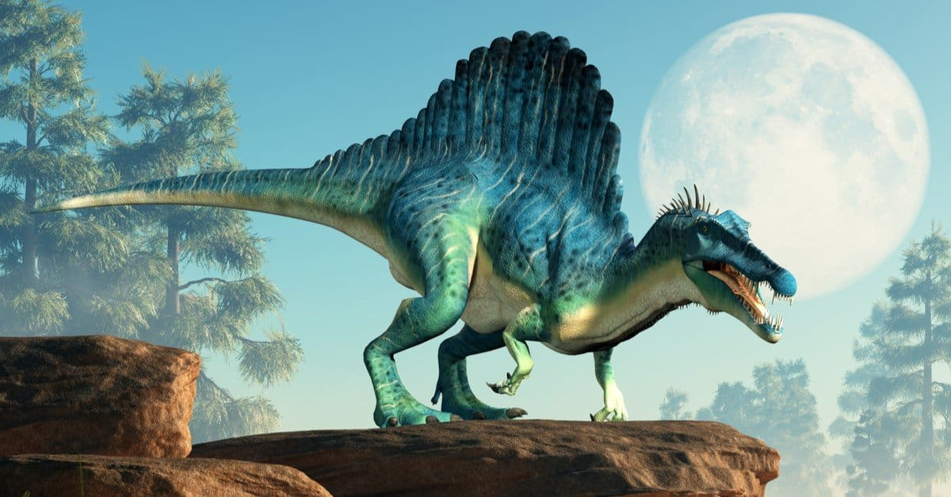
How to help your child at home:
- Practise reading all set 1/2 letter sounds and using the letter rhyme to help your child write their letters correctly
- Encourage your child to zip their coat up independently
- Listen to them read at home as much as possible
- Practise reading and writing the red words learnt in phonics
- Encourage your child to practise ordering and recognising numbers to 15
- Encourage your child to write simple sentences using their Fred fingers to sound out the words
- Talk to your child about the environment they live in and how it is different from other places in the world
- Encourage your child to practise writing their first and last name



